**Dominic Ottl, Troop 610 Eagle Scout**

**Court of Honor Agenda and Script:**

**Nov 2nd, 2024 at 2-5pm**

**St. Stephens Catholic Church Family Center, Riverview, FL**

Eagle Scout: Dominic Ottl

MC: (Jacob Towns/Daniel Alerta)

SPL: Alex Payne

Scout Master: Scott Townes

Color Guards/Honor Guards: (Daniel Alerta?), Nicholas Ottl, Julian Ottl

Scout Law Scouts: Nicholas Ottl/Julian Ottl

Benediction: Lubomir Ottl

Decorations/Set up: Linda Ottl

Historian/Media:

12pm – Room opens and basic set up (3-5 volunteer scouts)

-tables, chairs, decorations, food, drinks, trash cans, ice, cake

-BSA/Troop items and decorations arrangements in place

-position flags and decorate Eagle Table

-set up PA System, video recording, and projector

12.30pm – Ceremony/Script Rehearsal (30-45 min)

1.30pm – Guest arrive – find/take seats, music is played in background

(volunteer scouts escort people, guide traffic, help out)

**2.05PM - MC: “Good afternoon, the ceremony will start in 5 minutes. Please, take your seats, mute your phones and electronics. Thank you.”**

2.10pm – Lights turn off except the main eagle scout table and podium. Music turns off.

**MC:** Scout sign up to get attention..20-30 seconds..and then speak”

**“Good afternoon ladies and gentlemen, scouts, friends, family. Welcome to Dominic Ottl Eagle Scout Ceremony. My name is Jacob Towns, a Star Scout with Troop 610, and your Master of Ceremonies for this very special event. It is my honor to declare that the Eagle Court of Honor for Dominic Ottl is now officially open.”**

**MC: “Honor Guards, please, escort Dominic Ottl, Eagle Scout, forward!”**

(Wait for Dominic to come up..Honor Guards return to back, wait for flags)

**MC: Please, remove your hats and join us for the opening prayer:”**

Prayer: Lubomir Ottl

**In the name of the Father, Son, and Holy Spirit, Amen..**

**Dear God, we are grateful to gather here today to celebrate this special day, a true victory and celebration of transformation of a boy to a fine young man, servant leader, valued member of our community, and exemplary citizen. We thank you for guiding this young man on his journey to become an Eagle Scout, the highest honor in Scouting Leadership and Personal Development program. May you continue to Bless Dominic, His Family, His troop, and this Community that helped prepare this young men and many others for their life purpose and significance. In the name of the Father, Son, and Holy Spirit..Amen..”**

**MC: “Please, rise for the presentation of colors”** (wait for everyone to rise)

**Dominic** turns towards the audience and directs color guards to present the colors

**Dominic:**

Leader: "Color Guard, Attention!" Leader: "Audience, Please Rise!"

Leader: "Scout Salute! Those not in uniform, please place your right hand over your heart."

Leader: "Color Guard, Forward March!" Wait for color guard to reach the front.

Leader: "Color Guard, Halt!" Leader: "Color Guard, Cross the Colors!" State and Troop flags stop. US Flag crosses in front of other flags to left-most flag stand (as viewed from the audience), then State flag advances, then Troop flag. Wait for flag bearers to move to the flag pole stands.

**Dominic commands: Please join me for the Pledge of Allegiance, Scout Oath, and Scout Law”**

"TWO!" Everyone drops salute.

**Dominic Speaks: “put your right hand on your heart..”**

**“I Pledge the allegiance to the flag of the United States of America and to the republic for which it stands, one nation under God, indivisible, with liberty and justice for all.”**

**Dominic speaks: “Scout Sign up! Scout Oath”**  (all scouts recite together)

**“On my honor I will do my best to do my duty to God and my country and to obey the Scout Law; to help other people at all times; to keep myself physically strong, mentally awake, and morally straight.”**

**Dominic Speaks: “Scout Law:”**

**“Scout is trustworthy, loyal, helpful, friendly, courteous, kind, obedient, cheerful, thrifty, brave, clean, and reverent”**

**MC: “please, be seated”**

**MC:** **As we begin this Eagle Court of Honor and examine the "Trail to Eagle," it is fitting that we start with the fundamental principles of Scouting: the Scout Oath and the Scout Law. We have just joined together in reciting the oath. Let us begin our ceremony by lighting candles symbolic of the three parts of the Scout Oath:  
  
Duty to God and country** [pause for Julian to light candle] **Duty to others** [pause for a Nicholas to light candle] **Duty to self** [pause for Dominic to light candle]  
  
**MC:** **In Scouting, as in most activities of life, there are rules. The rules of Scouting are found in the twelve points of the Scout Law. As a candle is lit for each point of the Scout Law, let us pay careful attention to the words and re-dedicate ourselves to the principles contained in those words.**

(Nicholas and Julian come forward and each takes one mic)

**!!NICHOLAS/JULIAN: (**as alternating scouts read the scout law explanation)

**Nick: A SCOUT IS TRUSTWORTHY.**

**Julian: A Scout tells the truth. He keeps his promises. Honesty is a part of his code of conduct.  
  
Nicholas: A SCOUT IS LOYAL.**

**Julian: A Scout is true to his family, friends, Scout leaders, school, nation, and world community.**

**Nicholas: A SCOUT IS HELPFUL.  
  
Julian: A Scout is concerned about other people. He willingly volunteers to help others without expecting payment or reward.  
  
Nicholas: A SCOUT IS FRIENDLY.  
  
Julian: A Scout is a friend to all. He is a brother to other Scouts. He seeks to understand others. He respects those with ideas and customs that are different from his own.  
  
Nicholas: A SCOUT IS COURTEOUS.  
  
Julian: A Scout is polite to everyone regardless of age or position. He knows that good manners make it easier for people to get along together.  
  
Nicholas: A SCOUT IS KIND.  
  
Julian: A Scout understands there is strength in being gentle. He treats others as he wants to be treated. He does not harm or kill anything without reason.  
  
Nicholas: A SCOUT IS OBEDIENT.  
  
Julian: A Scout follows the rules of his family, school, and troop. He obeys the laws of his community and country. If he thinks these rules and laws are unfair, he tries to have them changed in an orderly manner rather than disobey them.**

**Nicholas: A SCOUT IS CHEERFUL.  
  
Julian: A Scout looks for the bright side of life. He cheerfully does tasks that come his way. He tries to make others happy.  
  
MC: A SCOUT IS THRIFTY.  
  
Julian: A Scout works to pay his way and to help others. He saves for the future. He protects and conserves natural resources. He carefully uses time and property.  
  
Nicholas: A SCOUT IS BRAVE.  
  
Julian: A Scout can face danger even if he is afraid. He has the courage to stand for what he thinks is right even if others laugh at him or threaten him.  
  
Nicholas: A SCOUT IS CLEAN.  
  
Julian: A Scout keeps his body and mind fit and clean. He goes around with those who believe in living by these same ideals. He helps keep his home and community clean.  
  
Nicholas: A SCOUT IS REVERENT.  
  
Julian: A Scout is reverent toward God. He is faithful in his religious duties. He respects the beliefs of others.**

**MC: “The pathway to Eagle can be described as a steep trail leading up to three peaks, the highest being that of Eagle Scout. Officially, the trail starts with the Tenderfoot rank and continues through Second and First Class ranks. Then, the mountain climbing begins. The path is marked with merit badges, leadership responsibilities, service projects, and the practice of Scouting skills and ideals. The first peak reached is that of Star Scout, the second is Life Scout, and, finally, Eagle Scout.”  
  
MC: “Would the honor guard please escort Dominic Ottl's parents forward”**  
  
[Pause for honor guard to escort parents to the front.]  
  
**MC: It is my pleasure to introduce Ms Linda Ottl and Mr Lubomir Ottl.**

**MC: “Would all Eagle Scouts, Scout Master, and SPL present, please come forward and stand behind Dominic Ottl as he re-dedicates himself to the principles of Scouting by repeating the Scout Oath?”**  
(Wait for everyone to come forward, Candidate/Dominic Ottl raises right hand with scout sign to recites Scout Oath)

**Dominic Ottl speaks:** **“On my honor I will do my best to do my duty to God and my country and to obey the Scout Law; to help other people at all times; to keep myself physically strong, mentally awake, and morally straight.”**

**MC: “I would like to present Mr. Scott Towns, the incoming Scout Master of Troop 610, who will deliver the Eagle Challenge.”**

**Scott Towns**: Read Scout Challenge

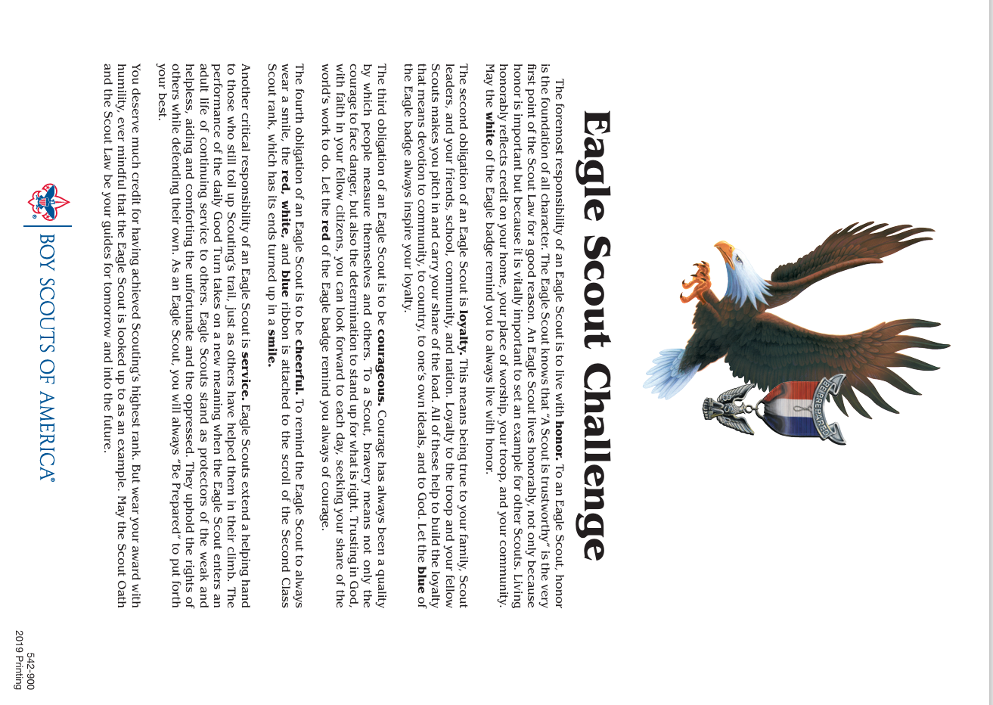

**SCOUTMASTER Scott Towns:**

**“The symbol of your success is the Eagle badge which I now present to your mother. Your mother will, in turn, pin the badge over your heart**”  
  
[Presentation of Eagle badge]  
 **SCOUTMASTER Scott Towns:**

**“Dominic Ottl, in recognition of the wisdom and guidance given to you by your father, will you present to him this Eagle tie tack, which he will be proud to wear in your honor.”**  
  
[Presentation of Eagle tie tack]

**SCOUTMASTER Scott Towns:  
“And now, also in recognition of the many hours of patient guidance given by her in your efforts, will you pin the Eagle mother's pin on your mother.”**  
  
[Presentation of Eagle mother's pin]  
 **MC: “At this point in the court of honor, the new Eagle Scout, Dominic Ottl, would like to make a few remarks:”**

(DOMINIC OTTL MAKES HIS EAGEL SCOUT SPEECH)

..welcomes, thanks, special moments from the journey, next plans, etc.

**SPL Alex Paine**: **“My name is Alex Paine, I am current Senior Patrol Leader of Troop 610. As a representative of all scouts in the troop and on their behalf, I would like to offer my congratulations to Dominic Ottl for achieving the rank of Eagle Scout. Well Done Dominic!!**

**MC: “Here is a short video from the scouting journey of Dominic Ottl.”**

(Video Plays)

**MC: “Moment of Silence for the Closing Prayer”**

MINISTER: (Dad)

**“In the name of the Father, Son, and The Holy Spirit..**

**Praise the Lord! What a moment to celebrate, what a moment to share..and the best part is keeping you, Lord, at the center of it all. For the greatest accomplishment of a man is his humility and reverence for You. We thank you once again for touching and guiding this young man’s heart and may you be with him always! In the name of the Father, Son, and the Holy Spirit..Amen!”**

**MC: “We invite everyone present to come forward to congratulate the new Eagle Scout and his parents and to join us for refreshments. Dominic Ottl’s's project workbook and letters and certificates of congratulations will also be available for viewing at this time. I would also remind everyone to sign the guest book for this occasion. Thank you for joining us today.”**

**MC: “I now declare this Eagle court of honor closed.”**

(volunteers help clean up on later than 5.30pm to leave premise by 6pm)

Other preparations:

Secure a room (church) for date, time, place and ask for any restrictions

Create a invite/flyer

2-4 weeks ahead of the ceremony, make a list and invite people

Secure Eagle Supplies: Flags/stands, table clothes, candle holders, banners, etc.

Estimate a head count for visitors: request tables and seats for that number

Secure regular décor supplies like plates, cups, table cloths, center piece, ballons

Select and order food, drinks, “EAGLE” cake, etc.

Helpful Extras: PA System, Audio/video to play any memorable pics/videos or music

Request key people to help: Scoutmaster, SPL, other troop, council rep, and master of ceremonies

Create an agenda and script (like this one) and have it proof read by BSA leaders

Schedule a rehearsal (could be before the ceremony), this scripted ceremony took 45 min..about 2 hours with food after..total time in room with set up, rehearsal, ceremony, food, and clean up was 5 hours