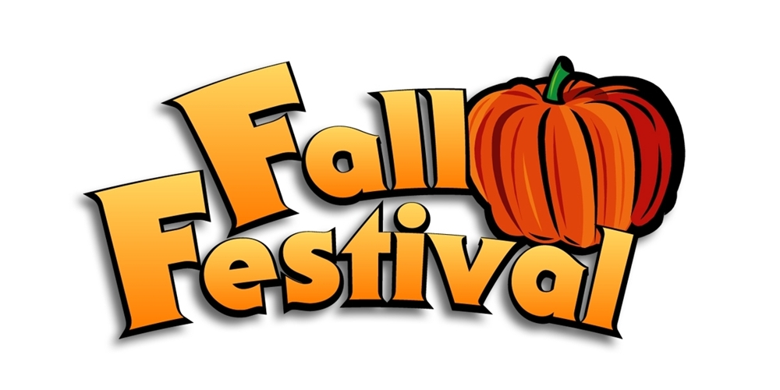

**Sunday, October 20th**

**11am-3pm**

**Lincroft School**

* Inflatables *Pumpkin Painting *Pony Rides

*Games & Crafts *Food Court *Petting Zoo

*Ice Cream Truck *Scarecrow Contest *Mummy Game

**We will also have local vendors present where you can shop for jewelry, fall décor, yummy pies, Fall Fashions, beauty items, and so much more. Enjoy performances by US Black Belt and Pure Artistry Dance Studio. We have also added inflatables, games, crafts, and more for our younger 4 and under friends!**

**Wristbands are available now for $20.00 for students and $15.00 for younger siblings- Bracelets must be purchased for any child participating in any activities. *There will not be individual tickets sold at the event.\***

**Wristbands will be sold for $25.00 on the day of event**

**Activities included in wrist band are:**

**All Inflatables Crafts (1) Petting Zoo**

**Pony rides Games Candy Jar Guessing**

**Hayride Photo Area Paint a Pumpkin (1)**

**Sandy Candy (1) Popcorn Hands (1)**

**Volunteers always welcome and needed! Reach out to Gail Pellicone or Melissa Russo if you would like to help.**

**Please send bottom portion of this flyer with payment to school or pay on the PTA website via VENMO:**

**Attn: PTA, Fall Festival- Melissa Russo or Gail Pellicone**

**_________________________________________________________________________________________________**

**Family:____________________________________________________________________ #of wristbands___________________**

**Teacher_________________________________________ Grade___________ Total Amount$_________________________**

**Extra Activities:**

**Scarecrow decorating Contest: $10.00- Name: __________________________________ Amount$_____________ Make your Grown Up a MUMMY: *No charge but you must sign up to participate* Name_____________________________________________________________________ How Many__________________________**

**WRISTBANDS WILL BE SOLD AT BACK TO SCHOOL NIGHT**