The purpose of this writing is to convey just one thing: You can protect yourself and your loved-ones. It is not an easy task, but it is a possible one. With proper physical and mental training, you can and will use the tool of “forceful-aggression” to defend against any attack.

“Kokishin Renshu” – The Bushi’s Skill Shop
Kokishin Renshu refers to a study and practice of martial principles. The skills and tools developed will vary from person to person. Everybody is different. Each person has a unique paradigm through which they see and interact with people and things in the world. Kokishin Renshu (Fig #1) is a reference, a guide if you will, to help you discover and develop body mechanics, or techniques, with which to defend yourself. It is a workshop filled with tools. Some of these tools are pre-existing and already reside in your personal workshop; others, just the raw materials waiting for you to create your customized tool collection.
Although Kokishin Renshu consists of 5 main classifications, and 25 sub classifications. These are not all inclusive there are many more, but they are the basics, and I feel, the most fundamentally poignant. Kokishin Renshu is intended to be a guide and reference chart, in the learning proper mechanics, to come to an understanding of the best way for you to fight and develop tools of forceful-aggression. It is also a tool of fitness, a way to develop strength, speed, balance and toughness-of-body.
The practicing of Kokishin Renshu can provide seemingly endless ways for personal discovery, practice and growth, in reference to martial tools, and can conveniently be done anywhere. It is a practice that can be done with helpers requires none. You always have a way for training, learning and staying fit.
Without the training suite that accompanies Fig. #1, Kokishin Renshu will be far less effective. It is not a “then, and then, and then” model. This means that it is not intended that the practitioner will take, say, 1sub-component and add it to another sub-component and so on. Some sub-components simply do not work with each other or are irrelevant when put together. Kokishin Renshu is meant to provide a Lens with which you can look through, at your martial tools, to understand them, develop them and customize them so that you can effectively use them. Kokishin Renshu is the first segment of a much larger process-practice called Jippou , which has an ultimate aim of “development of overall martial prowess”, to be used by the common law abiding citizen for self-defense.

Fig. #1
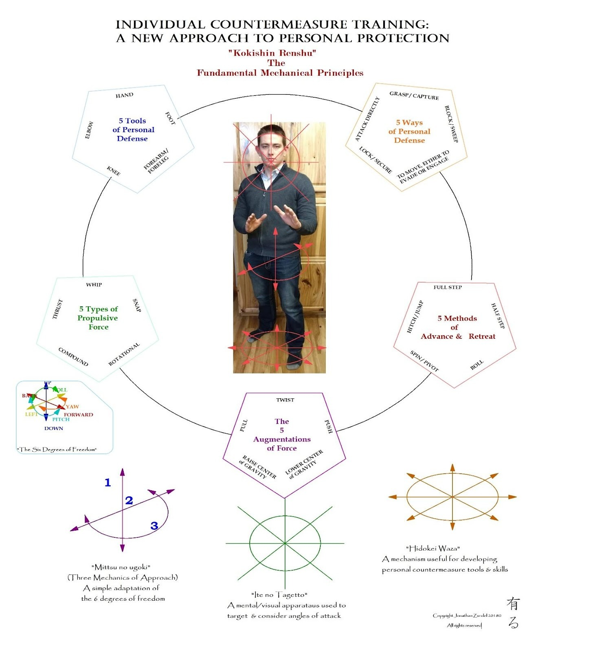

Components of Kokishin Renshu

5 Personal-Tools of Defense: Personal tools of defense refer tools that you have with you a all times; your body. Truthfully, almost any part of the human anatomy can be utilized as a weapon of defense. Here we will discuss 5 main common tools.
Hand:
Foot:
Forearm/Foreleg:
Knee:
Elbow:

5 Types of Propulsive Force:
Whip:
Snap:
Rotational
Compound:
Thrust:
5 Augmentations of Force:
Twist:
Push:
Lower the Center of Gravity:
Raise the Center of Gravity:
Pull:
5 Methods of Advance & Retreat:
Full Step:
Half-Step
Roll:
Spin / Pivot:
Hitch / Jump
5 Ways of Personal Defense:
Block / Sweep
To Move; Either to Advance or Retreat
Lock / Secure
Attack Directly:
Grasp / Capture
“Kokishin-do no Shirin-gaku” – The Bushi’s Mindset; Fundamental Psychological Principles

Fig. #2
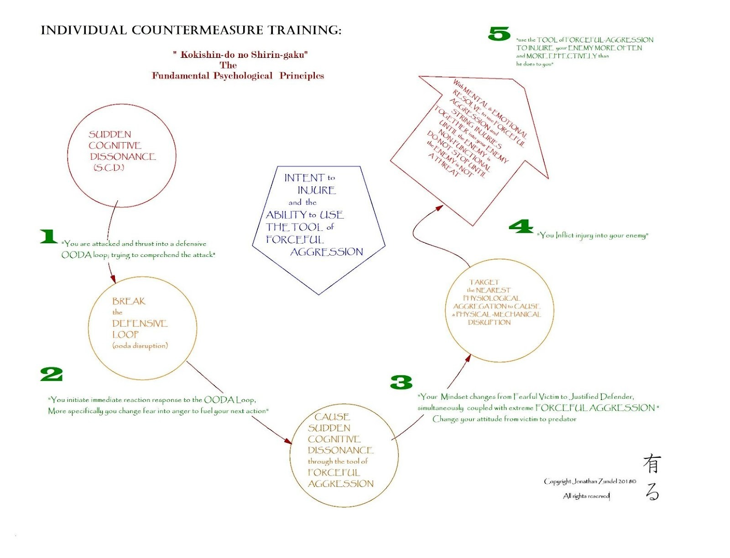
Step 1. Sudden Cognitive Dissonance
Step 2. Break the Defensive OODA Loop
Step 3. Cause Sudden Cognitive Dissonance through the tool of Forceful Aggression
Step 4. Target the Nearest and Most Available Physiological Aggregation to cause Physical, Mechanical or Electrical Disruption

“Kowasu” – The Bushi’s way of Targeting
Fig. #3
