PRUNING FOR FRUITFULNESS | MAY 2020

*I am the true vine, and my Father is the gardener. He cuts off every branch in me that bears no fruit, while every branch that does bear fruit, he prunesso that it will be even more fruitful. You are already clean because of the word I have spoken to you. Remain in me, as I also remain in you. No branch can bear fruit by itself; it must remain in the vine. Neither can you bear fruit unless you remain in me.“I am the vine; you are the branches. If you remain in me and I in you, you will bear much fruit; apart from me you can do nothing. If you do not remain in me, you are like a branch that is thrown away and withers; such branches are picked up, thrown into the fire and burned. If you remain in me and my words remain in you, ask whatever you wish, and it will be done for you. This is to my Father’s glory, that you bear much fruit, showing yourselves to be my disciples. John 15:1-8*

Years ago, I moved into a house that had two unproductive apple trees. Being a city kid, I didn’t know the first thing about taking care of an apple tree, especially one that was not producing any fruit. I approached an old local farmer to obtain instructions regarding the care our trees. He suggested that I prune the tree to maximize its fruitfulness. I was amazed at the deeper more spiritual meaning that was hidden in the pruning process. The pruning process involved knowing and understanding the *purpose of pruning*, the *phraseology of pruning* and the *process of pruning*. Take note of this process to see if there are any areas in your life that God may be speaking to your heart and how he may need to prune you for greater fruitfulness.

**Purpose of Pruning**

* **Stimulates growth-**makes healthy branches stronger and more vigorous which results in greater fruitfulness. Getting rid of old dead branches that have no purpose, will allow more nutrients to be fed to branches resulting in greater fruitfulness. (Does God need to stimulate growth in your heart?)
* **Strong Structure Shape-**pruning is necessary to create not only a strong shape but a structured shape. Pruning establishes the basic tree structure. The natural shape of the tree is not always the best for its maximum fruit production. If left on its own with no pruning, the tree will not ever reach its maximum production. The Vinedresser/Gardner needs to change the shape from its natural tendency. Pruning trains the branches to grow towards a center leader structure.
* **Supplements Sunlight-**pruning will keep the tree’s canopy from becoming too thick and crowded. By thinning out branches, it permits **sun**light to enter the tree which helps the fruit to ripen evenly. (Does God need to prune you so that you can obtain the maximum **Son**light needed for you to be spiritually fruitful and ripen evenly?)

**Phraseology of Pruning**

* **Dormant State-**A period when growth, development, and activity are temporarily stopped. A time when the branches are not growing for its intended use and purpose. This is the best time to prune a tree-when it is not growing. (What does the dormant state look like in your life? Are you in a season of spiritual dormancy? Are you not as fruitful as you would like to be?)
* **Cross over branches-**branches that never fully develop and will most likely bear little to no fruit. They often cause wounds because they rub against other branches and result in opened wounds. Open wounds lead to disease. They are a burden and detriment to the tree. (Do you have any cross over branches in your life that need to be removed? Where do you need to stay in your lane and not cross over into someone else’s lane? Do you find that you cross over into the lane of your husband, a coworker, or friend? Early in my marriage I often crossed over my lane into my husband’s lane and it always created a rub, friction, and wounds.)
* **Dead and diseased branches-**pretty self-explanatory. Branches that must be removed so that the other branches will not be adversely affected by them. (What dead branches does the Lord need to lovingly prune from you? Could it be unhealthy relationships? What is broken in your heart that needs to be healed? Do dead branches from our past need to be cut away and burned? I had a branch that grew in my heart from childhood. My parents were divorced. My Father had left us. I grew up thinking all men would leave you. God had to remove that dead unfruitful branch if I was going to have a stable, strong, and fruitful marriage. It was a temporary painful process, but that severed branch enabled me to draw nutrients freely from the main Leader and Root. What does a diseased branch look like in your life? Is it unhealthy emotions or feelings? Anger, pride, bad attitude, bad habits, fear, or unforgiveness? What fruit is visible to others when you are frustrated, mad, or angry? Good fruit or bad fruit?)
* **Suckers-**growths that sap a tree of its vitality. They can overgrow the original tree causing the main graft to die. (What sucker branches need to be removed from your life? What areas are sucking the life out of you and preventing you from being fruitful in the kingdom? What is sucking your energy, time, and strength?)
* **Water sprouts or water shoots-**overly aggressive branches that grow at an alarming rate and if left unpruned will ruin the shape of the tree. They do not produce any fruit and are completely useless. (What areas of your life are you running out in front of God, not waiting on Him? Do you get out Infront of God with your prayers? Do your prayers include requests from the Lord and then the next day you decide to take matters into your own hands thinking God needs a little help from you in answering your prayers?)
* **The Central Leader-**the central branch that grows upwards ahead of the other branches and can be found in the center of all the branches. The leader branch is the very branch that directs the entire tree’s growth. If you cut the leader off, the tree will become weak, produce unstable branches and have an unnatural appearance. Your tree will be prone to breakage. It will also expose the branches to decay and invasion from insects and disease as it weakens the root. Cutting off the leader branch will reduce the tree’s structural strength. (Who is your leader? Who are you allowing to create and shape your attitude, heart, and direction? Is your leader your flesh or Jesus? Is your leader someone else’s opinion or Jesus? Who is your leader on a daily basis? Who is your leader when it comes to loving the unlovable? Do you spend time abiding in your Leader or do you cut Him out of your day?)

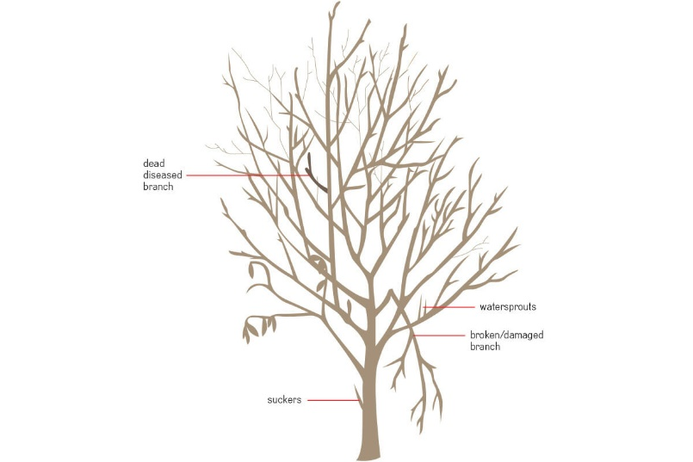

**Process of Pruning**

Do you want to produce more fruit? Abide in Jesus

Do you want to love the unlovable? Abide in Jesus

Do you want to improve your character? Abide in Jesus

Do you want to help others? Abide in Jesus

What is the process of pruning for you? What does that look like in our life? Well, friend, that is between you and Vinedresser-God. Pray and get into the Word of God. Write out the pruning process for your life. Humbly ask the Master Gardner to identify what branches in your life need to be pruned once and for all. Invite Him to lovingly clear out the debris and obstacles that are blocking access to His nutrients and that will allow you to obtain more SONlight for maximum fruitfulness. Get excited about the freedom of pruning. Wouldn’t you rather be cut back, through pruning, than cut off and thrown into the fire?

*“Search me, God, and know my heart; test me and know my anxious thoughts. See if there is any offensive way in me, and lead me in the way everlasting.” Ps 139:23*