2026-2027

Valley Stream School District 24
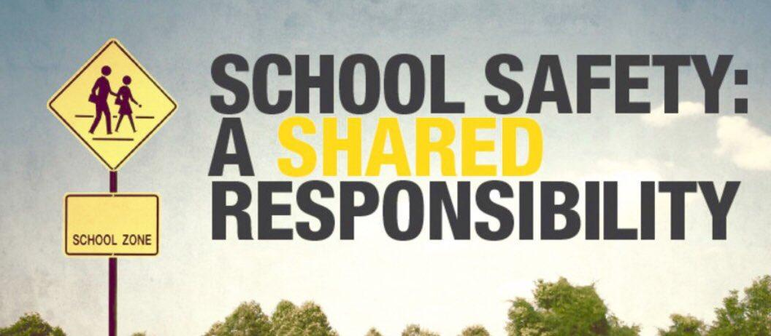
District-Wide School Safety Plan
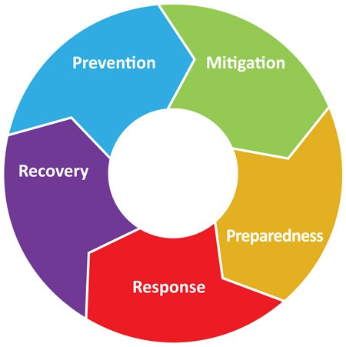

This District-wide School Safety Plan template has been developed by Nassau BOCES for the exclusive use of Nassau County School Districts participating in the Nassau BOCES Health & Safety Training and Information Service. This guidance document was written to assist school districts in their compliance efforts to meet the requirements of the Safe Schools Against Violence in Education Act (SAVE) and related legislation. This Plan should be customized as necessary to reflect individual school district’s specific endeavors to achieve a safe school environment. This is a general overarching document that can be shared with the public and should be posted on the school district website by October 1st of each school year, as required by law. Parts of the Plan which may include names, contacts and personal information can be redacted for posting purposes. This Plan can also serve as an educational tool to help in-district personnel and the public to understand the requirements of the SAVE legislation. This contrasts to the Building-level Emergency Response Plan which details specific emergency response procedures, and as such, is a confidential document which cannot be shared with the public, cannot be foiled and is protected under law. This Plan includes proposed amendments to Section 155.17 and 136.4 of the Commissioner of Education Regulations. If adopted at the May 2026 Regents meeting, the proposed amendments to section 155.17 and 136.4(e) and (f) of the Commissioner’s regulations will become effective on June 3, 2026, and the proposed amendments to section 136.4(a), (b), (c), (d), and (g) of the Commissioner’s regulations will become effective on July 1, 2026. If the proposals change or are removed, this Plan, which is a living document, will be revised at that time. This update is being provided now to assist school districts in meeting the September 1st deadline for school board approval.

Table of Contents
DISTRICT-WIDE SCHOOL SAFETY PLAN

Policy Statement 4

Compliance Checklist 4

Safety Plan Regulatory Requirements 5

Elements of the District-Wide School Safety Plan Checklist 5

Public Health Emergencies – Communicable Disease 7

Desha’s Law___________________________________________________________________________________________ 8

Remote Instruction Due to Emergency Conditions 9

Alyssa’s Law 9

School District Chief Emergency Officer 9

District-Wide School Safety Team 11

Responsibilities of the District-Wide School Safety Team 11

Building-Level Emergency Response Planning Team 12

Prevention and Intervention Strategies/Risk Reduction 12

Training, Drills and Exercises 14

Implementation of School Security 15

Vital Educational Agency Information 15

Early Detection of Potentially Violent Behavior 16

Hazard Identification 16

Responses to Violence 17
Reporting 17
Investigation 17
Follow-up 17
Evaluation 18
Disciplinary Measures 18
Code of Conduct 18

Emergency Response Protocols Notification and Activation (Internal and External Communication) 19
Bomb Threats 19
Hostage Taking 19
Intrusions 19
Unidentified Visitor 19
Kidnapping 19

Responses to Acts of Violence (Implied or Direct Threats) 20
Responses to Acts of Violence (Actual) 20
Response Protocols 20
School Building Chain-of-Command Table 21
Emergency Assistance and Advice from Local Government 21

District Resources Use and Coordination 21

Protective Action Options 21
- School Cancellation 21
- Emergency Dismissal 21
- Evacuate/Evacuation 21
- Shelter/Shelter-In-Place 21
  - Shelter/Shelter-In-Place (Weather Related) 21
  - Generic (Non-Specific Bomb Threat) 21
  - Specific Bomb Threat 21
- Hold/Hold-In-Place 21
- Lockdown 21
- Secure Lockout 21

National Terrorism Advisory System (NTAS) 21
Recovery – School District Support for Buildings 22
Disaster Mental Health Services 22
Threat Assessment 22
Forms and Recordkeeping 23

Appendix A 24
- Parents/Students/Staff Annual Notification 24
Appendix B 26
- District-wide School Safety Team Meeting Minutes and Attendance 26
Appendix C 27
- Suicide and Mental Health Resources 27
Appendix D 29
- Communicable Disease – Pandemic Plan 30
  - Essential Position Type 31
  - Telecommuting Protocol: Technology 33
  - Work Shift Modifications 33
  - Personal Protective Equipment (PPE) Protocol 34
  - PPE Plan for Storage/Access 34
  - Employee Exposure Protocol 35
  - Disinfection Protocol 38
  - Employer Policy on Available Leave to Receive Testing, Treatment, Isolation, or Quarantine 39
  - Hours and Work Location Protocol 40
  - Emergency Housing Protocol 40
  - Department of Health Requirements 41
  - School District (K-12) Pandemic Influenza Planning Checklist 43
Appendix E 46
- Remote Instruction Plan and Student Access Survey 47
Appendix F 49
- Threat Assessment Guidance 49
  - Creating a Comprehensive Targeted Violence Prevention Plan 49
  - Enhancing School Safety Using a Threat Assessment Model 51
  - Eleven Questions to Guide Data Collection in a Threat Assessment Inquiry 53
  - New York State Police Threat Assessment Model 58
Appendix G ___________________________________________________________________________________________ 60
Cardiac Emergency Response Plan _________________________________________________________________________ 60
Emergency Contact Numbers _____________________________________________________________________________ 61
AED Locations _________________________________________________________________________________________ 61
CPR/AED Certified School Personnel _______________________________________________________________________ 61
Resources ____________________________________________________________________________________________ 62
American Heart Association Sudden Cardia Arrest vs Heart Attack Information _____________________________________ 63

Valley Stream School District 24

District-wide School Safety Plan

Policy Statement

The District-Wide School Safety Plan (as required by the SAVE Law – Safe Schools Against Violence in Education – Commissioner of Education Regulation 155.17 and Education Law 2801-a) has been established to provide for the safety, health and security of both students and staff and allows for input from the entire school community. This particular component of Project SAVE is a comprehensive planning effort that addresses prevention, mitigation, protection, response and recovery with respect to a variety of emergencies that may occur in the school district and its component school buildings.

The Board of Education has appointed, under the direction of the Superintendent of Schools, a District-Wide School Safety Team to develop, implement and maintain all provisions of the Plan. This Plan incorporates all Building-Level Emergency Response Plans that have been developed by the Building-Level Emergency Response Planning Teams appointed by the Building Principals. In the event of an emergency or violent incident, the initial response at an individual school building will be the responsibility of the school building Emergency Response Team. Upon activation of the school building Emergency Response Team the Superintendent of Schools or designee and appropriate local emergency response officials will be notified. The nature of any given emergency will dictate the degree of interaction with both State and Local Emergency Response Agencies. If activation of the Building-Level Emergency Response Plan results in the closing of a school building the Superintendent or designee will notify the Commissioner of Education and the Nassau BOCES District Superintendent. The BOCES Health & Safety Office will assist in development of protocols for accessing these services.

The District-Wide School Safety Team reviewed and approved the District-Wide School Safety Plan. The District-Wide School Safety Plan was made available for public comment 30 days prior to its adoption and provided for participation of the entire school community. By September 1st of each school year, the District-Wide and Building-Level Plans are formally adopted by the School Board after at least one public hearing. As required by law, the District-Wide School Safety Plan is posted on the school district website by October 1st of each school year and will be reviewed annually by the District-Wide School Safety Team by September 1st of each school year. Building-Level Emergency Response Plans will be updated by September 1st of each school year by the Building-level Emergency Response Planning Team and filed with both State and Local Police by October 1st of each school year.

Compliance Checklist | Date Achieved
Board of Education Appoints District-Wide School Safety Team | 7/2/26
District-Wide School Safety Team reviews/approves District-Wide School Safety Plan | 5/20/26
Brooklyn Avenue Elementary School Building-Level ERPT approves Building-Level ERP/Enters in Portal | 8/6/26 / 10/1/26
R. W. Carbonaro Elementary School Building-Level ERPT approves Building-Level ERP/Enters in Portal | 6/18/26 / 10/1/26
W. L. Buck Elementary School Building-Level ERPT approves Building-Level ERP/Enters in Portal | 5/4/26 / 10/1/26
School Board has at least one public hearing on District-Wide School Safety Plan | 7/2/26
School Board establishes 30-day public comment period | 7/2/26 to 8/2/26
School Board adopts District-Wide School Safety Plan & Building-Level Emergency Response Plans | 8/19/26
District-Wide School Safety Plan posted on website. The URL is (SampleURL.org) | 10/1/25
All Building-Level Emergency Response Plans filed with local police | 10/1/25
Written information on emergency procedures provided to all staff and students by October 1st | 10/1/25
Certify that all staff have been trained by 9/15 on the Building-level Emergency Response Plan including components on violence prevention, and mental health, and Sudden Cardiac Arrest. | 9/15/25

The school district refuses to tolerate violence or threats of violence on school grounds and, by implementation of this Plan, will make every effort to prevent violent incidents from occurring. We will provide the appropriate authority and budgetary resources in support of this effort. Violence prevention is the responsibility of the entire school community and we encourage participation of all individuals. Our Plan requires the prompt reporting of all violent incidents or threats and assures that victims or reporters of incidents of violence will not be discriminated against. A copy of the District-Wide School Safety Plan is also available upon request at central administration in the office of the Superintendent of Schools. Although the Building-Level Emergency Response Plans are linked to the District-Wide School Safety Plan, in accordance with Education Law Section 2801-a, the Building-Level Emergency Response Plan will remain confidential and not be subject to disclosure. This will ensure safety at the building-level and reduce potential for planned sabotage.

Regulatory Requirements Overview

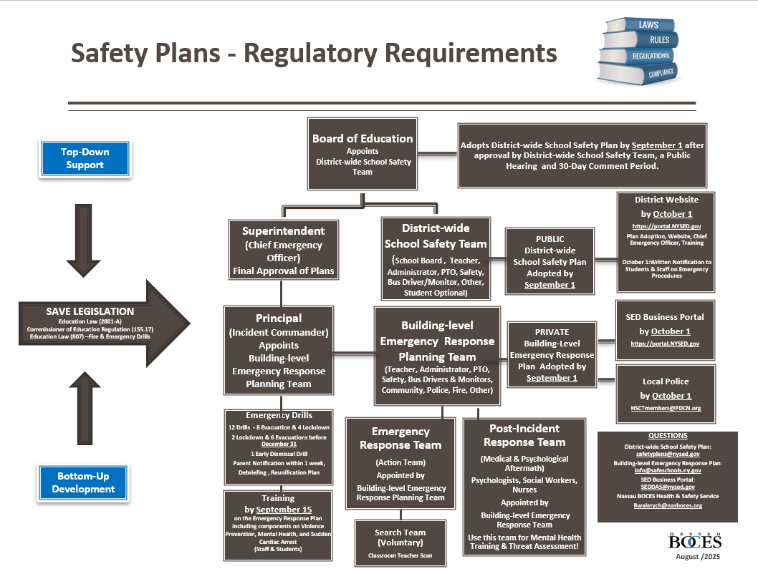
Elements of the District-wide School Safety Plan: Compliance Checklist

Policies and procedures for:

- responding to implied or direct threats of violence by students, teachers, other school personnel and visitors to the school, including threats by students against themselves (including suicide) CR155.17(c)(1)(i)
- responding to acts of violence by students, teachers, other school personnel and visitors to the school, including consideration of zero-tolerance policies for school violence CR155.17(c)(1)(ii)
- contacting appropriate law enforcement officials in the event of a violent incident CR155.17(c)(1)(iv)
- contacting parents, guardians, or persons in parental relation to the students of the district in the event of a violent incident or an early dismissal CR155.17(c)(1)(ix)
- contacting parents, guardians, or persons in parental relation to an individual student of the district in the event of an implied or direct threat of violence by such student against themselves (including suicide) CR155.17(c)(1)(x)
- the dissemination of informative materials regarding the early detection of potentially violent behaviors, including but not limited to the identification of family, community and environmental factors to teachers, administrators, parents and other persons in parental relation to students of the school district or board, students and other persons deemed appropriate to receive such information CR155.17(c)(1)(xii)
- Beginning with the 2025-26 school year and every school year thereafter, the district-wide school safety team shall develop and implement a cardiac emergency response plan that addresses the use of appropriate personnel to respond to incidents involving any individual experiencing sudden cardiac arrest or similar life-threatening emergency on any school site owned or operated by a school or at a location of a school sponsored event, including all athletic events. School officials shall collaborate with local community emergency medical services (EMS) to integrate their cardiac emergency response plan with community EMS responder protocols. The district-wide school safety team may voluntarily provide first aid, CPR, and AED training for relevant staff, including members of building-level emergency response teams. CR155.17(c)(1)(xii)

Prevention and intervention strategies, such as:

- collaborative arrangements with State and local law enforcement officials, designed to ensure that school safety officers and other security personnel are adequately trained, including being trained to de-escalate potentially violent situations, and are effectively and fairly recruited CR155.17(c)(1)(iii)
- nonviolent conflict resolution training programs CR155.17(c)(1)(iii)
- peer mediation programs and youth courts CR155.17(c)(1)(iii)
- extended day and other school safety programs CR155.17(c)(1)(iii)

Arrangements and/or Procedures during emergencies for:

- description of the arrangements for obtaining assistance during emergencies from emergency services organizations and local governmental agencies* CR155.17(c)(1)(v)
- the procedures for obtaining advice and assistance from local government officials, including the county or city officials responsible for implementation of article 2-B of the Executive Law* CR155.17(c)(1)(vi)
- the identification of district resources which may be available for use during an emergency* CR155.17(c)(1)(vii)
- description of procedures to coordinate the use of school district resources and manpower during emergencies, including identification of the officials authorized to make decisions and of the staff members assigned to provide assistance during emergencies* CR155.17(c)(1)(viii)
- a system for informing all educational agencies within such school district of a disaster* CR155.17(c)(1)(xviii)
- The identification of appropriate responses to emergencies, including protocols for responding to bomb threats, hostage-takings, intrusions and kidnappings CR155.17(c)(1)(xv)

Policies and Procedures relating to school building security, including, where appropriate:
The use of school safety or security officers and/or school resource officers:

- Beginning with the 2019-20 school year, and every school year thereafter, every school shall define the areas of responsibility of school personnel, security personnel and law enforcement in response to student misconduct that violates the code of conduct. A school district or charter school that employs, contracts with, or otherwise retains law enforcement or public or private security personnel, including school resource officers, shall establish a written contract or memorandum of understanding that is developed with stakeholder input, including, but not limited to, parents, students, school administrators, teachers, collective bargaining units, parent and student organizations and community members, as well as probation officers, prosecutors, defense counsels and courts that are familiar with school discipline. Such written contract or memorandum of understanding shall define the relationship between a school district or charter school, school personnel, students, visitors, law enforcement, and public or private security personnel. Such contract or memorandum of understanding shall be consistent with the code of conduct, define law enforcement or security personnel's roles, responsibilities and involvement within a school and clearly delegate the role of school discipline to the school administration. Such written contract or memorandum of understanding shall be incorporated into and published as part of the district safety plan CR155.17(c)(1)(xi)(a)
- security devices or procedures CR155.17(c)(1)(xi)(b)
- Procedures for review and the conduct of drills and other exercises to test components of the emergency response plan, including the use of tabletop exercises, in coordination with local and county emergency responders and preparedness officials CR155.17(c)(1)(xiv)
- Strategies for improving communication among students and between students and staff and reporting of potentially violent incidents, such as the establishment of youth- run programs, peer mediation, conflict resolution, creating a forum or designating a mentor for students concerned with bullying or violence and establishing anonymous reporting mechanisms for school violence CR155.17(c)(1)(xvi)
- A description of the duties of hall monitors and any other school safety personnel CR155.17(c)(1)(xvii)
- A description of the training required of all personnel acting in a school security capacity CR155.17(c)(1)(xvii)
- A description of the hiring and screening process for all personnel acting in a school security capacity CR155.17(c)(1)(xvii)
- Protocols for responding to state disaster emergencies involving public health; districts must adopt a continuation of operations plan in the event the governor declares a public health emergency involving communicable disease; Due April 1, 2021
- The designation of the superintendent, or superintendent’s designee, as the district chief emergency officer whose duties shall include, but not be limited to: (a) coordination of the communication between school staff, law enforcement, and other first responders; (b) lead the efforts of the district-wide school safety team in the completion and yearly update of the district-wide school safety plan and the coordination of the district-wide plan with the building-level emergency response plans; (c) ensure staff understanding of the district–wide school safety plan; (d) ensure the completion and yearly update of building-level emergency response plans for each school building; (e) assist in the selection of security related technology and development of procedures for the use of such technology; (f) coordinate appropriate safety, security, and emergency training for district and school staff, including required training in the emergency response plan; (g) ensure the conduct of required evacuation and lock-down drills in all district buildings as required by Education Law section 807; and (h) ensure the completion and yearly update of building-level emergency response plans by the dates designated by the commissioner. CR155.17(c)(1)(xix)

Policies and procedures for annual multi-hazard school safety training for staff and students providing that the district must:

certify to the commissioner that all staff have undergone annual training by September 15, 2016 and each subsequent September 15th thereafter on the building-level emergency response plan which must include components on violence prevention, mental health, and sudden cardiac arrest provided further that new employees hired after the start of the school year shall receive such training within 30 days of hire or as part of the district’s existing new hire training program, whichever is sooner. The required training shall also include how to recognize sudden cardiac arrest or similar life-threatening health emergencies and the specific procedures outlined in the cardiac-emergency response plan CR155.17(c)(1)(xiii).

The district-wide safety plan must be available for public comment at least 30 days prior to its adoption. CR155.17(3)(i)

- Such district-wide plans may be adopted by the school board only after at least one public hearing that provides for the participation of school personnel, parents, students and any other interested parties. CR155.17(3)(i)
- Each district shall submit its district-wide safety plan and all amendments to such plan to the commissioner, in a manner prescribed by the commissioner, within 30 days after its adoption. Commencing with the 2019-2020 school year, such district-wide plans must be submitted no later than October 1, 2019, and each subsequent October 1st thereafter. CR155.17(3)(i)

Public Health Emergencies – Communicable Disease

Effective April 1, 2021, Labor Law §27-c, amends Labor Law §27-1 and adds a new provision to Education Law §2801-a. Labor Law §27-c requires public employers to develop operation plans in the event of certain declared public health emergencies. Education Law §2801-a requires school districts to develop plans consistent with the new Labor Law requirement. The new law requires public employers to prepare a plan for the continuation of operations in the event that the Governor declares a public health emergency involving a communicable disease. Educational institutions must prepare plans consistent with Labor Law §27-c as part of their school safety plans pursuant to newly added subsection (2)(m) of Education Law §2801-a. The Plan must include the following at a minimum:

A list and description of positions and titles considered essential with justification for that determination.

The specific protocols that will be followed to enable non-essential employees and contractors to telecommute.

A description of how the employer will, to the extent possible, stagger work shifts of essential employees and contractors to reduce workplace and public transportation overcrowding.
- Protocols to be implemented to secure personal protective equipment (PPE) sufficient to supply essential workers with 2 pieces of each PPE device needed for each work shift for at least six months. This must include a plan for storage of such equipment to prevent degradation and permit immediate access in the event of an emergency declaration.

Protocols to prevent spread in the workplace in the event an employee or contractor is exposed, exhibits symptoms, or tests positive for the relevant communicable disease. Such protocols must include disinfection of the individual’s work area and common areas. It must also address the policy on available leave with respect to testing, treatment, isolation or quarantine.

Protocols for documenting precise hours and work locations of essential workers for purposes of aiding in tracking the disease and identifying exposed workers in order to facilitate the provision of any benefits that may be available to them on that basis.

Protocols for coordinating with the locality to identify sites for emergency housing for essential employees to contain the spread of the disease, to the extent applicable to the needs of the workplace.

Details on this Plan are included in Appendix D (Communicable Disease - Pandemic Plan).

Desha’s Law-Cardiac Emergency Response Plan

Effective January 20, 2026, amendments to Education Law §§ 917 and 2801-a (2) regarding AED equipment, AED maintenance and signage, and school safety training regarding cardiac emergency response plans are to be included in district-wide school safety plans.
The requirements for the development of a cardiac emergency response plan essentially formalize and embed within district-wide school safety plans and building-level emergency response plans, preexisting emergency protocols to respond to sudden cardiac arrest and other life-threatening emergencies. The requirements, as now set forth in the amendments to Education Law § 2801a(2)(n), are:
- The use of appropriate personnel to respond to incidents involving any individual experiencing sudden cardiac arrest or similar life-threatening emergency on any school site owned or operated by a school or at a location of a school sponsored event, including but not limited to all athletic programs.
- Specific procedures for incidents involving an individual experiencing sudden cardiac arrest or a similar life-threatening emergency while attending or participating in an athletic practice or event while on school grounds that are venue specific.
- Integration of nationally recognized, evidence-based core elements, such as those recommended by the American Heart Association.
- Consideration of how to best integrate cardiac emergency response plans into community Emergency Medical Services (EMS) responder protocols.

Effective January 20, 2026, amendments to Education Law § 2801-a(2)(h) require that the school safety training for students and staff required in the district-wide school safety plan must now include training in sudden cardiac arrest. Additionally, effective January 20, 2026, Education Law § 2801a(2)(n), provides that district-wide school safety teams may provide voluntary first aid, CPR, and AED training to school staff, including members of the building level emergency response teams provided that Education Law and Commissioner’s regulations require such training to be in accordance with PHL §3000-b.
Building-level emergency response plans:
Effective September 1, 2025, amendments to Education Law §2801-a(3)(a) require that policies and procedures for response to sudden cardiac arrest be included in building level emergency response plans. The requirements for building-level emergency response plans include building and venue specific requirements and procedures that address medical needs, transportation, and emergency notification of parents/guardians in the event of a sudden cardiac arrest incident.

A Cardiac Emergency Response Plan is included in Appendix G. (Building-specific details are included in the building-level emergency response plans).

Cardiac-emergency response plan means a school or district written plan developed in collaboration with the Director of School Health Services or a duly licensed physician, nurse practitioner, physician assistant, or registered professional nurse that outlines specific actions and procedures for recognizing and responding to a sudden cardiac arrest or similar life threatening health emergency at any school site owned or operated by a school or at a location of a school sponsored event, including venue-specific, but not limited to athletic programs. Each plan shall integrate nationally recognized, evidence-based core elements, such as those recommended by the American Heart Association. Pursuant to sections 101, 207, 305, and 2801-a of the Education Law, CR155.17 (a).

Amendments to Section CR136.4(a)(b)(c)(d)(e)(f)(g)

- Instructional school facility includes buildings or facilities maintained by a school district, board of cooperative educational services (BOCES), county vocational education and extension board, charter school, or nonpublic school where instruction is provided pursuant to its curriculum.
- School-sponsored or school-approved curricular or extracurricular events or activities include events or activities of a school district, BOCES, county vocational education and extension board, charter school, or nonpublic school that are associated with its instructional curriculum or otherwise offered to its students.

AED Requirement in Facilities:
- Each school district, BOCES, county vocational education and extension board, charter school, and nonpublic school must provide and maintain on-site functional automated external defibrillator (AED) equipment in each instructional school facility for emergency use.
- Each facility must have sufficient AEDs to ensure ready and appropriate access during emergencies.
- Quantity and placement of AEDs must be determined with appropriate consideration (as required by the regulation).

Trained Staff at School Events:
- Whenever an instructional school facility is used for a school-sponsored or school-approved curricular or extracurricular event or activity, school officials and administrators responsible for the facility must ensure the presence of at least one staff person trained in AED operation and use pursuant to Public Health Law §3000-b(3)(a).

Athletic Events:
- During any school-sponsored athletic contest or competitive athletic event held at any location, school officials and administrators responsible must:
  - Ensure AED equipment is provided on-site; and
  - Ensure at least one staff person trained in AED use (pursuant to Public Health Law §3000-b(3)(a)) is present during the event.

AED Standards and Maintenance:
- Each AED must be FDA-approved for adult and/or pediatric use, as appropriate for the anticipated population.
- AEDs must be used according to manufacturer instructions, with attention to operating procedures, maintenance, and expiration dates.
- Each school district, BOCES, county vocational education and extension board, and charter school must ensure AEDs are:
  - Clearly marked,
  - Accessible, and
  - Maintained in accordance with American Heart Association or other nationally recognized emergency cardiovascular care guidelines.

Reporting AED Use:
- Pursuant to Public Health Law §3000-b(3)(d), any use of an AED must be:
  - Immediately reported to the appropriate local emergency medical services system, emergency communications center, or emergency vehicle dispatch center; and
  - Promptly reported to the emergency health care provider.

Signage Requirements:
- Each school district, BOCES, county vocational education and extension board, charter school, and nonpublic school must post a sign or notice at the main entrance of the facility or building where the AED is stored.
- The sign must indicate the AED’s location within the building or facility.
- Each AED must be clearly marked.

Remote Instruction Due to Emergency Conditions

Effective July 27, 2022, Commissioner of Education Regulations 100.1, 155.17, and 175.5 have been amended to address remote instruction and its delivery under emergency conditions. If a school district would otherwise close due to an emergency, including but not limited to, extraordinary adverse weather conditions, impairment of heating facilities, insufficiency of water supply, shortage of fuel, destruction of a school building, or a communicable disease outbreak, the school district may remain in session and provide remote instruction. Commencing with the 2023-2024 school year district-wide school safety plans shall include plans for the provision of remote instruction during any emergency school closure to include the following:

1. Policies and procedures to ensure computing devices will be made available to students or other means by which students will participate in synchronous instruction.
2. Policies and procedures to ensure students receiving remote instruction under emergency conditions will access internet connectivity.
3. Expectations for school staff as to the proportion of time spent in synchronous and asynchronous instruction of students on days of remote instruction under emergency conditions with an expectation that asynchronous instruction is supplementary to synchronous instruction.
4. A description of how instruction will occur for those students for whom remote instruction by digital technology is not available or appropriate.
5. A description of how special education and related services will be provided to students with disabilities and preschool students with disabilities, as applicable, in accordance with their individualized education programs to ensure the continued provision of a free appropriate public education.
6. For school districts that receive foundation aid, the estimated number of instructional hours the school district intends to claim for State aid purposes for each day spent in remote instruction due to emergency conditions pursuant to section 175.5.

Beginning in the 2022-2023 school year, each chief executive officer shall report to the Commissioner, no later than June 30 of each school year, on a form and format prescribed by the Commissioner, the results of the survey on student access to computing devices and access to internet connectivity

Our Remote Instruction Plan and Student Access Survey can be found in Appendix E.

Alyssa’s Law

Effective June 23, 2022, Education Law 2801-a is amended to require schools to consider installation of Silent Panic Alarms in any school when reviewing and amending school safety plans. A Panic Alarm system is a silent security signal generated by the manual activation of a device intended to signal a life-threatening or emergency situation requiring a response from local law enforcement.

The District-wide School Safety Team discussed the issue of Silent Panic Alarms at their meeting on_ October 19, 2022_. It was agreed that the Nassau County RAVE system installed and tested annually in our district meets this need.

School District Chief Emergency Officer

The Superintendent of Schools is the Chief Emergency Officer and through designated personnel will provide:

- Coordination of communication between school staff/law enforcement/first responders.
- Assistance in the selection of security related technology and procedures for its use.
- Coordination of safety, security, and emergency training for school staff.
- Assistance in required evacuation and lock-down drills completion as required by law.
- Assurance that all school district staff understands the District-Wide School Safety Plan.
- Assurance that the District-Wide School Safety Plan and Building-Level Emergency Response Plans are completed, reviewed annually and updated as needed.

Superintendent of Schools:

Address: Dr. Unal Karakas Contact # (516) 434-2830

District-Wide School Safety Team

The District-Wide School Safety Team was appointed by the School District Board of Education and will always include the representation noted below at a minimum (Specific information not included for posting purposes). The major function of the District-Wide School Safety Team is to create the District-Wide School Safety Plan. The Team will meet routinely and will meet in the 2026-27 school year on (fill in dates). Minutes will be kept for each meeting and attendance documented (see Appendix B).

· School Board Member- Armando Hernandez
· Superintendent- Dr. Unal Karakas
· Assistant Superintendent for Business- Victoria Galante
· Director of Facilities and Operations- Mr. Charles Brocher
· Brooklyn Avenue Principal- Dr. Scott J. Comis
· R.W. Carbonaro Principal- Mr. Rosario Iacono
· W. L. Buck Principal- Mr. Michael DeBlasio
· Head Nurse- Ms. Estelle Dempsey
· BOCES Health & Safety- Joseph Capobianco
· POP Officers- 5th precinct available officers
· Principal Account Clerk- Saundra Hernandez
· Security- Ms. Corliss Danas
· PTA Presidents- WLB: Lucy Perez, Ana Ramirez
BAS: Robin Davson, Annette Matthew
RWC: Merlina Fernandez-Bisono, Shelly Ann Berment
· Others including Bus Drivers and Monitors- Transportation Typist Clerk – Valerie McGovern

Responsibilities of the District-Wide School Safety Team

The District-Wide School Safety Team will be responsible to assess the vulnerability of the school district to violence and recommend to the Superintendent and School Board preventive actions that they feel are necessary. The Team will meet on a regular basis and minutes of each meeting will be kept. An agenda will be established prior to each meeting. The Team will maintain responsibility for auditing the District-Wide School Safety Plan to determine its success in violence prevention. Some of the teams’ primary responsibilities will include:
- Annual multi-hazard school safety training will be completed by September 15th including training programs for students and staff in violence prevention, mental health, and sudden cardiac arrest which may be included in existing professional development. New employees will receive training within 30 days of hire. Annual staff training on safety and emergency procedures will include information regarding the purpose and procedures of the behavioral assessment team.
- Dissemination of information regarding early detection of potentially violent behavior.
- Developing response plans to acts of violence and address threats made by students against themselves, including suicide. Will also address methods for contacting parents/guardians when students make threats of violence against themselves.
- Communicating the Plan to students and staff and providing written information about emergency procedures by October 1st of each school year. See Appendix A
- Reviewing previous incidents of violence and examining existing records to identify patterns and trends that may indicate causes of violence (School Safety and Educational Climate (SSEC) including DASA and VADIR; OSHA 200 Logs; Incident Logs; Worker Compensation Reports; Police Reports; Accident Investigations; Grievances, etc.).
- Making recommendations necessary for change.
- Arranging for annual security analysis including the inspection of all buildings to evaluate the potential for violence. Possible evaluators include County and Local Police Departments, consultants or District-Wide School Safety Team Sub-Committee or Building-Level Emergency Response Planning Team.
- Recommending improved security measures based on school building inspection results.
- Conducting annual school building survey of students and staff to identify the potential for violent incidents.
- Reviewing survey results and recommending actions that are necessary.

Building-Level Emergency Response Planning Team

The Building-Level Emergency Response Planning Team is appointed by the School Building Principal. The major focus of this team is to create, monitor, and update the Building-Level Emergency Response Plan. This team, at a minimum will include the following representation:

- Teacher
- Administrator
- Parent Organization
- School Safety Personnel
- Bus Drivers and Bus Monitors
- Community Members
- Law Enforcement
- Fire Officials
- Others

The Building-Level Emergency Response Planning Team is responsible for selecting the following:

- Emergency Response Team (Core group of actual responders not to be confused with the Building-Level Emergency Response Planning Team which is a larger team for the purposes of planning and monitoring) which has the following representation:
  - School Personnel
  - Law Enforcement Officials
  - Fire Officials
  - Emergency Response Agencies

- Post-Incident Response Team (Individuals who can assist in the medical and psychological aftermath of a violent incident or emergency) which has the following representation:
  - Appropriate School Personnel
  - Medical Personnel
  - Mental Health Counselors
  - School Health Professionals
  - Others (Psychologists, Social Workers, etc.)

Prevention and Intervention Strategies/Risk Reduction

Program Initiatives in the School District include:

- 1 Emotional Intelligence/ K-6 Character Education:
The activities are geared to promote the concepts of anti-violence: anger management, understanding conflict, managing conflict, and practicing mediation. Students demonstrate learning by choosing, organizing, creating and carrying out a hands-on project that reflects cooperative and collaborative learning.
Emotional Literacy:
The focus in The Anchors of Emotional Intelligence is on helping educators and their students to develop their five key RULER skills:
- Recognize emotions
- Understanding the causes and consequences of emotions to predict behavior
- Labeling emotions to describe feelings precisely
- Expressing emotions to communicate effectively
- Regulating emotions to promote learning and personal growth
Character Education
Students learn skills for understanding feelings and opinions, thinking of the consequences before they act, making good decisions, problem solving, understanding anger management, accepting diversity, substance abuse, violence, anti-bullying strategies and resolving conflicts.
- The Peaceful Peers and Gender Equity/Raising a Beautiful Child through the Hance Foundation:
This program was developed in District and is supported by the Long Island Fund for Women and Girls as a model for gender equity.
While the concepts of conflict resolution, harassment, anti-bullying, and substance abuse prevention are reviewed in varied contexts for grades 4, 5, & 6, the emphasis within this program is on the importance of gender equity. This program is presented by a consultant and the district social worker. Some of the sessions require boys and girls groups. The topics of role models, friendship, decision making, problem solving, peer pressure and bullying are addressed. A culminating community service group project is then presented.
- Peer Mediation for Students:
The district Social Workers work with the district consultant in facilitating conflict resolution concepts and counseling students. Students are trained by the Social Workers, and are referred by the school Principals in grades 4, 5, & 6 to be peer mediators.
- Intervention/ Response Lessons:
Throughout the year, the Psychologists and Social Workers present lessons and/or individual intervention response lessons for crisis and related immediate response situations.
- Safety Lessons:
The professional staff present safety communication sessions to students by grade level K-6. Staying safe, sharing information that is dangerous with appropriate adults, understanding consequences and the required legal procedures involved in response to threats and/or acts of violence are some of the topics which are covered.
- Parent Workshops:
As parent involvement is recommended and necessary for safe school programs to be effective, District 24 presents Conflict Resolution Program Awareness workshops to each school’s parent community. The district Conflict Resolution Consultant and PTAs have supported these programs that include: anti-bullying, diversity exclusion, character education and anger management. Parent workshops include: Childhood Stress, Effective Discipline Strategies, and Raising a Responsible Child.
- Student Recognition Programs:
Each school recognizes students who demonstrate high level citizenship, character development and motivation for achievement. “Citizen of the Month”, “School Stars”, and “Principal Awards” are among the district’s student recognition programs.
Valley Stream UFSD # 24 is committed to assuring the safety and wellbeing of all students. The restructuring of curriculum required to promote the state standards is founded on a safe school and child centered responsible environment. The programs and strategies, which are interconnected, will continue to evolve as they are assessed and planned to promote our goals for our children.
- Cyber Safety/Bullying: Programs provided by guest speakers as well as internal programs/speakers.
- DASA Workshop: dignity for all students workshop and training for staff.
- CARE: a District-wide wellness initiative in conjunction with the Nassau County Department of Human Services that promotes wellness for students, staff and parents.

Training, Drills and Exercises

The best way to train students and staff on emergency response procedures is through annual drills and exercises in each school building. After each drill/exercise or real event, teachers in each classroom will review the purpose of the drill with students. Based on the determination of the District-Wide School Safety Team and the Building-Level Emergency Response Planning Team, at a minimum, the following methods may be used:

- Trauma-informed Emergency Dismissal Drill (at a time not to occur more than 15 minutes earlier than normal dismissal time) to test communication and transportation. Parents to be notified at least one-week prior to drill.
- Trauma-informed live drills including shelter/shelter-in-place, hold/hold-in-place, evacuate/evacuation, lockdown, and secure lockout. Parents to be notified within one-week preceding any such drill.
- Trauma-informed live drills for specific responses (hostage taking, bomb-threat, etc.)
- Trauma-informed Situational Drills
- Tabletop exercises may be used as a training resource for staff
- Emergency Response Team exercises
- Building pre-clearance searches

The school district recognizes that critical evaluation of drills and exercises is the best learning experience and results in improved response procedures. As a result, the district will invite local agencies to participate in and to help evaluate all exercises. These agencies may include but not be limited to the Police and Fire Departments, Rescue and Ambulance Services, Local Office of Emergency Management and the local BOCES Health & Safety Office. Each school district shall practice emergency response procedures (evacuation, lockdown, and emergency dismissal drills) under its District-wide School Safety Plan and each of its Building-Level Emergency Response Plans. Procedures and timeframes for notification of parents or persons in parental relation regarding drills and other emergency response training(s) that include students will be developed. Drills conducted during the school day with students present shall be conducted in a trauma-informed, developmentally, and age-appropriate manner and shall not include props, actors, or simulations or other tactics to mimic a school shooting or other act of violence or emergency. At the time drills are conducted, students and staff shall be informed that the activities being conducted are a drill. Full-scale exercises shall not be conducted on a regular school day and such exercises will not include students without the written consent from parents or persons in parental relation. Drills shall be completed on different days of the week and during different times of the school day. Drills shall occur after annual training in emergency procedures has been provided to students and staff.

Education Law Section 807 requires eight (8) evacuation and four (4) lockdown drills to be completed in each school building every school year. (6) evacuation drills and (2) lockdown drills shall be completed between September 1st and December 31st. De-briefings will occur after every drill or actual event.

* Persons in charge of after school events and programs will inform all attendees of building emergency procedures, including evacuation routes, prior to the beginning of the event.

Emergency Drills (Minimum Every School Year):
EDUCATION LAW SECTION 807
- 12 Drills Total Required for School Year

  - 8 Evacuations and 4 Lockdowns

    - 6 evacuation and 2 lockdown drills shall be held between September 1st and December 31st

    - 2 evacuation and 2 lockdown drills during the remainder of the school year

    - 4 of the evacuation drills through secondary means of egress

    - For both evacuation and lockdown drills pupils shall be instructed in the procedure to be followed if a fire/emergency occurs during the lunch period or assembly, provided, however, that additional instruction may be waived where a drill is held during the regular school lunch or assembly.

    - Parents shall be given advance notice of each drill being conducted within one-week preceding any drill.

    - Drills shall be conducted after annual training in emergency procedures has been provided to students and staff.

- 2 Additional Evacuation Drills Required during Summer School (1 during first week)

- 1 Early Dismissal Drill at a time not to occur more than 15 minutes earlier than normal dismissal time.

Implementation of School Security

School safety personnel will help carry out the District-Wide School Safety Plan and may include anyone in the school community. These individuals have received appropriate annual training as required under the Regulation.

Appropriate school building security measures and procedures have been determined by the District-Wide School Safety Team and Building-Level Emergency Response Planning Team after review of school building procedures and practices, emergency response plan, code of conduct, security surveys/audits, and building-level climate surveys. Based on these findings we have implemented the following security measures:
• Entrance and hall monitors.
• Visitors to the building will be questioned prior to entry into the building as to their business and if they have an appointment. If there is any question the building principal will be consulted. If this has been confirmed they will be admitted.
• Visitor badge/sign-in procedures – we utilize a visitor badge system. Upon entry into the building the visitor must show photo identification; then receives a badge with heir name and identification on it as well as a picture of the individual. Anyone in the building without a badge would be immediately questioned by building staff.
• Security Monitoring Camera System.
• A designated School District Security Director
• On-going security review with the District Security Director.
• We will employ any other methods deemed necessary and constantly review our current practices.

Vital Educational Agency Information

Each Building-Level Emergency Response Plan will contain vital information such as school population, number of staff, transportation needs and telephone numbers of key educational officials.

Early Detection of Potentially Violent Behavior (Information & Training)

The District-Wide School Safety Team will make recommendations for appropriate annual training for students and staff in violence prevention, and mental health (on-line training may be utilized). Training will include early warning signs of potentially violent behavior and early intervention/prevention strategies (See Appendix C). Training will be conducted by in-house staff, local agencies or others as deemed appropriate. New employees will receive training within 30 days of hire. Annual multi-hazard school safety training for staff and students on the Building-Level Emergency Response Plan will be completed by September 15th of each school year and include:
- An explanation of what constitutes school violence and a description of the school Code of Conduct. Written information on early detection of potentially violent behavior and a summary of the Code of Conduct.
- Dissemination of the New York State Office of Mental Health one-page handout What Every Teacher Needs to Know – Recognizing Suicide Risk in Students and review of the “FACTS” warning signs.
- The district will utilize any resources available for violence prevention, mental health training including those found at the following websites:
http://www.p12.nysed.gov/sss/documents/MentalHealthResourcesforEducators.pdf http://www.p12.nysed.gov/sss/documents/SVPIRequiredComponents.pdf.
- A description of the school district’s Violence Prevention Program and Safety Plan.
- A description of the roles and responsibilities of the Building-Level Emergency Response Planning Team.
- The building level Incident Command System including the roles and responsibilities of designated staff.
- The Building-Level Emergency Response Plan procedures for implementing the following emergency response terms: shelter/shelter-in-place; hold/hold-in-place; evacuate/evacuation; secure lockout and lockdown.
- Procedures for conducting drills as noted in the section above on Training, Drills, and Exercises.
- District and building policies, procedures, and programs related to safety including those which include components on violence prevention and mental health also noted above.
- Information on how to report incidents of violence including threats and verbal abuse.
- How to recognize and respond to school security hazards.
- Review of measures implemented to prevent school violence such as use of security equipment and safety procedures and how to diffuse hostile situations.
- How to summon assistance in the event of an emergency.
- Special procedures for bomb threats, hostage-taking, intrusions and kidnapping.
- Post-incident procedures including medical follow-up and the availability of counseling and referral.
- Student training will include post-drill or actual event review by classroom teachers.

Other methods for informing parents and students include:

• Cyber Bullying and Internet Safety
• Project Pride
• School social worker outreach
• School counselor involvement
• Second Step programs
• Anger Management programs
• Communication to parents on violence prevention and early recognition
• Conflict resolution programs

Records will be maintained of all participants along with their evaluation of the training program. Trainers will be knowledgeable and familiar with our District-Wide School Safety Plan.

Hazard Identification

As part of each Building-Level Emergency Response Plan, each Building-Level Emergency Response Team will determine sites of potential emergencies that may impact the individual school building. Such sites may include but not be limited to all school buildings, playground areas, properties adjacent to schools, off-site athletic fields, buses and off-site field trips. Specifically defined areas of current concern include:

Sunrise Highway and Merrick Road

Long Island Railroad

Close proximity to JFK Airport

Flood zones and canals

Peninsula Blvd

Mill Road

Green Acres Mall

Responses to Violence
(Incident reporting, Investigation, Follow-Up, Evaluation, and Disciplinary Measures)

All incidents of violence, whether-or-not, physical injury has occurred (verbal abuse, threats of violence, etc.), should be reported immediately and documented through the School Safety and Educational Climate (SSEC) Summary Data Collection Form as part of the Dignity for All Students Act (DASA) and Violent and Disruptive Incident Reporting (VADIR). With the realization that employees and students may otherwise be reluctant to come forward, we will maintain confidentiality. Individuals will be assured that there will be no reprisal for reporting their concerns. Incidents will be reported as follows:

The School Building Principal/Administrator or Designee will be responsible for receiving and responding to all incident reports including anonymous reports. Information on the reporting process for students and staff will be provided as part of the violence prevention training program. Each incident will be reported to and evaluated by the District-Wide School Safety Team or Threat Assessment Team for the purpose of compiling data and evaluating the Violence Prevention Program.

Relationships have been established with the Police Department and other emergency response agencies at the building level. Representatives from these agencies participate on Building-Level School Safety Teams.

Reporting:

Once an incident has been reported, and depending on its severity, the School Building Principal/Administrator or Designee will assume responsibility as the Incident Commander.

- Report it to the Police Department – 911 will always be utilized as the first emergency contact method.
- Secure the area where the disturbance has occurred.
- Ensure the physical safety/medical management of students/staff remaining in the area as soon as possible.
- Ensure that while responding to the incident, the remainder of the building remains appropriately supervised.
- Quickly assess the area of the incident to determine damage as a result of the incident and if it is safe to remain. If necessary, evacuate or shelter as per the Building-Level Emergency Response Plans.
- Provide incident debriefing to students/staff as needed. Notify parents.

Investigation:

After the incident has occurred the appropriate Building-Level Emergency Response Team/Threat Assessment Team will conduct a detailed investigation. It is the purpose of the Team to focus on facts that may prevent recurrence, not find fault. The Team conducting the investigation will:

- Collect facts on how the incident occurred.
- Record information.
- Identify contributing causes.
- Recommend corrective action.
- Encourage appropriate follow-up.
- Consider changes in controls, policy and procedures.

Follow-up:

The school district recognizes the importance of responding quickly and appropriately to the medical and psychological needs of students/staff following exposure to a violent incident. All individuals affected by a violent act in the school district will be provided with appropriate medical and psychological treatment and follow-up. Provisions for medical confidentiality and protection from discrimination will be included to prevent the victims of violent incidents from suffering further loss.

Evaluation:

The District-Wide School Safety Team is responsible for ensuring that an initial school building security analysis is conducted and periodically re-evaluated. These physical evaluations will focus on the identification and assessment of school building security hazards and address necessary changes in building practices. These evaluations will review the potential for different types of violent incidents including bomb threats, hostage-taking, intrusions, and kidnapping. Professionals will be utilized from local law enforcement and private consultants as necessary.

Disciplinary Measures:

The school district Code of Conduct will be the basis for determining the appropriate disciplinary measures that may be necessary.

Code of Conduct:

The school district has created a detailed Code of Conduct to describe the expected behavior of students, staff and visitors to school buildings and the disciplinary actions resulting for violations of the Code. The Code, which will be communicated to all students/staff and parents, will serve as a major component of our violence prevention program. The Code will be evaluated annually and revised as necessary to reflect changes in school policies and procedures. A copy of the Code of Conduct will be made available to students, parents, staff and community members. The Code of Conduct was updated on April 16th, 2024, made available and posted on our website.

Emergency Response Protocols
Notification and Activation (Internal and External Communication)

Quick and accurate contact with appropriate law enforcement officials is essential in the event of a violent incident. These relationships have been established by participation of local response officials on Building-Level Emergency Response Planning Teams. These individuals and appropriate means of contact are documented in the Building-Level Emergency Response Plan.

Internal communication is also of prime importance and will be specifically defined in the Building-Level Emergency Response Plan. Depending on the nature of the emergency, some of the communication methods will include telephone, fax/e-mail, district radio system, NOAA weather radio, intercom, local media, emergency alert system, cellular phones, and others as deemed necessary. Appropriate notifications and methods will be determined by the District-Wide School Safety Team. The Superintendent of Schools recognizes his/her responsibility to notify all educational agencies within the school district of a disaster and has established the following notification list:

School | Phone | Fax | E-Mail
Brooklyn Avenue School | (516) 434-2851 | 256-0169 | Scomis@vs24.org
R.W. Carbonaro School | (516) 434-2861 | 791-4573 | Riacono@vs24.org
W.L. Buck School | (516) 434-2841 | 256-0157 | mdeblasio@vs24.org

In general, parent/guardian notification will be conducted by means of the phone tree of emergency contacts established in each school building or other mass notification system (School Messenger). However, in some cases it may be necessary to use other means such as local media. Prior arrangements have been established with the appropriate media.
The school district recognizes that many different types of emergency situations may arise resulting in emergency specific responses. A detailed listing of emergency responses are included in each Building-Level Emergency Response Plan, specifically addressing Criminal Offenses, Fire and Explosion, Medical Emergencies, Natural Hazards, System Failure and Technological Hazards. Each Building-Level Emergency Response Team will be responsible for reviewing and updating these responses and communicating them to students and staff. The following emergency situations are of prime importance:

Bomb Threats:

All school district administrators have familiarized themselves with the Bomb Threat Standards outlined in the Building-Level Emergency Response Plan so that appropriate decisions may be made depending on the exact nature of the situation. Issues such as searches, pre-clearance, weather conditions, evacuation, sheltering, notification, returning to the building and false bomb threat prevention are addressed in the Building Plan. The FBI Bomb Threat Call Checklist will be available at phone reception areas.

Hostage Taking:

The Building-Level Emergency Response Plan for Missing/Abducted/Kidnapped Student procedures will be followed in the event of a hostage situation. In general, the following response actions will be taken:
- The first person aware of the situation will immediately notify the principal’s office and call 911.
- The school principal or designee will issue the appropriate alert if necessary and isolate the area.
- The school principal or designee will notify the School Superintendent. No response to the media will be given at this time.
- The school principal or designee will turn over authority to the police upon their arrival and assist as requested.

Intrusions:

The Building-Level Emergency Response Plan hazard specific procedures will be followed in the event of an intrusion. In general, the following response action will be taken:

- The first person becoming aware of an intruder or suspicious person will immediately report this information to the principal’s office.
- The principal or designee will approach the intruder to determine the nature of their presence and ask them for identification.
- The principal or designee will accompany the individual(s) to the proper office or if no acceptable purpose can be ascertained, ask the individual(s) to leave. The principal or designee should ensure that the individual(s) has exited the building and alert staff to prevent unrecognized re-entry.
- If the individual(s) refuse to leave, inform them that they are in violation of the law and that the police will be notified. Notify building security if available and Dial 911 or other appropriate emergency notification.
- If the situation escalates, plain language will be utilized to notify all building occupants to lockdown according to pre-defined procedures.
- The School Superintendent’s office will be notified so appropriate resources can be made available to the school district.
- The building principal should be prepared to relinquish authority and assist the first emergency responder from the police or emergency services.

Unidentified Visitor:

- The first person becoming aware of an Unidentified Visitor to the school building will approach the Visitor to determine the nature of their presence and ask them for identification. This will also be reported to the principal’s office.
- If no acceptable purpose can be ascertained, ask the individual(s) to leave. Ensure that the individual(s) has exited the building and alert staff to prevent unrecognized re-entry.
- If the individual(s) refuse to leave, inform them that they are in violation of the law. And that if they do not leave Law Enforcement will be notified.
- If the situation escalates, an Automated Lockdown procedure will be put into effect.
- The School Superintendent’s office will be notified so appropriate resources can be made available to the school district.
- The building principal should be prepared to relinquish authority and assist the first emergency responder from the police or emergency services in a unified command manner.

Kidnapping or Missing Student:

The Building-Level Emergency Response Plan procedures will be followed in the event of a kidnapping. In general, the following response action will be taken:

- During school hours, when a student has already been documented as present, the first person aware of a kidnapping or missing student will immediately notify the principal’s office who will obtain student information and photo I.D. School building staff and security personnel will search the building and also utilize the public announcement system.
- Parent/guardian will be notified. If student is not found, police will be notified.
- The school principal will turn over the investigation to the police upon arrival and assist as requested. No information is to be released to the media.
- Parents will be notified immediately if the student is located.
- During school hours, when a student has not arrived at school, parent or guardian will immediately be contacted. Parents should be asked to contact the school if the student is located.
- If a student is not legally absent, he/she could be lost, a runaway or truant (determine if any friends are also missing).
- The student’s means of transportation to school should be reviewed. If student is not located, the police should be notified. Student information and photo I.D. will be obtained.
- The School Superintendent will be notified.
- The school principal will turn over the investigation to the police upon arrival and assist as requested. No information is to be released to the media.
- Parents will be notified immediately if the student is located.
- After school hours, when a student has not arrived at home, the school may be notified by a concerned parent/guardian.
- Gather any information available on the student and their departure from school.
- Advise parent/guardian to contact friends.
- Advise parent/guardian to contact police if student is not located. School principal or designee should be available for police investigation.
- Ask parent/guardian to re-contact school if student is located.

Responses to Acts of Violence Including Suicide Threats (Implied or Direct Threats)

Response actions in individual buildings will include:

- Implementation of the Incident Command System.
- Use of staff trained in de-escalation techniques.
- Inform building Principal.
- Determine level of threat with Superintendent (Activate Threat Assessment Team).
- Contact law enforcement agency, if necessary.
- Monitor situation, adjust response as appropriate, utilize Building Emergency Response Team if necessary.

Responses to Acts of Violence (Actual)

The following procedures will be followed when responding to actual acts of violence:

- Implementation of the Incident Command System.
- Determine the level of threat.
- If necessary, isolate the immediate area through a Hold-In-Place.
- Inform building Principal/Superintendent.
- If necessary, initiate lockdown procedure and contact appropriate law enforcement agency.
- Monitor situation, adjust response as appropriate, if necessary, initiate early dismissal, sheltering or evacuation procedures.

Response Protocols

Response protocols to specific emergencies will vary but usually will include the following:

- Implementation of Incident Command System
- Identification of decision makers
- Plans to safeguard students and staff
- Procedures to provide transportation, if necessary
- Procedures to notify parents
- Procedures to notify media
- Debriefing procedures

School Building Chain-of-Command Table
School Building | IC #1 | IC #2 | IC #3
Brooklyn Avenue School | Dr. Scott J. Comis | Vincent Milano | Dan Sciglibaglio
R.W. Carbonaro School | Rosario Iacono | Deborah Adler | Matt Roth
W.L. Buck School | Michael DeBlasio | Joe Shumpf | Mark Onorato

Emergency Assistance and Advice from Local Government

Depending on the nature of the emergency, the school district may need to obtain assistance from local government agencies. During an emergency the Incident Commander will contact 911 to obtain emergency services. Other agencies that may be contacted to obtain assistance may include the Red Cross, Fire Department, Local Police Department, Nassau County Office of Emergency (Commissioner), Nassau County Department of Mental Health, Nassau BOCES District Superintendent, Private Industry Groups, Religious Organizations, among others. For specific assistance beyond the scope of the school district’s resources, the Nassau County Office of Emergency Management will coordinate with State and Federal agencies and assist in all post-incident response. These contacts are clearly delineated in the Building-Level Emergency Response Plans.

District Resources Use and Coordination

Building-Level Emergency Response Plans will address the identification, availability, and use of resources. This will include procedures for coordination of these resources including manpower and Chain-Of-Command.

Protective Action Options

Building-Level Emergency Response Plans, which are confidential, address the following response actions as determined by the nature of the emergency. Specific response actions are explained in detail in each building plan:

- School Cancellation (Conditions warrant making a decision not to open schools)

- Emergency Dismissal Drill (Conditions warrant returning students to their homes)

- Evacuate/Evacuation (Conditions in the building are unsafe warranting relocation)

- Shelter/Shelter-In-Place (Conditions warrant movement to a safe place in the building)

- Shelter/Shelter-In-Place (weather related)

- Shelter/Shelter-In-Place (Generic/Non-specific Bomb Threat)

- Shelter/Shelter-In-Place (Specific Bomb Threat)

- Hold/Hold-In-Place (Conditions warrant isolation of a specific area of the building – usually short-term)

- Lockdown (The most serious situation for a school – a threat is in or immediately around the building)

  - Secure Lockout (A threat exists outside the school building or in the vicinity)

National Terrorism Advisory System (NTAS)

NTAS advisories – whether they be Alerts or Bulletins – encourage individuals to follow the guidance provided by state and local officials and to report suspicious activity. Where possible and applicable, NTAS advisories will include steps that individuals and communities can take to protect themselves from the threat as well as help detect or prevent an attack before it happens. Individuals should review the information contained in the Alert or Bulletin, and based upon the circumstances, take the recommended precautionary or preparedness measures for themselves and their families.

Bulletin:
Describes current developments or general trends regarding threats of terrorism.

Elevated Threat Alert:
Warns of a credible terrorism threat against the United States.

Imminent Threat Alert:
Warns of a credible, specific, and impending terrorism threat against the United States.

Individuals should report suspicious activity to local law enforcement authorities. Often, local law enforcement and public safety officials will be best positioned to provide specific details on what indicators to look for and how to report suspicious activity. The If You See Something, Say Something™ campaign across the United States encourages the public and leaders of communities to be vigilant for indicators of potential terroristic activity, and to follow the guidance provided by the advisory and/or state and local officials for information about threats in specific places or for identifying specific types of suspicious activity.

Recovery – School District Support for Buildings

The Emergency Response Teams and the Post-Incident Response Teams will be supported in their efforts by all available in-district resources and personnel as required by the nature of the emergency. County and State resources and personnel will be obtained as dictated by the nature of the emergency.

A School District Support Team will be available when necessary to assist all school buildings in their response effort. This Team will be composed of:
- Superintendent of Schools or Designee
- School Business Official
- Director of Facilities
- Transportation Coordinator
- Food Service Director
- Head Nurse
- Others as deemed necessary

Disaster Mental Health Services

The Building-Level Emergency Response Planning Team will designate the Post-Incident Response Team in each school building to respond in crisis situations and help provide disaster mental health services as outlined in our Building-Level Emergency Response Plan. Depending on the scope of the situation, the Nassau County Office of Emergency Management and Department of Mental Health may be contacted to help coordinate a County or State-Wide effort.

Threat Assessment

Threat Assessment is a fact-based investigative and analytical approach that:

- Focuses on what a particular student is doing and saying; and
- Not on whether the student "looks like" those who have attacked schools in the past.
- Threat assessment emphasizes the importance of such behavior and communications for identifying, evaluating, and reducing the risk posed by a student who may be thinking about or planning for a school-based attack.

The Six Principles of Threat Assessment:
1. Targeted violence is the end result of an understandable, and oftentimes discernible, process of thinking and behavior.
2. Targeted violence stems from an interaction between the individual, the situation, the setting, and the target.
3. An investigative, skeptical, inquisitive mindset is critical to successful threat assessment.
4. Effective threat assessment is based upon facts, rather than characteristics or traits.
5. Threat assessment is guided by an integrated systems approach.
6. The central question in a threat assessment inquiry is whether a student poses a threat, not whether a student made a threat.
Please see the following documents and Appendix F for further Threat Assessment guidance:
Enhancing School Safety Using a Threat Assessment Model; United States Secret Service, 2018. Enhancing School Safety Using a Threat Assessment Model (cisa.gov)
Averting Targeted School Violence; United States Secret Service, 2021. USSS Averting Targeted School Violence.2021.03.pdf (secretservice.gov)
Please see Appendix F – Threat Assessment Guidance

Multi-Disciplinary Behavioral Assessment Team

Nassau County Threat Advisory Committee (NASTAC)
1. The Nassau County Threat Advisory Committee (NASTAC) is comprised of select representatives from Participating Member Agencies (PMA). The NASTAC acts as a central clearinghouse of information flow specific to situations, herein referred to as Threat Cases (TC), where the risk of violence is assessed to be imminent and/or a cluster of risk factors and warning behaviors commonly associated with elevated risks for targeted violence are present.
2. NASTAC assists PMA’s with the development of balanced intervention and a case management strategy for TC’s presented to the committee. The NASTAC acts solely as an advisory group. NASTAC cannot mandate PMA’s implement or act on suggested intervention and case management strategies. NASTAC does not dictate policy or procedural change within PMA’s other than requirements set forth in this PMA agreement.
3. Members of the NASTAC do not act in the capacity of traditional law enforcement taskforce members who have dual responsibilities to follow policies and procedures of the task force sponsoring agency and their own agency. The NASTAC member shall maintain the standard protocols and interests of its agency and follow all rules and regulations set forth by its agency. For example, members shall comply with matters of confidentiality and sharing of sensitive information in accordance with its agency polices and any applicable laws.
4. NASTAC serves as a resource for the community to improve targeted violence threat response protocols by providing multidisciplinary expert advice and seamless sharing of threat information across systems. NASTAC uses a multidisciplinary restorative approach to prevent acts of targeted violence that balances the safety needs of the public with the health and wellness needs of the person at-risk for committing an act of targeted violence.
*If a school district or building-level Behavioral Assessment Team exists it should be described here:

Forms and Recordkeeping

The success of our Violence Prevention Program will be greatly enhanced by our ability to document and accurately report on various elements of the program along with training staff on our Plan. This will allow us to monitor its success and update the program as necessary. Forms, resources, and training materials have been developed for this purpose and can be obtained on the Nassau Schools Emergency Planning Consortium Website at:

www.nassauschoolemergency.org under the Safety Plans tab

APPENDIX A

Parents/Students/Staff Annual Notification
Valley Stream 24 School District

EMERGENCY PLANNING ∙ A GUIDE FOR PARENTS/STUDENTS/STAFF

The Valley Stream School District 24has always been serious about being prepared for emergencies. Each year, the District-wide School Safety Plan and Building-level Emergency Response Plans are reviewed and updated to meet New York State regulations. Students and staff are trained on our emergency procedures annually by September 15th of each school year. The plans address an enormous range of issues, from dealing with the onset of a crisis situation, to addressing the psychological and emotional needs of students and adults in its aftermath.

When an emergency occurs, the first and foremost concern of every staff member is the safety of the children in our care. This guide provides a brief description of how the school district will manage an emergency and how Valley Stream School District 24 parents can support those vital efforts.

GENERAL INFORMATION:
The Valley Stream School District 24has established a District-Wide School Safety Plan (which is posted on our website at www.valleystreamschooldistrict24.org) and a Building-Level Emergency Response Plan for each School Building in the District. The Building-Level Emergency Response Plan is a confidential document which cannot be shared with the public. Each of these plans is coordinated with police, fire, and other officials in the county and state-wide agencies.

WHAT ARE THE SCHOOL SECURITY PROCEDURES?
All doors that lead to the outside are locked when school is in session. In order to enter the building, the parent/visitor may only enter through the main entrance and must obtain a visitor’s pass. Any unauthorized person on school property will be reported to the school Principal or designee. Unauthorized persons will be asked to leave. School personnel are required to wear photo ID badges for identification purposes. Children are instructed to look for these ID badges. Visitors are required to wear a temporary badge which indicates an individual is an authorized visitor.

HOW WILL THE SCHOOL RESPOND TO AN EMERGENCY?
The Superintendent of Schools or Designee may implement one of the following emergency response procedures:

- Emergency Dismissal: Returns students to their homes and family as quickly as possible. Schools maintain the names and contact numbers of family/guardians, and identify students with special needs. No student will be released to an empty home.
- Shelter/Shelter-In-Place: Keeps students and staff in their buildings in a secure location when it is safer to stay inside than go out. Generally, sheltering is for a short time until it is safe to either evacuate to another building, or to send students home. However, the District is prepared to shelter students as long as necessary. This option may even be utilized during a bomb threat if specific procedures are followed.
- Hold/Hold-In-Place: This action is meant to restrict movement of students and staff within the building while responding to short-term emergencies. Some examples could be a medical emergency or deescalating a situation.
- Evacuate/Evacuation: Requires all building occupants to leave the building and go to a pre-determined, safe location outside of the school building. Evacuation could mean going outside to the evacuation site until the danger has passed. It could also mean going to the evacuation site with the intention to be transferred to another location. Circumstances in which this could happen would include severe weather outside, or a very dangerous hazard that requires students to be out of the area of the school. Evacuation locations are not given out to the general public for safety reasons. However, if students are transferred to another location, parents/guardians will be notified as soon as students are settled and safe.
- Secure Lockout: A lockout is a procedure which allows the school to continue with a normal day inside the building, but locks out any unauthorized persons into the building. A situation which could warrant this would be a dangerous person or threat in the community or area. Students will not be released to parents/guardians when a lockout is in progress.
- Lockdown: A lockdown of the building requires all students and staff to remain in the room that they are in, lock all doors and stay out of sight. Students and staff that are in the hallway are to go to the nearest classroom. The presence of an intruder is one reason to invoke this type of response. The only way a lockdown can end is by emergency responders physically releasing all locations that are locked down. Students will not be released to parents/guardians when a lockdown is in progress.
WHAT KIND OF EMERGENCIES DOES THE SCHOOL DISTRICT’S EMERGENCY PLAN ADDRESS?
- Criminal offenses such as bomb threats, kidnapping or violent behavior.
- Natural hazards such as severe weather, earthquake, air quality.
- Environmental hazards, for example, exposure to hazardous materials, fire, explosions or plane crash.
- Medical emergencies including serious contagious disease, accident or illness of a student or staff member.

ARE THERE EMERGENCY PLANNING DRILLS?
Yes, New York State regulations require school districts to test their emergency plans in each school building through exercises and drills. All exercises and drills are conducted in a trauma-informed, developmentally and age-appropriate manner. Parents will be informed of drills or emergency response training that involves students within one-week preceding any such drill. For an emergency dismissal drill, parents/guardians will be informed of the drill at least one week in advance, without specific details, to ensure safety. At the time of the drill students and staff shall be informed that the activities being conducted are a drill.

SHOULD I PICK UP MY CHILD AT SCHOOL DURING AN EMERGENCY?
Not unless directed to do so. While every parent’s natural instinct in an emergency is to go to the school to protect his/her own child, it is important to realize that doing so may significantly affect the District’s ability to respond to the situation. For example, cars driving up to the building will restrict access by emergency vehicles that are responding to the emergency, or school buses that are loading children to evacuate them or take them home. The building’s staff will be actively working to ensure the safety of all students. It may seem logical that every student taken home by a parent reduces the responsibility of the staff, but in a fast-moving situation that requires a great deal of careful coordination and communication, it makes the critical task of keeping track of students more difficult.

HOW WILL PARENTS/GUARDIANS AND STUDENTS BE REUNITED?
In the event of an emergency, the school district has a specific Parent-Student Reunification Plan. An area will be designated for parents to pick up students. Photo identification must be shown in order for a student to be brought to the reunification area.

WHAT PROVISIONS ARE MADE FOR STUDENTS WITH DISABILITIES?
Every school building has a plan of action to evacuate any student with special needs.

WHERE CAN I GET INFORMATION DURING AN EMERGENCY?
Chances are that you will have difficulty reaching the school by phone when you try. The school will be making every effort to contact you through automated calling systems and our website. The schools have every child’s emergency contact information that they have readily available for emergencies. Other sources of information include the PTA Presidents. School officials may utilize the parent organizations to activate their phone chains. TV News 12 and local media will also be utilized.

WHAT CAN I DO TO PLAN AHEAD?
The two most important things you can do are:
- Make sure your child’s school has the most up-to-date emergency contact information.
- Review with your child any alternative arrangements you have made in case an emergency prevents you from being home.

PRINCIPAL CONTACTS:

School Building | Principal’s Name | Telephone #
Brooklyn Avenue School | Dr. Scott J. Comis-Principal | (516) 434-2851
R.W. Carbonaro School | Mr. Rosario Iacono | (516) 434-2861
W.L. Buck School | Mr. Michael DeBlasio | (516) 434-2841

Valley Stream School District 24, 75 Horton Avenue, Valley Stream, NY 11581
Superintendent, Dr. Unal Karakas

APPENDIX B

District-wide School Safety Team Meeting Minutes and Attendance

Valley Stream School District 24
District-wide School Safety Team Meeting Attendance and Minutes
September 10, 2026

Required Attendance

Representatives | Name | Absent/Present
School Board Member
Teacher Representative
Administrator
Parent/Teacher Organization
School Safety Personnel
Bus Drivers & Bus Monitors
Student (Optional)

Additional Attendance

Organization or School | Name | Title
Brooklyn Avenue School
R.W. Carbonaro School
W.L. Buck School
Others:

Agenda
- District-wide Safety Plan Review
- Incident Review
- Principal Reports
- Status of Exercises/Drills
- Training

Minutes

APPENDIX C

Suicide Prevention & Mental Health Resources

What Every Teacher Needs to Know: Recognizing Suicide Risks in Students (see example on next page)
(https://www.preventsuicideny.org/wp-content/uploads/2020/05/SPCNY-Teachers-Brochure.pdf)

A Guide to Suicide Prevention in New York Schools
(https://www.preventsuicideny.org/wp-content/uploads/2019/08/SchoolsSuicidePreventionGuide.pdf)

School Mental Health Resource Training Center
(https://www.mentalhealthednys.org/)

Suicide Prevention: Classroom Talking Points
(https://www.preventsuicideny.org/wp-content/uploads/2020/05/SP-in-the-Classrooms-Bleed-File.pdf)

National Alliance on Mental Illness in New York State
(https://www.naminys.org/)

NYS Education Department and NYS Center for School Safety Training module to meet the requirements for annual safety plan training to be completed by September 15th as required by the SAVE legislation can be viewed at:
Annual Safety Login | nyscfss.org

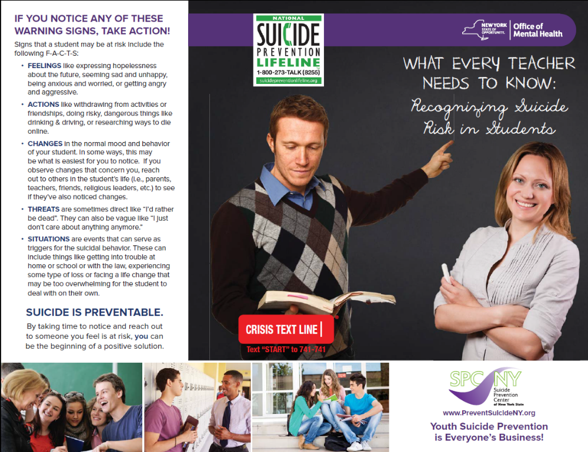

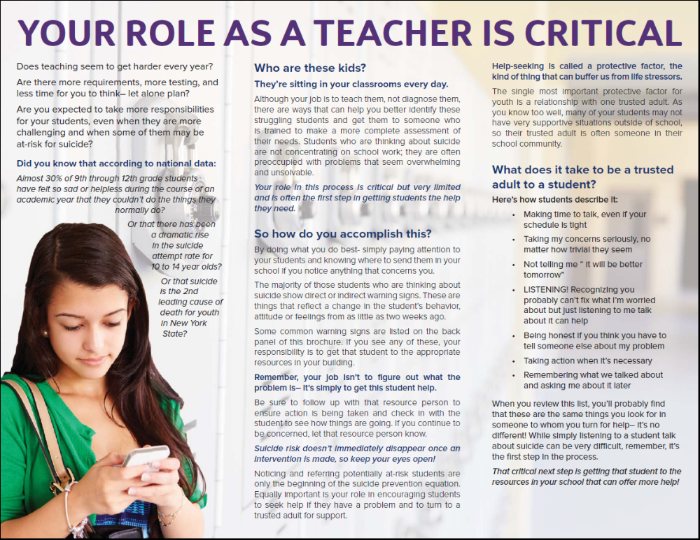

APPENDIX D

Communicable Disease - Pandemic Plan

Valley Stream School District 24
2801-a (2)(m) District-wide Safety Plan:
Protocols for a State Disaster Emergency Involving a Communicable Disease

On September 7, 2020, Governor Cuomo signed into law Chapter 168 of the Laws of 2020, as amended by Chapter 30 of the Laws of 2021 that requires public employers, including public school districts, to adopt a continuation of operations plan in the event that the governor declares a state disaster emergency involving a communicable disease. The legislation (S.8617-B/ A.10832) amends subdivision 2 of section 2801-a of New York Education Law to require that District Safety Plans include protocols for responding to a state disaster emergency involving a communicable disease that are “substantially consistent” with the provisions of section 27-c of the Labor Law. As a result of this change, the Board of Regents adopted amendments to Commissioner’s Regulation §155.17 in April 2021, that were that were made permanent at the July 2021 meeting of the Board of Regents.

Pursuant to the amendments to New York Education Law §2801-a and Commissioner’s Regulation §155.17, the district-wide school safety team should incorporate required continuation of operations components in the District-wide School Safety Plan. Amendments to the District-wide School Safety Plan must be made available for public comment at least thirty (30) days prior to adoption and may be adopted by the school board (or governing body) only after at least one (1) public hearing that provides for the participation of school personnel, parents, students, and any other interested parties.

a.) A list and description of the types of positions considered essential in the event of a state-ordered reduction of in-person workforce as a result of a state disaster emergencies involving public health. Such designation may be changed at any time in the sole discretion of the employer.

Consider whether cafeteria, transportation and/or other staff may be necessary for meal preparation and delivery to homes; check-ins with students and technology delivery systems; staff providing mental health or technology services; business staff for continued operations, and other staff providing services to students.

 | Essential Position Type
 | See below:
Essential Employee Determination (Example – Fill-in your own)
Title |  | Description |  | Justification |  | Work Shift |  | Protocol
Superintendent of Schools |  | District activities and Chief Emergency Officer |  | The Supt makes all major decisions affecting district activities, operations and staff. |  | As Needed |  | Building sign in sheets
Superintendent Secretary |  | District operations, personnel items, BOE secretary |  | Support Superintendent with ongoing district activities |  | As needed |  | Building sign in sheets
Central Office Administrators |  | Assistant Superintendents |  | The three Assistant Superintendents supervise district operations in Business, Personnel and Curriculum. They ensure ongoing activities continue and serve as back up to the Superintendent of Schools. |  | As needed |  | Building sign in sheets
Building Administration |  | Principals  Assistant Principals  Curriculum Coordinators |  | Supervise the staff and daily operations of the school buildings |  | As needed |  | Building sign in sheets
Main office/Guidance Clerical |  | Clerical support for building Admin |  | Mail processing, certain mailings, reporting and various office activities |  | As needed |  | Building sign in sheets
Asst. Bus Administrator |  | In-depth business analysis/ invoicing/ purchasing agent |  | Performs in-depth analysis of business operations, oversees all purchasing activities, back up to Asst. Supt for Business |  | As needed |  | Building sign in sheets
Treasurer |  | Financial activities and funds transfers |  | Banking/ financial operations/ funds transfers/ reconciliation |  | As needed - 8:00 am – 4:30 pm  Staggered by day or morning afternoon shifts |  | Building sign in sheets
Principal Typist Clerk - Business |  | Personnel Action For Civil Service/ Purchasing/ Budget Vote/ BOE Agenda |  | Printing and mailing, contracts and other updates after Board Meeting, employee changes, attendance |  | As needed - 8:00 am – 4:30 pm  Staggered by day or morning afternoon shifts |  | Building sign in sheets
Principal Account Clerk Benefits |  | Employee Benefits/ FLEX/ Workers Compensation |  | Enrollment/Mailing letters/documentation/check processing |  | As needed - 8:00 am – 4:30 pm  Staggered by day or morning afternoon shifts |  | Building sign in sheets
Account Clerks Payroll |  | Payroll processing |  | Ongoing payroll services |  | As needed - 8:00 am – 4:30 pm – staggered by day or morning. |  | Building sign in sheets
Account Clerks Business Office |  |  | Purchasing/ Accounting/ Accounts Payable |  | District-wide purchasing, accounting and record keeping, bill payments |  | As needed - 8:00 am – 4:30 pm  Staggered by day or morning afternoon shifts |  | Building sign in sheets
Principal and Senior Typist Clerk - Personnel |  |  | Personnel Action for instructional staff |  | Mail and communication with instructional personnel, leaves of absence, attendance |  | As needed - 8:00 am – 4:30 pm  Staggered by day or morning afternoon shifts |  | Building sign in sheets
Food Service Director |  |  | Oversees and supervises food operations |  | Provides ongoing and emergency meals to students |  | As needed |  | Building sign in sheets
Transportation Administration |  |  | Director, Asst. Director, Asst. Dispatcher, Clerical |  | Supervises and/or communicates with transportation staff. Utilizes all communication and tracking software. Parent inquiries |  | As needed |  | Building sign in sheets
Bus Drivers/Bus Attendants |  |  | Transportation services |  | Provides continuity of student transportation. Assist with meal distribution |  | As needed |  | Building sign in sheets
Facilities Director |  |  | Supervises all building and operations staff |  | Ensures safety, cleaning and function of all district buildings and grounds |  | As needed |  | Building sign in sheets
Maintenance/Grounds/ Custodian/Cleaners |  |  | Ensures building and grounds cleaning and operations |  | Ensures buildings and grounds are operational and sanitized for students and staff |  | As needed - 5:30 am – 10:00 pm  Staggered by day or morning afternoon shifts |  | Building sign in sheets
Technology Director and IT Manager |  |  | IT Management |  | Infrastructure support, instructional technology and supervises IT staff |  | As needed |  | Building sign in sheets
Technology Specialists |  |  | Technology Support |  | Support IT infrastructure, distribution and maintenance of personal devices |  | As needed |  | Building sign in sheets
IT Clerical |  |  | Clerical support for IT Office |  | Mail processing, certain mailings, reporting and various office activities |  | As needed |  | Building sign in sheets
Pupil Personnel Director, Asst. Director |  |  | Supervises PPS staff and services |  | Ensure continuity of services for special education and other student support services |  | As needed |  | Building sign in sheets
Account Clerk - PPS |  |  | STAC, bill payment, purchasing |  | Ongoing business services |  | As needed - 8:00 am – 4:30 pm  Staggered by day or morning afternoon shifts |  | Building sign in sheets
PPS Clerical |  |  | Clerical support for PPS |  | Mail processing, certain mailings, reporting and various office activities |  | As needed |  | Building sign in sheets
Nurses |  |  | Health office |  | Distribution of medication and other consultation |  | As needed |  | Building sign in sheets

b.) A description of protocols the employer will follow for non-essential employees to telecommute including, but not limited to, facilitating or requesting the procurement, distribution, downloading and installation of any needed technology, including software, data, and the transferring of office phone lines to work or personal cell phones as practicable or applicable to the workplace, and may include devices.

Telecommuting Protocol: Technology

Technology & Connectivity for Students - Mandatory Requirements:
- To the extent possible, have knowledge of the level of access to devices and high-speed broadband all students and teachers have in their places of residence;
- To the extent practicable, address the need to provide devices and internet access to students and teachers who currently do not have sufficient access; and
- Provide multiple ways for students to participate in learning and demonstrate mastery of Learning Standards in remote or blended models, especially if all students do not yet have sufficient access to devices and/or high-speed internet.

Mobile Devices Delivery:
Technology offers schools and districts increased options for continuing learning during extended closures. Technology can be leveraged in different ways to meet local needs, including but not limited to:
- Communication (e-mail, phone, online conferencing, social media)
- Teacher/student and student/student interaction (office hours, check-ins, peer collaboration)
- Instruction (video/audio recordings of instruction, instructional materials, synchronous distance learning, asynchronous online courses)
- Learning Materials and Content (digital content, online learning activities)
- Additional Technology Devices Assessments:
  - Identify students’ technology needs to include adaptive technologies
  - Use the Asset Tracking Management System procedures to check out all mobile devices
  - If a shutdown happens abruptly, plan a pick-up time and location, and arrange to deliver devices to those who cannot pick them up.
- Providing Multiple Ways for Students to Learn
  - Support instructional programs as needed in preparation of non-digital, alternative ways for students to participate in learning and demonstrate mastery of Learning Standards in remote or blended models in circumstances in which students do not yet have sufficient access to devices and/or high-speed internet.

c.) A description of how the employer will, to the extent possible, stagger work shifts of essential employees to reduce overcrowding on public transportation systems and at worksites.

Work shift Modification(s)
See Work Shift – page 29.

Depending on the exact nature of the communicable disease and its impact, the district is prepared to enact numerous strategies to reduce traffic congestion and maintain social distancing requirements in order to minimize building occupancy. The following will be considered:

- Limiting building occupancy to 25%, 50% or 75% of capacity or the maximum allowable by State or Local guidance.
- Forming employee work shift cohorts to limit potential contacts.
- Limit employee travel within the building.
- Limit restroom usage to specific work areas.
- Stagger arrival and dismissal times.
- Alternate work-days or work weeks.
- Implement a four-day work week.
- Limit or eliminate visitors to the building.

The school district will utilize these base strategies and expand upon them as necessary in order to address any public health emergency.

d.) A description of the protocol the employer will implement, in order to procure the appropriate Personal Protective Equipment (PPE) for essential employees, based upon the various tasks and needs of such employees in a quantity sufficient to provide personal protective equipment to each essential employee during any given work shift. Such description shall also include a plan for storage of such equipment, to prevent degradation and permit immediate access, in the event of an emergency declaration.

Personal Protective Equipment (PPE) Protocol

PPE & Face Covering Availability:
- The school district will provide employees with an acceptable face covering at no-cost to the employee and have an adequate supply of coverings in case of replacement.
- Cloth face coverings are meant to protect other people in case the wearer is unknowingly infected.
- Cloth face coverings are not surgical masks, respirators, or personal protective equipment.
- Information should be provided to staff and students on proper use, removal, and washing of cloth face coverings.
- Procurement, other than some very basic preliminary purchases will be done on a consolidated basis to ensure that the Agency is getting the most for its PPE dollars.
- We have encouraged all staff to utilize their own personal face coverings but have secured and will provide PPE for any employee requesting such protection. Specialized PPE (N95s, face shields, gowns, gloves, etc.) may be required for specific work tasks and will be provided as deemed necessary. Those individuals that are required to wear N-95 respirators will be fit-tested and medically screened prior to use to assure they are physically able to do so. Parents will also be encouraged to provide face coverings for students however, face coverings will be provided for any student that cannot provide their own.

Plan for Storage/Access

PPE Supply Management

- The Facilities Department is working with programs to determine the overall PPE needs of the Agency. Centralized purchasing will be used when possible.

 |  |  | Disposable Face Covering Supplies
Group | Quantity per  100 per Group | 12 Week Supply  100% Attendance |  | 12 Week Supply  50% Attendance |  | 12 Week Supply  25% Attendance | Assumptions
Students | 100 Masks per Week | 1200 |  | 600 |  | 300 | 1 Disposable Mask per Week per Student (supplements  parent provided)
Teachers/Staff | 500 | 6000 |  | 3000 |  | 1500 | 5 Disposable Masks per Week per Teacher
Nurse/Health Staff | 1000 | 12,000 |  | 6000 |  | 3000 | 10 Disposable Masks per Week  per School Nurse

 |  | PPE for High Intensity Contact with Students
Item | 1 Week Supply for 1 Staff |  | 12 Week Supply |  | Assumptions
Disposable Nitrile Gloves | 10 |  | 120 |  | 10 per Week per Staff
Disposable Gowns | 10 |  | 120 |  | 10 per Week per Staff
Eye Protection | 2 |  | n/a |  | 2 Re-usable per Staff
Face Shields | 2 |  | n/a |  | 2 Re-usable per Staff
Waste Disposal Medium | 1 |  | n/a |  | 1 Unit per Staff Total
N-95 Respirators* | 10 |  | 120 |  | 10 per Week per Staff

e.) A description of the protocol, in the event an employee is exposed to a known case of the communicable disease that is the subject of the state disaster emergency, exhibits symptoms of such disease, or tests positive for such disease in order to prevent the spread or contraction of such disease in the workplace. Include actions to be taken to immediately and thoroughly disinfect the work area of any employee known or suspected to be infected with the communicable disease as well as any common area surface and shared equipment, and employer policy on available leave to receive testing, treatment, isolation, or quarantine.
Consider disinfection protocols, substitute workers, testing and tracing.

Employee Exposure Protocol
We have collaborated with our partners to assure complementary efforts. We have invited
representatives from the Nassau County Department of Health, Police Department, Office of Emergency Management, Department of Mental Health and others to attend our District-wide School Safety Team meetings. This will allow us to send consistent messages to the school community on pandemic related issues.

- The District-wide Command Center will be at The Administration Building with the alternate at
St. Paul’s and will be activated at the direction of the School District Incident Commander. We
have established our District-wide Incident Command Structure as follows:

Superintendent Dr. Unal Karakas

Assistant Superintendent of Curriculum Dr. Christopher Keogh

Assistant Superintendent of Finance/Operations Victoria Galante

Director of Instructional Technology Mr. Mark Onorato

Director of Facilities Mr. Charles Brocher

Principals Dr. Scott J. Comis, Mr. Rosario Iacono,
Mr. Michael DeBlasio

- Building-level Command Posts and Incident Command Structures are defined in the Building-Level Emergency Response Plans. Our Incident Command System will complement and work in concert with the Federal, State, and Local Command Systems. Our central administrators and school building principals have completed the IS 100 (Introduction to Incident Command), we will also make them aware of other useful trainings available from FEMA such as the: IS 362 (Multi-Hazard Emergency Planning for Schools) and IS 700 (National Incident Management System) training courses which are available on-line through the Nassau Schools Emergency Planning Consortium Website at www.nassauschoolemergency.org or FEMA website. We are also recommending that key administrators, principals, and nurses take the Johns Hopkins University COVID-19 Contact Tracing Course which is offered free-of-charge at https://www.coursera.org/learn/covid-19- contact-tracing.

- The school district has designated the building principals as the Communicable Disease Safety Coordinator (administrator), for each of its schools, whose responsibilities include continuous compliance with all aspects of the school’s reopening plan, as well as any phased-in reopening activities necessary to allow for operational issues to be resolved before activities return to normal or “new normal” levels. The coordinators shall be the main contact upon the identification of communicable disease cases and are responsible for subsequent communication. Coordinators shall be responsible for answering questions from students, faculty, staff, and parents or legal guardians of students regarding the communicable disease public health emergency and plans implemented by the school.
School/Program | Communicable Disease Safety Coordinator | Contact #
Brooklyn Avenue School | Dr. Scott J. Comis | 434-2851
R. W. Carbonaro School | Mr. Rosario Iacono | 434-2861
W. L. Buck School | Mr. Michael DeBlasio | 434-2841
Administration | Victoria Galante | 434-2831

- Communication will be important throughout a pandemic outbreak. It will be necessary to communicate with parents, students, staff, and the school community. A school district Public Information Officer (PIO) (Fill-in Name) has been designated to coordinate this effort and act as the central point for all communication. The PIO will also retain responsibility for establishing and maintaining contact with accepted media partners. The PIO will work closely with our Technology Director to assure proper function of all communication systems. This coordination will also help assure that as many redundant communication systems as possible are available.

- Continuity of operations and business office function could be severely impacted by a loss of staff. As such, our plan will include procedures for maintaining essential functions and services. This will include:

- Recognizing the need for these essential individuals to have frequent communication we have established as many redundant communication systems as possible. Communication will be important throughout a pandemic outbreak. It will be necessary to communicate with parents, students, staff, and the school community. Communication methods may include; websites; school postings; general mailings; e-mails; phones and cell phones, texting and the public media. (Fill-in Name) has been designated to coordinate this effort and act as the central point for all communication. Available in the district are email, telephone, radio, twitter and mass parent and staff communications. We have test/exercise our communication systems throughout the school year.
- The Business Office is essential for maintaining overall function and facilities operation. Back-up personnel will be important to maintain purchasing and payroll responsibilities. We have defined the following job titles for having back-up responsibility in these areas: Purchasing, accounts payable, payroll, benefits, and Treasurer. The district maintains employee redundancy as it pertains to these essential business office functions. We have also established the ability to maintain these essential functions off-site from remote locations. The district houses a main server for our financial functions, and a redundant back-up server offsite. In addition, employees serving essential business functions were issued a district laptop to facilitate remote access to their primary job functions.
• Maintenance of facilities will be difficult with a reduced or absent maintenance staff. The Director of Facilities or back-up designee will keep the business office informed of such status and of the point at which buildings can no longer be maintained. The Director of Facilities has provided building administrators with procedures for maintaining essential building functions (HVAC system operation, alarms, security, etc. along with a list of telephone numbers of outside companies and alternates for repair and maintenance of these systems). If necessary, we will pool maintenance staff to form a mobile central team to help assist in essential building function and cleaning of critical areas such as bathrooms.
Human Resources will be essential in monitoring absenteeism and assuring appropriate delegation of authority. Changes to district policies and procedures to reflect crisis response may become necessary and will be implemented by Human Resources. The Human Resources Director (Assistant Superintendent for Business) has provided cross-training of staff to ensure essential function (Invision training, and Frontline for attendance). The Principals Account Clerk and the Account Clerk will have this function. Human Resources will help develop the Plan, in conjunction with all bargaining units, for emergency use of personnel in non-traditional functions and changes in the normal work-day such as alternate or reduced work hours, working from home, etc. Working with administration and local officials, the Human Resources Department will help to decide if schools need to be closed
• Continuity of instruction will need to be considered in the event of significant absences or school closure. Restructuring of the school calendar may become necessary. We will work closely with the New York State Education Department on this potential result throughout the crisis period. Some of the alternate learning strategies we have implemented to be used in combination as necessary include remote teaching, learning and support. This may include providing devices to those children and staff who require them, as well as professional development and learning standards.
• On-line instruction; on-line resources; on-line textbooks, Google classroom, Seesaw.
• Communication modalities for assignment postings and follow-up: telephone; e-mail; automated notification systems; website postings

CDC and NYSDOH Recommendations:

- Closing off areas used by a sick person and not using these areas until after cleaning and disinfection has occurred;
- Opening outside doors and windows to increase air circulation in the area.
- Clean and disinfect all areas used by the person suspected or confirmed to be sick, such as offices, classrooms, bathrooms, lockers, and common areas.
- Once the area has been appropriately cleaned and disinfected it can be reopened for use.
- Individuals can return to the area and resume school activities immediately after cleaning and disinfection.

Notifications:

To protect themselves and others and stop the spread of communicable disease in the household and community, schools should notify through either group or individual level contact tracing affected school staff, students, and their parents/guardians whenever an individual either:
1. Was in the same room as an infected individual and so was exposed or potentially exposed (i.e., in the same classroom as an infected individual for longer than 1 minutes), if schools are employing “group level contact tracing,” or
2. Was identified as being exposed because they were a close contact of an infected individual if schools are employing “individual level contact tracing.”

Note: Group contract tracing, (e.g., classroom, school bus), in #1 above, is expected to alleviate the need for most classic (“individual”) contact tracing in schools. Criterion #2 above should be used if the school is conducting individual-level contact tracing to reduce the number of students affected by masking/testing and in some situations where there might have been exposures outside the classroom setting, such as non-classroom-based extracurricular activities.

Disinfection Protocol

Cleaning removes germs, dirt, and impurities from surfaces or objects. Cleaning works by using soap (or detergent) and water to physically remove germs from surfaces. This process does not necessarily kill germs, but by removing them, it lowers their numbers and the risk of spreading infection. Visibly soiled surfaces and objects must be cleaned first. If surfaces or objects are soiled with body fluids or blood, use gloves and other standard precautions to avoid coming into contact with the fluid. Remove the spill, and then clean and disinfect the surface.
Sanitizing lowers the number of germs on surfaces or objects to a safe level, as judged by public health standards or requirements. This process works by either cleaning or disinfecting surfaces or objects to lower the risk of spreading infection.

Routine cleaning of school settings includes:
- Cleaning high contact surfaces that are touched by many different people, such as light switches, handrails and doorknobs/handles
- Dust- and wet-mopping or auto-scrubbing floors
- Vacuuming of entryways and high traffic areas
- Removing trash
- Cleaning restrooms
- Wiping heat and air conditioner vents
- Spot cleaning walls
- Spot cleaning carpets
- Dusting horizontal surfaces and light fixtures
- Cleaning spills
Disinfecting:
Disinfecting kills germs on surfaces or objects by using chemicals to kill germs on surfaces or objects. This process does not necessarily clean dirty surfaces or remove germs, but by killing germs on a surface after cleaning, it can further lower the risk of spreading infection.

- We will follow cleaning and disinfection requirements from the Centers for Disease Control and Prevention (CDC) and the Department of Health will be adhered to.
- Custodial logs will be maintained that include the date, time and scope of cleaning and disinfection. Cleaning and disinfection frequency will be identified for each facility type and responsibilities will be assigned.
- Hand hygiene stations will be provided and maintained, including handwashing with soap, running warm water, and disposable paper towels, as well as an alcohol-based hand sanitizer containing 60% or more alcohol for areas where handwashing is not feasible.
- Regular cleaning and disinfection of facilities and more frequent cleaning and disinfection for high-risk areas used by many individuals and for frequently touched surfaces, including desks and cafeteria tables will be conducted.
- Regular cleaning and disinfection of restrooms will be performed.
- Cleaning and disinfection of exposed areas will be performed in the event an individual is confirmed to have communicable disease, with such cleaning and disinfection to include, at a minimum, all heavy transit areas and high-touch surfaces.
- Although cleaning and disinfection is primarily a custodial responsibility, appropriate cleaning and disinfection supplies will be provided to faculty and staff as approved by Central Administration.
- Additional paper towel dispensers may be installed in other designated spaces.

Hand Sanitizing:
- Hand sanitizer dispensers will be located and installed in approved locations.

Trash removal:
- Trash will be removed daily.
- Garbage cans or process for collecting trash during lunch periods in classrooms will be increased where necessary.
- No-touch trash receptacles will be utilized, where possible.

Alternate Cleaning Methods:
- The effectiveness of such as ultrasonic waves, high intensity UV radiation, and LED blue light, against the virus that causes COVID-19 or other communicable disease has not been fully established.
- In most cases, fogging, fumigation, and wide-area or electrostatic spraying are not recommended as primary methods of surface disinfection and have several safety risks to consider, unless specified as a method of application on the product label.

Employer Policy on Available Leave to Receive Testing, Treatment, Isolation, or Quarantine
Employee Assistance Program (EAP)

- The Human Resources Department will continue to disseminate information to employees about EAP resources. EAP is a voluntary, work-based program that offers free and confidential assessments, short-term counseling, referrals, and follow-up services to employees who have personal and/or work-related problems. EAPs address a broad and complex body of issues affecting mental and emotional well-being, such as alcohol and other substance abuse, stress, grief, family problems, and psychological disorders.

Staff Absenteeism

- Instructional staff will call into the Absence Management System when they are absent due to illness. Substitutes will be provided as necessary and as requested.
- The instructional departments will develop a plan to monitor absenteeism of staff, cross-train staff, and create a roster of trained back-up staff.

- Local health departments (LHD) will assess conditions and tailor guidance to their jurisdiction. A LHD may implement masking requirements that are more restrictive than the state. LHDs and school districts and private schools may consult and collaborate on masking and testing decisions. Some school districts cross county boundaries. Schools should follow the guidance of the LHD for the county in which the school building is located.

f.) A protocol for documenting hours and work locations, including off-site visits, for essential employees. Such protocol shall be designed only to aid in tracking of the disease and to identify the population of exposed employees, to facilitate the provision of any benefits which may be available to certain employees and contractors on that basis.
Consider daily symptom checks, absences, and supervisor notification.

Hours and Work Locations Protocol
It is recognized that as the work environment changes to adapt to the emergency situation and typical work schedules are modified it can become more difficult to track employees especially if they conduct work off site or in numerous locations. The ability to identify these individuals will be extremely important if contact tracing is necessary during a communicable disease crisis.

See Work Shift and Protocols – page 29.

g.) A protocol for how the public employer will work with such employer's locality to identify sites for emergency housing for essential employees in order to further contain the spread of the communicable disease that is the subject of the declared emergency, to the extent applicable to the needs of the workplace.

Emergency Housing Protocol (These are examples – Fill-in your own)
Emergency housing for essential workers is not considered to be generally required for school employees as opposed to healthcare workers and other critical care employees. However, we have canvassed local hotels/motels so we may be prepared for an unanticipated need and should be able to access the following if necessary:

    - Holiday Inn Express Lynbrook - 516.596.3000
    - Best Western Mill River - 516.678.1300
    - Holiday Inn JFK - 718.712.0100

Nassau County School Districts have also established school building shelter sites across the County in cooperation with the Nassau County Office of Emergency Management which may be utilized in the event of any emergency situation. If deemed necessary, school districts will work closely with Office of Emergency Management to determine housing options.

h.) Other requirements determined by the department of health such as contact tracing or testing, social distancing, hand hygiene and disinfectant, or mask wearing.

Department of Health Requirements
We will work closely with the Nassau County Department of Health to determine the need for activation of our Plan. The following procedures will be followed by administrators, principals, school nurses for reporting communicable disease, including Coronavirus, Influenza, etc., and communicating with the Health Department: o Report suspected and confirmed cases of influenza on the monthly school’s Communicable Disease Report, (DMS-485.7/93; HE-112.4/81) and submit to: Nassau County Department of Health, Bureau of Infectious Diseases, 240 Old Country Road, Mineola, N.Y. 11501.

  - o Public Health Consultation and Immediate Reporting: 516-227-9639
  - o Fax: 516-227-9669
  - o Weekend/After-hours Consultation and Reporting: 516-742-6154

• The Nassau County Department of Health will monitor County-wide cases of communicable disease and inform school districts as to appropriate actions.
• The Superintendent (Fill-in your own) will help coordinate our Pandemic planning and response effort. This person will work closely with the District-Wide School Safety Team that has responsibility for reviewing and approving all recommendations and incorporating them into the District-Wide School Safety Plan. The school district Medical Director and nurses will be vital members of the Safety Team. Because of the potential importance of technology in the response effort (communication and notification) the school district technology director will also be an important Team member. The Assistant Superintendent of Human Resources, Business Official, Facility Director, Food Service Director, Transportation Coordinator, Public Information Officer and Curriculum Director will also be vital to the planning effort. Other non-traditional individuals may also be required to be part of the Team.
• The District-Wide School Safety Team will review and assess any obstacles to implementation of the Plan. The CDC School District Pandemic Influenza Planning Checklist was reviewed on (Fill-in Date) for this determination and has considered issues related to Planning and Coordination; Continuity of Student Learning; Core Operations; Infection Control Policies and Procedures; and Communication.
• The school district will emphasize hand-washing and cough/sneezing etiquette through educational campaigns including the CDC Germ Stopper Materials; Cover Your Cough Materials; It’s a SNAP Toolkit; and the NSF Scrub Clean; which can all be accessed at http://www.cdc.gov/flu/school/.
• We will educate and provide information to parents, staff, and students about our Pandemic Plan and about how to make an informed decision to stay home when ill. We will utilize our website, postings and direct mailings for this purpose.

Date draft was presented to employee representative(s): __________

Date finalized: __________

Location of publication: www.valleystreamschooldistrict24.org
________________________________________________

Definitions included in the legislation are provided below.

Essential worker: is required to be physically present at a work site to perform his or her job. Such designation may be changed at any time in the sole discretion of the employer.

Non-essential worker: is not required to be physically present at a work site to perform his or her job. Such designation may be changed at any time in the sole discretion of the employer.

Personal protective equipment: all equipment worn to minimize exposure to hazards, including gloves, masks, face shields, foot and eye protection, protective hearing devices, respirators, hard hats, and disposable gowns and aprons.

Communicable disease: an illness caused by an infectious agent or its toxins that occurs through the direct or indirect transmission of the infectious agent or its products from an infected individual [or via an animal, vector or the inanimate environment to a susceptible animal or human host].

Retaliatory action: the discharge, suspension, demotion, or discrimination against any employee, or other adverse employment action taken against an employee in the terms and conditions of employment.

- We will utilize the Centers for Disease Control (CDC) School District (K-12) Pandemic Influenza Planning Checklist below as a guide and basic information for planning and responding to any potential Pandemic.
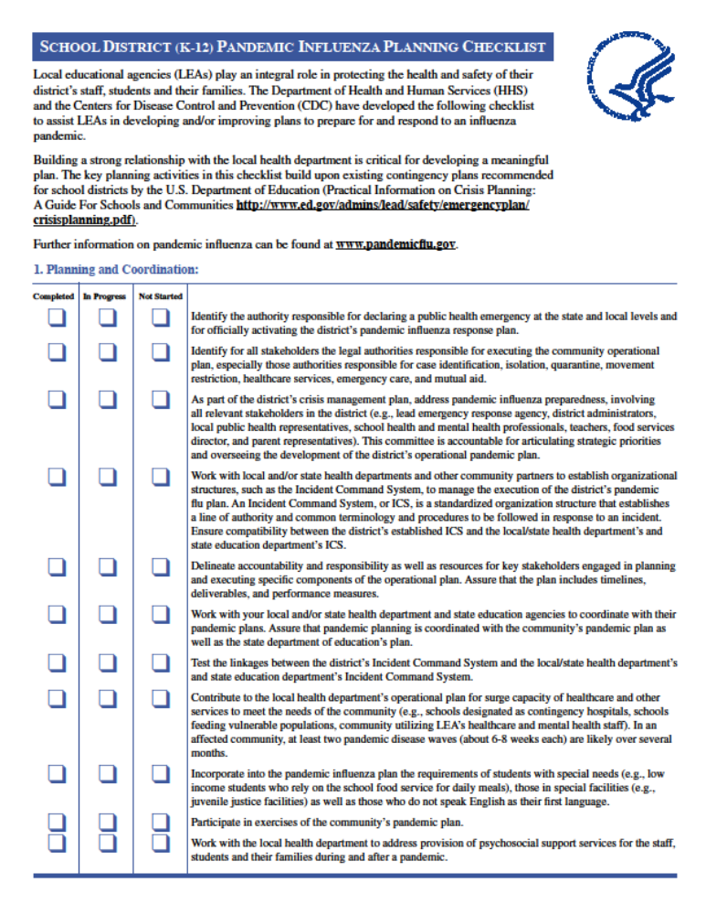
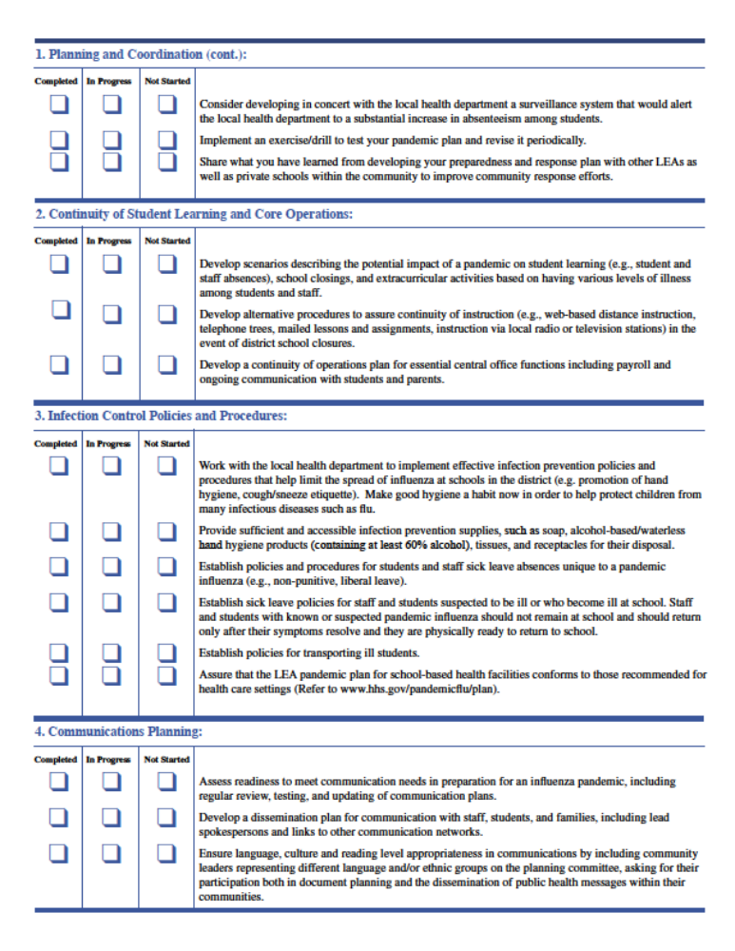
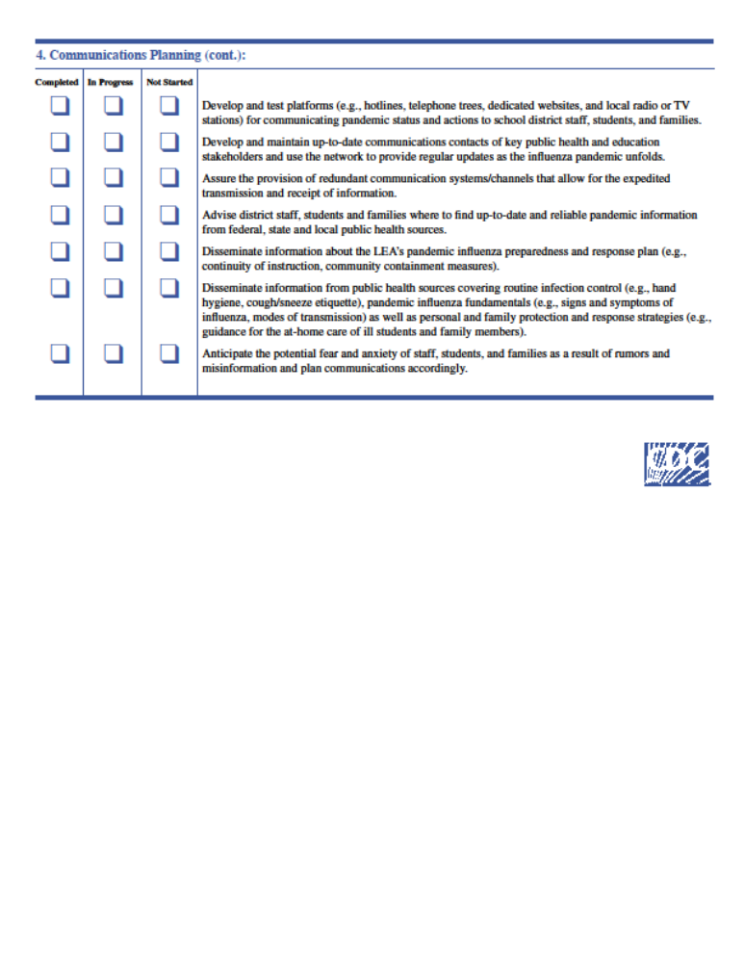
APPENDIX E

Remote Instruction Plan & Student Access Survey

VALLEY STREAM DISTRICT 24 REMOTE LEARNING PLAN
Valley Stream District 24 will provide equitable instruction for all students with continuity of learning ensured with all of the instructional models inclusive of Remote Instruction Model if necessary.
Instruction will focus on the New York State Learning Standards. Daily interaction will take place between the students and teachers to ensure that students may interact and seek feedback and support from them.
Attendance data will remain consistent with past practice unless modified by law, regulation, or executive order.The classroom teacher will be the point of contact for their cohorts of students. Daily attendance will be taken by the teacher in all models. If it is a hybrid and/or remote day, then the teacher will utilize Google Meets with a virtual entry to gather the students’ attendance data. This data will then be administered into the eSchool Program daily by the teacher. Attendance data will be reported to the student information system or SIRS. Chronic absenteeism will be addressed immediately with parents. If a student does not engage in distance learning, immediate outreach will take place with teachers, social workers or psychologists reaching out to the students and family.
The Remote Instruction Models outlined below will include synchronous instruction (Google Meets) and asynchronous instruction (Google Classroom). The synchronous instruction will include daily live meets as defined in the learning plans below and asynchronous instruction with activities provided through Google Classroom. In addition, project based learning activities and project guides will be utilized.
Class Link (https://launchpad.classlink.com/vs24) will be utilized as the Learning Management System for access to the following online curriculum resources: (In compliance with the New York State Learning Standards.)
English Language Arts: Superkids Program (K-Grade2) Think Central Program: (Grades 3-6)
Math: Think Central Program (K-Grade 6)
Science: Inspire Science Program (K-6)
Social Studies: PNW BOCES Program (K-6)
Independent activities will be provided through:
- Pre-recorded videos
- EdPuzzle videos
- Pear Deck
- Use of Google Suite
- Use of District Curriculum Subscriptions and Resources
- The following will be provided through Google Classroom:
- Google Docs.
- Google Slides
- Pear Deck
- Google Forms
- Google Drawings
- Jamboard
- SMART Learning Suite

In addition, the following resources will be utilized and linked to Google Classroom:
- Trueflix
- Bookflix
- PBS Learning Media
- Readworks - reading comprehension activities
- EdPuzzle
- Flip Grid
- Pear Deck
- I3 LearnHub
- Khan Academy
- Learn Zillion
- NWEA Mappers
- Library eBooks
- JLG DIgital (audio/digital books)
- Light Box
- Additional resources include:
- Brain Pop and Brain Pop Jr.
- Pebble Go
- Discovery Education
- Culture Grams
- Dictionary.com
- Worldbook Online
- Learning.com
- Camp Wonderopolis
- Classics for Kids
- Hour of Code
- ABCYA
- Starfall

Wellness activities will be provided daily and include some of the following yoga exercises, breathing, fitness, brain breaks, scavenger hunt activities, etc.
Alternate Remote Day Learning Plan:
Remote learning will take place on required days.
The following will be included:
● Every student and staff member will be provided with a device if needed and access to wi-fi will be accessible to those who need it through hotspots procured by the district. The teachers will poll the parents to find out if they need access to devices or internet access.
●Technology guides and videos will be made available to parents to support their students if needed. Guides will be shared explaining how to access the digital curriculum programs and apps that are utilized. Parent technology support guides and videos will be made accessible on the district website. Parents will have access to technology team support by contacting the building principal if needed.
●Staff have been provided with ongoing professional development and support in the area of remote learning which will continue in the future.
●Multiple ways for student participation to demonstrate their mastery of the learning standards will be provided.
●Students will have their devices home with them to allow for remote days and bring them back to school on their in-person days unless they are remote home instruction.
●Students will be provided with assignments for remote learning days. The assignments will focus on pre-teaching, re-teaching, project-based, or enrichment lessons.
● Teachers will follow the curriculum schedule listed below.
●An office hour for a Google Meet with remote students will be provided by a teacher to support students with their assigned work if needed or answer questions. A schedule will be provided to parents.
●Parents and students will be notified of the established daily schedule by the classroom teacher.
●Attendance will be taken daily by the teacher.
●Students will be provided access to continuous learning in all curriculum areas using technology and curriculum materials.
●Teachers will assess progress and use data to plan instruction to meet every student’s needs.
●Challenge, Instrumental Music, and General Music programs will be scheduled on remote days and will be provided live through Google Meets. A schedule will be developed and provided to parents and students.
●Students will be provided mental health and emotional support services and daily wellness activities through teachers, psychologists and social workers.
●Consistent daily cohort instructional schedules will be created:
ELA Block - 60 minutes daily with in person instruction adhering to social distancing or remote learning at home.
Math Block - 60 minutes daily with in person instruction adhering to social distancing or remote learning at home.
Science - 2 lessons per week
Social Studies - 2 lessons per week
Wellness - Daily
Physical Education, Art, Library - push-in classroom model or class/whole grade live stream. No full chorus, band, or orchestra rehearsal done live in person at this time.
●Academic support services will be provided to close learning gaps and will generally follow a push-in classroom model when services are delivered in school. They may also be offered on remote days with live instruction through Google Meets.
●All teachers will be responsible for providing instruction in their certified areas.
●No assemblies, large gatherings or meetings.
●Access to continuous learning in all curriculum areas will be supported through the use of technology.
●The NWEA will be administered in the fall, winter, and spring to assess learning gaps and use data to plan instruction to meet every student’s needs.

APPENDIX F

Threat Assessment Guidance

U.S. Department of Homeland Security
United States Secret Service
Creating a Comprehensive Targeted Violence Prevention Plan
The July 2018 report from the United States Secret Service highlights the many factors necessary for creating a school violence prevention plan including physical security, emergency management and violence prevention through a threat assessment process. The basis of this document focuses on violence prevention by the creation of a Comprehensive Targeted Violence Prevention Plan. Components of the Plan include the following:
- Forming a Multidisciplinary Threat Assessment Team
- Identifying Behaviors of Concern
- Establishing Central Reporting Mechanisms
- Defining the Threshold for Law Enforcement Intervention
- Establish Threat Assessment Procedures
- Develop Risk Management Options
- Promoting Safe School Climates
- Providing Training to Stakeholders

New York State has been a leader and National model for violence prevention in schools through the creation of the SAVE (Safe Schools Against Violence in Education) legislation in 2000 along with more recent revisions and guidance on the law reflecting lessons learned from violent incidents across the Country. The following information compares the recommendations from the U.S. Secret Service with existing requirements and guidelines in New York State.
U. S. Secret Service Recommendations | NYS Requirements & Guidelines
Step 1: Threat Assessment Team  - District-wide or School Building Team  - Variety of Disciplines  - Specific Designated Leader  - Protocols and Procedures  - Meet on a Regular Basis | The SAVE legislation requires school districts to have a District-wide School Safety Team; Building-level Emergency Response Planning Team; Emergency Response Team and Post-Incident Response Team. There is cross-sectional representation of the school community with specific leadership. Teams are encouraged to meet at least 4 times annually and many meet monthly.
Step 2: Define Prohibited & Concerning Behaviors  - Threatening or Violent Actions; Weapons; Bullying/Harassment; Criminal Behavior.  - Performance Decline; Absenteeism; Withdrawal/Isolation; Change in Behavior or Appearance; Drug/Alcohol Use; Depression or other Emotional/Mental Health Symptoms.  - Threshold for Intervention Should be Low.  - Identify Other Concerning Statements or Actions. | The SAVE legislation also has requirements for recognizing, reporting and documenting threatening and violent actions through School Safety and the Educational Climate (SSEC) provisions. This consists of the Dignity for all Students Act (DASA) and Violent and Disruptive Incident Reporting (VADIR) which includes Homicide; Sexual Offense; Assault; Weapons Possession; Discrimination, Harassment, and Bullying; Bomb Threats; False Alarms; and Use, Possession and Sale of Drugs and Alcohol. The mandated Code of Conduct sets the Standard.
Step 3: Create a Central Reporting Mechanism  - Establish One or More Reporting Mechanisms (on-line, email, phone, etc.)  - Promote and Provide Training on Reporting System. Make sure everyone knows their roles.  - Establish monitoring and response protocols.  - Establish anonymous reporting procedures.  - Act quickly, appropriately and maintain confidentiality. | Reporting systems exist and anonymous reporting is encouraged. In New York State schools are encouraged to adopt the concept “If You See Something, Say Something.” There are existing requirements for reporting of child abuse in the home along with training for mandated reporters. Additional requirements exist for reporting of suspected child abuse within the educational setting. Timeframes are established for reporting.
Step 4: Threshold for Law Enforcement  - Weapons, threats, physical violence, safety of individual.  - Importance of law enforcement representation on team. | The SAVE legislation requires representation of law enforcement on the Building-level Emergency Response Planning Team. School districts are encouraged to report weapons, threats, physical violence, and anything concerning the safety of an individual to law enforcement.
Step 5: Establish Threat Assessment Procedures  - Standardized Incident Form.  - Consider different sources of information.  - Examine online social media, desks, lockers.  - Examine academic, disciplinary, law enforcement and other formal records.  - Establish rapport with student and guardian.  - Evaluate the behavior in the context of age and social/emotional development.  - Investigate Themes: Motives; Communications, Inappropriate Interests; Weapons Access; Stressors; Emotional or Developmental Issues; Desperation or Despair; Violence as an Option; Concerned Others; Capacity to Carry Out an Attack; Planning; Consistency; Protective Factors. | School districts use standardized incident reporting forms which become the basis for the annual School Safety and the Educational Climate (SSEC) Summary Form. Emergency response procedures are required to be shared with parents, students and staff by October 1st of each school year.
Step 6: Develop Risk Management Options  - Individualized Management Plan.  - Need for Monitoring or Guidance.  - Available Resources.  - Removal and its impact on monitoring and maintaining connection.  - Notify law enforcement immediately if student is thinking about or planning to engage in violence.  - Address the safety of any potential targets.  - Create a situation that is less prone to violence.  - Remove or redirect the student’s motive.  - Reduce the effect of stressors. | Addressed in the SAVE legislation and required to be defined in the Building-Level Emergency Response Plan.
Step 7: Create/Promote Safe School Climate  - Build culture of safety, respect, trust and social/emotional support.  - Encourage teachers/staff to build positive, trusting relationships with students.  - Break down “codes of silence.”  - Help students feel connected to the school community and classmates.  - Identify clubs or teams at school.  - Support Positive Behavioral Interventions and Supports (PBIS) programs.  - Encourage student involvement. | The Dignity for all Students Act (DASA) promotes a safe school climate through requirements for Dignity Act Coordinators in school buildings. DASA Coordinators are required to complete specific training in order to fulfill their responsibilities.
Step 8: Conduct Training for all Stakeholders  - School safety is everyone’s responsibility.  - All employees require training.  - Students need training on the threat assessment process, reporting process, breaking the code-of-silence and confidentiality.  - Parents need training on their role in the threat assessment process.  - Law enforcement can provide training and should also be aware of the threat assessment process. | Training is required on many different levels. Teacher/Administrator certification requires 2-hours of training for both Child Abuse and Violence Prevention. Annual school safety training for all students and staff is required to be completed by September 15th of every school year. Parents are made aware of their role by providing them with a copy of the Code of Conduct and summary of Emergency Response Procedures. School districts works closely with law enforcement to provide training and establish procedures.


Nassau BOCES Health & Safety Training and Information Service (2025)
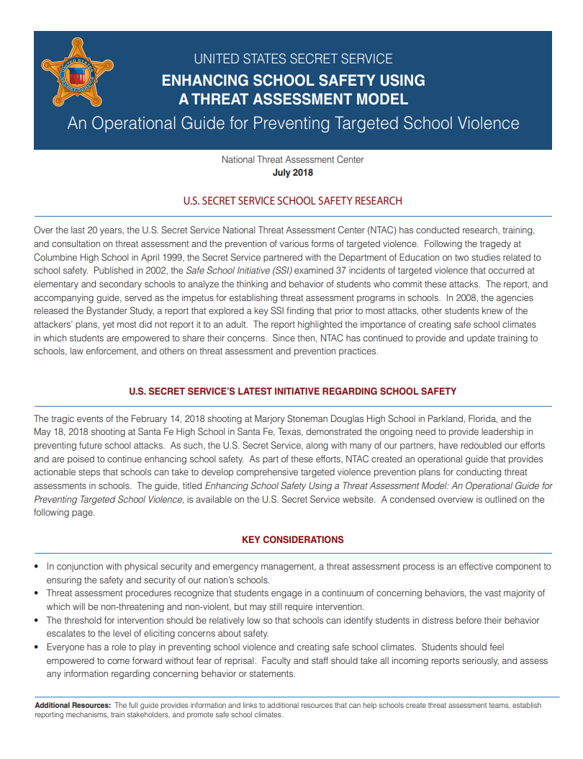
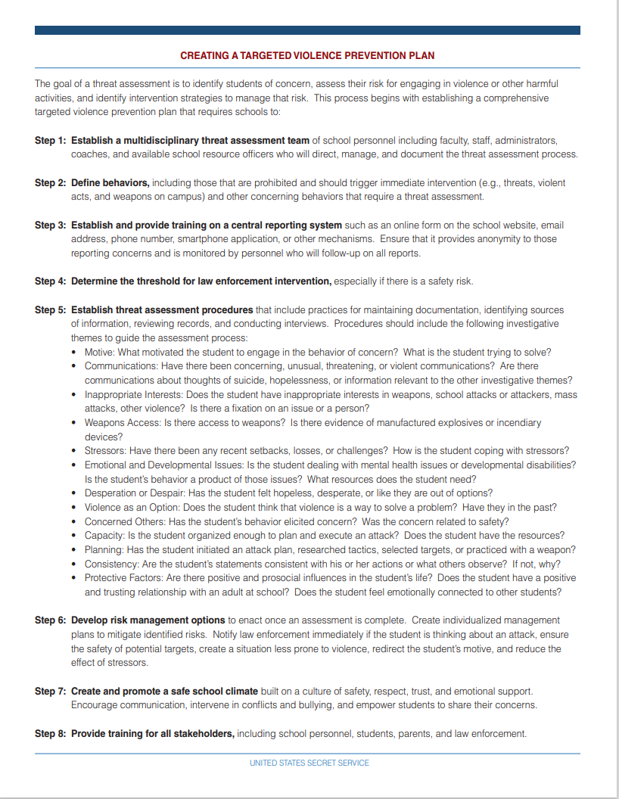
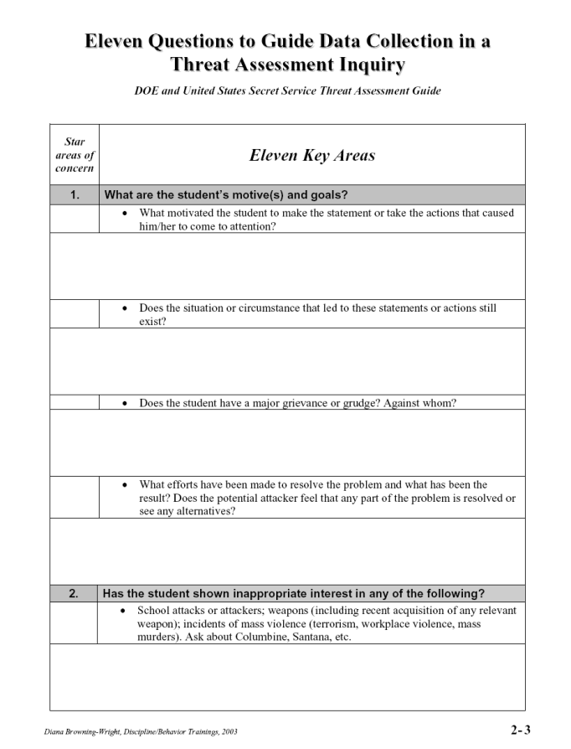
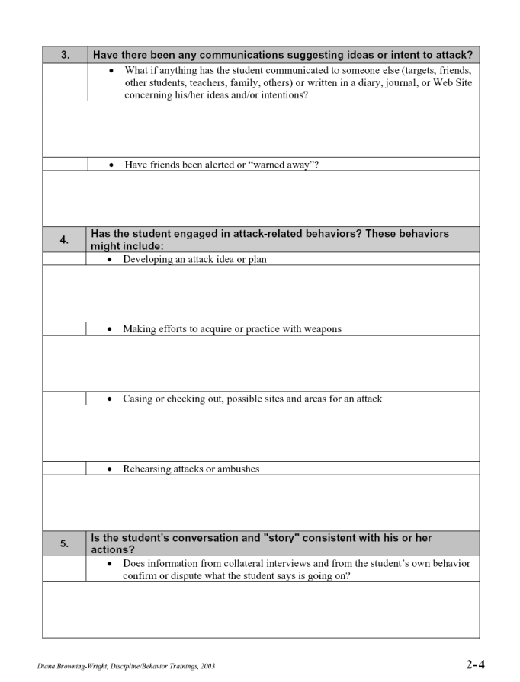

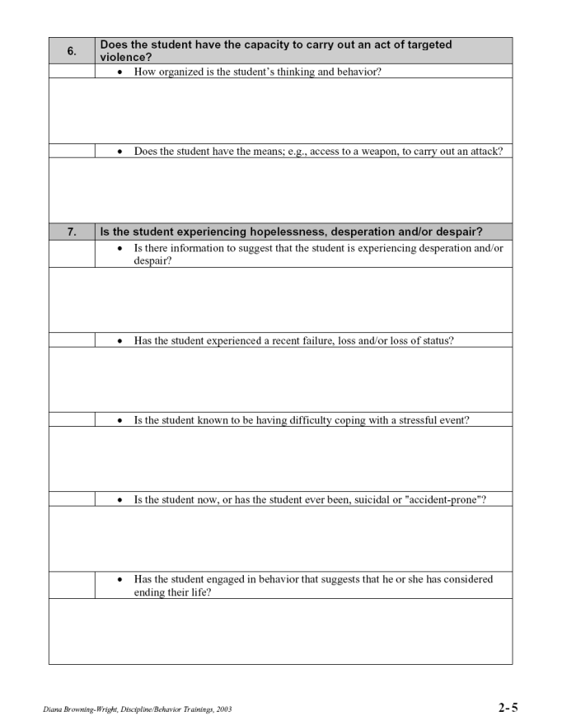

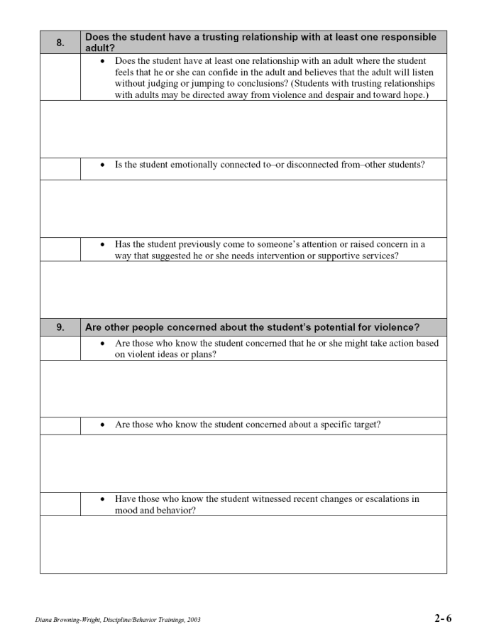

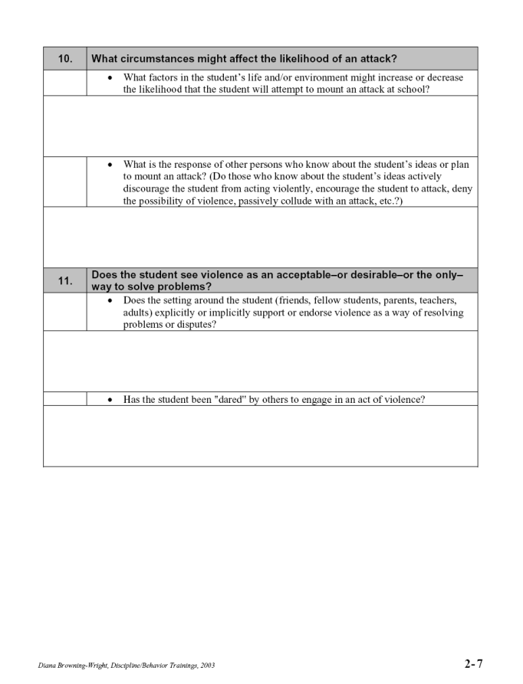

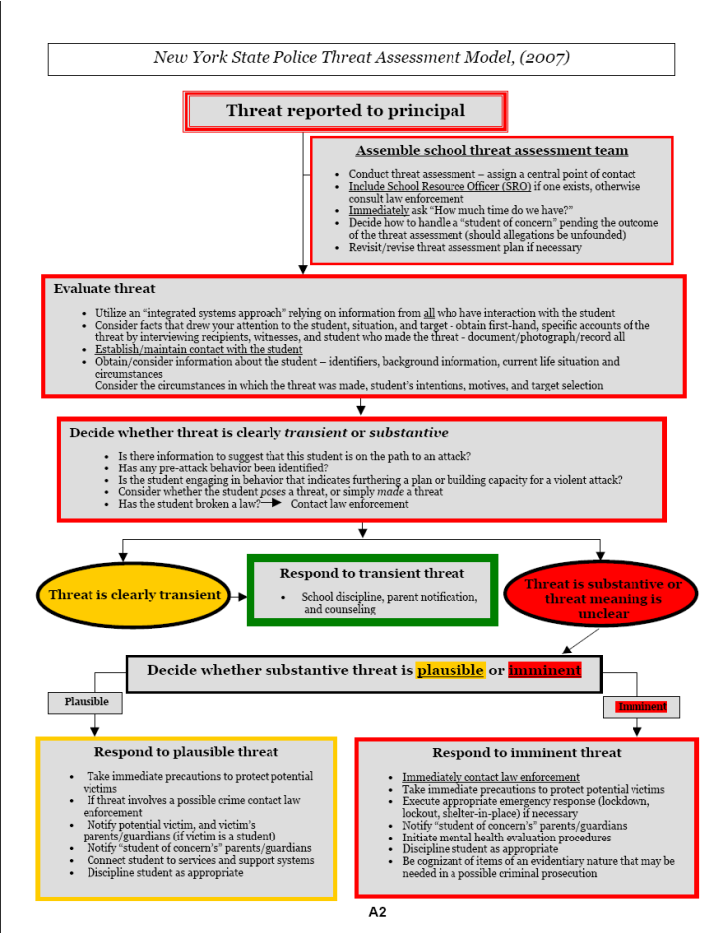
APPENDIX G
Appendix G describes the specific procedures for incidents involving an individual experiencing sudden cardiac arrest or a similar life-threatening emergency. The Cardiac-emergency response plan is a school or district written plan developed in collaboration with the Director of School Health Services or a duly licensed physician, nurse practitioner, physician assistant, or registered professional nurse that outlines specific actions and procedures for recognizing and responding to a sudden cardiac arrest or similar life threatening health emergency at any school site owned or operated by a school or at a location of a school sponsored event, including venue-specific, but not limited to athletic programs. Each plan shall integrate nationally recognized, evidence-based core elements, such as those recommended by the American Heart Association. School officials shall collaborate with local community emergency medical services (EMS) to integrate their cardiac emergency response plan with community EMS responder protocols. The district-wide school safety team may voluntarily provide first aid, CPR, and AED training for relevant staff, including members of building-level emergency response teams. Building specific procedures are detailed in the Building-Level Emergency Response Plans.

Valley Stream 24 Cardiac Emergency Response Plan
All staff know where Automatic External Defibrillators (AEDs) are located and how to call for help. AED cases should contain supplies for first responders including gloves, CPR barrier device, and scissors. Staff outside or off school property should always carry communication devices and emergency contact information for assistance.
Warning signs or signs of a Sudden Cardiac Arrest (SCA) or similar life-threatening emergency:
- Racing heart, palpitations, or irregular heartbeat
- Dizziness, lightheadedness, or extreme fatigue with exercise
- Chest pain or discomfort with exercise
- Excessive shortness of breath during exercise
- Excessive unexpected fatigue during or after exercise
- History of recurrent fainting or unusual seizures
- Sudden collapse or “passes out”
- Not responsive
- Abnormal breathing
- No pulse

Steps to take in school building, on school grounds, or at athletic events

- Ensure scene safety
  - Survey the area to protect victim, yourself, and anyone else nearby (e.g., remove victim from water or unstable surface to a stable level surface, cease athletic play, move bystanders from area etc.)
- Shout for help. If alone, call for Emergency Medical Services (EMS) via 911 or in accordance with district policy and obtain Automatic External Defibrillator (AED)
  - Follow 911 emergency dispatcher’s instructions.
  - *Call for any Certified Cardiopulmonary Resuscitation (CPR)/Automatic External
Defibrillator (AED) certified school personnel and notify administration or designee.
- CPR by CPR/AED certified school personnel
  - Check for breathing- if none or person gasping begin CPR immediately.
- Defibrillation by CPR/AED certified school personnel
  - Use an AED to restore the heart to its normal rhythm.
- EMS assumes lead upon arrival. • If a student is the person needing care, school administration or designee should accompany the student to the hospital until the parent/guardian arrives.
• Be prepared to download the school’s AED data onto flash drive to provide to EMS to give to the emergency department’s physician.
- School administration or designee notifies • parent/guardian or staff member’s emergency contact in accordance with district policy.
- Document • In accordance with district policy, document event including observations, all steps taken and by whom, who was notified, and information reported to EMS.
- Hold a post event debriefing

*Emergency contact numbers for obtaining help:
Number to call for help in school building (RWC: (516) 434-2863) (Brooklyn Ave: (516) 434-2853)
Number to call for help on school grounds (RWC: (516) 434-2863) (Brooklyn Ave: (516)434-2853)(WLB; Brooklyn Ave: (516) 434-2853)
Number to call to notify if SCA occurs at offsite location 911
Secondary contact number if primary not available 911.

CPR/AED Certified School Personnel
Staff Name | Title | Telephone Number | Location | Availability
Mrs. Estelle Dempsey | Nurse | (516) 434-2863 | Nurse RWC | - School Day  - School Events
Marie Walsh | Nurse | (516) 434-2853 | 2nd Fl Brooklyn Ave | - School Day  - Athletic Events
Scott Comis | Principal | (516) 434-2850 | 2nd Fl Brooklyn Ave | - Before School  - After School  - School Day  - School Events
Mrs. Carole Meaney | Nurse | (516) 434-2843 | WLB Nurse Office | - Before School  - After School  - School Day  - School Events

Automated External Defibrillator (AED) Locations
Note: All AEDs should be clearly labeled and stored in appropriate storage containers, cabinets, or go bags/cases.
Number of AEDs needed inside the building and at each athletic practice and event: AED Locations:
Brooklyn Ave: 1st Fl – Hallway (by staircase leading downstairs)
2nd Fl – Nurse’s Office (middle of hallway)
William L Buck: 1. AED mounted outside the Technology Department door in the main hallway, adjacent to the main lobby.
RWC: 1. AED mounted in the main hallway, adjacent to the main lobby

Training

AED/SCA on the Global Compliance Network (GCN) for Staff
Training for Students done by PE/Health Dept.

Resources
AHA Cardiac Emergency Response Plan and Protocol
AED Fact Sheet - American Heart Association CPR & First Aid
AED Steps | Stes to Use an AED | Red Cross
American Heart Association Out of Hospital Chain of Survival
About Cardiac Arrest | Heart Disease | CDC
Eric Paredes Save a Life Foundation
Heart Safe Schools
New York State Department of Health Issues A Health Advisory On Proper Use of Automated External Defibrillators In Pediatric Emergency Care
New York State Department of Health Sudden Cardiac Arrest (SCA) in Youth
Parent Heart Watch Cardiac Emergency Response Plan
Project Adam Saves Lives
Sudden Cardiac Arrest - Heart Screen NY
What is SCA? | Dominic A. Murray 21 Memorial Foundation

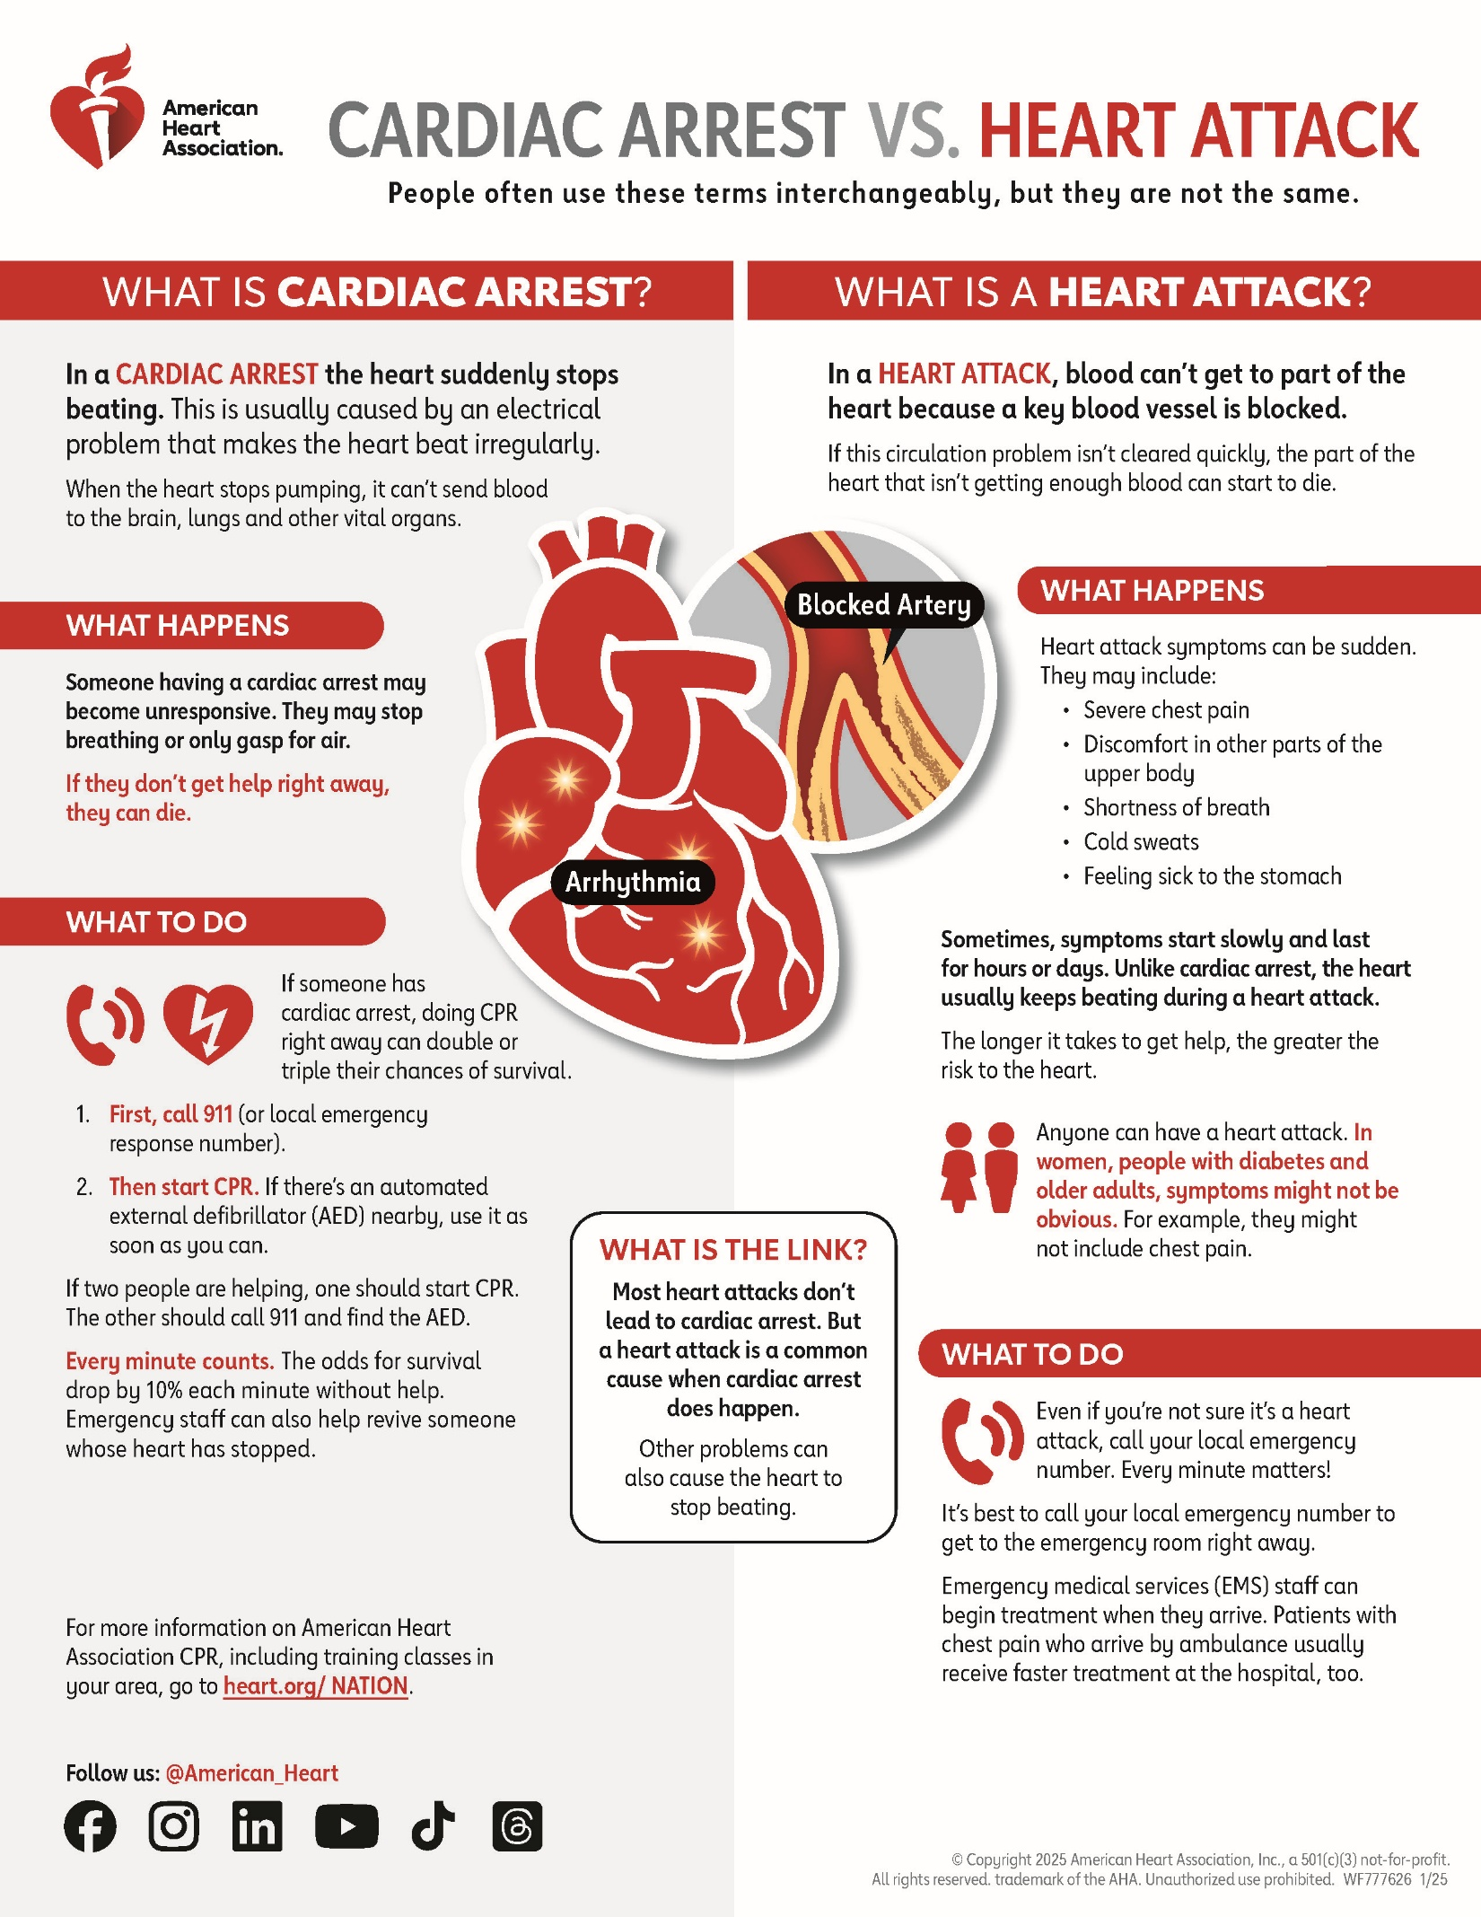

See April 2021 Regents Meeting Agenda Item: Proposed Amendment to §155.17 of the Regulations of the Commissioner of Education Relating to District-wide School Safety Plans at: https://www.regents.nysed.gov/common/regents/files/421p12a1.pdf and July 2021 Regents Meeting Item: Proposed Amendment to §155.17 of the Regulations of the Commissioner of Education Relating to District-wide School Safety Plans at: https://www.regents.nysed.gov/common/regents/files/721brca9.pdf

