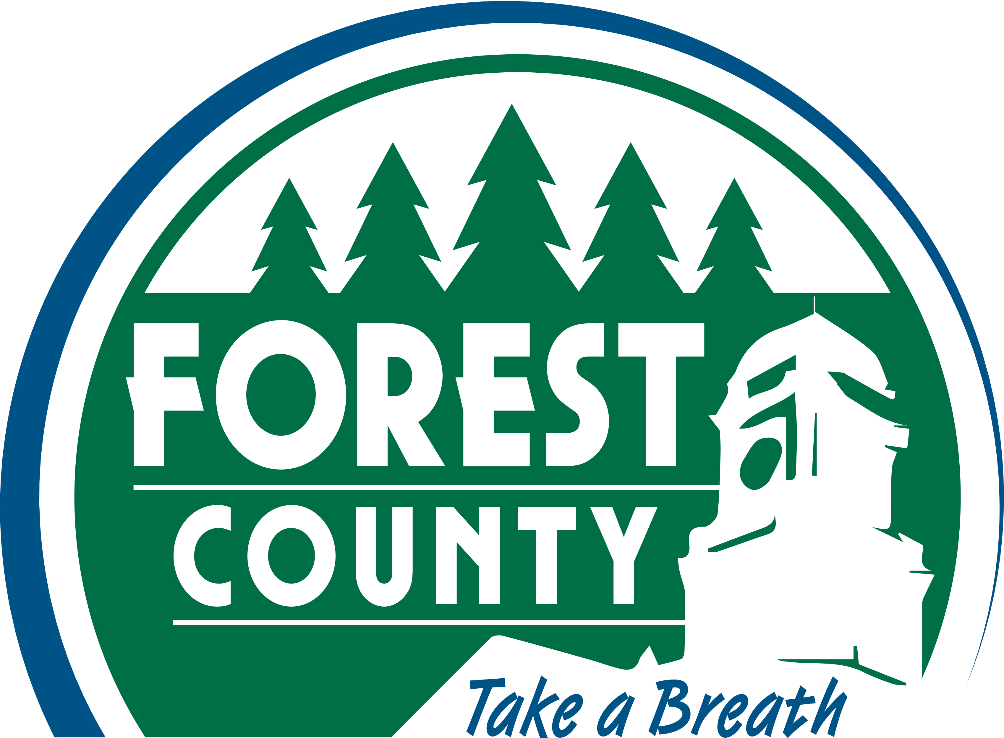
FOREST COUNTY OFFICE ON AGING
200 East Madison Street
Crandon, WI 54520

ROUTE SERVICES REGISTRATION FORM - 2022

******************************************************************************
The information you are being asked to provide is needed to comply with DOT reporting requirements. This information will be stored in a secure electronic database and will not be used for any other purpose. Your information will not be shared with another agency without your permission. This information will not be sold to anyone. You have the right to review your electronic record and request changes to assure accuracy. You may be denied services if you refuse to provide this information.

Date: ________________

Name: _______________________________________ Date of Birth: _________________
Last First M.I. Month Day Year

Mailing Address: ________________________________ Phone #: ______________________

___________________________________
City, State Zip Code Sex: ____Male ____Female

******************************************************************************
Information Required by Federal and State Regulations

Ethnic/Racial Status Marital Status
☐ White ☐ Married
☐ Hispanic Origin ☐ Widowed
☐ African American ☐ Single
☐ American Indian/Alaska Native ☐ Divorced
☐ Asian American/Pacific Islander ☐ Life Partner

Registration: Regular _____ or Guest _____

******************************************************************************
In case of Emergency, contact:

Name: ______________________________________Relationship: _____________________

Address: ____________________________________ Phone: ______________________________________________________________
Thank you for allowing the Forest County Office on Aging to serve you. If you have any questions, comments or concerns regarding our services and programs, please call the Office on Aging at (715) 478-3256. Forest County Office on Aging is not responsible for any lost or stolen property left in any vehicle.

