- What's Up Roc
Jan. 12, 2014 5:32 am
- Video
- Leo Roth: Welker symbolic of concussion fight
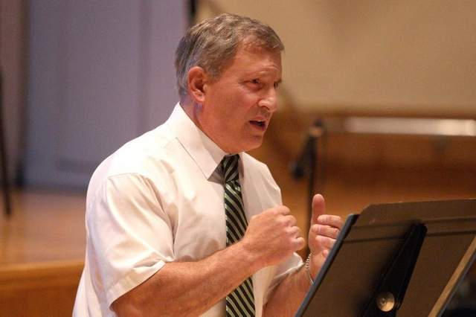
Purchase Image

Former middleweight boxer Ray Ciancaglini raises concussion awareness through speaking to athletes like the football players at East High School. / Jamie Germano / Staff Photographer

Written by

Leo Roth

Sports columnist

I’ve long been a fan of Wes Welker, the Mighty Mite wide receiver for the Denver Broncos.
He was sand in the shorts of the Buffalo Bills when he played for the New England Patriots. Three of Welker’s 31 career 100-yard games have come against Buffalo, including a 16-catch, 217-yard, 2-touchdown masterpiece in 2011. A performance like that has to be admired no matter the uniform.
Now Welker is set to return to action Sunday in an NFL playoff game against the San Diego Chargers. A very durable player in the past, Welker suffered two concussions in a span of four weeks

Page 2
in November/December. Now, after five weeks total rest and getting doctors to sign off, it’s time for Wonder Wes to play football again.
So why will I wince now whenever Welker goes over the middle for a Peyton Manning pass, working in those tight spaces as a slot receiver where the hits just keep coming? Why will I hope and pray that he gets up?
Is it because of the NFL’s $765 million concussion litigation settlement with former players suffering from headaches, memory loss and depression? Is it because many ex-players ended their silent suffering through suicide? Is it because we know so much more about the effects of “second-impact” concussions and that a price has been put on glory? It’s called chronic traumatic encephalopathy (CTE).
For Ray Ciancaglini, 62, of Varick, Seneca County, a renowned concussion awareness advocate and former boxer who suffers from dementia pugilistica, a variant of CTE, and Parkinson’s Syndrome, a case like Welker’s means one step forward and two back in this battle to save lives.
“I just pray for Mr. Welker because my God, a third concussion in such a short period of time could be career ending and could affect his quality of life down the road,” he said. “This is coming from me. I’m not a doctor and I wish him well. But knowing what I know, there isn’t anything worth the risk of a life of misery.”
After following the NFL’s concussion protocol, Welker was declared symptom-free by the Broncos’ medical staff and an independent doctor. Welker himself told reporters, “I think we’ve taken enough time. I feel fine. I’m ready to go.”
But is he? A single brain trauma is said to double the risk for a future head injury (bingo). And two such injuries raise the risk of brain damage eight-fold.
Yes, NFL player safety is far better than when single-bar helmets were in use. But allowing concussed players to return to play so quickly makes me want to believe this whole protocol thing is just good public relations and legal butt covering. NFL brain experts say you can’t manage concussions by a calendar. But when it comes to the mysteries of the brain, common sense would say one week is pretty quick to return to contact even after a minor concussion.
Welker, after leaving a game against the Chiefs on Nov. 17 with a head/neck injury, was back in action Nov. 24 against the Patriots. Two weeks after that, he crumpled after a hit to the head by Titans safety Bernard Pollard. A second impact. A brain bruise on top of a brain bruise. Denver did shut Welker down, but only after two concussions, not one. And now he’s back.
Page 3
“The NFL’s return-to-play policy appears to be very anemic to me,” said Ciancaglini, who has taken part in leading CTE research at Boston University. “The policy should be that any player receiving two concussions in one season should be done for the year, period.”
Ciancaglini, a promising middleweight whose ring career ended in 1974, has made it his life’s mission to knock out concussion ignorance. He’s an example of a fearless athlete who didn’t properly treat a series of head injuries, leaving him with debilitating consequences.
Some days, it’s difficult for Ray to write his name, form complete thoughts, focus, and recognize lifelong friends. His speech will slow, his coordination turn clumsy, all symptoms that forced him to retire early from a job he loved at Kodak
Today, through his The Second Impact website (thesecondimpact.com) and a tireless speaking schedule (all of his talks are free), Ray tells his story to as many high school, college and professional athletes he can reach. He encourages them to be honest about their symptoms if they suffer a head injury and to grasp the seriousness. That risking your health doesn’t make you tough, just foolish. And given the pressures of competition, it’s up to coaches, parents and friends to save athletes from themselves. This weekend in the NFL, half a dozen players were likely to play despite concussion issues.
“What frustrates me is the role modeling,” said Ciancaglini, who has been honored many times for his one-man concussion crusade and will be the keynote speaker at the Brain Injury Association of New York State’s annual conference in June. “For every high school or college athlete that I have resonated with about properly sitting these injuries out, a star athlete circumvents the whole message. It makes my job harder, but I’m not giving up.”
No, Ray Ciancaglini just keeps punching. Tackling the concussion issue head on.

