INSIDE THE FLX: Take Your Role Model to the Game Night (podcast)
Ted Baker June 24, 2022 @ 10:43 AM
In this episode, we visit McDonough Park in Geneva for “Take Your Role Model to the Game” night.
The purpose of the evening was to allow kids to honor their role models by watching a ballgame with them and meeting new ones. In attendance were Geneva Police and firefighters, an Ontario County Sheriff’s Department K-9 unit, EMS personnel, military recruiters, sports officials, and more.
The event was sponsored by The Second Impact and the Geneva Red Wings. The Second Impact is the foundation begun by Genevan Ray Ciancaglini to raise awareness of head injuries. Ray’s life was changed forever when he received blows to the head in boxing matches just days apart when he was 16. He has suffered the effects ever since. His testimony before Congress called attention to the ways fighters could receive head injuries, yet continue to fight, leading to better policing of the sport. He travels the country speaking to student-athletes about the importance of reporting even seemingly minor blows to the head. He recently spoke at Columbia University. Ray also serves as an assistant coach for the Geneva High football team. During the game, Ray gave out prizes including Red Wings merchandise, signed boxing gloves, and signed copies of the book about his life, “Second Impact: The Ray Ciancaglini Story” by Andy Siegel.
I also spoke with Geneva’s Mr. Baseball, John Oughterson, known to many as Johnny O. As a member of the front office of several of the minor league teams that have called McDonough home over the years, he’s watched a number of young men make the leap from Geneva to the Major Leagues. He’s remained friends with many of them, including pitcher Jamie Moyer, who went from being a Geneva Cub to a Major League career that saw him win 269 games, including two 20-win seasons, and saw him pitch until he was 49 years old.

Cub Scout Pack 5 of Geneva presented the colors before the game. I talked with Cubmaster Jason Haag about developing character and leadership skills through Scouting and what his becoming an Eagle Scout has meant in his adult life.
Incoming Geneva Fire Chief Del Parotta was at the game with a number of Geneva firefighters. We talked about letting kids see first responders and law enforcement as regular people and what it takes to have a job that involves risking danger every day.
Finally, we caught up with Bob Ohmann, who owns the Red Wings, the Auburn Doubledays, and the Newark Pilots of the Perfect Game Collegiate Baseball League, whose games can be heard this summer on fingerlakes1.com. He reminisced about watching the members of the Cincinnati Reds Big Red Machine that dominated baseball in the 1970s when they were the Geneva Redlegs of the 1960s, about the revival of baseball at Hobart College, and about providing quality entertainment at a fair price.

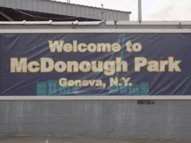
Game night at historic McDonough Park
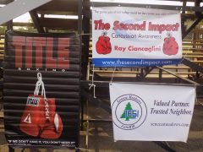
The Second Impact is Ray Ciancaglini’s foundation that raises awareness of head injuries
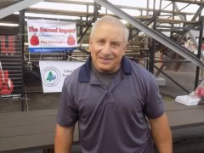
Ray Ciancaglini
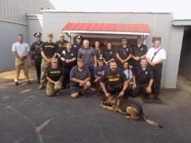
Ray and friends
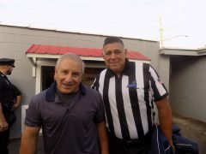
Friends and role models stopped to say hello
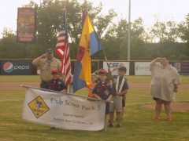
Cub Scout Pack 5 presents the colors
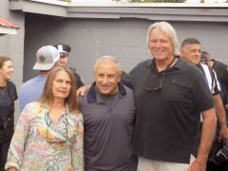
Ray has lots of friends
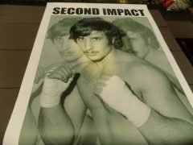
Portrait of a young fighter
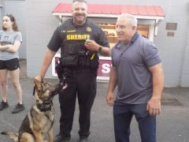
Deputy Pat Fitzgerald and his K-9 partner
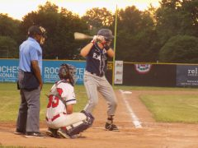
Batter up
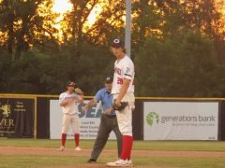
Red Wings pitcher Luke Gabrysh gets the sign
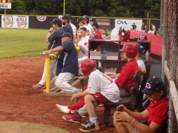
The Red Wings dugout
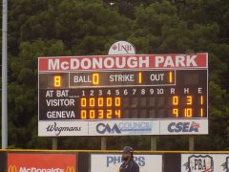
Red Wings light up the scoreboard
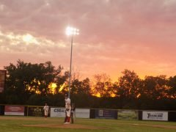
Sunset over McDonough Park

