**GREEN PRODUCTS FOR INDUSTRIAL USE**

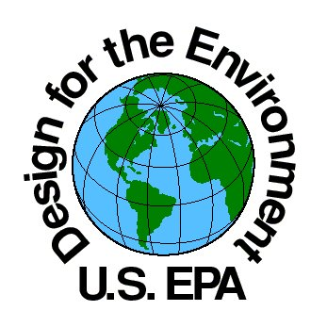

These products are made from 100% earth friendly chemicals. All products listed attached meets VOC, OSHA and EPA Rules and Regulations. Products are non-flammable, non-corrosive and fireproof. They do not contain solvents, acids, hydrocarbons, alcohols, chlorinated solvents, butyls, chlorides, bleach, ammonia, phosphates, silicates, strong scents, harsh surfactants, and/or detergents.

While these products have not been submitted for Green Seal Approval, we have reviewed all pertinent Green Seal documents. We hereby certify that all of the products listed above have been manufactured in compliance with all Green Seal Standards set forth in the following Green Seal Product Releases:

• **GS-34** – Green Seal Standards for Cleaner/De-greasing Agents

• **GS-37** – Green Seal Environmental Standard for General Purpose, Bathroom, Glass and Carpet Cleaner Used for Industrial and Institutional Purposes

• **GS-40** – Green Seal Environmental Standard for Industrial and Institutional Floor Care Products