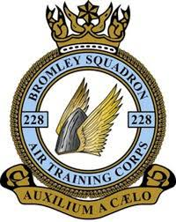
Uniform Measuring Guide and Initial Kitting Order Form

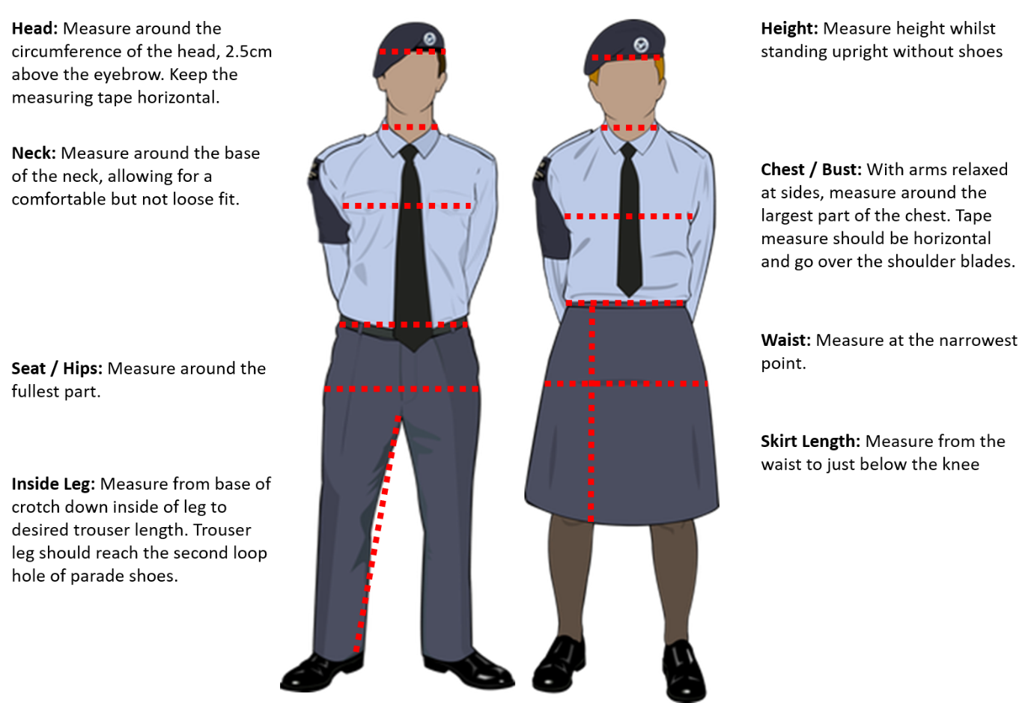

Cadet uniform measurements
Name

Height (cm) |  | Waist (cm)
Head (cm) |  | Seat / Hips (cm)
Neck (cm) |  | Inside Leg (cm)
Chest / Bust (cm) |  | Skirt Length (cm)

Note: Female cadets who wish to wear trousers rather than a skirt should provide an inside leg measurement instead of skirt length.
Please hand your completed form to a member of staff.

