2022

Saskatoon Pet-Friendly
Rental Housing Guide

Disclaimer
This Saskatoon Pet-Friendly Rental Housing Guide is modeled after the Pet Friendly Housing Renters Guide developed by the Regina Humane Society and the British Columbia Society for the Prevention of Cruelty to Animals Renter’s Guide. A (*) identifies where the information presented in this guide is similar to information in one of these two guides. All three guides are valuable resources for tenants and rental property owners or managers, with this one specific to Saskatoon.
The information provided in this guide is for general informational purposes only. All information provided is done so in good faith; we make no guarantee of any kind, expressed or implied, regarding its accuracy, adequacy, validity, reliability, availability, or completeness.
This guide presents and links to content belonging to or originating from third party sources and sites. We do not endorse, guarantee, or assume responsibility for the accuracy or reliability of this third-party information.

This guide does not contain legal or professional advice. The information provided herein is for general informational and educational purposes only. Before taking any action based on information in this guide, we encourage you to consult with the appropriate professionals. The use of or reliance on any information contained in this guide is solely your own choice.
Saskatoon Pet-Friendly Rental Housing Guide
Table of Contents
Disclaimer 2
Introduction 4
Our Team 4
What do pet-friendly and pet-friendly rental housing mean? 5
The Human-Animal Bond 6
Pet-friendly Saskatoon 6
Pet-friendly Places in Saskatoon 7
Pets in Kiwanis Memorial Park 7
City (Saskatoon) and Provincial (Saskatchewan) Policies 8
Service Animal & Emotional Support Animal Regulations 10
Regulations for Service Animals (Mostly Dogs) 10
Regulations for Emotional Support Animals 11
Tenant Rights & Rental Property Rights 12
Emergency Shelters & Residences 14
Emergency Housing Shelters 14
Domestic violence shelters, including safe animal sheltering 15
Older Adult Residences 16
Resources 18
Tips for Finding and Keeping Pet-friendly Rental Housing in Saskatoon (*) 18
Sample Rental Unit Agreement for Saskatoon (*) 21
Pet Resume (*) 23
Pet Reference Form (*) 26
Further Reading and Souces 28
Conclusion…………………………………………………………..…………………………………………………………………………….….29

Introduction
The availability of pet-friendly rental housing is limited in Saskatoon, Saskatchewan. We know from documented experiences in other North American cities that increasing the availability of pet-friendly rental housing can be beneficial to both tenants and rental property owners. As a tenant, understanding your rights and obligations when renting with your pet is an important part of being a responsible pet caretaker. As a property owner, pet-friendly properties can increase interest from potential tenants and if tenants have pets they often stay longer.
In 2021, faculty and students at the University of Saskatchewan partnered with Royal Canin to tackle the topic of companion animals in places that have not traditionally been welcoming to pets in the city of Saskatoon. The project is titled PAWS in PLACES. The first sub-project (2021) examined a pets in the workplace policy at a University of Saskatchewan worksite and made recommendations for its improvement. An infographic for developing a ‘Pets in the Workplace Policy’ is available on the PAWS in PLACES website. The second sub-project (2022) is this pet-friendly housing guide for tenants and rental property owners and managers in Saskatoon.
The goal of this guide is to educate and raise awareness about the benefits of companion animals in rental housing for tenants and rental property owners. Rental property owner or manager is defined here as private landlords, rental agencies, and housing organizations. Tenant is defined as an individual renting a property. The terms pet and companion animal are used interchangeably.

Our Team
Leads (University of Saskatchewan): Drs. Colleen Anne Dell, Holly McKenzie, Linzi Williamson (Sociology, Office of One Health & Wellness), Liz Snead (Western College of Veterinary Medicine)
Western College of Veterinary Medicine Students: Kaylyn Kubes, Erynn Buhr, Breeze Agar, Catherine Beaupre
Social Science Students: Kayla Arisman, Maryellen Gibson, Aliya Khalid
Coordination: Ben Carey
Knowledge Mobilization: Bonnie Zink
This project is financially supported by Royal Canin, a division of Mars Petcare, and the University of Saskatchewan Office of One Health and Wellness. It is up-to-date as of October 2022.

What do pet-friendly and pet-friendly rental housing mean?
Pet-friendly
Pet-friendly is generally understood to mean when a pet (also known as a companion animal) is allowed to be in a public or private space with their caretaker. Making places pet-friendly recognizes the importance of the human-animal bond.

Cultures vary across the world, with countries, provinces, territories, and cities having varying levels of pet-friendliness. The European Union is home to some of the most pet-friendly countries. In Vienna, Austria, for example, you can take your dog into a coffee shop and on public transportation. In Switzerland you can take your dog on most public transportation, into many shops and stores, and into a large number of restaurants. Some Canadian cities are quite pet-friendly. Pets are welcome in many hotels and inns, on beaches and lakes, and at the famous Butchart Gardens in Victoria, British Columbia.
Pet-friendly rental housing
Depending on where you live, pet-friendly rental housing may be common. In Germany, for example, tenants have a right to live with their pet. In Ontario, Canada the Residential Tenancies Act (2006) does not allow a no-pets clause to be in rental agreements. Ontario rental property owners also cannot require a pet-specific security deposit. The Saskatchewan Residential Tenancies Act (2006), unfortunately, does not include similar protections.
My partner and I have been looking for pet-friendly rental housing in Saskatoon since May 2020 (two whole years!) with no success. We are so ready to adopt a dog from one of our wonderful local rescue organizations, but it's been impossible to find a suitable home - to the point where it's actually a huge factor in us considering moving out of the province. Often we will go to apartment or condo viewings that are listed as pet-friendly, only to find that the landlord or property manager is actually very hesitant to allow pets, or that there are strict animal size restrictions and hidden additional monthly fees.
-Amy Saint-Pierre, Saskatoon

Pet-friendly rental housing is quite limited in Saskatchewan, including the city of Saskatoon. Properties that are pet-friendly often impose limitations on tenants.
Saskatchewan provincial policy allows pets in a rental unit if it is outlined in the rental agreement. The Government of Saskatchewan pet fees and deposit policy states that a refundable security deposit and/or a one-time or monthly pet rental fee can be charged for pet-friendly units.
While non-pet friendly policies can be challenging for anyone, they can impact some groups more than others. This includes students, underemployed people, and individuals who are or have become homeless because of rental challenges with their pets. The Saskatchewan Human Rights Commission protects the rights of tenants from discrimination. This does not include pet ownership. Unfortunately, there are commonly held stereotypes in the province about who are clean and responsible tenants and this can influence a property owner’s willingness to allow pets in rental units. The Saskatchewan Human Rights Code requires landlords to accommodate the needs of persons with service animals and emotional support animals. A commitment needs to be made by everyone to treat all people who rent with pets fairly and to provide opportunities to access pet-friendly rental units.
The Saskatchewan Human Rights Code protects your right to equality without discrimination based on the protected grounds of disability, age (18 or more), religion or religious creed, family status, marital status, sex, sexual orientation, race or perceived race, nationality, place of origin, ancestry, colour, receipt of public assistance, and gender identity. Discrimination based on any of these protected areas is against the law when a person is applying for rental accommodation or housing.
-Saskatchewan Human Rights Commission
The Human-Animal Bond
The College of Veterinary Medicine at Purdue University defines the human-animal bond as “the dynamic relationship between people and animals such that each influences the psychological and physiological state of the other.” The American Veterinary Medical Association expands on this definition and adds that the relationship “is influenced by behaviors that are essential to the health and well-being of both. This includes emotional, psychological, and physical interactions of people, animals, and the environment.”
The benefits of the human animal bond have gained increased attention during the COVID-19 pandemic. Many humans have spent more time than ever before with their pets, turned to them for comfort and support, and animal adoptions reached an all-time high. Some also experienced challenges related to living with pets, such as those facing financial challenges.

FOR MORE INFORMATION ON THE HUMAN-ANIMAL BOND, please visit: The Human-Animal Bond Research Institute.

Pet-friendly Places in Saskatoon
Saskatoon is home to numerous pet-friendly businesses and workspaces:
- garden centres and hardware stores
- dog parks
- pet stores
- restaurant patios
- a variety of retail stores
- a cat café, The Purrfect Cup
Access to an up-to-date listing of pet-friendly places in Saskatoon is available at Bring Fido and SASKPETS.
Saskatoon also has several pet-friendly special events and services:
- Blades hockey night with pets
- Pet Expo & Pets in the Park
- Dog kennels and daycare
- Dog training classes
- Dog shows and sports (everything from herding trials to trailing and locating)
- Hospital wards
- Groomers
- Indoor dog swimming pool & outdoor dock diving pool
- Mayfair United Church pet blessing
- The Star Phoenix Pet Magazine
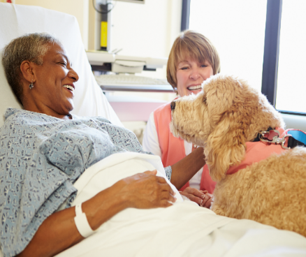
Saskatoon is also leading the country in welcoming therapy dogs into spaces that have not traditionally allowed animals. This includes:

- Hospital emergency departments
- University of Saskatchewan
- COVID-19 vaccination clinics

Pets in Kiwanis Memorial Park
For nearly 40 years pets were not allowed in the popular Kiwanis Memorial Park in downtown Saskatoon. In October 2021, unanimous support was given to the city of Saskatoon’s policy committee to change Bylaw No. 7860, Animal Control Bylaw (1999) to include pets in this well-liked destination.

City (Saskatoon) and Provincial (Saskatchewan) Policies
The city of Saskatoon and the province of Saskatchewan rental policies do not support pet-friendly housing. Rental property owners and managers can refuse to rent to individuals with pets. Landlords are only required to accommodate individuals with a prescribed emotional support animal (cat, dog, rabbit, and others) or service animal (almost always a dog). As a result, few landlords, rental agencies, and housing organizations within Saskatoon provide pet-friendly rental units.
Three Types of Pet Ownership & Access to Rental Housing
When I accepted my job at the Western College of Veterinary Medicine the last issue I could have predicted was finding somewhere to live with my one year old Irish setter. Finn turned a year old on my first day of work. I missed his birthday because I had not been able to secure a place that would allow him and had to leave him in Alberta with my parents. I found most places would allow small dogs under 25lb or cats but there were none that would consider larger dogs despite the fact that I was a veterinarian. I ended up eventually finding a suite for rent on an acreage outside the city that was willing to let me have him there. Not ideal since it was a bit of a drive and he was crated when home unsupervised but luckily I had a car and was able to bring him to work with me so we managed to make it work. I can imagine how challenging it is for people who might need to stay within the city or those who can't bring their dogs to work if they have to live outside the city and can't get home to let the dog out on a reasonable timeline. It was very stressful for me and I ended up having to buy a house when the lease was up that year to be able to have consistent housing for us both. Again, luckily my budget allowed me to do this which it likely currently wouldn't be an option with housing prices, interest rates and mortgages being higher.
-Dr. Kira Penney, Saskatoon

There are three types of animal ownership in Saskatoon that impact access to rental housing: pets or companion animals, service dogs, and emotional support animals. Further, according to Bylaw No. 7860, Animal Control Bylaw (1999), certain species of animals are not allowed in the city of Saskatoon, including cattle, sheep, swine, goats, llamas, horses, chickens, turkeys, and waterfowl. Additional prohibited animals are listed in the bylaw. A fine can be up to $2,000.
The three types of pet ownership differ by required training, the animals’ access to places, and proof of their role as either a pet, service dog, or emotional support animal. Although not discussed here, therapy dogs fall under the category of pet ownership when renting, but do have access to specific places when they visit members of the community to offer comfort and support. See summary table below.

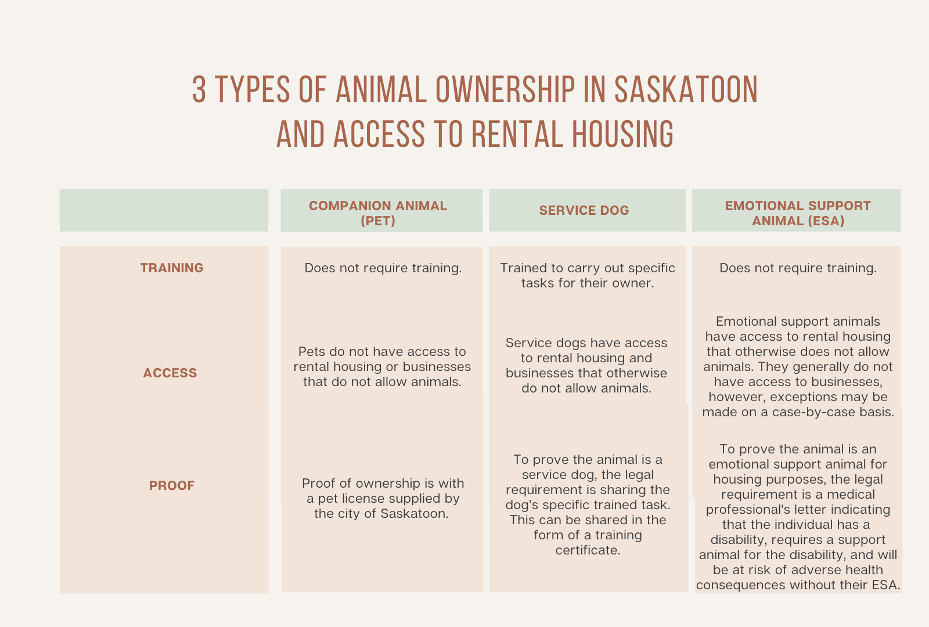
Pets or Companion Animals
The Saskatchewan Residential Tenancies Act (2006) does not make provisions for people living with pets. Of Saskatoon’s approximate 32,000 rental units, there are limited housing organizations, rental agencies, and private landlords that offer pet-friendly rental housing; however, listing a rental as pet-friendly can save unit turnover-related expenses and increase occupancy of rentals. Landlords and property managers in Calgary, Alberta reported that pet caretakers tend to stay longer in rental housing than non-pet caretakers and pet-friendly rentals receive more applications than non-pet-friendly rentals. One Saskatoon property owner observed that when they listed their property as pet-friendly, inquiries increased tenfold.
Some housing organizations, rental agencies, and private landlords do offer pet-friendly rental housing in Saskatoon. These include:
- The Saskatoon Housing Coalition is a housing organization with a pet-friendly policy. This organization does not allow large pets such as cats or dogs, but it does allow fish in a tank, quiet caged birds, and guinea pigs. Tenants with pets are expected to sign a pet agreement and provide a $50 damage deposit. Any major damage caused by the pet is the tenant’s responsibility.
- Some private property owners accept pets on a case-by-case basis, often requiring a damage deposit and/or a monthly fee for pets to live in their units.
- Rental agencies often discourage private landlords from listing rentals as pet-friendly. One pet-friendly Saskatoon property management company, Prairie Homes Property Management Ltd., manages over 60 units with 90% of units occupied by pets.

Service Animal & Emotional Support Animal Regulations
The Saskatchewan Residential Tenancies Act (2006) does not make provisions for people with emotional support animals (ESAs) in rental housing. It does, however, require that rental property owners allow for emotional support animals and service animals under the Saskatchewan Human Rights Commission Code. The Code recognizes both service animals and emotional support animals and provides guidance to rental property owners and managers for accommodating individuals with limitations or disabilities.
The University of Saskatchewan recently updated its Animals on Campus Policy regarding service animals and emotional support animals. This policy “…recognizes the role that service and support animals may perform in the provision of reasonable accommodation for students, staff and faculty with disabilities while on campus grounds.” The policy outlines procedures for students with service dogs and emotional support animals to access campus.

Regulations for Service Animals (Mostly Dogs)
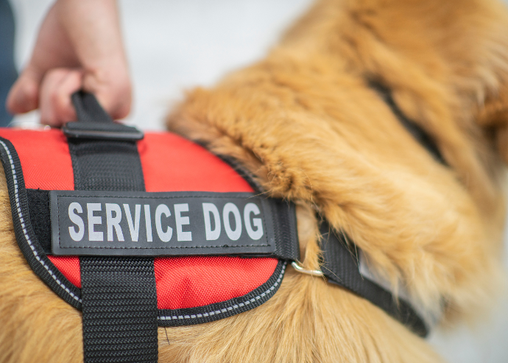
The Saskatchewan Human Rights Commission defines a service animal as:
“… [an] animal with specialized training to assist a person with recognized physical and/or mental disabilities. The Service Animal must be able to take a specific action, when needed, to assist the person with an aspect of their disability. These may include a guide dog, hearing dog, assist dog, social signal dog, seizure response dog, and psychiatric service animal”.
Individuals with service animals should not be discriminated against by service providers, businesses, employers, rental property owners and managers, and public facilities. Individuals with service animals have the right to request to be accommodated. Rental property owners and managers must accommodate individuals with service animals even if there is a no-pets policy in place. Exceptions are allowed where undue hardships exist. Pet caretakers have the responsibility to ensure proper control over the service animal, provide a brief description of the role of the service animal, and be aware that they are responsible for any damage or injury incurred.
TO LEARN MORE ABOUT SERVICE ANIMALS: The Saskatoon SPCA (2018) developed a helpful paper outlining the roles of service animals, access to public spaces, and differences from therapy and emotional support animals.

Regulations for Emotional Support Animals
The Saskatchewan Human Rights Commission defines an emotional support animal as:
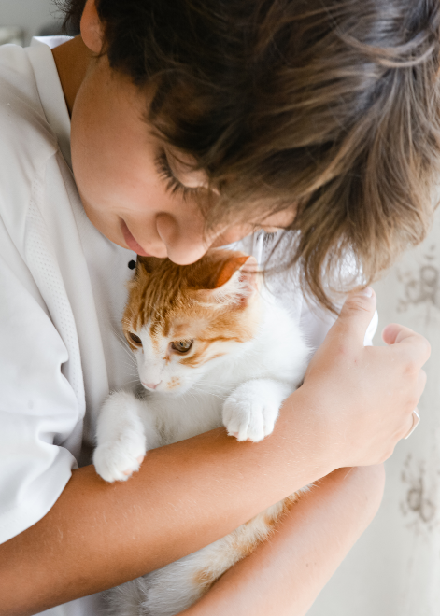
“…one that has been proven to be effective at alleviating symptoms of certain mental disorders but is not a Service Animal. These animals provide therapeutic nurture and support to their handlers/partners, but have no specialized training. Emotional Support Animals may be prescribed by a professional or be proven retroactively where they started out as a pet but result in a person’s disability improving and are therefore identified by a professional as necessary. Typically, Emotional Support Animals are for at home support but they may be required for other forms of support by some people.”
If a tenant requests accommodation for their emotional support animal, they must provide evidence that they have a disability, require a support animal for their disability, and that they would be at risk of adverse health effects if they were unable to live with the animal. This is typically provided in a letter or prescription from a health care professional. The rental property is required to consider this request through the “reasonableness test.” Unless accommodating the emotional support animal would lead to undue hardship or may prove to be fatal for another tenant with an allergy, the rental property is required to accommodate them. The Saskatchewan Human Rights Commission explains that emotional support animals are not pets and no extra damage or security deposits can be charged to a tenant. Accommodation for emotional support animals in public spaces and facilities is currently under consideration in Saskatchewan.
In September, 2020 the Saskatchewan Landlord Association released a position paper on emotional support animals in response to many tenants requesting to bring emotional support animals into units with a no-pets policy. The position paper states that all pets are meant to provide emotional support, deeming it unnecessary to have the separate category of emotional support animals. They identified the current Saskatchewan Human Rights Commission Code on emotional support animals as vague and made several recommendations, including mandatory training for the animals.
TO LEARN MORE ABOUT EMOTIONAL SUPPORT ANIMALS: The Saskatchewan Housing Corporation released a paper on emotional support animals, explaining who qualifies, how a tenant can apply, and what happens after approval.

Tenant Rights & Rental Property Rights
Lease agreement: In Saskatchewan, a lease agreement must clearly state its policy on pets. If pets are allowed, the lease should include the number of pets allowed, size, breed, and species. If the lease fails to mention pets in the agreement, the property may not legally terminate the lease due to pets being in the home.
Breaking a lease: If a lease agreement is broken in Saskatchewan by the tenant for having pets in the unit, the tenant can receive an eviction notice from the landlord. If the tenant can rectify the violation within a time-limited grace period, they can continue living at the rental property. If not, then this may mean that a tenant has to re-home their pet or end their lease.
Additional pet fees: Rental property owners may charge a one-time pet fee, a monthly pet fee, or both. Neither is refundable at the end of the rental period. They may also charge an additional pet security deposit. The pet deposit plus the regular rental security deposit cannot exceed one month of rent. The security deposit and pet deposit are money held by the rental property during the tenant’s stay. At the end of the lease, the deposits are used to clean or repair anything damaged or left dirtied by the tenant and/or their pet. Rental property owners or managers have seven business days to return the security deposits to the tenant or give written notice of full or partial claim on the deposits.
Condominiums: Condominium owners who rent out their properties must ensure that their rental agreement matches with the condominium rules and policies. For example, if a condominium building has a no-pets policy, then the rental agreement should as well. If the condominium does allow pets, the owner is not required to allow pets in their unit.

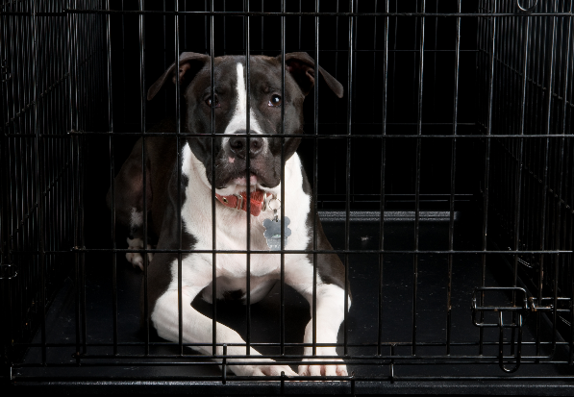
Unit inspection: Inspection of a rental unit may happen if the tenant gives permission for entry at an agreed upon time or if a Notice of Entry form is issued to the tenant. Forms must be issued 24 hours in advance but not more than seven days before entry to the unit. The form must state the reason for entry, a maximum four-hour period of entry between 8am and 8pm, and the date of entry, which may not be a religious day of worship for the tenant. The rental property owner or manager may only enter the unit without notice in the case of an emergency or if there is sufficient evidence that the rental unit has been abandoned. When the property is entered legally by the landlord, it is important for the tenant to secure their animal and prevent them from interacting with anyone entering the unit unless consent to interacting with the animal is given. The animal can be secured with a leash or placed inside a crate or behind a closed door in a room the individuals entering the unit will not access.
Disputes: Formal disputes between rental property owners or managers and tenants regarding pets are handled by the Office of Residential Tenancies, commonly known as the Rentalsman. A rental property owner or manager or tenant can make a claim directly to the Office of Rental Tenancies for a $50 filing fee. The Office of Rental Tenancies will schedule a hearing, where evidence from both parties will be reviewed by a hearing officer. The hearing officer will make a decision, which is enforceable by law.
Eviction: A notice of one month is required for most types of evictions, including for breaking lease restrictions involving pets. Rental property owners and managers must identify the reason for eviction on the eviction notice. A tenant may dispute the reason for eviction within 15 days of receiving it to the Office of Residential Tenancies.
TO ACCESS PLAIN LANGUAGE LEGAL INFORMATION ABOUT RENTING, CONDOMINIUMS, HUMAN RIGHTS, AND PETS IN THE COMMUNITY, VISIT: Saskatchewan’s source for free legal information – Public Legal Education Association (PLEA).

Emergency Shelters & Residences
Lookout Housing and Health Society serves Downtown Eastside and Central Vancouver, among other locations in British Columbia. “Lookout shelters are pet friendly, include onsite storage for valuables, 3 meals per day, 24 hour staffing, harm reduction supplies and some even have spaces suitable for couples”.

Emergency Housing Shelters
Saskatoon has seven emergency housing shelters. Similar to some Canadian cities, there are limited services available for people entering emergency housing shelters that have a pet in Saskatoon. In fact, no emergency shelters in Saskatoon currently has a pet-friendly policy or provides consistent housing for individuals with pets. In select cases, the shelters partner with local organizations to care for pets in foster homes. Other cities, like Vancouver, have pet-friendly emergency housing shelters.
The following table describes animal policies for housing shelters, including service dogs and emotional support animals (ESA).
Organization/Shelter | Animal Policies
Brief & Social Detox Unit (SHA) | Does not allow pets. Does not allow ESAs. Service animals are allowed but with the requirement that no other current client can have associated fears or allergies to the animal.
The Salvation Army | Does not allow pets. Does not allows ESAs. Service animals are allowed but they need to be certified and the handler is required to provide proof of certification.
Saskatoon Crisis Nursery (Haven Family Connections) | Does not allow pets. Does not allows ESAs. Is a temporary respite facility for children whose families are undergoing a crisis, so they are unable to accommodate service animals due to the absence of an adult caretaker for the animal.
Saskatoon Interval House | Does not allow pets. Does not allow ESAs.
The Lighthouse Supported Living | Unknown.
YWCA Saskatoon | Currently updating its policy on animals. They have made exceptions to their former policy that did not allow animals at the shelter and people have stayed with their dogs.
Emergency Wellness Centre, Saskatoon Tribal Centre | Evaluated on a case-by-case basis for each animal people bring to the centre.

Domestic violence shelters, including safe animal sheltering
It is well-established that many people consider pets to be family members. A joint Saskatchewan SPCA, PATHS, and STOPS to Violence study with human service workers reported that 77% of domestic violence victims did not flee from abusive situations because they did not want to leave their pets for various reasons, including fearing for the animals’ safety.
Many of the domestic violence support services in Saskatoon do not allow pets, including transition housing, social support services, and shelters. Co-sheltering with pets have been allowed in a small number of individual cases. There are two pet-friendly, co-sheltering second stage housing programs in Saskatchewan, SOFIA House in Regina and Regina Transition House. Examples of other domestic violence shelters in Canada that have successfully incorporated pet safekeeping into their programs include the Crossroads Resource Centre in Alberta and Maplegate House in Ontario.
An October 2021 report by the Provincial Association of Transition Houses and Services in Saskatchewan offers recommendations for training, legislation, and pet-friendly domestic violence shelters and rental housing for the province.

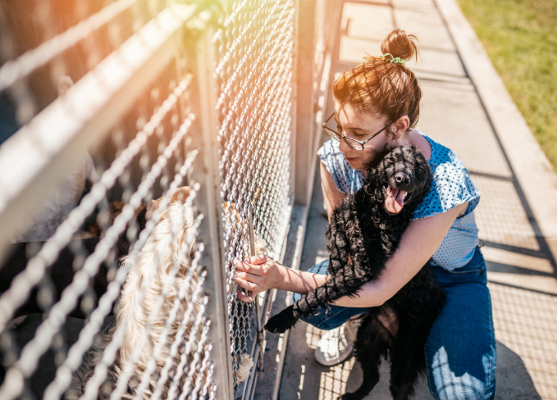

PATHS, STOPS to Violence, and Saskatchewan SPCA published a 90-page Pet Friendly Shelter Viability Report in 2021 for human shelters looking to becoming pet friendly in Saskatchewan. Visit The Link to learn more about the connection between people and animal abuse.

Saskatoon’s New Hope Dog Rescue Animal Safekeeping Program provides programming for individuals who have experienced intimate partner violence and are worried about the safety of their pets. The program is free of charge and confidential for the safety of the pet, pet caretaker, and foster home. The program covers the fees and fostering of a companion animal for up to 90 days while their caretaker is fleeing interpersonal violence and seeking new housing. Spaces are limited. Fostering of a companion animal is decided on a case-by-case basis. The organization also offers a similar Hospital Care Program.
In 2017 the Saskatchewan SPCA hired an Animal Safekeeping Coordinator to: raise awareness of the link between interpersonal violence and animal abuse; create a database of available animal safekeeping resources; and promote collaboration between the human services and animal welfare sectors.
This position ended in 2020 due to funding, but a new position of Family Ties Coordinator exists.
Across the province of Saskatchewan, numerous shelters do offer informal safekeeping programs to support individuals fleeing domestic violence, and on a case-by-case basis and when resources (e.g., shelter space, available foster homes) are available.
Older Adult Residences
There are many potential benefits of having a companion animal in our families; this is true for both the pet caretakers and the pets. Older adults (over 65) are no exception. Increased physical activity, loyal and constant companionship, and improved community involvement are some of the health advantages older adults experience when they live with a companion animal. A pet-friendly housing option in Saskatoon is Sherbrooke Community Centre.
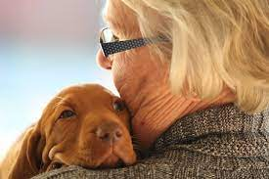
However, many older pet caretakers face the same barriers as their younger counterparts when trying to secure pet-friendly rental housing. This can be particularly difficult if they are attempting to transition from independent living to accommodations that offer a higher level of health care. If a pet-friendly rental housing option is available, it often has an additional fee attached, making the housing unaffordable. This can lead to a decision by older adults to stay where they are living or to relinquish their companion animal to a family member, friend, or shelter or, in some situations, have the animal humanely euthanized. Being separated from a beloved companion animal can leave older adults open to deteriorating physical health, mental health, and social well-being. The pet’s health can also suffer.
The following 2022 Letter to the Editor of the Prince Albert Herald documents an unfortunate real-life scenario.
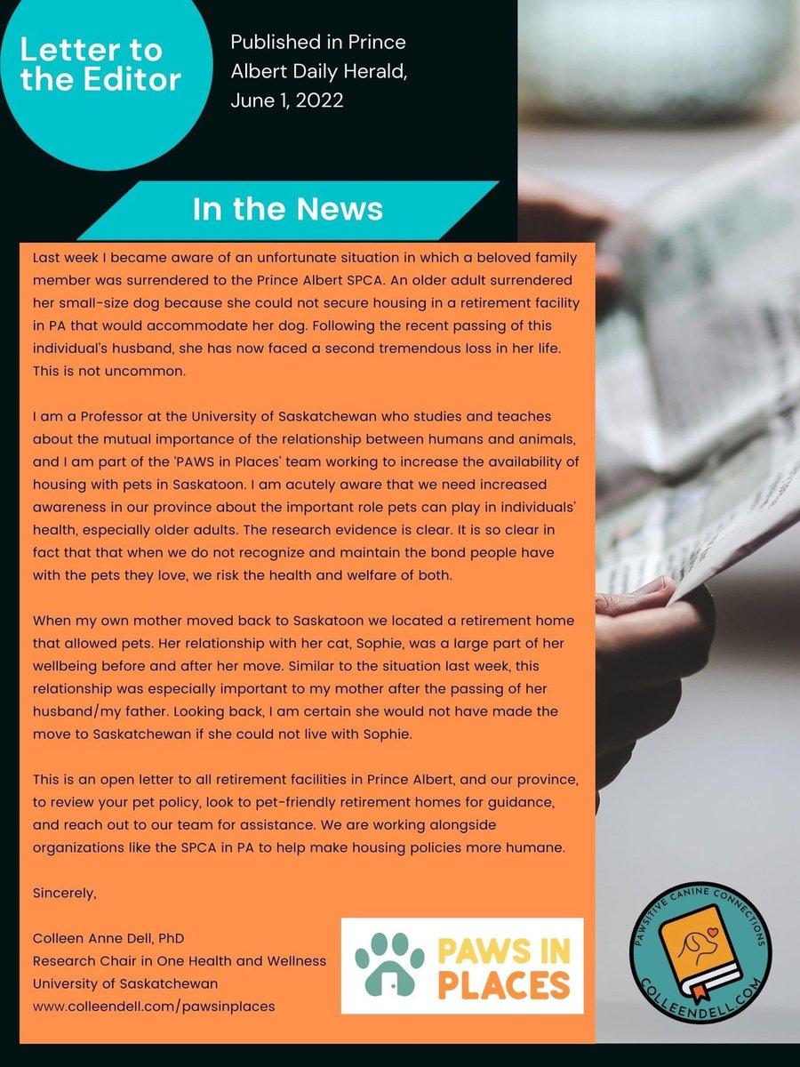

Resources

Tips for Finding and Keeping Pet-friendly Rental Housing in Saskatoon (*)
1) Prepare in advance
Identifying and applying for pet-friendly rental housing can be time consuming. If you are planning to look for a new home for you and your companion animal, allow plenty of time for your search. As we know, there is not an abundance of pet-friendly rentals in the city. Do not expect a “no pets” rental property to make an exception for you. Moving into non-pet-friendly housing with your animal or concealing your pet will put you at risk of eviction.
2) Provide references and show that you are a responsible pet caretaker
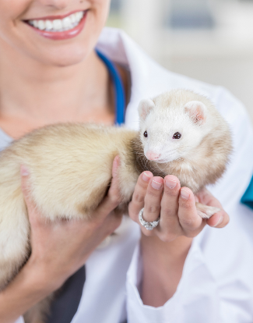
Letters from previous rental property owners and managers, veterinarians, trainers, pet sitters and neighbors can help establish you as a responsible pet caretaker and that your pet is well behaved. Some pet caretakers prepare a resume for their pet. Responsible pet caretakers are frequently responsible tenants. Consider scheduling a meet-and-greet for you, your companion animal, and potential rental property in Saskatoon.
3) Highlight the benefits of increased security and sense of community
Pets often remain at home when their caretakers are out of the home. This can help increase the security of a rental unit and surrounding area. Dog caretakers frequently walk their animals in the early morning and late at night, and can notice and report suspicious activity. Companion animals can increase a sense of community by promoting friendly interactions and relationship-building among your Saskatoon neighbors.
4) Extra costs
On average, pet-friendly accommodations charge a higher rental fee in Saskatoon and can require an additional pet damage deposit over and above a regular rental damage deposit. While pet-specific damage deposits can be attractive for rental property owners and managers to welcome pets, it means extra expenses for tenants. Some security deposits are non-refundable, so tenants should discuss deposits or any other pet fees in advance and factor these costs into their decisions.

5) Documentation and proof of permission
It is important for tenants and rental property owners and managers in Saskatoon to have written documentation and proof of permission that companion animals can live in the rental unit. A verbal agreement is not sufficient and cannot be upheld like a written contract. Pet deposits or monthly fees should be specified in the written rental lease. Prior to signing a pet-friendly lease, discuss and negotiate the pet deposit or monthly pet fee amount with the rental property. Keep a signed copy of the lease in case it is needed.
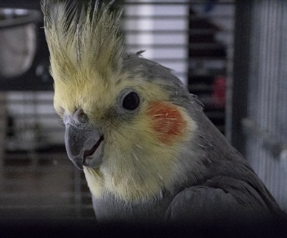
6) Responsible pet caretakers
Responsible pet caretakers:
- Follow all local pet bylaws.
- Ask the rental property if they have written house rules for pets and keep a copy.
- Keep companion animals groomed, access routine veterinary care, and follow veterinarian recommendations for spaying and neutering.
- Microchip, tattoo and/or wear pet identification on their pet.
- Keep cats indoors or in a managed outdoor environment.
- Pick up after your pet, be mindful of shared indoor and outdoor spaces, and keep your pet on a leash when outside.
- Ask your neighbors if they hear any noise from your animal when you are away and if they have any concerns about your pet.
- Consider adjusting your schedule to check on your pet during the day, bring your pet to work or daycare, or consider having someone check on your pet when you are out.

7) Responding to a pet nuisance complaint
Receiving a nuisance complaint about your pet in rental housing can be scary, but there are effective ways to respond to and resolve a complaint. Clear communication is critical to successfully resolving a complaint.
If you receive a nuisance complaint about your companion animal when renting in Saskatoon, first speak with your neighbors and explain that a nuisance complaint was received about your pet and the nature of the complaint. Ask your neighbors for their honest feedback. If they share that your pet is not a nuisance, ask them if they are willing to be contacted by the rental property to share this. If one or more neighbors states that they believe the nuisance complaint is valid, politely explain that you will be working on addressing the nuisance and thank them for their patience. To address your pet’s underlying behaviour that led to the complaint, you may want to consult your veterinarian, trainer, or a veterinary behaviorist for assistance.
Remember that it is the tenant’s responsibility to ensure that their pets are welcome in the rental community. If you allow your pet to violate property rules, damage property, disturb or make others uncomfortable, it may negatively impact your ability to acquire and retain pet-friendly housing. Helpful resources are available from the city of Saskatoon, including The Pet Wellness Guide and Good Dogs Bite too.

Sample Rental Unit Agreement for Saskatoon (*)
This sample Rental Unit Agreement is intended as a general guide to assist tenants and rental properties in Saskatoon to develop and implement rules regarding pets in rental housing. Although this sample will accommodate the needs and concerns of most tenants and rental properties, we encourage you to expand or modify it to fit your individual circumstances.

- The tenant may have the following described pet(s) in their rental unit, subject to the terms and conditions within this Agreement and in accordance with the Tenancy Agreement. Should the tenant no longer own these pet(s), this Agreement automatically ends. In the event that the tenant acquires another pet, a new Agreement will be entered into. Should the tenant wish to pet sit on a short-term basis, the rental property must be notified in writing. All pets should be in a cage or confined to an area when the rental property or their representative enters the unit. Upon entering the unit for maintenance or other reason, the rental unit will ensure that the pets are not let out of the unit.

Description of Pet(s): (species, breed(s), name, colour(s), age, temperament, potential requirements, indoor/outdoor, permanent ID #):
Attach pet reference and pet resume.
- All pet(s) must be licensed or registered annually in accordance with the existing municipal Saskatoon bylaw.

- All dogs and cats must have permanent identification in the form of a tattoo or microchip.

- Pet(s) must be under control, such as using a leash or in a secure cage, when outside of the tenant’s rental unit and in building common areas. Rentals with yards will be considered separately.

- The tenant will pick up any pet(s) waste immediately from any area on the
residential property, as well as any area considered part of the tenant’s rental unit.

- As outlined in the Tenancy Agreement, the tenant is responsible for damages caused by pet(s) that fall outside of the range of regular wear and tear. This includes, but is not limited to, damage to the walls, floors, carpets, linoleum, bathtub, drapes/blinds, patio, or balcony. The rental property is responsible for disclosing prior known damage to the unit. The tenant is responsible for confirming what prior damage was there.

- The tenant will maintain a regular parasite control and vaccination program appropriate to the type of pet(s). Should flea infestation from the pet(s) occur in the rental unit or on the residential property, the rental property may require the tenant to have the carpets shampooed and the rental unit de-fleaed at any time. Failure by the tenant to act promptly on this request will be a breach of this Agreement. Should flea infestation attributable to the tenant’s pet(s) occur subsequent to the tenancy, the rental property may seek compensation from the tenant for the subsequent flea removal treatment. The tenant is responsible for prompt appropriate parasitic treatment of any affected animal(s). Failure to treat will be considered a breach of this Agreement.

- The tenant will act in accordance with the municipal Saskatoon noise bylaw. If the tenant’s pet(s) is disturbing the quiet enjoyment of others, the tenant will fix the problem through work with a pet trainer, behaviorist, daycare or sitter/walker, or other.

- The tenant must ensure that all pet(s) are kept well-groomed; in particular the nails of dogs and cats are kept trimmed to potentially limit noise and damage related to pacing, walking, and scratching.

- The pet(s) must not be left in the rental unit if the tenant will be absent from the rental unit for an extended period of time. If the pet(s) are left in the care of an alternate caregiver in the unit, the name and telephone number of the caregiver will be provided to the rental property upon request.

- Prohibited or restricted exotic animals, as defined by the Saskatchewan Captive Wildlife Regulations are not permitted as pets.

- Animal welfare standards must be upheld and respected in accordance with Animal Protection Services’ Animal Protection Act.

Tenant Signature
Date

Property Owner or Manager Signature
Date

Pet Resume (*)
A pet resume can help share your pet’s strengths and personality and why they would be a good tenant alongside you. The resume should be 1-2 pages, straight forward and include information about your rental history and your pet’s track record, conveying to your potential rental property that you and your pet are responsible tenants.

When drafting your pet’s resume be sure to include the following:

The Basics
- Caretaker name and contact information
- Pet name, breed, description, and photo
Caretaker Statement
- Describe what your companion animal means to you
- Share why you feel it is important to have a safe and welcoming home, and how your pet contributes to that.
Pet Information
- Describe your typical day and include your pet’s exercise times, how long your pet is left alone, anyone that comes to provide care to your pet when you are at work, and whether your pet is kenneled, in the yard, or free roaming.
Experience
- Describe your pet’s current (and previous) living situation. Is your pet used to living in an apartment or house? Does your pet interact well with roommates and other tenants? How does your pet interact with other pets?
Training
- List any obedience classes or private training your pet has completed.
- List any certifications your pet has completed, such as the Canine Good Neighbor Test and/or the St. John Ambulance Therapy Dog Test.
Pet References
- Veterinary clinics can confirm regular health checks and up-to-date information on vaccinations.
- Previous landlords can confirm your and your pet’s experience.
- Trainers, dog daycare, or pet boarding staff can share their experience with your pet, possibly on multiple occasions and for long durations.
- Previous roommates, friends, and family can share their experience interacting with you and your pet in your daily routine.

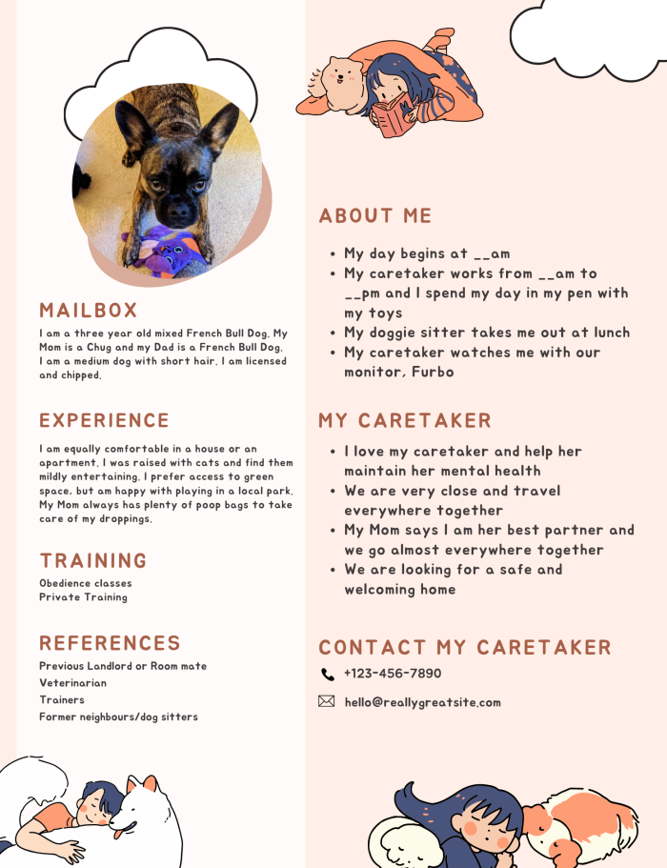
Pet resume example:

Pet Resume
Caregiver Information
Tenant Name:
Address:
Telephone #:
Email Address:
About Your Pet
Name:
Species/ Breed:
Colouring:
Caretaker Statement
Add information here
Pet Information
Add information here
Your Pet’s Picture

Experience
Add information here
Training
Add information here
Pet References
Add information here

Pet Reference Form (*)
In addition to the pet resume, or on its own, a pet reference form can also share your pet’s strengths and personality traits that make them a good tenant.
Referee Information: Include the name and contact information of the referee. Appropriate references include previous roommates and landlords, your pet’s previous foster family (if any), your family members, or previous neighbors.
Pet Information: Include your pet’s name, age, breed, colouring (noting anything unique), and size.
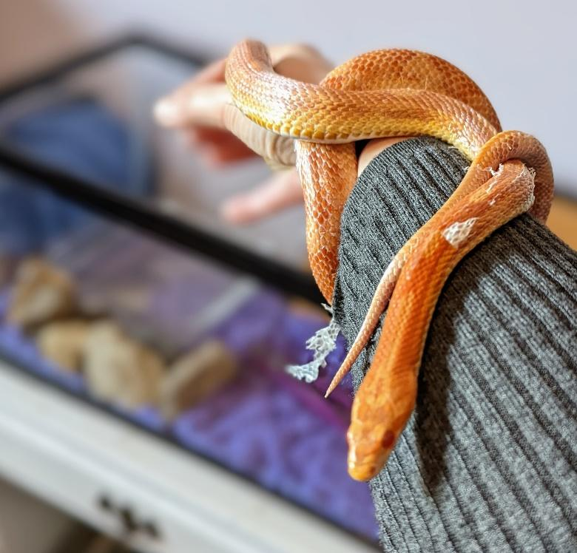
The reference should address your pet’s history, behavior, strengths, and overall personality. Be sure to include:
- How long the reference has known you and your pet, where they were interacting with you and your pet (e.g., in your home, at the dog park, workspace), and observations of those interactions.
- Veterinary clinics, previous landlords, trainers, dog daycares, former roommates, etc. can all confirm you and your pet’s experiences and routines.
- A history of any damage or injury your pet has caused. Mention how the issues were resolved. If yes to either be sure to mention any special circumstances (separation anxiety).
- Note whether the referee would recommend you and your pet be rented to.
Pet Reference Form

RENTAL APPLICANT:
Applicant name

REFEREE INFORMATION:
Referee name | How long have you known the pet?
Relationship to pet | How long have you known the pet caretaker?
Phone number/email address

PET INFORMATION:
Pet name | Pet species
Pet age | Colouring and unique physical traits of the pet

What positive experiences have you had with the pet?

Do you know if the pet has caused injury to other animals, people, or property? If yes, were there special circumstances surrounding the damage? How did the pet caretaker address it?

Would you recommend this pet to live in a rental unit? Why or why not?

Conclusion
This guide brought important Saskatchewan-specific information into one place for both renters and property owners to support all involved. As the number of households with pets continues to increase, so too will the available information. Be sure to follow Saskatchewan specific organizations highlighted in this guide, including our office of One Health & Wellness at the University of Saskatchewan (on social media follow us @ PAWSitive Canine Connections). Also follow other leading organizations in this area in North America, such as the Human Animal Bond Research Institute located in the United States, who in partnership with the Michelson Found Animals Foundation released a Pet-Inclusive Housing Report in 2021. This report, along with other sources, offers factual information and innovative ideas to move pet-friendly rental housing forward! Examples include organizing a virtual meeting between potential renters, their pets and landlords & recognizing Millennials are now the largest share of consumers for pet products and a high proportion of the rental market. For an increasing number of people in Canada:
A house is not a home without paw prints.
-Anonymous

Further Reading and Sources

Biber, F. (2021, October 12). Proposal to allow pets on leashes in a Saskatoon park passes first hurdle. CTV News. https://saskatoon.ctvnews.ca/proposal-to-allow-pets-on-leashes-in-a-saskatoon-park-passes-first-hurdle-1.5620428
Bridges, A. (2017, May 28). SPCA says some Sask. domestic violence victims staying to protect their pets. CBC. https://www.cbc.ca/news/canada/saskatoon/spca-domestic-violence-saskatchewan-study-1.4134389
Butchart Gardens. (2022, June 28). Pet policy. https://www.butchartgardens.com/pet-policy/
Carey, B., Dell, C. A., Stempien, J., Tupper, S., Rohr, B., Carr, E., Cruz, M., Acoose, S., Butt, P., Broberg, L., Collard, L., Fele-Slaferek, L., Fornssler, C., Goodridge, D., Gunderson, J., McKenzie, H., Rubin, J., Shand, J., Smith, J., … Meier, S. (2022). Outcomes of a controlled trial with visiting therapy dog teams on pain in adults in an emergency department. PloS one, 17(3), e0262599.
Cheung, M., Chan, A., Wing, K., Cheung, K. W., & Lo, L. F. (2007). An exploratory study of pet raising and health of the elderly people in Hong Kong. APIAS Monograph Paper Series, 12.
Chur-Hansen, A., Winefield, H., & Beckwith, M. (2008). Reasons given by elderly men and women for not owning a pet, and the implications for clinical practice and research. Journal of Health Psychology, 13(8), 988-995.
City of Saskatoon. (2019). Housing handbook resources for renters, landlords & first-time homebuyers in Saskatoon. https://www.saskatoon.ca/sites/default/files/documents/housing_handbook_2019_web.pdf
City of Saskatoon. (2021). The Animal Control Bylaw, C 1999, c 1-8. https://www.saskatoon.ca/sites/default/files/documents/city-clerk/bylaws/7860.pdf
Dell, C., Gibson, M., Carey, B., McKenzie, H., Peachey, S., Williamson, L., & Chalmers, D. (2022). How therapy dogs are helping to reduce needle fear at a COVID-19 vaccination clinic. Canadian Nurse. https://www.canadian-nurse.com/blogs/cn-content/2022/03/28/how-therapy-dogs-are-helping-to-reduce-needle-fear#:~:text=Takeaway%20messages,the%20well%2Dbeing%20of%20nurses.
Giesbrecht, C. J. (2021). Animal safekeeping in situations of intimate partner violence: Experiences of human service and animal welfare professionals. Journal of Interpersonal Violence, 08862605211025037. doi: 10.1177/08862605211025037
Government of Saskatchewan. (n.d.). Landlord’s right to enter a rental property. https://www.saskatchewan.ca/business/housing-development-construction-and-property-management/landlords-and-rental-properties/landlords-rights-on-entering-a-property-or-unit
Government of Saskatchewan. (2006). Rental Tenancies Act: Chapter R-22.0001 The Statutes of Saskatchewan. https://pubsaskdev.blob.core.windows.net/pubsask-prod/29464/R22-0001.pdf
Himsworth, C. G., & Rock, M. (2013). Pet ownership, other domestic relationships, and satisfaction with life among seniors: Results from a Canadian national survey. Anthrozoös, 26(2), 295-305.
Horwood, J. (2022, January 7). Calgarians experiencing homelessness forced to choose between warmth and pets. CBC. https://www.cbc.ca/news/canada/calgary/calgary-cold-snap-parachutes-for-pets-melissa-david-1.6306955
Huss, R. J. (2014). Re-evaluating the role of companion animals in the era of the aging boomer. Akron Law Review, 47(2), Article 5.
Knight, S., & Edwards, V. (2008). In the company of wolves: the physical, social, and psychological benefits of dog ownership. Journal of Aging and Health, 20(4), 437-455.
Mattern, C. (2018, September 7). 'He's my medical equipment': Woman with service dog says she was turned away by psychiatrist. CBC. https://www.cbc.ca/news/canada/saskatoon/saskatoon-woman-service-dog-psychiatrist-1.4814274
McColgan, G., & Schofield, I. (2007). The importance of companion animal relationships in the lives of older people. Nursing Older People, 19(1), 21-23. doi: 10.7748/nop2007.02.19.1.21.c4361.
McNicholas, J. (2014). The role of pets in the lives of older people: A review. Working with Older People, 18(3), 128-133. doi: 10.1108/WWOP-06-2014-0014
Muraco, A., Putney, J., Shiu, C., & Fredriksen-Goldsen, K. I. (2018). Lifesaving in every way: The role of companion animals in the lives of older lesbian, gay, bisexual, and transgender adults age 50 and over. Research on aging, 40(9), 859-882.
New Hope Dog Rescue. (n.d.). Animal Safekeeping Program. https://www.newhoperescue.org/animal-safekeeping/
Office of Residential Tenancies. (n.d.). Pet fees or deposits. Government of Saskatchewan. https://www.saskatchewan.ca/residents/housing-and-renting/renting-and-leasing/security-deposits/pet-fees-or-deposits
Ontario Government. (2018, November 19). Residential Tenancies Act, 2006. https://www.ontario.ca/laws/statute/06r17
Poestges, A., Gresser, U., & Richartz, B. M. (2016). The Impact of a Pet, in This Case a Dog, on Physical Activity, Independence, Social Contacts, Health and Quality of Life of Elderly People. Advances in Aging Research, 5(4), 83-95.
Regina Humane Society. (2021, February 2). Pet friendly housing. https://reginahumanesociety.ca/programs-services/municipal-services/alternatives-to-admission/pet-friendly-housing/ Saskatoon Housing Coalition. (n.d.). https://www.saskatoonhousingcoalition.ca/
Saskatchewan Housing Corporation. (n.d.). Emotional support animal policy fact sheet. http://saskatoonhousingauthority.com/wp-content/uploads/2021/04/Emotional-Support-Animal-Tenant-Fact-Sheet.pdf
Saskatchewan Human Rights Commission. (n.d.-a) Policy on service animals. https://saskatchewanhumanrights.ca/education-resources/policies-guidelines/policy-on-service-animals/
Saskatchewan Human Rights Commission. (n.d.-b). Policy on Support Animals. https://saskatchewanhumanrights.ca/wp-content/uploads/2020/03/SHRC_-PolicyEmotionalSupportAnimals.pdf
Saskatchewan Human Rights Commission. (October 2018). Policy on support animals. https://saskatchewanhumanrights.ca/education-resources/policies-guidelines/policy-on-support-animals/
Saskatchewan Landlord Association. (2020). Position paper: Emotional support animals. https://saskatchewanlandlordassociation.ca/wp-content/uploads/2020/12/Emotional-Support-Animals-Position-Paper.pdf
Saskatchewan SPCA. (2021, October 23). Pet friendly shelter viability report. https://www.violencelink.ca/_files/ugd/f9f2f2_4568d7e4028e47f6a854d7e0a97cc288.pdf
Saskatoon Housing Initiatives Partnership. (n.d.). Emergency shelters. https://www.shipweb.ca/emergency-shelters-1
Saskatoon SPCA. (2018, November 13). Ask an expert: All about service animals. https://www.saskatoonspca.com/download/5beaf276-947c-4ee7-af33-11bb405a2269
ShelterSafe. (2021, November 2). Saskatchewan. https://sheltersafe.ca/saskatchewan/
Taniguchi, Y., Seino, S., Nishi, M., Tomine, Y., Tanaka, I., Yokoyama, Y., Amano, H., Kitamura, A., & Shinkai, S. (2018). Physical, social, and psychological characteristics of community-dwelling elderly Japanese dog and cat owners. PloS one, 13(11), e0206399.
Tenant Rights. (n.d.). Tenant rights and landlord rights in Saskatchewan. https://tenantrights.ca/facts/saskatchewan
Toohey, A. M., Hewson, J. A., Adams, C. L., & Rock, M. J. (2017). When places include pets: broadening the scope of relational approaches to promoting aging-in-place. Journal of Sociology & Social Welfare, 44(3), 119-145.
Toohey, A. M., Hewson, J. A., Adams, C. L., & Rock, M. J. (2018). Why age-friendly cities need affordable pet-friendly housing: Finding from an ethnographic case study. Innovation in Aging, 2(suppl_1), 380.
Toohey, A. M., & Krahn, T. M. (2018). ‘Simply to be let in’: Opening the doors to lower-income older adults and their companion animals. Journal of Public Health, 40(3), 661-665.
University of Saskatchewan. (2020, March 23). Animals on Campus Policy. https://policies.usask.ca/policies/research-and-scholarly-activities/animals-on-campus-policy.php#AuthorizationandApproval
World Health Organization. (1970, January 1). Global age-friendly cities: A guide. World Health Organization. Retrieved August 25, 2022, from https://apps.who.int/iris/handle/10665/43755
World Health Organization. (2020). Decade of healthy ageing: Baseline report. https://www.who.int/publications/i/item/9789240017900

