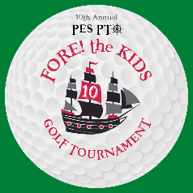
Palencia Fore the Kids! 2022 Sponsorship Benefits

ALL SPONSORSHIPS INCLUDE:
- Company recognition on social media and web-based event promotions
- Distribution of promotional materials to each player in welcome bags (provided by sponsor)
TITLE SPONSORSHIP $5,000
- Company name listed on program and verbal recognition at Awards Dinner
- Recognition/logo on event promotional materials (including flyers, press releases)
- Two complimentary foursome teams (Value $1,400)
- Guest of honor tables at Awards Dinner
- Prominent recognition and company banner displayed
- Custom logo on gifts for players
- Two preferred holes with prominent signage and custom pin flags
- Opportunity to distribute promotional materials at exclusive holes
- Prominent recognition/logo on event signage at check-in/welcome reception and Awards Dinner

DOUBLE EAGLE SPONSORSHIPS*
ALL Double Eagle Sponsorships include:
- Company name listed on program and verbal recognition at awards ceremony
- Recognition/logo on event promotional materials (including flyers, press releases)
- Prominent recognition/logo on event signage at check-in/welcome reception and Awards Dinner
- Tournament foursome discount ($100 Value)
Putting Contest Sponsor (1 available) - $1,100
- Prominent recognition/logo on signage at putting green where contest is held
- Company recognition at contest playoffs (to be played at the beginning of Awards Dinner)
Golf Ball Sponsor (1 available) - $1,000
- Custom company logo on golf ball given to each registered player
Hole Sponsors - $1,000 (7 available)
- Prominent signage at your exclusive hole includes pin flag with company logo to keep
- Opportunity to distribute promotional materials at exclusive hole

* Sign up for a Double Eagle sponsorship opportunity before September 30th
and receive an early bird special of $100 off the price of sponsorship.

EAGLE SPONSORSHIPS **
ALL Eagle Sponsorships include:
- Company recognition/logo on event signage at check-in/welcome reception and Awards Dinner
- Tournament Foursome Discount ($100 Value)
Golf Cart Sponsor (1 available) - $800
- Custom company logo on all provided golf carts
Ball Marker Sponsor - $500 (1 Available)
- Custom company logo on ball markers to be distributed to all registered golfers
Koozie Sponsor - $500 (1 Available)
- Custom company logo on koozies to be distributed to all registered golfers
Tee Sponsor - $500 (1 Available)
- Custom company logo on tees to be distributed to all registered golfers
* Sign up for an Eagle sponsorship opportunity before September 30th
and receive an early bird special of $50 off the price of sponsorship.
BIRDIE SPONSORSHIPS
ALL Birdie Sponsorships include:
- Company recognition/logo on scoreboard and displayed at check-in/welcome reception
Driving Range Sponsor (1 available)- $400
- Company recognition/logo at driving range
Golden Raffle Sponsor (1 available)- $400
- Company recognition/logo at raffle throughout entire tournament
Beverage Cart Sponsor (1 available) - $400
- Custom Company logo on beverage cart
Refreshment Station Sponsor (2 available) - $400
- Custom Company logo and recognition on beverage station
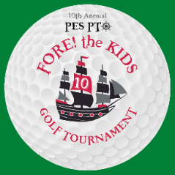
Mulligan Sponsor (1 available) - $350
- Custom Company logo on cards given to players
Closet to the Pin Sponsor (1 available) - $300
- Prominent recognition/logo on signage at Par 3 contest
19th Hole Crew Sponsors (unlimited amount available) $100
- Family/Company recognition displayed at Awards Dinner

