Application 3: Catesby Estates (200 homes)
This proposal relates to a 10.33 hectares site adjacent to the Tops site (see 4). The proposed development is described as being a mix of house size types between 1 and 5 bedrooms, with up to 80 being affordable. The proposed development will include extensive public open space, with a trim track for walking and running and equipped and local play areas, together with a network of walking and cycling areas.
Negative considerations: -
- A large-scale urbanising housing development which will extend the existing built environment significantly westwards to abut the Norton Hall Special Landscape Area and increase the village population by over 20 per cent.
- The proposed development site involves over 3 hectares of land that has previously been deemed to be inappropriate for residential development, with the remainder being beyond any of the sites put forward for potential development consideration in 2021. As such the proposal is entirely speculative and not located in an area designated as appropriate for development.
- Impacts on the setting of Norton Hall Special Landscape Area, abutting the western boundary of the proposed development site, and also on views across from Meon Hill and the greater Cotswold escarpment.
- Impact on traffic through the village and on the local rural road network.
- Lack of essential village amenities, such as a medical practice, dentist and post office.
- Impact on primary and secondary school capacities.
- Lack of local employment opportunies, resulting in the use of private motor vehicles as the primary source of travel, given the limited public transport network.
- Previous over development of the village between 2011 and 2031 (38 per cent population increase).
- Noise, air and light pollution impacting upon the tranquillity of the environment and dark skies.

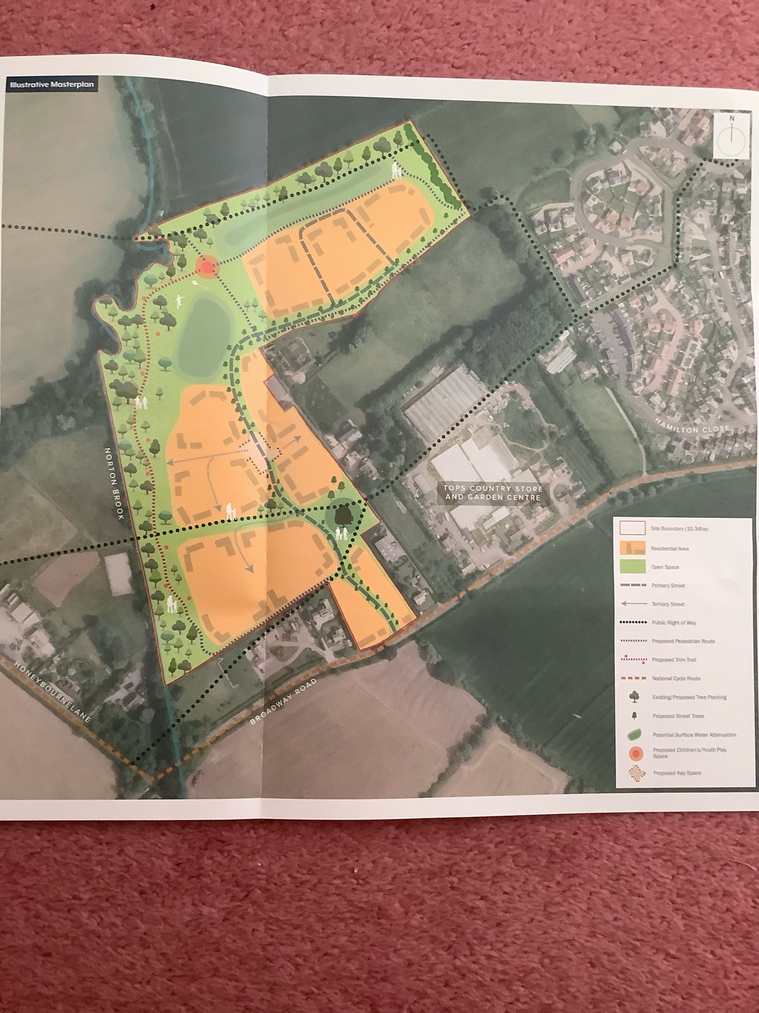
Site Overview

