Application 1: Brookworth Homes (120 houses)
This proposal relates to 5.09 hectares of agricultural land beyond the existing Furrow Way Cala development towards Meon Hill. The application refers to 40 per cent of the housing as being affordable and the provision of significant green infrastructure, public and internal roads and footways. The location is described as being sustainable, at a well-serviced and accessible village that is capable of further growth.
Potential negatives to consider:-
- Visual impacts of densely constructed housing development to and from the Cotswold National Landscape outlier/Iron Age hillfort (heritage asset) of Meon Hill.
- Impacts upon Heart of England Way in relation to loss of recreational amenity and dangers presented to users by mixed use of Canada Lane by pedestrians and car users crossing it for access purposes.
- Highways safety concerns regarding to single point of access to the proposed site along the restrictively narrow Furrow Way.
- Impact on traffic through the village and beyond on the local rural road network.
- Lack of essential village amenities, such as a medical practice, dentist and post office.
- Impact on primary and secondary school capacities.
- Lack of local employment opportunities leading to reliance on private vehicles to travel given the very limited public transport network.
- Previous overdevelopment of Mickleton between 2011 and 2021 (38 per cent increase on population).
- Impacts of noise, air and light pollution upon tranquillity and dark skies.

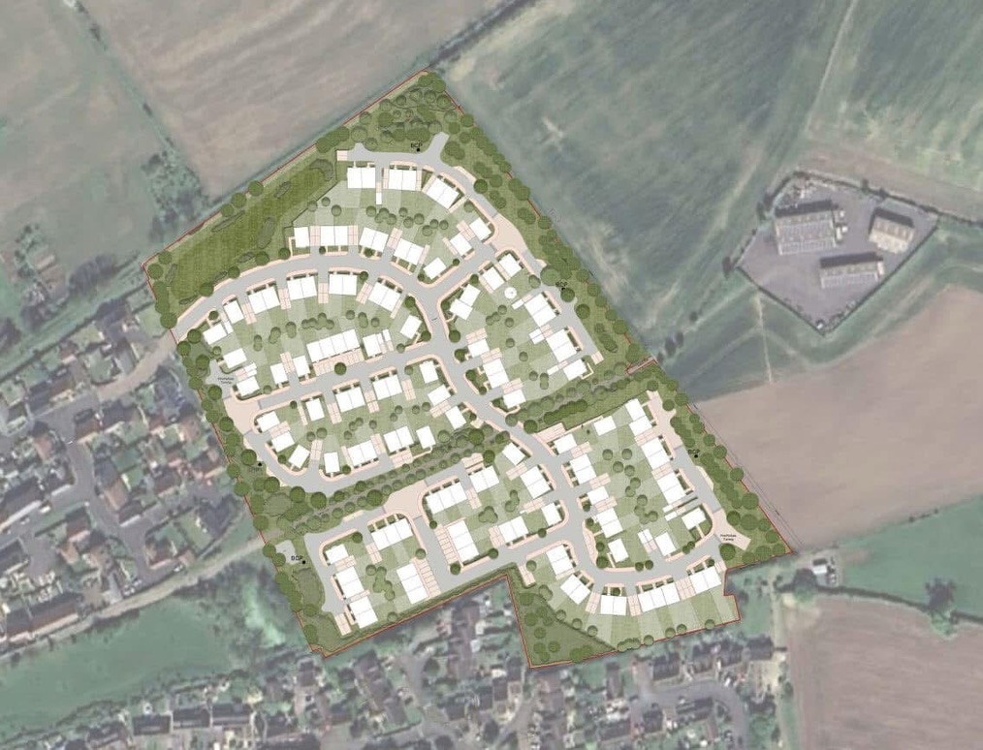
Site Overview

