Application 4: Newland Homes (90 homes)
This proposal relates to 5.5 hectares on land adjoining Tops Nurseries off Broadway Road. 40 per cent of the homes would be affordable. The existing pedestrian link to the village would be upgraded by the improvement of a footbridge. Other pedestrian links will be created internally on the site and open space will also be created.
Negative considerations: -
- Uncertainty as to the area to be built on, given that the Tops site, and an existing dwelling, appear to be included on the land in question. This could have a bearing on the density of the buildings and affect how they relate to the surrounding environment.
- The urbanisation of agricultural land on the western boundary of the village, with significantly negative environmental impacts arising when considered along with the adjacent Catesby Estates development proposals (see 3 above).
- Impact on traffic movements through the village and beyond along local rural road networks.
- Lack of essential village amenities, such as a medical practice, dentist and post office.
- Impact on primary and secondary school capacities.
- Lack of local employment opportunities, resulting in reliance on private motor vehicles as the primary mode of transport, given the very limited public transport system.
- Previous overdevelopment of the village between 2011 and 2021 when the population increased by 38 per cent.
- Noise, air and light pollution impacting on the prevailing tranquillity and dark skies.

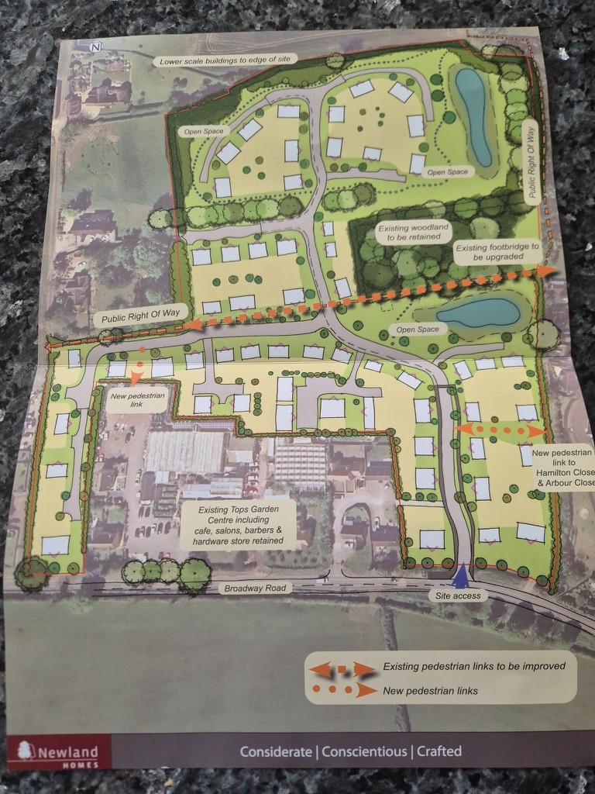
Site Overview

