Children on the 2024 Ballot: Where Do Harris-Walz and Trump-Vance Stand?
BRUCE LESLEY
[personal views on substack by one of nation’s leading child policy experts and advocates: retrieved at: https://brucelesley.substack.com The substack includes videos of statements and additional charts]
Sep 29, 2024
Children represent nearly one-quarter of the population and all of our future, yet they are often ignored and invisible when it comes to the focus of political candidates and coverage by the media during elections.
In an analysis of the first 20 debates during the 2012 presidential campaign, a partner in the child advocacy community (Voices for America’s Children, which has since been reconstituted as the Partnership for America’s Children), found that out of over 1,000 questions asked of candidates during the debates, just 2% of the questions were focused on child policy issues, such as child health, education, child abuse and neglect, child poverty, and other child-relevant issues.
Speaking of Kids is a reader-supported publication. To receive new posts and support my work, consider becoming a free or paid subscriber.

Fortunately, at the presidential campaign level, just 37 days before the 2024 election, candidates Kamala Harris and Donald Trump have spoken about children’s issues during the campaign and have extensive records from their time in office – Harris as a U.S. senator and vice president, and Trump as president. Their vice-presidential running mates, Minnesota Gov. Tim Walz and Sen. J.D. Vance, have also spoken about children and also have records in office.
Using their past records, statements, campaign websites, and social media posts – in that order – reveals their policy positions on key issues of importance to children. The following analysis offers a resource for people concerned about the election and issues that would impact children – both positively and negatively.
The plan is to regularly update this page through Election Day, as candidates make additional statements and readers identify policy positions of importance to children that I may have missed.
Children in the Budget
Since 2008, First Focus on Children has recognized that a politician’s budget priorities tell you what they truly value. Far too often, politicians pay “lip-service” to caring about children while cutting investments in their health, education, safety, and well-being. To ascertain “who’s really for kids and who’s just kidding,” First Focus on Children publishes an annual publication called Children’s Budget, which tracks programs of importance to children and trends in their funding by Congress and the Administration for them.
Trump-Vance: The Trump Administration often proposed cuts to children’s programs, including education, health care, and nutrition in its annual budget proposals. As I wrotein the forward to our Children’s Budget 2020 report:
…the overall federal share of investments in children dropped from 8.19% in fiscal year (FY) 2016 to just 7.48% in FY 2020.[1] This represents a decrease in the share of federal spending dedicated to children of 9 percent over the period.
The problem is systemic. As our analysis finds, even when the allocations for nondefense discretionary funding go up, as they did in FY 2020, kids don’t get their fair share. While the Bipartisan Budget Act of 2019 and subsequent appropriations deals led to $66 billion in additional discretionary spending, only $3.5 billion of that went to children. Overall discretionary spending went up by about 6%, but children’s spending grew even more slowly, resulting in the decrease of the federal share of spending on children.
For FY 2021, President Trump proposed that the share of federal spending on children drop further, to just 7.32%. As an example, President Trump proposed cutting education by 12% in FY 2021 by eliminating or consolidating 31 education programs into a block grant.
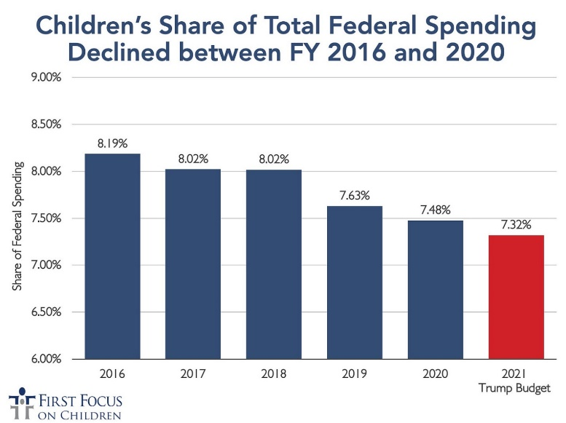
Harris-Walz: In contrast, the Biden-Harris Administration proposed and signed into law major increases in funding for children in 2021. Their priorities produced the most dramatic increase in the share of federal spending on children that our analysis has ever documented: from the record low in 2020 of 7.57% to a record high in 2021 of 11.99%.
Although the share of federal spending dedicated to children has declined since 2021, the Biden-Harris Administration has repeatedly proposed extensions and increases in investments in children. For example, as our Children’s Budget 2024 analysis shows, President Biden’s FY 2025 budget proposal includes a significant increase in federal spending on children, aiming to raise the share of the budget dedicated to kids from 8.84% in 2024 to 11.17% in 2025.
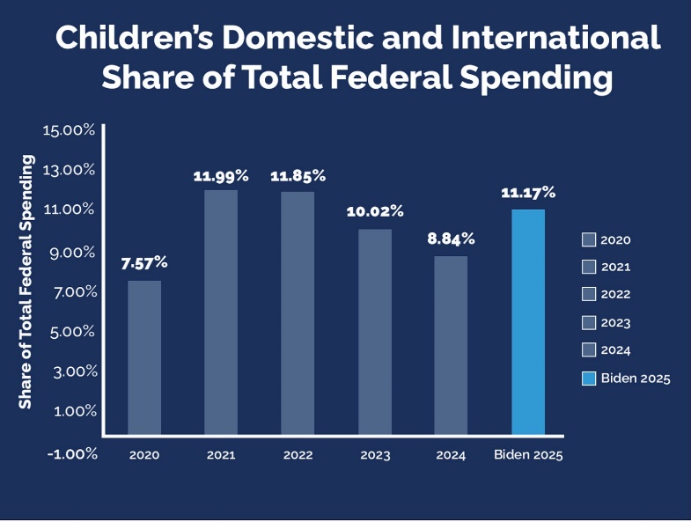
Child Tax Credit
Harris-Walz: In the 2021 American Rescue Plan Act (ARPA), the Child Tax Credit was made fully refundable, paid out in monthly checks for those who wanted that option, and expanded from $2,000 to $3,600 for children up to age 6 and to $3,000 for children up to age 18. This expansion of the Child Tax Credit reached more than 60 million children and their families.
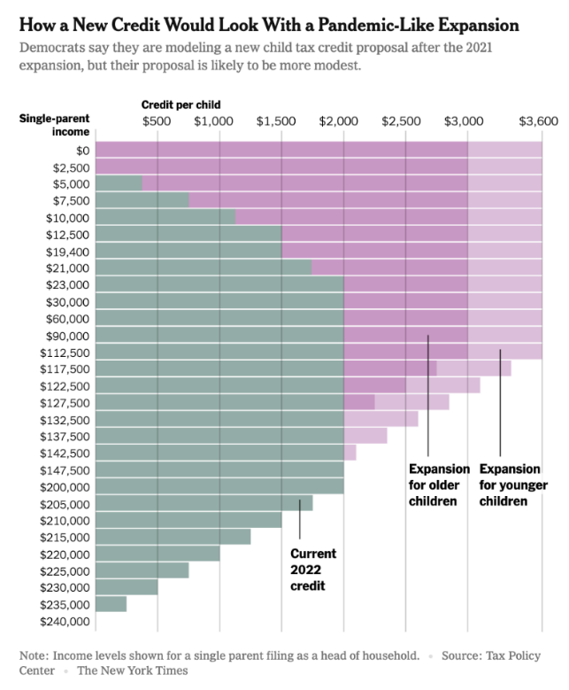
According to the U.S. Census Bureau, this policy change lifted nearly 3 million children out of poverty and cut the child poverty rate to a record low 5.2% in 2021
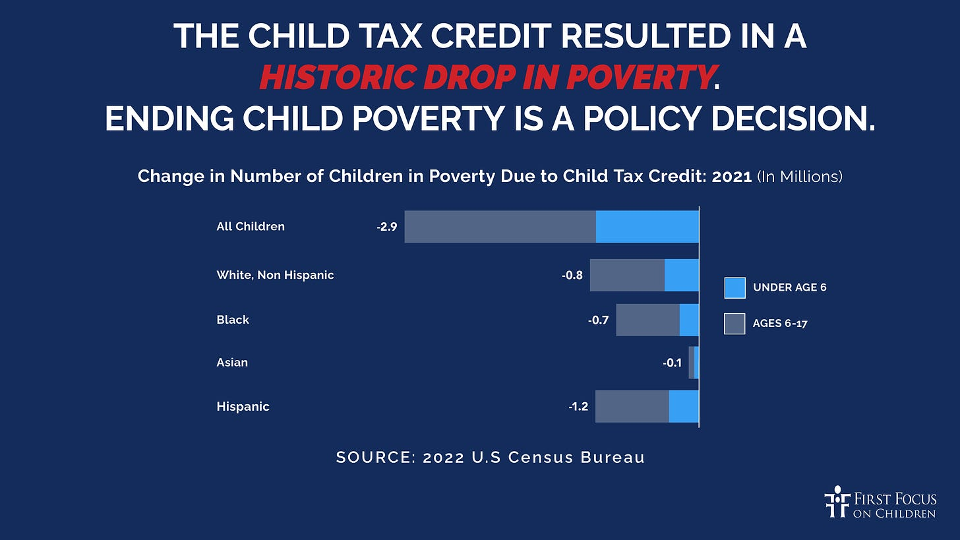
Vice President Harris supported extending the improved Child Tax Credit in 2022 via the Build Back Better Act (BBBA), which passed the House but failed to pass the Senate due to opposition from Senate Republicans and Sen. Joe Manchin (D-WV).
The Biden-Harris Administration continued to propose extending the improved Child Tax Credit in subsequent budgets, but it has not been taken up by Congress.
Earlier this year, a scaled-back version of the Child Tax Credit H.R. 7024, Tax Relief for American Families and Workers Act of 2024, was drafted by Rep. Jason Smith (R-MO) and Sen. Ron Wyden (D-OR) and considered by Congress.
The bill passed the House by a vote of 357-70 but was filibustered in the Senate, and consequently, failed by a vote of 48-44 (needing 60 votes to pass).Vice President Harris continued to press for a more expansive version of the Child Tax Credit (authored by Rep. Rosa DeLauro (D-CT) and Sen. Sherrod Brown (D-OH)), but said she supported the Smith-Wyden version as well.

In her campaign, Harris has proposed expanding the Child Tax Credit even further – to $6,000 for newborns – and has said an improved Child Tax Credit would be a Day 1 priority of a Harris-Walz Administration.
Harris also spoke about the Child Tax Credit in response to the first question of the only presidential debate between Trump and Harris this year.
As for Gov. Tim Walz, he made an expansion of the Child Tax Credit a priority in the State of Minnesota. The Child Tax Credit that was passed and signed into law by Gov. Walz is considered the country’s most robust state Child Tax Credit.
Trump-Vance: The 2017 Tax Cuts and Jobs Act (TCJA) signed into law by President Trump expanded the Child Tax Credit from $1,000 to $2,000 for most children. However, it eliminated the personal exemption, which taxpayers had previously used as a deduction for dependent children. The TCJA also leaves behind 18 million children, who receive only partial or no credit because the Child Tax Credit because of a phase-in that disadvantages low-income families and children.

Trump opposed efforts by Sens. Marco Rubio (R-FL) and Mike Lee (R-UT) to further improve the credit in 2017 for those 18 million children “left behind” by the Child Tax Credit.
With respect to the current presidential campaign, Trump has not put forth a formal proposal. However, to a reporter’s question about the future of the Child Tax Credit, he said:
Well, I was the one who did the Child Tax Credit, and I do support it and want to have it. . . We have two forms, even three forms, and as you know, it gets negotiated with Congress, but we’re doing the maximum. My daughter Ivanka was very involved in that, if you remember. She wanted more than anybody and understood it more than anybody. And the answer is yes, we will take care of children in this country….
With respect to H.R. 7024, the Trump campaign has not expressed a position on that legislation and Sen. Vance failed to vote on the package when it was considered by the Senate on August 1, 2024.
However, Sen. Vance did tell CBS News that he favors an expansion of the Child Tax Credit and suggested $5,000 as a figure to consider in the forthcoming tax debate with Congress. However, he has not repeated that claim, did not go into detail about whether all children would be eligible for the full credit or not, and has not introduced, cosponsored, or voted for any legislation that would improve the Child Tax Credit.
Consequently, I have called on Vance to formally propose a plan for an improved Child Tax Credit.
Child Health
Trump-Vance: As president, Trump proposed and supported legislation in 2017 to eliminate the Affordable Care Act (ACA) and cut hundreds of billions of dollars out of Medicaid and the Children’s Health Insurance Program (CHIP). In the Senate version of the bill, for example, the Medicaid cuts would have been disproportionately applied to children – an estimated cut of 31%.
President Trump’s proposal passed the House but was defeated in the Senate by a single vote when Sen. John McCain (R-AZ) gave it a thumbs down on July 28, 2017. It was estimated the American Health Care Act 0f 2017 would have cut Medicaid by $839 billion over 10 years.
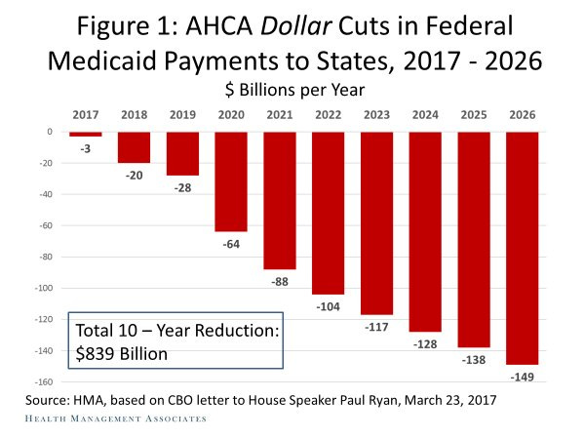
As the legislation moved through Congress, the Senate bill would have disproportionately cut funding for children’s health in comparison to other populations covered by Medicaid, such as senior citizens and people with disabilities. Avalere Health estimated that the Senate bill supported by Trump would have cut Medicaid funding for children by 31%.
Furthermore, during the Trump Administration, CHIP was allowed to expire for over 130 days, which threatened the health of millions of children at the time.
In addition to the proposed budget cuts to CHIP, Trump’s Office of Management and Budget (OMB) Director Mick Mulvaney targeted CHIP for nearly half of the cuts in a recission package that was defeated by one vote in the Senate in 2018.
During the campaign, Trump has not spoken to whether he would seek to cut Medicaid and CHIP if he were to be elected president. However, Project 2025, the House Republican Study Committee, and the House Budget Resolution this year have all proposed capping and cutting Medicaid.
As for Sen. Vance, he was reportedly working with Sen. Tim Kaine (D-VA) on a bipartisan bill to eliminate cost-sharing expenses related to childbirth, but withdrew from those discussions when the Trump campaign began to consider him as a running mate.
Harris-Walz: As both a senator and as vice president, Harris has consistently pushed states to take up Affordable Care Act (ACA)’s option to expand Medicaid for parents and adults. Evidence shows when parents are covered that it has a “welcome mat effect” or getting children covered as well.
Harris voted against the 2017 Senate bill that sought to abolish the ACA and to cut Medicaid and CHIP by hundreds of billions of dollars.
Harris has also championed work on addressing maternal and child mortality in the Administration. This agenda included legislation that expanded Medicaid postpartum coverage for women from 60 days to 12 months.
She has also made reproductive health issues a top priority in her presidential campaign.
Child Care
Harris-Walz: In the Senate, Harris supported the Child Care for Working Families Act, which would cap child care costs at 7% of household income for families earning up to 150% of their state's median income. This policy ensures that no family would have to choose between paying for basic necessities and accessing quality care for their children. Her proposal is grounded in research showing that access to affordable child care leads to better outcomes for children and allows more parents, particularly mothers, to remain in the workforce.
In her campaign, Harris continues to advocate for capping child care costs at 7% of household income, providing relief to working parents, and ensuring children have access to early education. She proposes increasing federal funding for child care centers, expanding child care options for infants and toddlers, and raising wages for child care workers, who are often paid poverty-level wages despite the critical role they play in children's development.
See Harris answer to child care question at 6:13 in video
Walz, as governor of Minnesota, has also made child care a top priority. His Administration expanded access to early childhood programs and allocated significant funds to child care centers through grants and subsidies, especially during the pandemic. Walz worked to create one of the nation’s most robust child care assistance programs, allowing thousands of families to access care while simultaneously boosting wages for child care workers. He also introduced funding for pre-K programs, which offer crucial early learning opportunities for children from disadvantaged backgrounds.
Trump-Vance: During his presidency, Trump introduced a child care tax deduction in the 2017 tax overhaul. While this tax provision provided some families with relief, it was insufficient for low- and middle-income families, many of whom don’t benefit as much from tax deductions because they lack sufficient taxable income to claim the full benefit.
The deduction also did little to address the upfront costs of child care, which require parents to have the funds available to pay for care before they can claim any relief.
Ivanka Trump, during her father’s presidency, advocated for expanded child care tax credits and paid leave, but her initiatives were modest in scope and failed to pass in a meaningful form.
Trump himself has not proposed a detailed child care plan in his 2024 campaign. Trump had the following to say in response to a question about child care at the Economic Club of New York.
Vance has taken a much more conservative stance on child care, stating that child care is best provided by family members, not the government. In past statements, Vance has expressed doubt about providing support to families for child care. At a Turning Point Action forum, Vance suggests families rely on relatives instead of government aid.
Education and Early Childhood
Trump-Vance: During the Trump Administration, significant cuts were proposed with respect to federal funding for various education programs. As noted earlier, in the 2020 budget proposal, the Trump Administration proposed 12% in cuts to education, which included the elimination of or consolidation of 31 different education programs into a block grant.
Trump also supports school vouchers, which allow public funds to be used for private school tuition. His administration attempted to expand the use of vouchers through initiatives like the Education Freedom Scholarships, which would divert public funding to private and religious schools.
As a candidate in 2020 and again in 2024, President Trump has called for the abolition of the Department of Education, a move that would radically reduce federal funding for public schools.
Trump has also called for the direct election of school principals in local jurisdictions by parents.
Additionally, Trump has allied himself with conservative groups like Moms for Liberty, which advocate for book bans, speech codes, more parental control over curriculum, particularly regarding subjects like race, gender, and LGBTQ issues, and the elimination of school-based health services. This has led to increased censorship and book bans in some states.
And in a recent interview with Moms for Liberty, Trump spread the lie that schools are engaging in gender changing surgeries. This is something that has has never happened in any school – either public r private – in this country.
At a Christian National Courage Tour event, Vance spoke about defunding public schools and to divert education funding to school vouchers.
Harris-Walz: Harris has long been a proponent of expanding access to universal pre-kindergarten (pre-K) for all 3- and 4-year-olds, including Head Start. Harris has also advocated for better pay and training for early childhood educators.
In addition to focusing on early childhood education, Harris has championed significant investments in public K-12 education. She has been outspoken about the need to increase teacher pay, which she has called a civil rights issue because underpaid teachers disproportionately affect schools in lower-income and minority communities. She has proposed federal grants to boost teacher salaries, recognizing that teachers are essential to the success of future generations.
Harris also supports increased federal funding for Title I schools, which serve predominantly low-income students. Title I funding helps reduce educational disparities by providing additional resources to schools in need, such as smaller class sizes, more support staff, and better educational materials. Harris has argued that education should not depend on a child’s zip code and that equal access to resources is fundamental to ensuring all children have the opportunity to succeed. This includes her call for full funding of the Individuals with Disabilities in Education Act.
Governor Walz is a former public school teacher and coach who has made education a priority during his tenure as governor. He spoke about his work as a geography teacher and how that related to his priorities as governor on children’s policy issues.
Child Nutrition
Harris-Walz: Harris has supported legislation to expand access to nutritious food through school meal programs, including free breakfast and lunch for all public school students. Harris also supports efforts to expand Supplemental Nutrition Assistance Program (SNAP) benefits, ensuring that low-income families have access to healthy food options.
As a senator, Harris opposed cuts proposed by President Trump to child nutrition programs.
In her presidential campaign, Harris has committed to further expanding federal food assistance programs, including an extension of pandemic-era initiatives that expanded access to food during school closures. She has also emphasized the importance of addressing food deserts by incentivizing grocery stores to operate in underserved communities, ensuring that all children have access to fresh and nutritious foods.
Gov. Walz has a track record of advancing nutrition programs in Minnesota. In 2023, he signed legislation making school meals free for all K-12 students in the state, ensuring that no child goes hungry while attending school. This initiative was hailed as one of the most progressive child nutrition policies in the country and is seen as a model for other states.
Trump-Vance: During his presidency, Trump sought to reduce federal spending on food assistance programs, including attempts to cut SNAP by billions of dollars. His Administration pushed for tighter eligibility requirements for SNAP, which could have denied benefits to millions of children in food-insecure households.
Under Trump’s Department of Agriculture, restrictions were placed on school meal standards, rolling back nutrition guidelines that required schools to serve more fruits, vegetables, and whole grains.
Vance has expressed support for reducing the role of government in aid programs, including food assistance. He has advocated for states to have more control over how nutrition programs are run, rather than federal oversight. Vance has been critical of large-scale federal food assistance, framing it as creating dependency, though he has not provided specific plans on how to address child hunger without these programs.
Paid Family Leave
Harris-Walz: Harris has long been an advocate for expanding paid family leave as a key element in supporting both parents and children. In the U.S. Senate, she co-sponsored the FAMILY Act, which would provide up to 12 weeks of paid family and medical leave for workers to care for a newborn, adopted child, or family member with a serious health condition. Harris understands that paid leave allows parents to bond with their children during critical early months of life, and research has shown that this parental bonding has lasting positive effects on children's emotional and cognitive development.
Harris has also made paid family leave a centerpiece of her 2024 campaign, including talking about it at her first presidential campaign event. Harris proposes building on President Biden's initiatives to make paid leave accessible to all American workers. Her plan emphasizes that no parent should have to choose between keeping their job and caring for their child. Under a Harris-Walz Administration, all workers would be guaranteed up to 12 weeks of paid leave, including part-time workers and those in the gig economy who are often excluded from traditional leave policies.
As governor of Minnesota, Walz signed one of the nation's most generous paid leave programs into law in 2023, providing state workers with 12 weeks of paid family and medical leave. Walz has also spoken out about the need for federal legislation.
Trump-Vance: During the Trump Administration, his daughter Ivanka Trump championed a limited version of paid parental leave, but no comprehensive federal policy was ever enacted. The version proposed by Ivanka Trump offered six weeks of paid leave, but it was tied to state unemployment insurance programs and would have only provided partial pay.
In his current campaign, Trump has not laid out a specific proposal for paid family leave. While he has supported limited expansions of child care tax credits, his focus has been more on economic growth and deregulation than on creating a national leave program.
Vance has voiced opposition to expansive federal paid leave, suggesting that businesses should voluntarily offer leave policies rather than being mandated by the government. Vance argues that federal requirements could place too much of a burden on small businesses, although he has not provided detailed alternatives that would ensure all workers have access to paid leave.
Gun Violence
Harris-Walz: Harris has been a vocal advocate for stronger gun safety measures, recognizing the devastating impact that gun violence has on children. During her tenure as a senator, she co-sponsored legislation aimed at universal background checks, banning assault weapons, and implementing red flag laws to prevent individuals who pose a risk to themselves or others from accessing firearms.
In her 2024 campaign, Harris has pledged to push for further gun safety reforms, including an assault weapons ban, universal background checks, safe storage laws, and “red flag” laws. Harris has also voiced support for programs to prevent school shootings by increasing mental health resources for students and strengthening safety measures in schools.
Gov. Walz has likewise prioritized gun safety. As governor of Minnesota, Walz signed measures into law that established universal background checks for gun purchases and introduced "red flag" laws, which allow law enforcement to remove guns from individuals deemed a threat to themselves or others.
Trump-Vance: Trump has positioned himself as a defender of the Second Amendment and has opposed most efforts to strengthen gun safety. During his presidency, Trump resisted calls for stricter background checks following mass shootings, instead focusing on hardening schools by increasing security measures, including armed guards and training teachers to carry firearms.
The Trump Administration did put in place a federal ban on “bump stocks,” which are devises that allow a gun to be modified to fire like a machine gun with up to 800 rounds per minute, but the Supreme Court struck down this rule and allowed bump stocks to be legal again.
Trump has said he refused to yield to pressure to take steps to do more to address gun safety.
Trump’s running mate, J.D. Vance, shares a similar stance, voicing opposition to gun control measures and advocating instead for policies that expand gun rights. Vance has suggested that increasing gun control could infringe upon constitutional rights. The Trump-Vance position largely defers responsibility for gun safety to individuals and schools, advocating for personal protection over systemic change.
Children of Immigrants
Trump-Vance: Trump has repeatedly promised more aggressive immigration enforcement, even suggesting the possibility of rounding up children in deportation efforts.
See Trump response to question about deportation of children beginning at 10:13 mark
He also wants to end birthright citizenship, which would disproportionately impact children born in the U.S. to immigrant parents.
Harris-Walz: Harris has expressed support for comprehensive immigration reform and support for bipartisan legislation proposed by Sens. Chris Murphy (D-CT), Kristen Sinema (I-AZ), and James Lankford (R-OK) to expand border enforcement.
Harris has also expressed support for a path to citizenship for Dreamers (undocumented individuals brought to the U.S. as children) and opposition to family separation policies
Prioritizing Children in 2024 and Beyond
As we look toward the 2024 election, it’s clear that the future of millions of children are on the ballot. The differences between the Harris-Walz and Trump-Vance campaigns are not just political – they are deeply personal for the nation's children and our collective future.
Children cannot vote, but they will inherit the consequences of the choices made in the upcoming election. This election presents a clear choice between different visions. Voters must remember that policies impacting children's health, education, safety, and well-being will shape not just the next four years, but an entire generation.
The stakes in the 2024 election could not be greater for children. Parents, grandparents, teachers, relatives, neighbors, in fact, anyone who is concerned about the future of our children and the future of our nation, should carefully review the policy positions of the candidates for public office and #VoteKids.

