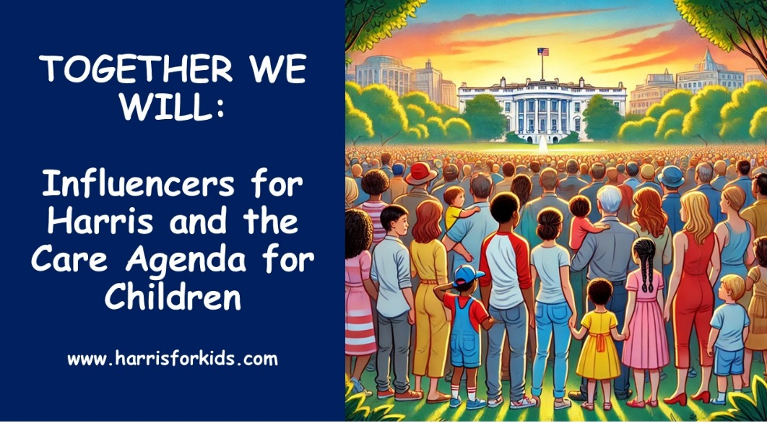
TWEET, INSTAGRAM, AND FACEBOOK IDEAS

Many of the jpegs on this page can be used for tweets, Instagram, or facebook posts. The major purpose of providing information is to get people in your spheres to: (1) know that Kamala Harris has a positive agenda for children they can learn about (with a link to the www.harrisforkids.com website), and (2) know that YOU believe it is a an agenda they should know about and a reason for supporting Kamala.
SAMPLE TWEETS AND FACEBOOK POSTS:
#1
Check out www.harrisforkids.com for Kamala Harris’ agenda for kids and how you can get out the message. #harrisforkids #votekids2024
#2
The Surgeon General’s report, Parents Under Stress, confirms that parents are under more pressure than ever raising their children. While it hasn’t received much attention, Kamala Harris’ care agenda really responds. See www.harrisforkids.com for more information. #harrisforkids.com #votekids2024
#3
There’s a pro-child, pro-family, pro-economy agenda that works for all families and can bring us together. www.harrisforkids.com #votekids2024 #harrisforkids
#4
If we want the best economy in the world and the best future for our children, we need the best caregiving economy in the world. Get the word out about Kamala Harris’s agenda for care and children at www.harrisforkids.com #harrisforkids #votekids2024
#5
An antidote for election fatigue and anxiety: Talking about a positive agenda for our country – Harris’ care plan for children. See: www.harrisforkids.com #harrisforkids #votekids2024I
#6
I’m a grandparent and this is why I’m supporting Kamala Harris www.harrisforkids.com #votekids2024 #harrisforkids
JPEGS FOR USE WITH POSTS (INSERT LIVE LINK):

