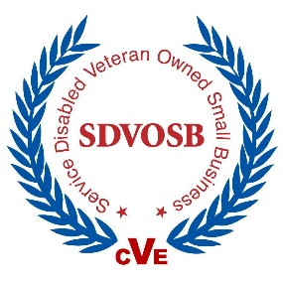  SERVICE-DISABLED VETERAN-OWNED SMALL BUSINESS  (CVE)  Cage Code: 46EK9  DUNS: 607436289  NACIS  Codes  541611 – Administrative Management & General Management  541614 – Process, Physical Distribution & Logistics Consulting Services  541618 – Other Management Consulting Services  541619 – Other Computer Related Services  561320 – Temporary Help Services | Fleet-Wi$e™ Management Group delivers global consultancy support services to our nation’s military, first responders, colleges & universities, businesses, federal, state and local governments. Our associates and partners provide the expertise, resources, and high-quality performance to achieve and sustain client goals and requirements. We also operate a full-service consulting center and asset management platforms for data analysis, and management of vehicle fleets and stationary assets. Also offered in our portfolio of services is Facilities Management and Sustainment support.  Management Experience. Fleet-Wi$e is a group of multidisciplinary, consulting engineers and specialists providing engineering and technical services with a focus on safety, sustainability and innovation. Our staff and associates offer extensive on-the-ground experience managing vehicle fleets and facility operations. Our team represents decades of knowledge and know-how as federal & commercial fleet and facility professionals. Consequently, we understand the day-to-day challenges of operating a vehicle fleet and maintaining facilities in the U.S. and foreign countries and the responsibility of providing secured, dependable and functional logistics and quality facility management in peaceful & difficult environments.  Subject Matter Experts (SME). Few Service-Disabled/Veteran-Owned Small Business management firms in the world can match the experience, recognized expertise, and reputation for high-quality work in the fleet and facility management field as Fleet-Wi$e Management Group. Designations include Florida Disabled Veteran Business Enterprise and Service-Disabled Veteran-Owned Small Business as well as various individual professional certifications (e.g. Certified Federal Fleet Manager, Federal Fleet Specialist & Federal Fleet Administrator).  Track Anything, Anywhere, Anytime – Asset Management Platform. We connect assets, people and customers to businesses worldwide. Our products and services are used in many industry verticals for tracking, monitoring and managing an extensive variety of asset types; from fleet vehicles to heavy equipment, petroleum products, parts & material, to stationary power units and airport support equipment. Fleet-Wi$e provides our customers with the ability to track and manage their valuable assets, including assets’ status and activities. Our products furnish management with information critical to the safety, usage, location and the efficiency of their people, equipment or product.  Management Services. Our management services include project management, operational analysis, interim management & administrative staffing, fleet composition, due-diligence studies and audits, etc.. We hand-pick multi-tasking individuals or develop small specialty and project teams to produce innovative, cost effective solutions for your technical requirements. We team local and global knowledge for the benefit of our clients, as needed.  Total Company Fleet Makeover. We evaluate the “health” of your vehicle(s), the curb-side appeal, work functionality, security, administration etc. and develop a “wellness” plan to address any areas requiring attention and improvement. We work with clients to build strong strategic plans, identify fleet-health goals, and then document paths to continuous improvement.

CURRENT AND PAST PROJECT/WORK LOCATIONS & NOTABLE CLIENTS and PARTNERS
CONUS  Alaska  Arizona  California  District of Columbia  Florida  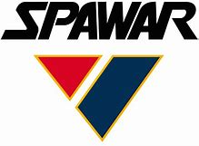  Georgia  Hawaii  Idaho  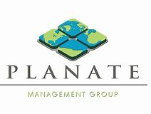  Maryland  Mississippi  Nevada  New Hampshire  North Carolina  Pennsylvania | South Carolina  Tennessee  Texas  Virginia  Washington | OVERSEAS  Afghanistan  Bahrain  Bermuda  Columbia  Diego Garcia  Guam  Jakarta  Japan  Marshall Islands  Okinawa  Philippines  Singapore  South Korea
