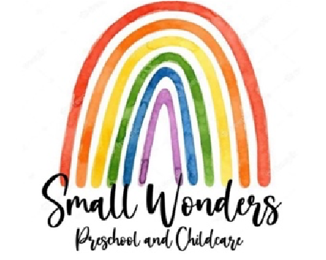
Supply List

Welcome Families,

We are so excited for this new adventure that your child is about to embark in. Listed below are the supplies your child will need to begin school. All items must be labeled with your child’s name. Please refer to your child’s classroom

Butterflies/dragonflies (3-5)
1 change of clothes including 1 pair of socks- weather appropriate
1 blanket for naptime
1 small travel pillow and/or favorite stuffed animal
Snow pants, Snow boots, gloves, & hat (for winter)
- package of wipes
- boxes of Kleenex
- small water bottle (that can fit in a cubby bin) this will go home each day with your child.
1-2 Pictures of your Family (We place around the room for children to see)

Fireflies/Bumble Bee’s (9-36 months)
1changes of clothes including 2 pair of socks
1 blanket for naptime
1 small travel pillow and/or favorite stuffed animal
Snow pants, Snow boots, gloves, & hat (for winter)
1 Large box of wipes
- Large package of diapers
Diaper cream (doctor form must be complete in the health statement form)
- boxes of Kleenex
- small water bottle (that can fit in a cubby bin) this will go home each day with your child.
sippy cup/bottles

- Picture of your Family (We place around the room for children to see)

Rollies (infant)
2 changes of clothes including 2 pair of socks
1 sleeper/swaddle for naptime
Snowsuit (for winter)

3-4 Prepared bottles for your infant (Bottles aren’t prepared on site, We will label them with your child’s first and last name)
water sippy
Baby food/baby snack foods
1 case of diaper wipes
- case of diapers to get started
Diaper ointment, if desired (with filled out diaper ointment form) Pacifiers (if using them for your infant) 2 boxes of Kleenex
- Picture of your Family (We place around the room for children to see)

Meals

We provide breakfast, lunch and PM snack

