
Worship Plan for Sunday, June 14, 2026
B Pentecost 3
ELW Setting 3, Setting 8 Kyrie
American Lutheran, Jesup

Welcome & Worship Announcements
Ringing of the Bell

Thanksgiving for Baptism
Water! Water! We praise you, O God, for water—
the Volga, Turkey, Maquoketa, and Wapsipinicon, and the mighty Mississippi.
the rain that nourishes animals and plants,
the water for drinking and bathing.
We praise you, O God, for water.
We praise you, O God, for water.

We praise you, O God, for our water stories—
a flood that cleansed the earth,
the sea that drowned the enemy,
a river that healed leprosy.
We praise you, O God, for water.
We praise you, O God, for water.

We remember the waters of Jesus—
baptized in the Jordan River,
calming the Sea of Galilee,
drinking from Jacob’s Well,
healing at the pool of Bethesda,
washing the disciples’ feet.
We praise you, O God, for water.
We praise you, O God, for water.

We praise you, O God, for this font,
for through this water
you have birthed us into the family of Christ,
bathed us in forgiveness,
and enlivened us in the Spirit.
We praise you, O God, for baptism.
We praise you, O God, for baptism.

O God, you are the Ocean, sustaining this earth.
O God, you are the River, saving us from death.
O God, you are the Fountain, granting us health and well-being.
We praise you, O God,
today, tomorrow, forever.
Amen, and amen.
Amen, and amen.

Gathering Song Children of the Heavenly Father (ELW 781)

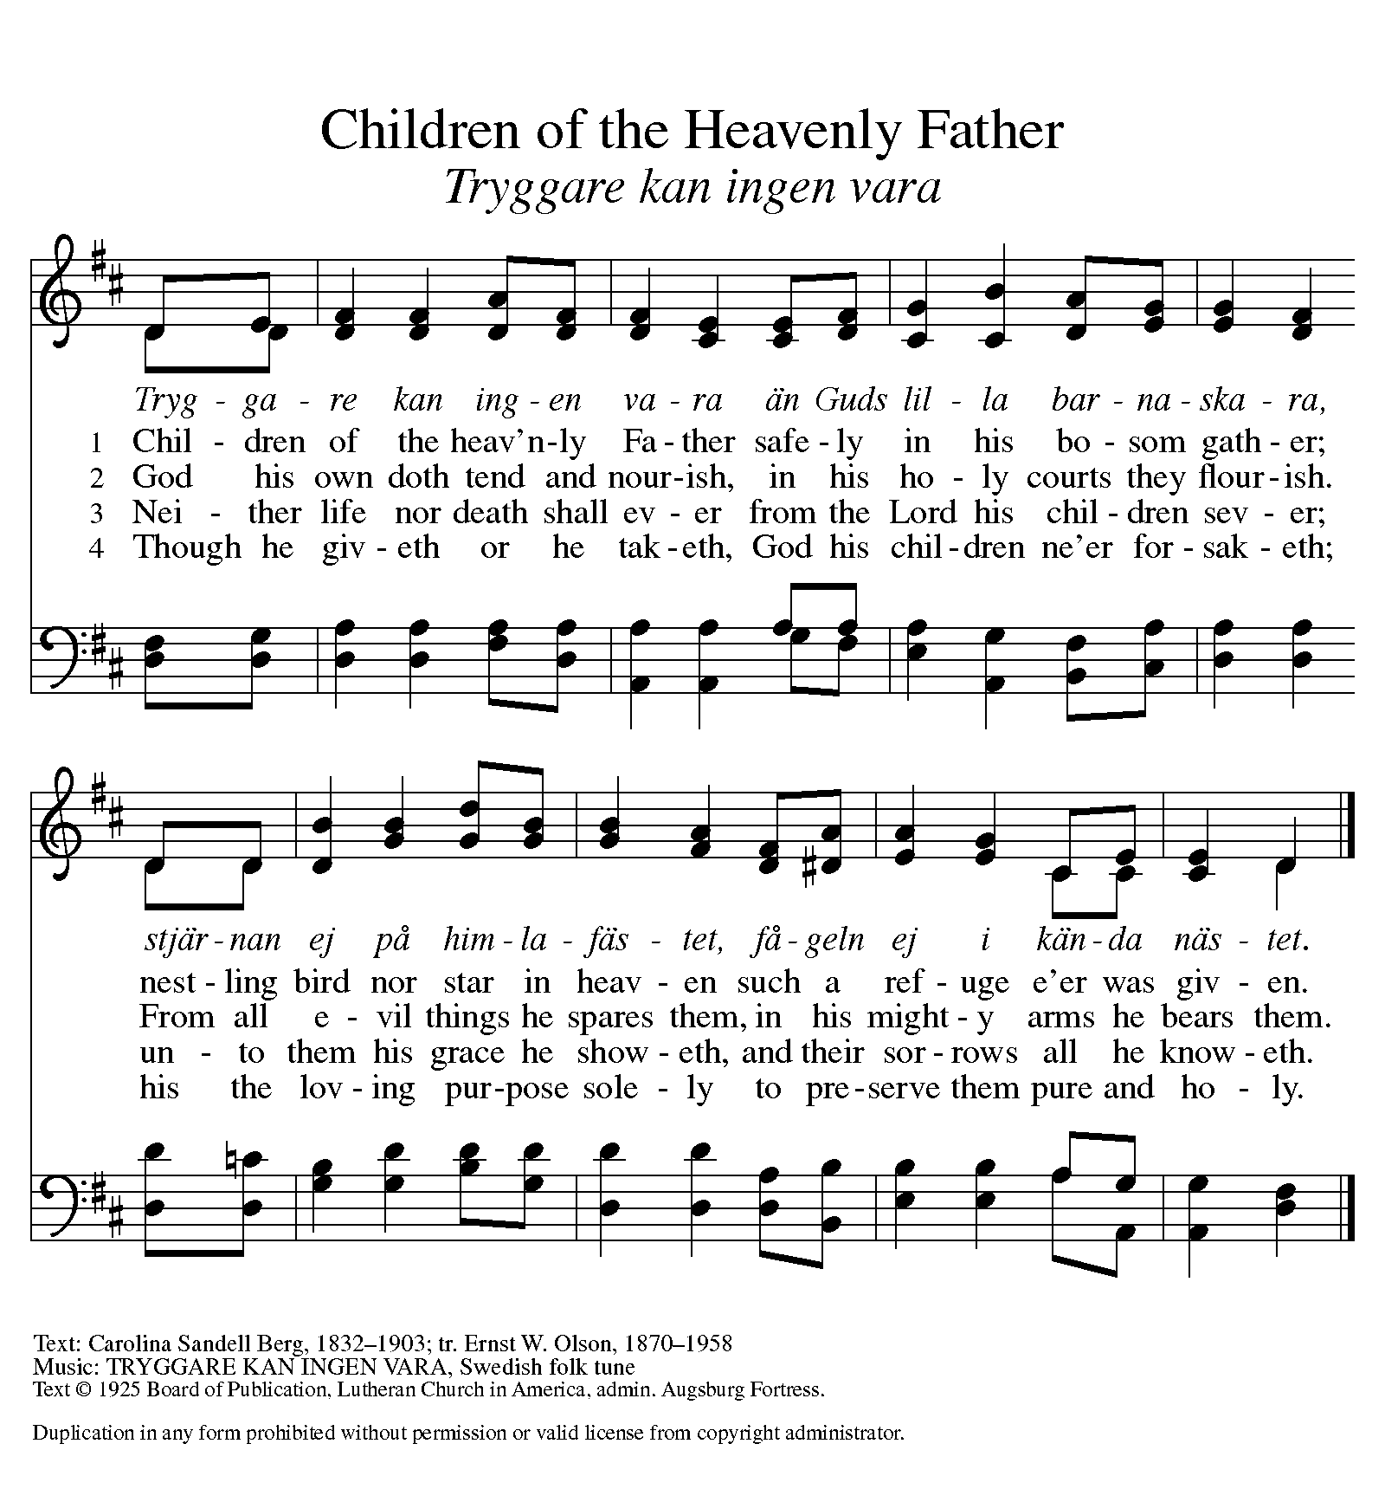

Greeting (ELW p. 138)
The grace of our Lord Jesus Christ, the love of God,
and the communion of the Holy Spirit be with you all.
And also with you.

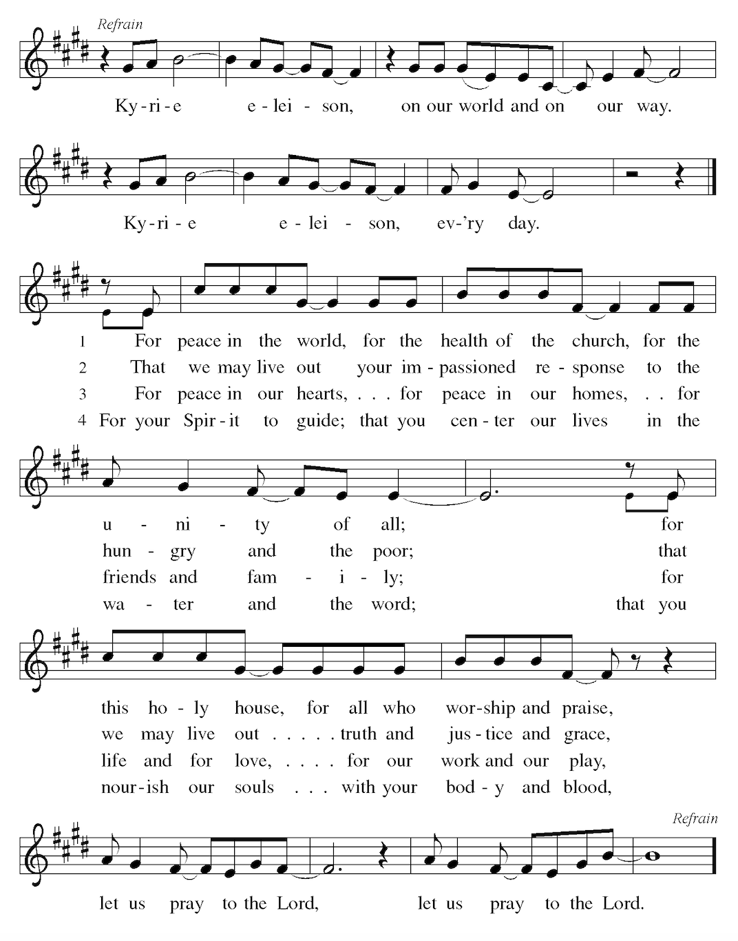
Kyrie (ELW p. 184)
Guitar leads; Accompaniment with piano

Prayer of the Day
Let us pray.
Teach us, good Lord God, to serve you as you deserve, to give and not to count the cost, to fight and not to heed the wounds, to toil and not to seek for rest, to labor and not to ask for reward, except that of knowing that we do your will, through Jesus Christ, our Savior and Lord.
Amen.

Kids’ Time

First Reading: Jeremiah 20:7-13
Lector
A reading from Jeremiah.
⁷ O Lord, you have enticed me,
and I was enticed;
you were too powerful for me,
and you have prevailed.
I have become a laughingstock all day long;
everyone mocks me.
⁸ For whenever I speak, I must cry out,
I must shout, “Violence and destruction!”
For the word of the Lord has become for me
a reproach and derision all day long.
⁹ If I say, “I will not mention the Lord,
or speak any more in the name of the Lord,”
then within me there is something like a burning fire
shut up in my bones;
I am weary with holding it in,
and I cannot.
¹⁰ For I hear many whispering:
“Terror is all around!
Denounce him! Let us denounce him!”
All my close friends
are watching for me to stumble.
“Perhaps Jeremiah can be enticed,
and we can prevail against him,
and take our revenge on him.”
¹¹ But the Lord is with me like a dread warrior;
therefore my persecutors will stumble,
and they will not prevail.
They will be greatly shamed,
for they will not succeed.
Their eternal dishonor
will never be forgotten.
¹² O Lord of hosts, you test the righteous,
you see the heart and the mind;
let me see your retribution upon them,
for to you I have committed my cause.
¹³ Sing to the Lord;
praise the Lord!
For the Lord has delivered the life of the needy
from the hands of evildoers.
Word of God, word of life.
Thanks be to God.
Lector
Psalm: Psalm 69:7-18
⁷ Surely, for your sake I have suf- | fered reproach,
and shame has cov- | ered my face.
⁸ I have become a stranger to | my own kindred,
an alien to my | mother’s children.
⁹ Zeal for your house has eat- | en me up;
the scorn of those who scorn you has fall- | en upon me.
¹⁰ I humbled my- | self with fasting,
but that was turned to | my reproach.
¹¹ I put on | sackcloth also,
and became a by- | word among them.
¹² Those who sit at the gate mur- | mur against me,
and the drunkards make | songs about me.
¹³ But as for me, this is my prayer to you, at the time you have | set, O Lord:
"In your great mercy, O God, answer me with your un- | failing help.
¹⁴ Save me from the mire; do not | let me sink;
let me be rescued from those who hate me and out of | the deep waters.
¹⁵ Let not the torrent of waters wash over me, neither let the deep swal- | low me up;
do not let the pit shut its | mouth upon me.
¹⁶ Answer me, O Lord, for your | love is kind;
in your great compassion, | turn to me.
¹⁷ Hide not your face | from your servant;
be swift and answer me, for I am | in distress.
¹⁸ Draw near to me | and redeem me;
because of my enemies de- | liver me.
Lector
Second Reading Romans 6:1b-11
A reading from Romans.
^{1b} Should we continue in sin in order that grace may abound? ² By no means! How can we who died to sin go on living in it? ³ Do you not know that all of us who have been baptized into Christ Jesus were baptized into his death? ⁴ Therefore we have been buried with him by baptism into death, so that, just as Christ was raised from the dead by the glory of the Father, so we too might walk in newness of life.
⁵ For if we have been united with Christ in a death like his, we will certainly be united with him in a resurrection like his. ⁶ We know that our old self was crucified with him so that the body of sin might be destroyed, and we might no longer be enslaved to sin. ⁷ For whoever has died is freed from sin. ⁸ But if we have died with Christ, we believe that we will also live with him. ⁹ We know that Christ, being raised from the dead, will never die again; death no longer has dominion over him. ¹⁰ The death he died, he died to sin, once for all; but the life he lives, he lives to God. ¹¹ So you also must consider yourselves dead to sin and alive to God in Christ Jesus.
Word of God, word of life.
Thanks be to God.

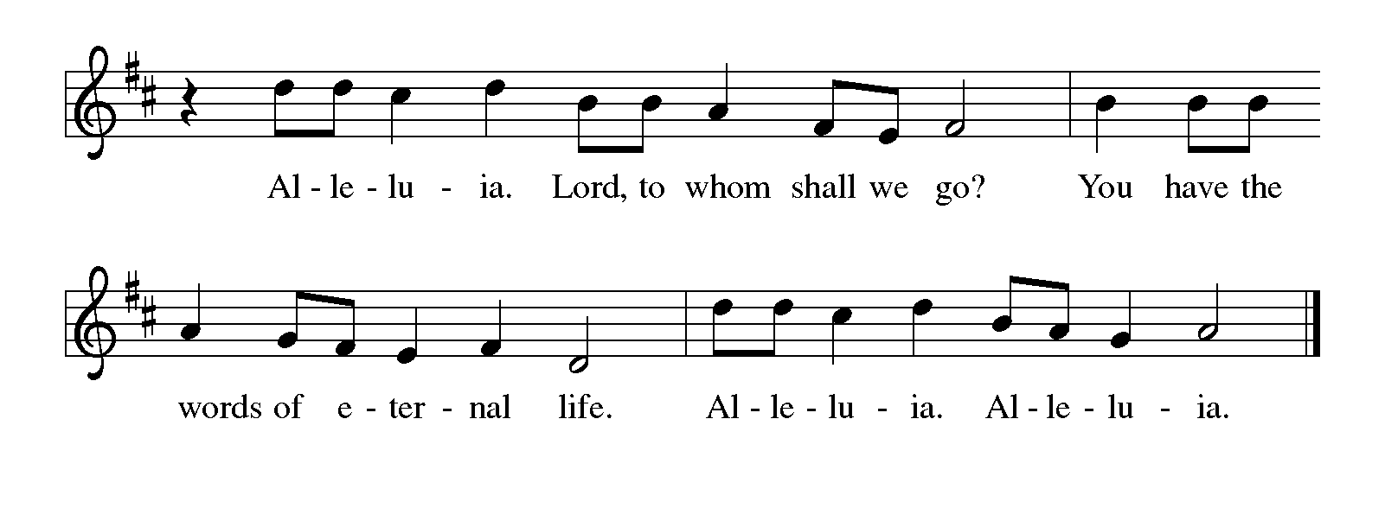
Gospel Acclamation (ELW p. 142)

Gospel: Matthew 10:24-39
The holy gospel according to Matthew.
Glory to you, O Lord.

[Jesus said:] ²⁴ “A disciple is not above the teacher, nor a slave above the master; ²⁵ it is enough for the disciple to be like the teacher, and the slave like the master. If they have called the master of the house Beelzebul, how much more will they malign those of the master’s household!”
²⁶ “So have no fear of them; for nothing is covered up that will not be uncovered, and nothing secret that will not become known. ²⁷ What I say to you in the dark, tell in the light; and what you hear whispered, proclaim from the housetops. ²⁸ Do not fear those who kill the body but cannot kill the soul; rather fear the one who can destroy both soul and body in hell. ²⁹ Are not two sparrows sold for a penny? Yet not one of them will fall to the ground apart from your Father. ³⁰ And even the hairs of your head are all counted. ³¹ So do not be afraid; you are of more value than many sparrows.”
³² “Everyone therefore who acknowledges me before others, I also will acknowledge before my Father in heaven; ³³ but whoever denies me before others, I also will deny before my Father in heaven.
³⁴ Do not think that I have come to bring peace to the earth; I have not come to bring peace, but a sword.
³⁵ For I have come to set a son against his father,
and a daughter against her mother,
and in-laws against one another;
³⁶ and one’s foes will be members of one’s own household.
³⁷ Whoever loves father or mother more than me is not worthy of me; and whoever loves son or daughter more than me is not worthy of me; ³⁸ and whoever does not take up the cross and follow me is not worthy of me. ³⁹ Those who find their life will lose it, and those who lose their life for my sake will find it.”

The gospel of the Lord.
Praise to you, O Christ.

sermon

Hymn of the Day We Are Baptized in Christ Jesus (ELW 451)
Guitar leads; Accompaniment with piano
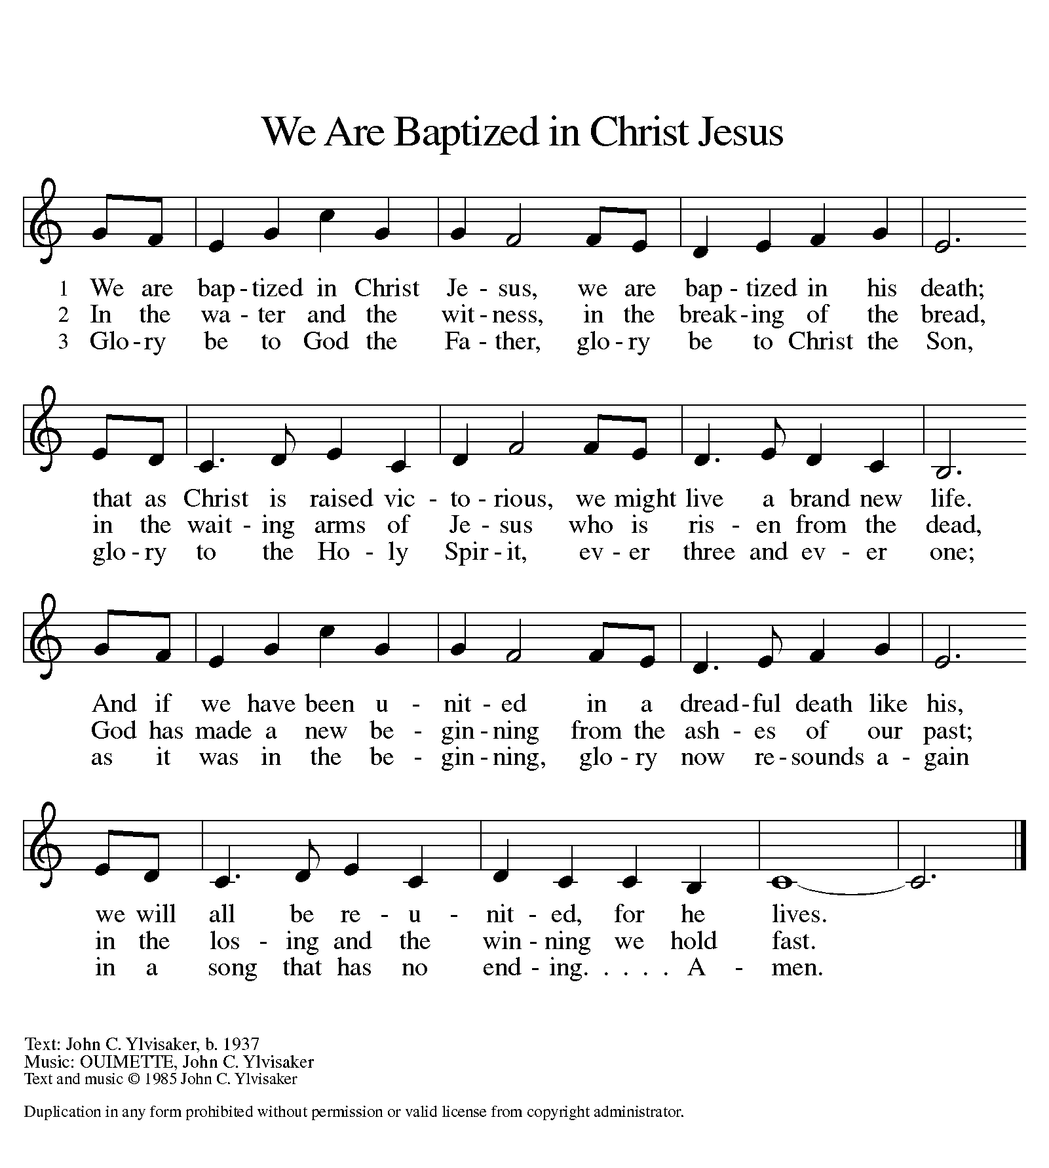

Apostles’ Creed
I believe in God, the Father almighty,
creator of heaven and earth.

I believe in Jesus Christ, God’s only Son, our Lord,
who was conceived by the Holy Spirit,
born of the virgin Mary,
suffered under Pontius Pilate,
was crucified, died, and was buried;
he descended to the dead.
On the third day he rose again;
he ascended into heaven,
he is seated at the right hand of the Father,
and he will come to judge the living and the dead.

I believe in the Holy Spirit,
the holy catholic church,
the communion of saints,
the forgiveness of sins,
the resurrection of the body,
and the life everlasting. Amen.

Prayers of Intercession
Petitions end with: God of grace, hear our prayer.
Last petition:
Trusting you receive all our prayers, we commend our spoken and unspoken prayers to you, O God, through Jesus our Savior.
Amen.

Peace
The peace of Christ be with you always.
And also with you.
Now we’ll share that peace with one another.

Offering Take My Life, That I May Be (ELW 685) vs. 1 & 6

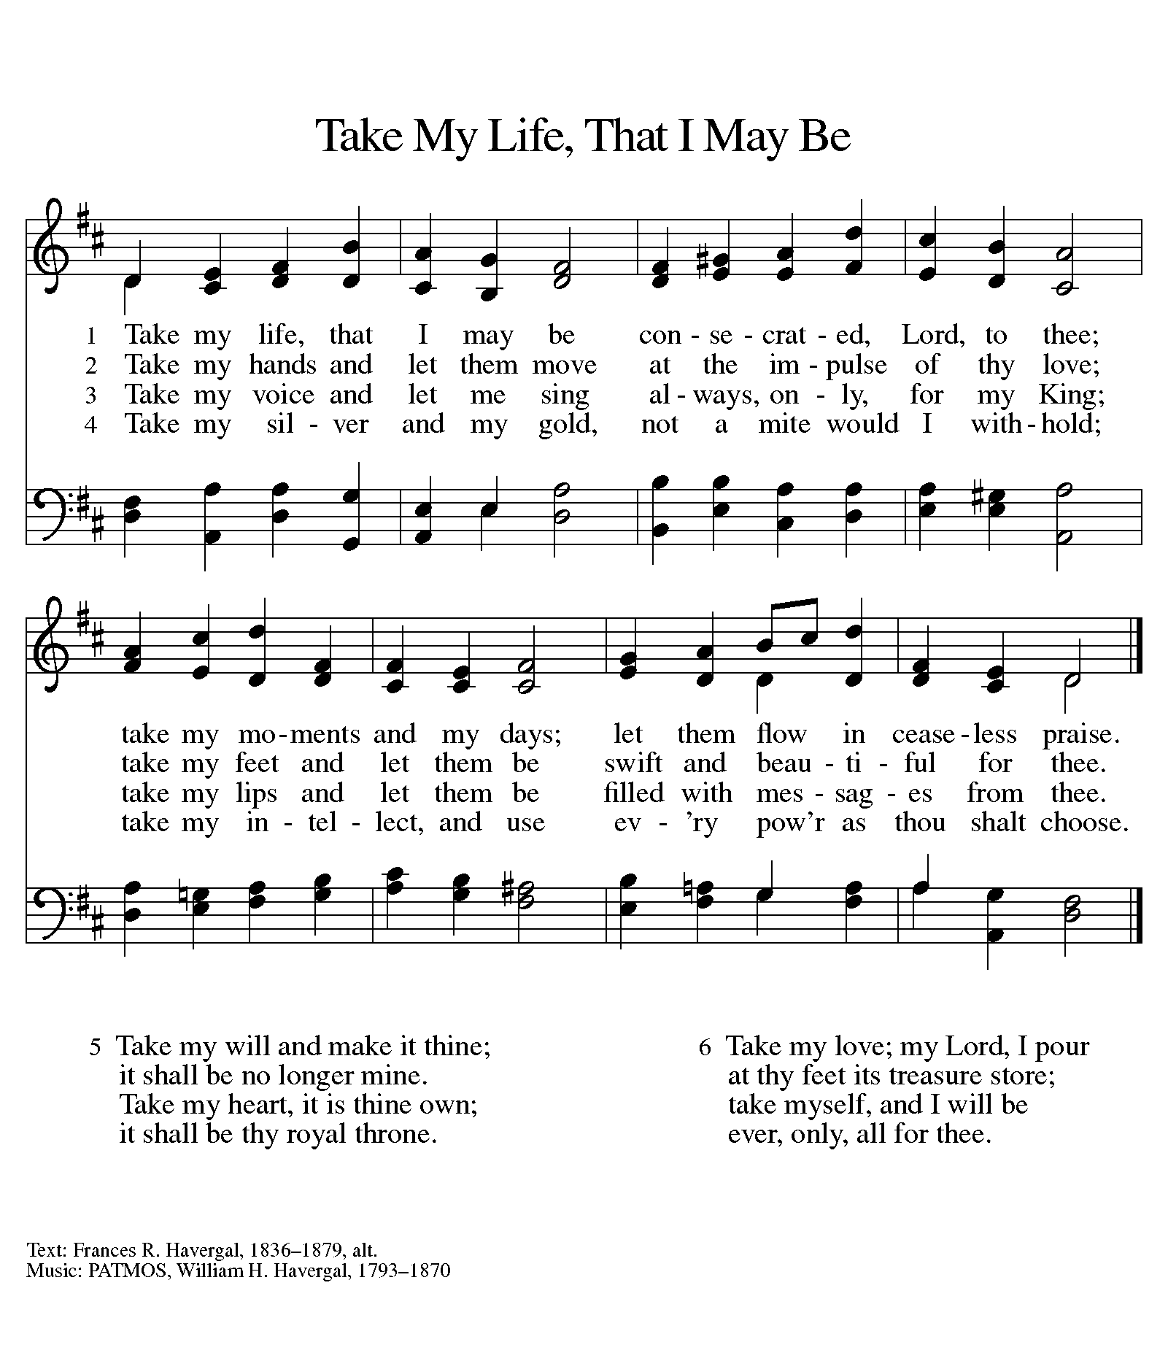
Offering Prayer
Let us pray. (brief silence)
Blessed are you, O God, maker of all things. Through your goodness you have blessed us with these gifts: our selves, our time, and our possessions. Use us, and what we have gathered, in feeding the world with your love, through the one who gave himself for us, Jesus Christ, our Savior and Lord.
Amen.

Thanksgiving at the Table
Holy, mighty, and merciful Lord,
heaven and earth are full of your glory.
In great love you sent to us Jesus, your Son,
who reached out to heal the sick and suffering,
who preached good news to the poor,
and who, on the cross, opened his arms to all.

In the night in which he was betrayed,
our Lord Jesus took bread, and gave thanks;
broke it, and gave it to his disciples, saying:
Take and eat; this is my body, given for you.
Do this for the remembrance of me.

Again, after supper, he took the cup, gave thanks,
and gave it for all to drink, saying:
This cup is the new covenant in my blood,
shed for you and for all people for the forgiveness of sin.
Do this for the remembrance of me.

Remembering, therefore, his death, resurrection, and ascension,
we await his coming in glory.

Pour out upon us the Spirit of your love, O Lord,
and unite the wills of all who share this heavenly food,
the body and blood of Jesus Christ, our Lord;
to whom, with you and the Holy Spirit,
be all honor and glory, now and forever.
Amen.

Lord’s Prayer (ELW p. 134)
Gathered into one by the Holy Spirit, let us pray as Jesus taught us.
Our Father, who art in heaven,
hallowed be thy name,
thy kingdom come,
thy will be done,
on earth as it is in heaven.
Give us this day our daily bread;
and forgive us our trespasses,
as we forgive those
who trespass against us;
and lead us not into temptation,
but deliver us from evil.
For thine is the kingdom,
and the power, and the glory,
forever and ever. Amen.

Invitation to Communion

Communion

Commmunion Song Lamb of God (ELW p. 146)

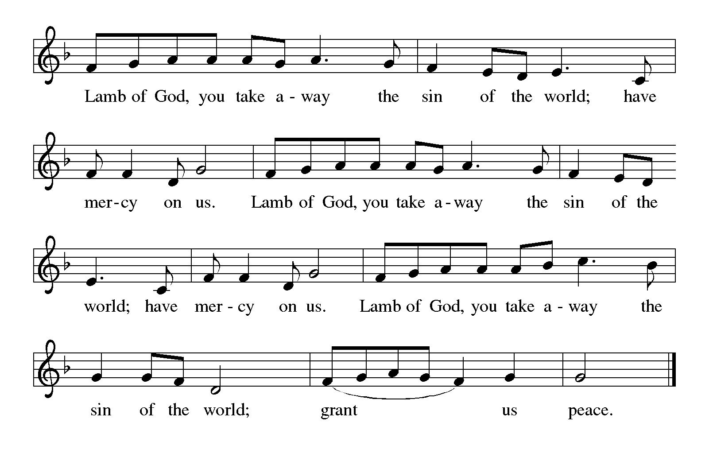

TABLE BLESSING
The body and blood of our Lord Jesus Christ strengthen you and keep you in his grace forever.
Amen.

Prayer after Communion
Let us pray. (brief silence)
God of abundance, with this bread of life and cup of salvation you have united us with Christ, making us one with all your people. Now send us forth in the power of your Spirit, that we may proclaim your redeeming love to the world and continue forever in the risen life of Jesus Christ, our Lord.
Amen.

Sending Announcements

Blessing
The God of glory,
☩ Jesus Christ, name above all names,
and the Spirit who lives in you,
bless you now and forever.
Amen.

Sending Song How Firm a Foundation (ELW 796)

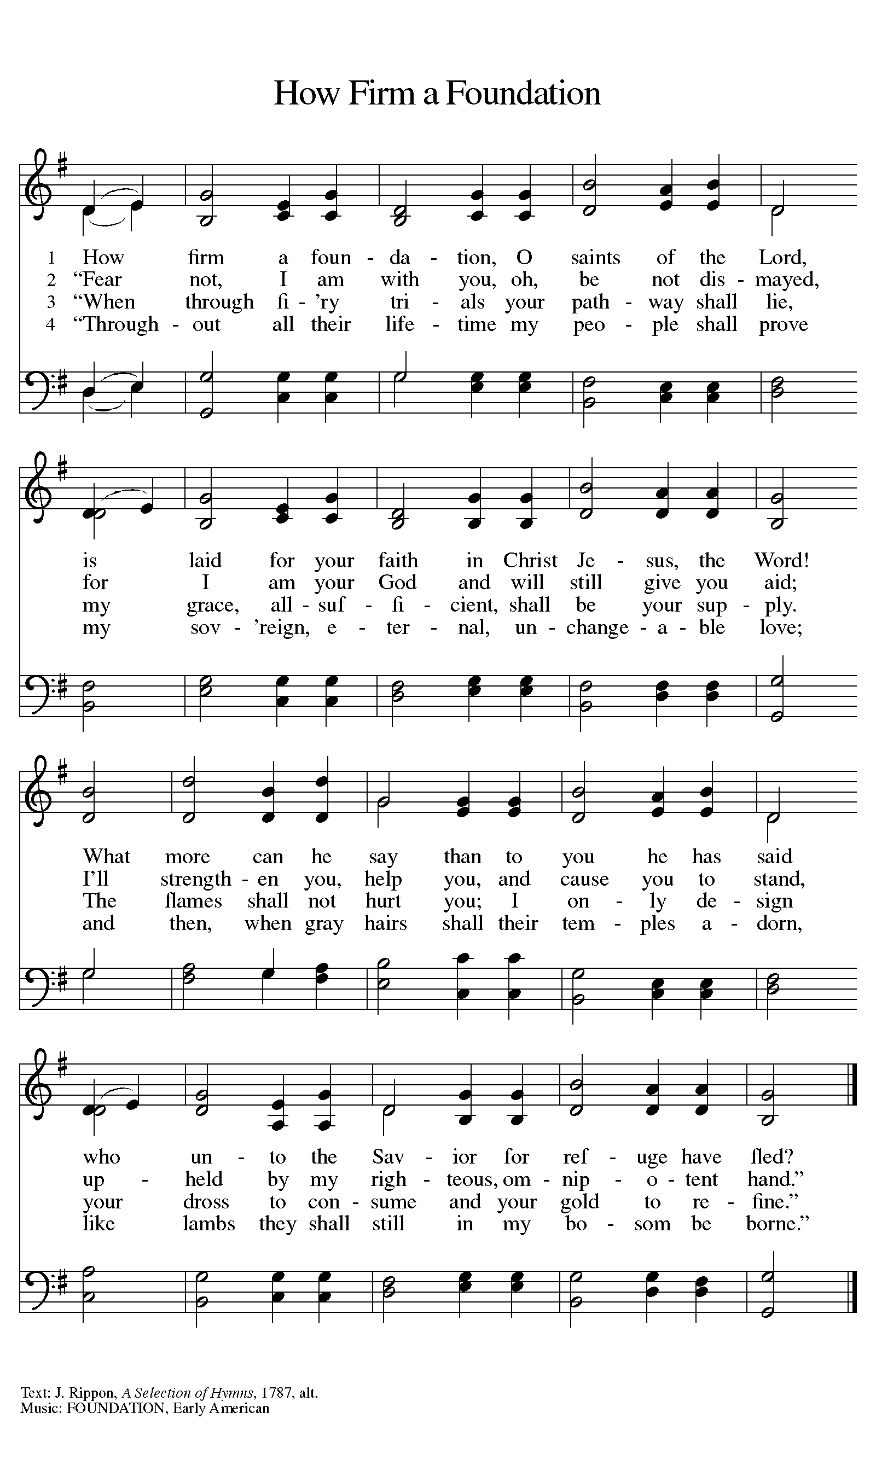

Dismissal
Go in peace. Serve the Lord.
Thanks be to God.

From sundaysandseasons.com
Copyright © 2026 Augsburg Fortress. All rights reserved.

