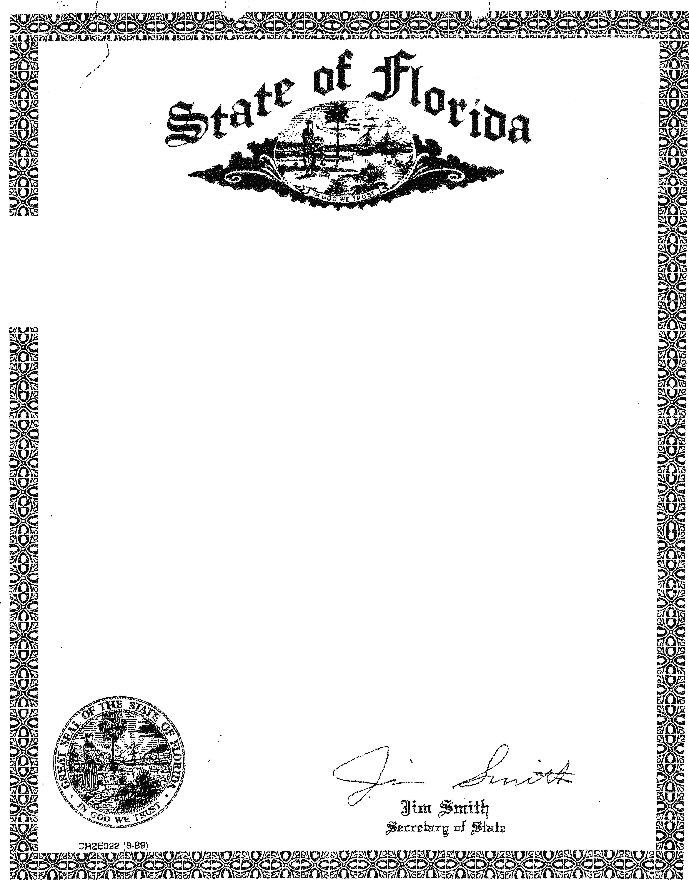

Department of State

I certify that the attached is a true and correct copy of the
Articles of Incorporation of LELY RESORT MASTER PROPERTY OWNERS
ASSOCIATION, INC., a corporation organized under the Laws of the State of Florida, filed on March 8, 1990, as shown by the records of this office.

The document number of this corporation is N36991.

Given under my hand and the
Great Seal of the State of Florida
At Tallahassee, the Capital, this the
8th day of March, 1990.

ARTICLES OF INCORPORATION FOR

LELY RESORT MASTER

PROPERTY OWNERS ASSOCIATION, INC.

The undersigned, for the purpose of forming a not-for-profit Corporation in accordance with the laws of the State of Florida, hereby acknowledge and file these Articles of Incorporation in the office of the Secretary of the State of Florida, an certify as
follows:

ARTICLE I

The name of this corporation shall be Lely Resort Master Property Owners Association, Inc. For convenience, the corporation shall be referred to as the "Corporation".

ARTICLE II
PURPOSES AND POWERS

The Corporation shall have the following powers:

A, To promote the health, safety and social welfare of the owners of property within Lely Resort, a community located near the city of Naples in Collier County, Florida and described on Exhibit A attached hereto and made a part hereof and hereinafter referred to as "the Properties".

B. To provide for maintenance service and such other services ("Community Services”) the responsibility for which has been imposed upon and delegated to the Corporation pursuant to the Declaration of General Covenants, conditions and Restrictions for Lely Resort.

C. To carry out the duties and obligations and receive the benefits given the corporation by the Declaration of General covenants, Conditions and Restrictions for Lely Resort.

D. To establish By-Laws and Rules and Regulations for the operation of the Corporation and to provide for the formal administration of the Corporation; to enforce the By-Laws, the Rules and Regulations of the corporation and the Declaration of General Covenants, Conditions and Restrictions for Lely Resort.

E. To contract for the management of the Properties and for the furnishing of the Community Services and to delegate to the party with who such contract has been entered into the powers and duties of the corporation.

PAGE -1-

Lely\Resort\MasterPOA.art

F. To acquire, own, operate, mortgage, lease, sell and trade property, whether real or personal, as may be necessary or convenient in the administration of the Properties.

G. To levy and collect assessments against Members of the Lely Resort Master Property Owners Association, Inc. in order to pay all expenses of the corporation as provided in the Declaration of General Covenants, Conditions and Restrictions for Lely Resort.

H. To manage, maintain, insure, equip, improve, repair, reconstruct, pay taxes and expenses, replace and operate the Properties and provide the Community Services and to contract with others for such Properties.

I. To grant easements, licenses, rights-of-way, etc., over and across the Properties.

J. The corporation shall have all of the common law and statutory powers of a Corporation not-for- profit which are not in conflict with the terms of these Articles, and the Declaration of Restrictions and Protective Covenants for Lely Resort.

ARTICLE III
MEMBERS

The members of the corporation shall be Lely Develop1nent Corporation, Triangle Properties Southwest, Inc., Associated Real Estate Southwest, Inc., Eagle Consolidated, Inc., Flamingo Properties of Naples, Inc. and Resort Development of Collier County, Inc., so long as they own all or any of the land subject to the Declaration of General Covenants, Conditions and Restrictions for Lely Resort; the owner of the Hotel Site described on Exhibit B; and all record owners of a dwelling unit and/or plot as defined in the Declaration of General Covenants, Conditions and Restrictions for Lely Resort. Membership shall be appurtenant to and may not be separated from ownership of a dwelling unit and/or plot.

ARTICLE IV
EXISTENCE

The Corporation shall have perpetual existence.

ARTICLE V
VOTING RIGHTS

Each member shall have one (1) vote for each dwelling unit and\or plot owned by it. The owner of the Hotel shall have one (1) vote for each room in the Hotel.

PAGE -2-

Lely\Resort\MasterPOA.art

ARTICLE VI
SUBSCRIBERS
The name and address of the Subscriber to these Articles of
Incorporation is as follows:
John F. Stanley
2660 Airport Road south
Maplesr Florida 33962

ARTICLR VII
BOARD OF DIRECTORS

The Initial Board of Directors shall consist of three (3}
Directors. The names and addresses of the Initial Directors are:

NAME

John J. Agnelli

Evelyn M. Cryder.

David N. Blank
ADDRESS

373 Bay Meadows Drive
Naples, Florida 33962

134 Arctic Way
Naples, Florida 33962

7GB Sea Co1J.rt
Marco Island, Florida 33937

The number of directors may be either increased or decreased from time to time by the By-Laws, but shall never be less than 3.
At the first Annual Meeting and at each Annual Meeting there after the members shall elect Directors for terms as set forth in the By-Laws. Directors need not be members of the Corporation.

ARTICLE VIII
OFFICERS

The affairs of the Corporation shall be administered by the Officers designated in the By-Laws, who shall serve at the pleasure of said Board of Directors. The names and addresses of the Officers who shall serve until the first election of Officers pursuant to the provisions of the By-Laws are as follows.

NAME
TITLE ADDRESS

John J. Agnelli President 372 Baymeadows Drive
Naples, Florida 33962.

David N. Blank Vice-President 768 Sea Court
Marco Island, FL 33937

Evelyn M: Cryder Secretary/Treasurer 134 Arctic way
Naples, Florida 33962
PAGE -3-
Lely\Resort\MasterPOA.art

ARTICLE IX
BY-LAWS

The original By-Laws of the corporation shall be adopted by the Initial Board of Directors. Thereafter, the By-Laws may be altered, amended or rescinded only in the manner provided for in By-Laws. Such alteration, amendment or rescission of the By-Laws may not be adopted and shall not become effective without the prior written consent of Lely Development Corporation for as long as it is a member.

ARTICLE X
TRANSACTIONS IN WHICH DIRECTORS OR OFFICERS
ARE INTERESTED

In the absence of fraud, no contract or other transaction between the Corporation and any other person, firm, association, corporation or partnership shall be affected or invalidated by the fact that any Director or Officer of the Corporation is pecuniarily or otherwise interested in such contract or other transactions, or in any way connected with any person, firm, association, corporation or partnership which is pecuniarily or otherwise interested therein. Any Director may vote and be counted in determining the existence of a quorum at any meeting of the Board of Directors of the Corporation for the purpose of authorizing such contract or transaction with like force and effect as if he were not so interested, or were not a Director, Member or Officer of such firm, association, corporation or partnership.

ARTICLE XI
INDEMNIFICATION

Every Director and every Officer of the Corporation shall be indemnified by the Corporation against all expenses and liabilities, including counsel fees reasonably incurred by or imposed upon the Director or Officer in connection with any proceeding or any settlement thereof to which the Director or Officer may be a party, or in which the Director or Officer may come involved by reason of the Director or Officer being or having been a Director or Officer of the Corporation, whether or not a Director or Officer at the time such expenses are incurred, except in such cases wherein the Director or Officer is adjudged guilty of willful misfeasance or malfeasance in the performance of the Director’s or Officer's duty; provided that in the event of a settlement, the indemnification herein shall apply only when the Board of Directors approves such settlement and reimbursement as being for the best interest of the Corporation. The foregoing right of indemnification shall be in addition to and not exclusive of all rights to which such Director or Officer may be entitled.

PAGE -4-

Lely\Resort\MasterPOA.art

ARTICLE XII
INITIAL REGISTERED OFFICE, AGENT AND ADDRESS

The principal office of the Corporation shall be at 2660 Airport Road South, Naples Florida 33962, or at such other place, within or without the State of Florida as may be subsequently designated by the Board of Directors. The initial registered office is at the above address and the initial registered agent therein is John F. Stanley.

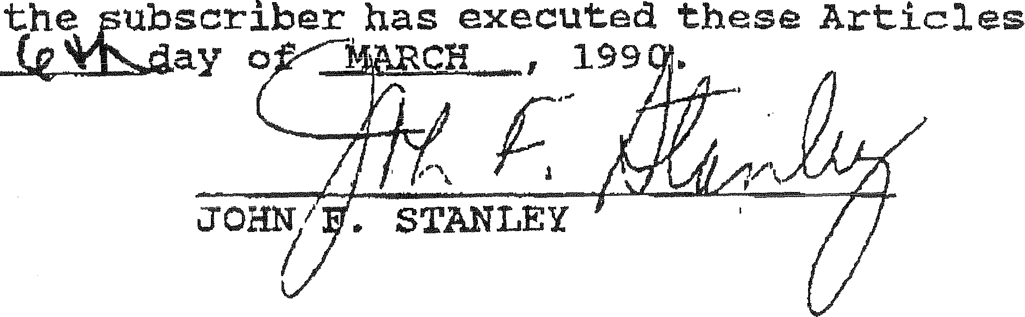
IN WITNESS WHEREOF,
of Incorporation, this

STATE OF FLORIDA )
:ss.
County of Collier )

I hereby certify that on this day, before me, an officer duly authorized in the state and County aforesaid to take acknowledgements, personally appeared JOHN F. STANLEY, well known to me and she acknowledged executing the foregoing Articles of Incorporation of Lely Resort Master Property Owners Association, Inc. for the uses and purposes expressed therein.

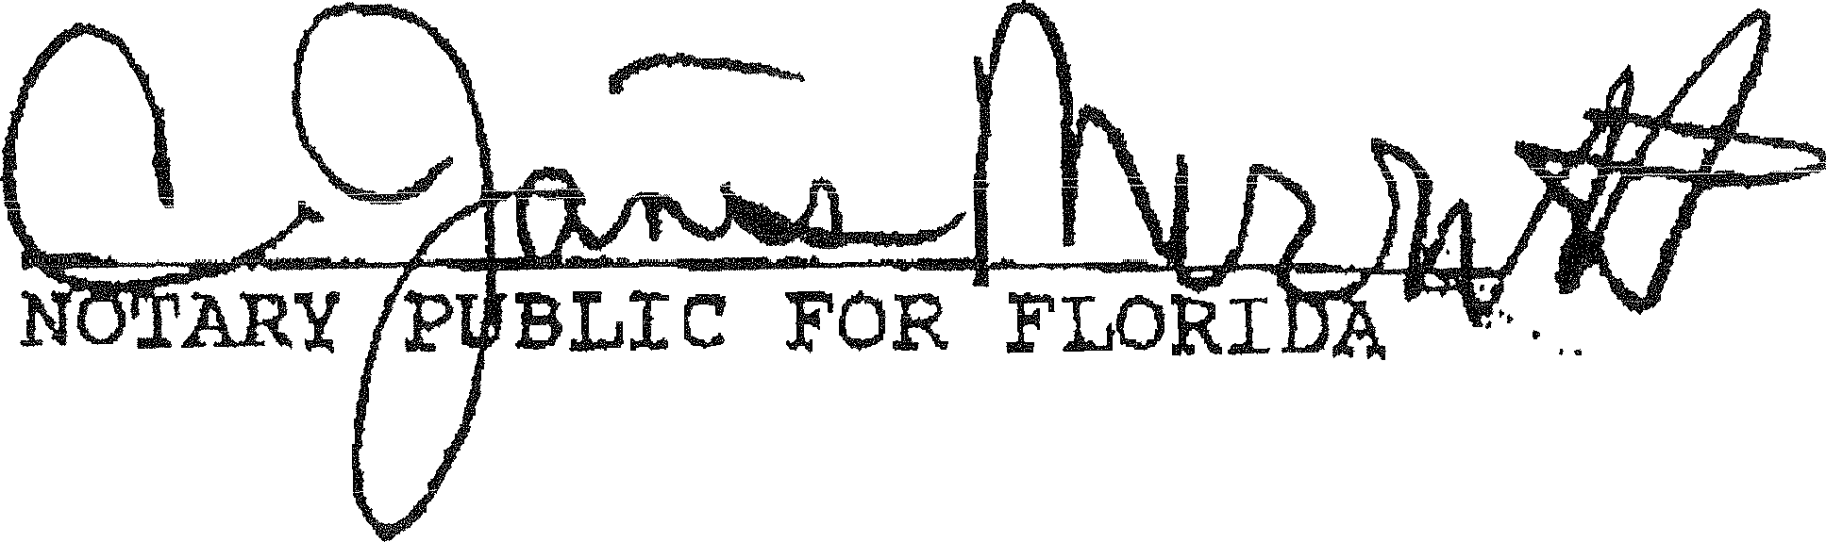
IN WITNESS WHEREOF, I have hereunto set my hand and affixed my official seal at Collier County, Florida, this 6th day of MARCH,1990.

My Commission Expires:

PAGE -5-

Lely\Resort\MasterPOA.art

CERTIFICATE DESIGNATING PLACE OF BUSINESS OR DOMICILE
FOR THE SERVICE OF PROCESS WITHIN THIS STATE
NAMING AGENT UPON WHOM PROCESS MAY BE SERVED

In pursuance of Chapter 48.091, Florida Statutes, the following is submitted, in compliance with said Act:

First, that Lely Resort Master Property Owners Association, Inc., desiring to organize under the laws of the state of Florida with its initial registered office as indicated in the Articles of Incorporation, at Naples, County of Collier, state of Florida, has named JOHN F. STANLEY, located at 2660 Airport Road South, Naples, Florida 33962, as its agent to accept service of process within the State.

ACKNOWLEDGEMENY

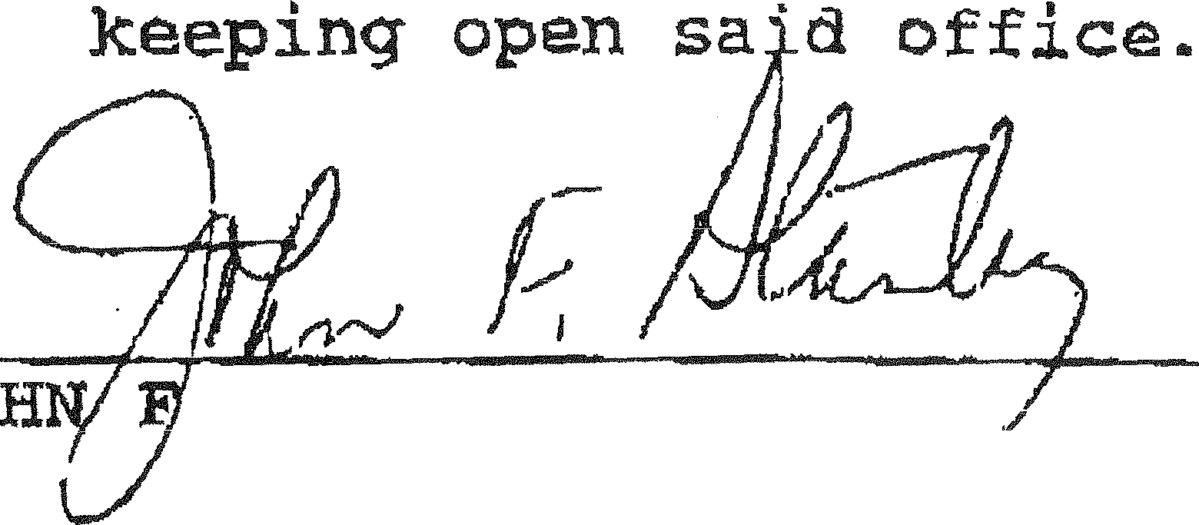
Having been named to accept service of process for the above styled corporation; at place designated in this certificate, I hereby accept to act in this capacity, and agree to comply with the provision of said Act relative to

JOHN F. STANLEY

PAGE -6-
Lely\Resort\MasterPOA.art

