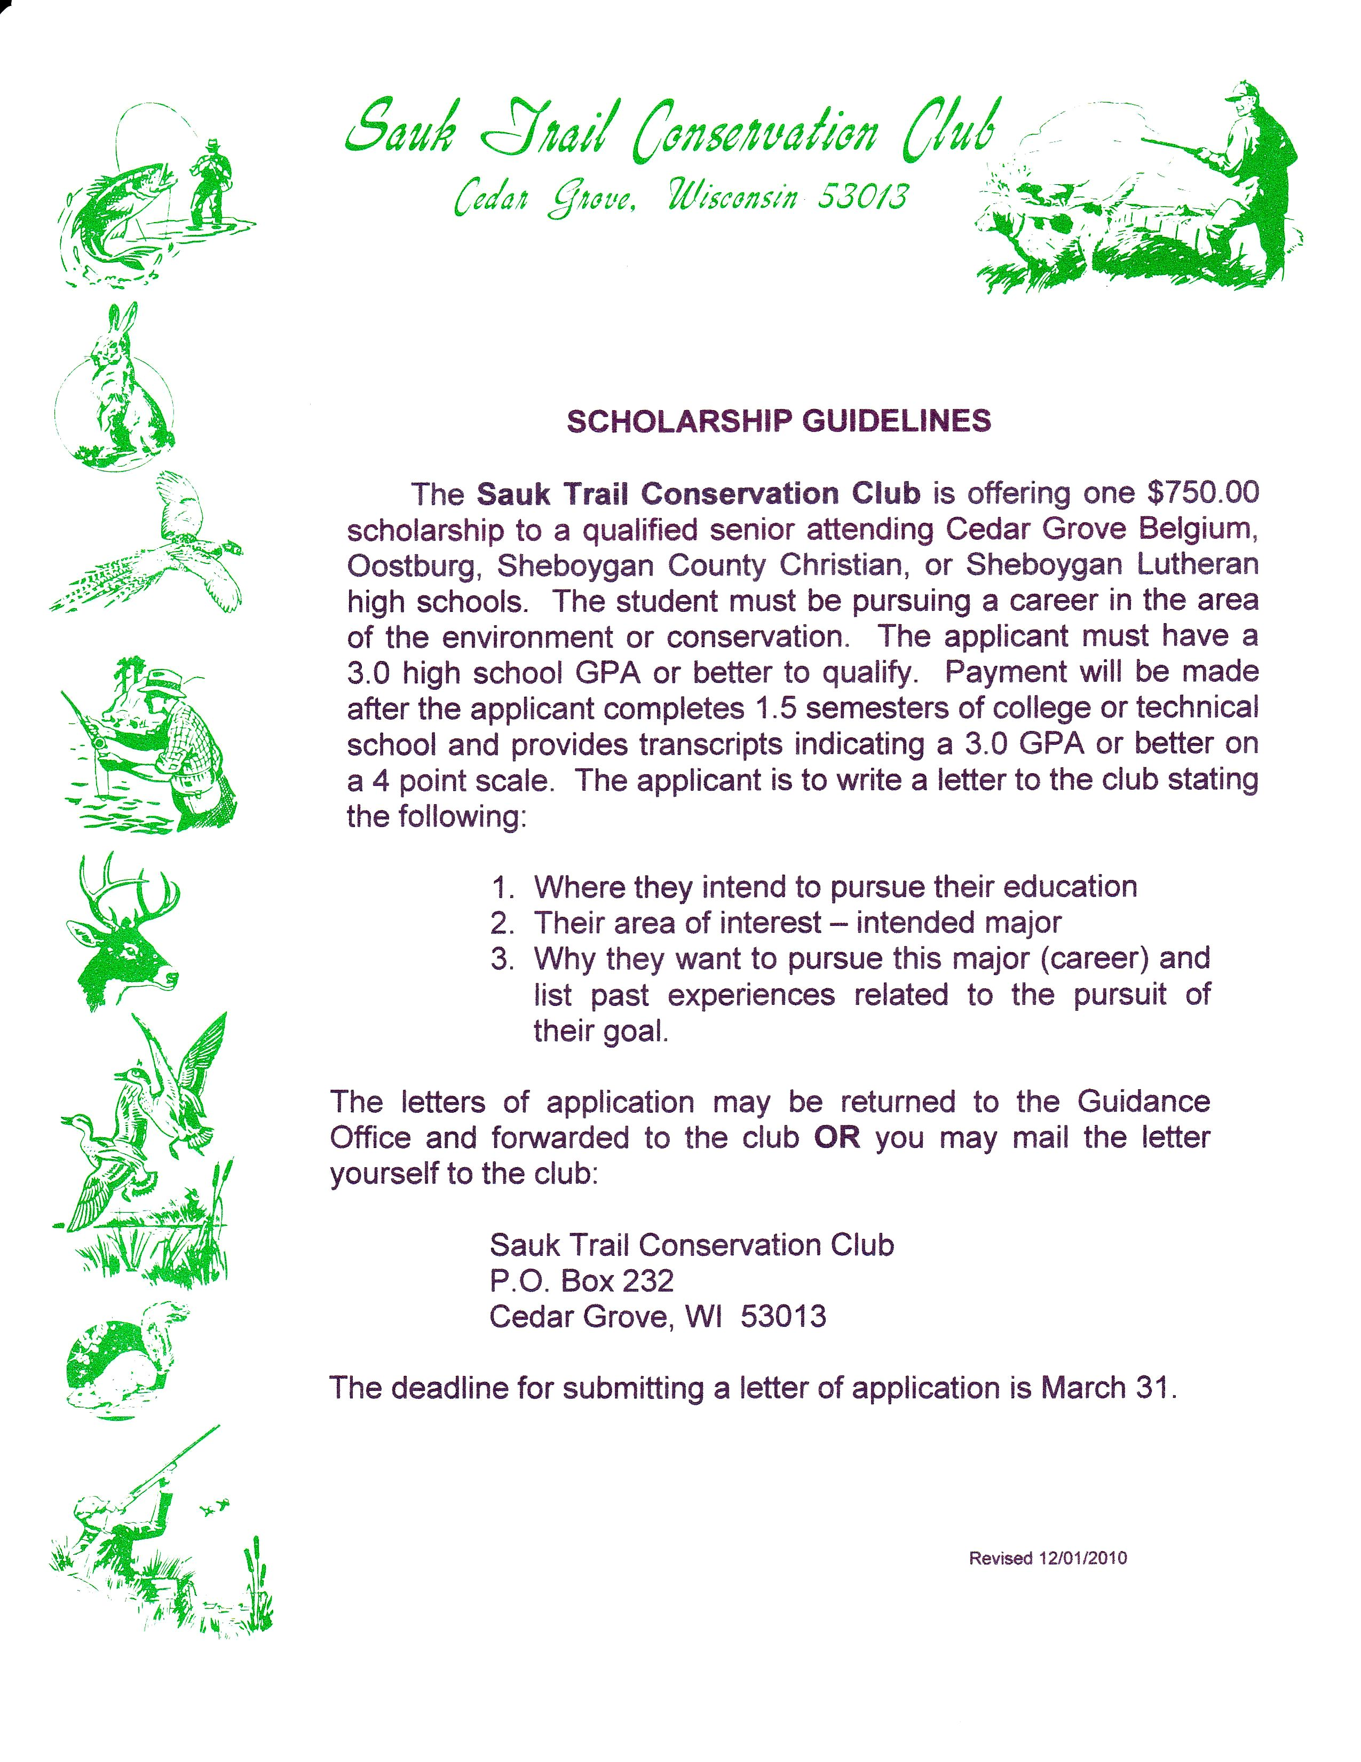
Please provide a transcript of your high school GPA with your application.

Revised 3/5/2011

SCHOLARSHIP GUIDELINES

The Sauk Trail Conservation Club is offering up to two $750.00 scholarships to qualified seniors attending Cedar Grove Belgium, Oostburg, Sheboygan County Christian, or Sheboygan Lutheran high schools. The students must be pursuing a career in the area of the environment or conservation. The applicants must have a 3.0 high school GPA or better to qualify. The applicants are to write a letter to the club stating the following:
- Where they intend to pursue their education
- Their area of interest – intended major
- Why they want to pursue this major (career) and list past experiences related to the pursuit of their goal.

Payment will be made after the applicant completes 3 semesters and 36 credits at an accredited college or technical school and provides transcripts indicating a cumulative 3.0 GPA or better on a 4 point scale and progression towards an environmental or conservation related degree.

The letters of application may be returned to the Guidance Office and forwarded to the club OR you may mail the letter yourself to the club:

Sauk Trail Conservation Club
P.O. Box 232
Cedar Grove, WI 53013

The deadline for submitting a letter of application is March 31.
Please provide a transcript of your high school GPA with your application.
Revised 5/7/2014

