***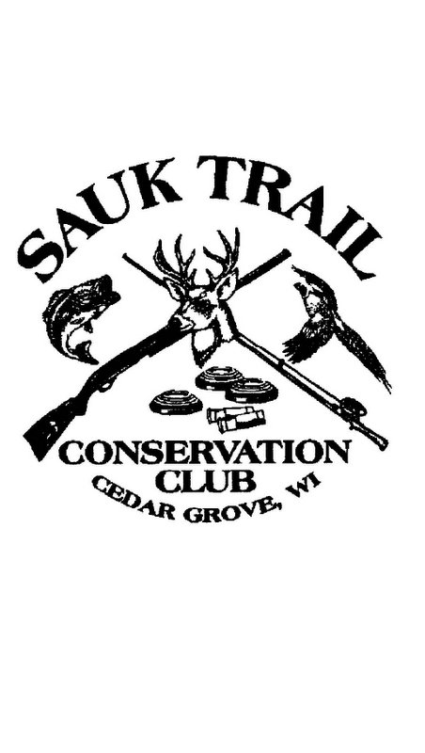*Welcome to the Sauk Trail Conservation Club Banquet**

This banquet is our main fund raising event each year. We thank you for coming.

Each year the Sauk Trail Conservation Club offers two scholarships to graduating seniors from Cedar Grove-Belgium High School, Oostburg High School, Sheboygan County Christian High School and Sheboygan Lutheran High School.

In addition to offering scholarships the Sauk Trail Conservation Club supported the following conservation and community centered causes in 2019:

First Reformed Church Beast Feast, Trees for Tomorrow, Pheasants Forever, Sheboygan Falls Conservation Club Youth Skeet Shooting program, Wisconsin Wildlife Federation, Maywood Environmental Park, Sheboygan Share the Spirit, Wounded Warriors, Sheboygan County Conservation Club, Cedar Grove Holland Festival, Sheboygan County Pheasant Release Program and the Ranger Rick Reading program at the Oostburg Public Library.

In addition to contributions to the above causes we continue to provide our annual hunters safety certificate program each spring. The course is very popular and we consistently service over 40 youth and adults each year. As a club we provide the facilities and the instructors. The instructors put in tons of hours both in class and preparation. If you see an instructor, be sure to thank them.

As a club we are happy to supply the “home field” and the coaches for the high school trap shooting teams from Cedar Grove-Belgium High School and Oostburg High School/Sheboygan County Christian High School.

Perhaps you know us best for providing shooting ranges for Monday night and Thursday night trap leagues in addition to special shoots throughout the year.

Everything we do throughout the year is made possible because of the funds we raise at this banquet.

**We thank each of our sponsors. Without their generous donations this banquet wouldn’t be possible. Please support them like they support us.**

**Platinum – over $500**

Daane Ace Hardware,D-D Meat Processing**,** DenBoer Construction, Intrepid Sport Fishing, Oostburg State Bank, Straight Arrow Financial Services-Pete Heimerman, Daane Electric**,** Lukens Excavating

**Gold – over $100**

Advance Comfort HVAC, Alicia Stollberg – Gerber Knives, Bill and Sue Theune, Blackhawk Shooting Sports, Blue Harbor Resort, Calvin and Jean VanEss, Cedar Grove Veterinary Services, Cedar Grove Warehousing, Claerbout Furniture and Flooring, Corevac, Cutting Edge Construction, Daane Electric, Dan Nett, Dave Nett, Dutchland Plastics, Fat Boys Bait and Tackle, Gerard Trimberger, Gibbsville Cheese, Hartman Chiropractic, Hubert Nett, Joe Trimberger, Lukens Excavating, Luedtke Electric, M&R Super Service, Mantech - All Fab, Pleasant View Tree Farm, Quality State Oil, Rathjen Greenhouse, Rich Kettenhoven, Richline Builders, Robb and Tiffany Leonhard/Viking Masek, Riveredge Taxidery, Serenity Farms, State Farm Insurance – Brian Gesch, Todd and Tammy Daane, Thunder Auto, Tom Katjna, VanEss Small Engine Repair, Wayne DeBlaey, Wensink Heating, Wild Wings Club Campbellsport, Zeke and Sally Lensink

**Silver**

American Family Insurance, Auto Enterprises Inc., Carl Nyhof Trucking, Cedar Grove Hardware Hank, DeTroye Electric, Dirkse’s Piggly Wiggly, Double A Auto Body, Flipse Insurance, Gary Theune, Gibbsville Implement, Homefront Restaurant, Images By Maggie Day Spa, James Onnink, Joose Trucking, Judi's Place, Kaat’s Specialty, Kim Verheslt, Kirby's Auto, Lakeshore Weekly, Mary’s Country Grove Restaurant, Mentink’s Market, Mike and Cheri Coernen, Mike Stauber Gun Repair, Nyhof Custom Gutter, Oostburg Bakery, Oostburg Financial Services, Oostburg Lumber, Principle Financial – Randy Roethel, Sauk Trail Youth Trap, Shear Imagination, Shuff’s Last Resort, Sports Core, Steve’s Painting, Tenpas Drywall, Terry’s Upolstery, Voskuil Machine Co, Wenig Funeral Home, Willman Industries,

Sauk Bucks were purchased when you registered. No Sauk Bucks are for sale this evening. Sauk Bucks are only good for this evening, they don’t carry over to next year. Use ‘em or lose ‘em.

Sauk Bucks are good for all table games or raffles except The Ticket Raffle, 10x Raffle, The Shell Game and the 50/50 Raffle. Sauk Bucks **cannot** be used at the bar.

**Table Games**

**Mystery gun**: One ticket wins the gun. No one knows what’s in the box. Win it and find out. Cash and Sauk Bucks can be used for this game. Gun provided by DenBoer Construction

**Youth Table**: Bucket raffle. Must be 16 or under to play this game. Cash and Sauk Bucks can be used for this game. Prizes provided by Huby, Dave and Dan Nett, Sauk Trail Youth Trap.

**Shell Game**: Pick a shell and the color of the shell determines how many Sauk Bucks you win, between $10 and $100. Everyone is a winner. **CASH ONLY** for this game.

**Pick Your Price**: Pick a slip from the board and you pay what the slip says for a ticket to win the gun. There are two boards; the Rifle board donated by Robb and Tiffany Leonhardt/Viking Masek and the Shotgun board donated by Dutchland Plastics and VanEss Small Engine Repair. Cash and Sauk Bucks can be used for this game.

**After The Hunt (aka The Ladies Table)**: Bucket raffle, put your tickets in the bucket and we pick winners until the prizes are gone. Cash and Sauk Bucks can be used for this game.

**Gun Board**: Bucket raffle, put your tickets in the bucket of any gun you are interested in winning. Cash and Sauk Bucks can be used for this game.

**Package Table**: One ticket will win the entire package, guns and all. Cash and Sauk Bucks can be used for this game.

**Chinese Raffle**: This is a bucket raffle, put your tickets in the bucket of any prize you are interested in winning. Cash and Sauk Bucks can be used for this game. Gun provided by Straight Arrow Financial Services-Pete Heimerman.

**Mantech All Fab Dog Box**: One winning ticket wins the dog box. Cash and Sauk Bucks can be used for this game.

**Beef Raffle**: One winning ticket wins a ¼ beef. Donated by D-D Meat Processing. Cash and Sauk Bucks can be used for this game.

**Walk Around Raffles (in order of appearance)**

**Can Raffle** – everyone donating a non-perishable food item receives a ticket for a special prize. Donated food items will be given to the Faith Reformed Church Food Pantry.

**50/50 raffle**: A single winning ticket wins half of the pot. $10 each. **CASH ONLY**

Floor Raffle #1 **Ticket Raffle**: win seven tickets for the Mystery Gun, seven tickets for After The Hunt, seven tickets for the Gun Board, seven tickets for the Package Table and an arm’s length of tickets for the Chinese Raffle. Tickets are $2 each or 3 for $5. **CASH ONLY**

Floor Raffle #2 $500 **Lake Michigan Charter Fishing** trip sponsored by Intrepid Sport Fishing. $10 each or 3 for $20. Cash or Sauk Bucks can be used for this raffle.

**10X Raffle -** Each place setting has an empty envelope. Place any amount of cash in the envelope between $1 and $20. After dinner we will collect the envelopes. One envelope will be selected and the winner will get 10 times the amount in the envelope in cash. **CASH ONLY**

**Ben Franklin**: five people win $100 Sauk Bucks. Ben Franklin tickets were ordered when you registered.

**SOYN**: 12 names are drawn. You decide to pick a name or pass. Once everyone agrees to pass the remaining people split $500 in cash. SOYN tickets were ordered when you registered.

Floor Raffle #3 **15 Bird Hunt and 870** sponsored by Wild Wings, Joe Trimberger and Gerard Trimberger. $10 each or 3 for $20. Cash or Sauk Bucks can be used for this raffle.

Floor Raffle #4 **Revolver Raffle** sponsored by Oostburg State Bank: one winning ticket wins the gun. $10 each or 3 for $20. Cash or Sauk Bucks can be used for this raffle.

**Heads or Tails**: $10 to enter sponsored by Gibbsville Cheese. Everyone lines up and chooses either heads or tails. Coin is flipped and losers sit. Repeat until there is a single winner who goes home with the gun.

Floor Raffle #5 **Big Gun** Raffle sponsored by Lukens Excavating: One winning ticket wins the gun. $10 each or 3 for $20. Cash or Sauk Bucks can be used for this raffle.

Floor Raffle #6 **Pick A Gun** sponsored by Daane Ace Hardware: **one** winning ticket gets to pick **on**e gun. ***Only one winner, only one gun.*** $10 each or 3 for $20. Cash or Sauk Bucks can be used for this raffle.