Bee Leaf USA Inc.

Beginning Beekeeping/Hive Management Course Syllabus
Objective: To provide the knowledge and resources for anyone to become a beekeeper.

Session 1: Introduction to Beekeeping Topics:
- Why beekeeping
- History of beekeeping
- Social order of honey bee colony- queen, workers, drones
- Stages of honey bee development- eggs, larvae, pupae
- Anatomy of a bee hive- brood chamber, resource comb, propolis, airflow/space
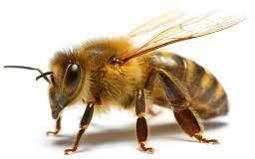
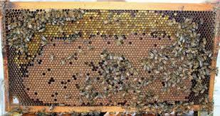
- Colony activity during the year- Spring buildup, foraging, Wintering, swarming Activity 1: Why beekeeping discussion and general thoughts on bees.

Student Notes:

Session 2: Equipment Topics:
- Hive components- bottom board, brood box, frames, queen excluder, honey super, inner cover, lid
- Hive Types- langstroth, top bar, flow hive
- Protective gear- bee suit, veil, gloves, boots
- Tools- hive tools, smoker, bee brush, straps

Activity 2: Let class examine all equipment and build a bee box themselves.
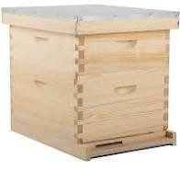

Student Notes:
Session 3: About the colony Topics:
- Types of bees- italian, russian, africanized, more?
- Pheromones
- Life stages of worker, drone, queen
- Division of labor
- Swarming

Activity 3: Observation hive brought into class.
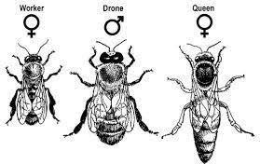
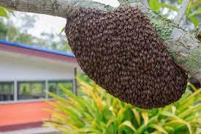
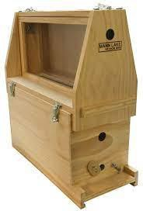

Student Notes:

Session 4: Starting a colony Topics:
- Location choice- water source, direction of entrance, amount of sunlight, windbreak, access, away from populated areas
- Site prep- level, weed block, gravel, stand, hive components, ant control
- Colony type- 10 frame hive, 5 frame nuc, package, swarm
- Feeding- in hive vs. public
- Inspecting- laying pattern, resources, drawing new comb, pests

Activity 4: Take class to apiary for a simple inspection, note all site prep and location choices.
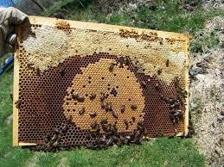

Student Notes:

Session 5: Pests and disease Topics:
- Mites- varroa, tracheal
- Disease- deformed wing virus, nosema, American foulbrood, chalkbrood, sacbrood
- Hive beetles
- Wax moths
- Pesticides
- Other- ants, spiders, hornets, wasps, mice

Student Notes

Session 6: Products of the hive Topics:
- Bees
- Honey
- Comb honey
- Wax
- Pollen
- Propolis
- Royal jelly
- Apitherapy

Activity 6: Honey tasting and product of the hive showing. Self-administered bee sting by instructor.
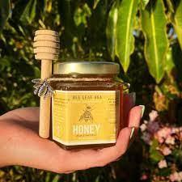
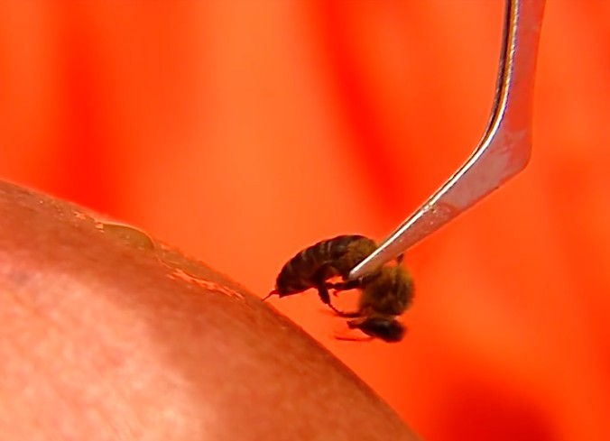

Student Notes:

Session 7: Managing your bees Topics:
- Seasonal management
- Increasing/decreasing hive space
- Inspections- when, what to look for, internal, external
- Checking food stores
- Food/water sources- natural and artificial water sources, flowering plants and tree (bloom period), feed and pollen substitutes (sugar, nutrients, pollen patties)
- Nectar flow
- Ventilation/moisture control
- Burr comb/managing old comb
- Requeening
- Pest control/prevention

Student Notes:

Session 8: In the Hive (Field Day Inspection) Topics:
- Light smoker and inspect a hive (instructor first, then students)
- Check for brood pattern, find queen, check for pests
- Identify workers, drone, queen
- Identify eggs, larvae, capped drone brood, capped worker brood, pollen, honey
- Show steps needed for prep for honey flow- add queen excluder/super
- Show steps of treatment for disease
- Show steps for wintering hives- checking honey stores, feeding, entrance reducers

Activity 8: Take class to apiary for each student to run an inspection. Used as an indicator of prowess.
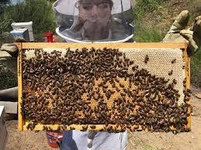
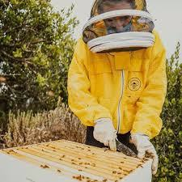
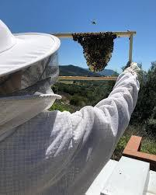

Student Notes:

Session # 1: Introduction to Beekeeping
Why beekeeping
- Beekeeping is done for various reasons spanning from a backyard hobby, profession, passion/lifestyle. The most common forms of beekeeping today in the 21st century are
    - Commercial Beekeeping – Tends to be migratory in nature and follows nectar flows and pollination contracts. Rooted in obtaining profits.
    - Residential/Backyard Beekeeping – Tends to be a Hobby or Passion where the driver is Honey and Property Pollination. Can have spiritual & therapeutic effects.
    - Science Based Beekeeping – Seeking to expand the understanding of bees, beekeeping, honey, etc.
    - Treatment Free Beekeeping – Hands off Beekeeping Philosophy rooted in the Darwinian concept of “Survival of the Fittest.”

  - Health benefits of Honey
    - Antibiotic
    - Antifungal
    - Beneficial Bacteria
    - Low Calorie Sweetener
    - Natural Sweetener
    - Health benefits of Keeping Bees
      - Apitherapy is a therapy that uses beehives and bee products including honey, propolis and royal jelly to strengthen the immune system and health. The Ancient Egyptians were the first to use apitherapy in their daily lives. Inhaling the air from beehives has positive effects on psychophysical wellbeing.
      - Bee Stings – Meticulously placed beestings can reduce and even eliminate the symptoms of Lymes Disease, MS, rheumatoid arthritis and other debilitating diseases. Bee Venom Therapy Sessions involves receiving up to 40 stings upon the meridians of the body to activate and stimulate certain centers of the body in need of healing.
      - Mental Flow State – Stressors are turned off and you can move freely while accomplishing, bound to real structure outsode the mind and allows for unlimited energy for the task at hand
      - Beehive Breathing – Breathing Beehive air therapy is recognized as a potential remedy for treating asthma, bronchitis, lung fibrosis, and respiratory tract infections. Developed countries in which beehive air therapy is currently authorized include Germany, Hungary, Slovenia, and Austria.

History of Beekeeping

The first written human records of honeybee interaction are about 10,000 years old and are found on the prehistoric cave drawings with an estimated date of 8,000 BC. The below depiction is a drawing that is roughly that old coming from Mesolithic Age.

Similar records are held in Spain but depict actual beekeeping in 5000 BC but the in this, we see that they are actually keeping the bees, using smoke around hives, etc.

Egyptians associated the bees with religious and spiritual significance and were also some of the first to practice beekeeping during the time of the “Old Kingdom” and even stored honey in jars, pottery, and even old sarcophagus’

Modern Beekeeping
1538 – Spanish import the first European honey bees to South America.
1682 – George Wheler – an English clergyman and travel writer, discovers and describes Greek hives (forerunner of modern hives with movable frames).
1700 – Again according to the book “Bee” above, written by Claire Preston, it wasn’t until 1700 that it was understood bees gather nectar from flowers with which honey is made. Prior to this time, it was thought the honey was collected by the bees ready-made in the flowers!
1838 - Johann Dzierzon, a Polish apiculturist, devised the first practical movable-comb beehive, which allowed manipulation of individual honeycombs without destroying the structure of the hive.
Dzierzon discovered the phenomenon of parthenogenesis in bees (- in 1835 Dzierzon discovered that drones are produced from unfertilized eggs. Dzierzon's paper, published in 1845, proposed that while queen honey bees and female worker bees were products of fertilization, drones were not, and that the diets of immature bees contributed to their subsequent roles).
1851 – L.L. Langstroth of Philadelphia USA – the "father of American beekeeping had access to translations of Dzierzon's works., built upon the design of Dzierzon, and others (such as Francis Huber of Switzerland), and designed a completely movable frame hive.

Social Order of the Honeybee Colony

The social organization of the honey-bees is established by the living of all individuals within the colony and they show the mutual cooperation among the members of the colony, and exhibit the overlapping generations. There are three known classes.

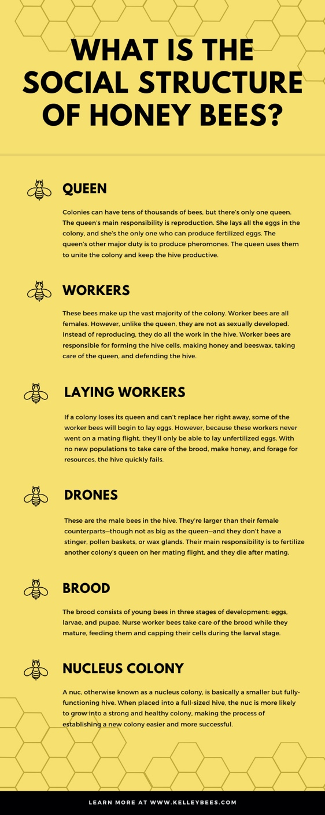

Stages of Honey Bee Development-

Honeybees, like butterflies, go through a process of metamorphosis and require help from other bees to assist them in becoming a fully developed adult. They have 4 stages of development.

- Eggs – the worker bees clean and prepare the cells for the queen to lay eggs; she hatches one egg in each cell. She positions the egg in an upright position at the bottom of the cell. (noticing changes of this inside the broods nest is a sign of a young Queen). The she goes on to fertilize the egg, this develops into a worker bee. The drones are developed from non-fertilized eggs. It is the responsibility of the workers to balance the ratio of female bees and drones.
- Larvae – Three days after the queen hatches the egg, it develops into larva. Healthy larvae can be identified by their snowy white color curling up at the corner of the cells. The larva takes a couple weeks to grow and shed their skin over 5 times. These tiny creatures have large appetites; they consume over 1300 meals a day. It is the responsibility of the nurse bees to feed the larvae royal jelly and bee bread, a (mixture of honey & pollen). The larvae grow swiftly in just 5 days they grow 10 times their size. At this point, workers seal the them into their cells with beeswax while they spin their own cocoon from the inside. Behind this cocoon, the larvae is making its final stages of development
- Pupa – The larvae is now going through full metamorphosis and the grubby larvae takes shape as a bee. In this process the head detaches from the thorax and abdomen, the eyes, wings, and legs develop. We see the hairs on the honeybee head develop and the bee begins to chew her way out of her cell to start her life.
Anatomy of a Natural Bee Hive

Brood Chamber – Where all bees are incubated and most protected from invasion, pests, etc. It is the deepest portion of the hive and requires an internal temperature of about 97 degrees.

Resource Comb – Holds the honey, pollen, and nectar while acting as an insulator for the hives.

Propolis – Taken from the latin roots “pro” as in protection, and “polis” as in city, propolis literally represents the “protection of the hive” by creating a tacky substance that can encase the hive in a space.

Airflow/Space – Talking point

Session #2 Beekeeping Equipment
Topics Covered:
- Hive components- bottom board, brood box, frames, queen excluder, honey super, inner cover, lid
- Hive Types- langstroth, top bar, flow hive
- Protective gear- bee suit, veil, gloves, boots
- Tools- hive tools, smoker, bee brush, straps

Activity 2: Let class examine all equipment and build a bee box themselves.

Hive Components

Parts of a Beehive (Langstroth)
A basic configuration for a hive consists of seven components: a hive stand, bottom board, hive body, queen excluder, honey super, inner cover, and a hive cover.

1. Hive Stand
Wooden hive stand
A Hive Stand functions to elevate the hive off of the ground. This keeps the bottom board dry and helps to insulate the hive. Some beekeepers, depending on the region, opt to create their own hive stands

2. Bottom Board
Standard bottom board
The Bottom Board forms the floor in a beehive and provides a single point for bees to enter and exit the hive. This entrance has two settings: a wide setting for warmer months, and a reduced size for colder conditions. This single entrance also helps bees to defend the hive from possible threats. The bottom board should always be kept off of the ground for proper moisture control in the beehive.

2a. (Alternative) Screened Bottom Board
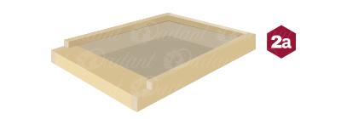Screened bottom board
Screened Bottom Boards have gained in popularity over the past few decades. By providing more ventilation, a screened bottom board keeps the beehive cooler in the summer and improves control of moisture levels in the winter.
Using a screened bottom board has also proved effective in keeping down Varroa mite numbers by allowing the mites to fall through the screen and out of the hives.

3. Hive Body (AKA Brood Chamber, Brood Nest, Brood Box, Deep Super)
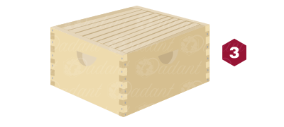9.5″ Hive bodies
Hive Bodies are wooden boxes that serve as the living quarters for the colony and sit directly on top of the bottom board. Measuring 9-½” tall, they are typically the largest components of the hive. Hive bodies hold either eight or 10 frames where the queen lays her eggs and workers store pollen and honey for food. Each hive body has enough space to house between 50,000 and 60,000 workers.

To allow room for expansion and prevent swarming, some beekeepers stack two hive bodies together to provide increased space. This configuration is especially useful in regions with cooler temperatures, as it allows for the larger colonies and increased food storage needed to survive the longer winters.

4. Queen Excluder
Queen excluder
The Queen Excluder is a flat section of the hive with a gauged metal grid. The precise size of the grid prevents the larger queen from leaving the hive body but allows worker bees to pass through. This restricts the queen to laying eggs and raising brood in the hive body while the workers fill frames in the upper sections with honey.

5. Honey Supers (AKA Shallow Super)
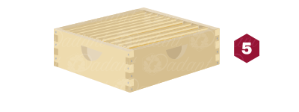Honey super
Honey Supers get their name from their position in the hive: they are “superior,” or above, the hive body. Available in 6-5/8″ and 5-11/16″ depths, they are smaller than hive bodies to keep them lighter and easier to handle when full of honey. When “pulling” or harvesting honey, beekeepers are removing full frames from honey supers to extract the honey they contain.

6. Inner Cover
Inner cover
The inner cover helps provide the proper amount of working space and ventilation bees need. Some suppliers offer a variety including the “innerview inner cover” made with two layers of laminated glass. This innovative design aids in insulation and allows beekeepers to easily check on their hives without disturbing the colony.

7. Telescoping Beehive Cover
Telescoping beehive cover
Using a telescoping cover that extends over the sides of the hive helps to protect the colony from inclement weather. However, it is very common for beekeepers to develop their own kind of lids that suit their goals. For example, some hives have migratory lids that promote easy stacking and storing of hives in transportation.

Types of Beehives

The Langstroth hive (pictured below) is the most common style in use today and a favorite for new beekeepers. The design was patented by Rev. Lorenzo Langstroth in the mid-19th century and features removable frames that the bees build comb in. Langstroth hives consist of boxes that stack on top of each other.
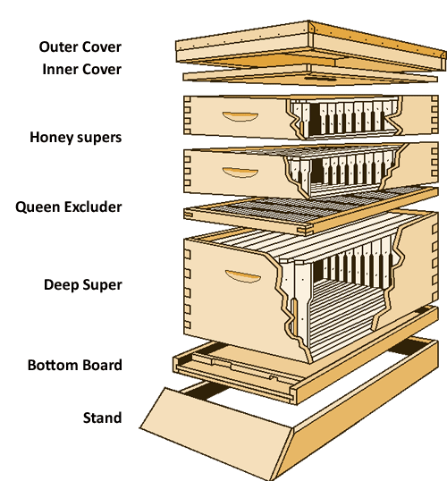

Types of Beehives (Continued)
The top bar hive is the oldest hive design in the world. A horizonal top bar hive features wooden bars that are laid along the top of the long box. One-piece bars are used instead of the 4-sided wooden frames of the Langstroth design. The honey bees build comb down from the top bars. No foundation is required, but the hive should be elevated off the ground with some sort of stand.
There are several advantages to a top bar hive. In addition to not needing foundation sheets, there are no wooden frames to assemble. Perhaps the biggest draw of the top bar hive: no heavy lifting. Unlike the Langstroth hive that requires moving several heavy hive boxes, management of a top bar hive is much easier on the beekeeper’s back.
Top bar beekeeping does have a few challenges, however. For example, a centrifugal honey extractor can not be used to remove honey from the natural comb, so the comb and honey will both need to be removed from the bar. This results in the honey bees having to make new comb each year. In general, top bar hives also require more frequent inspections to prevent overcrowding/swarming.

Types of Beehive (Continued)

The Warré (war-RAY) hive, created by Émile Warré in the mid 20th century,
is another top bar design. Instead of being a long horizontal top bar hive, the Warré hive is referred to as a vertical top bar hive. Identically sized stacked boxes have no frames or foundation sheets. Bees build honeycomb down from top bars placed within each box.
Beekeepers using the Warré style often “bottom-super” their hive: instead of putting empty boxes on top to give the colony more overhead room, empty boxes are placed at the bottom of the stack. They feel this arrangement better mimics bee life in the wild.
These are the three most popular hive designs, but every style has pros and cons! It is up to you to decide which type of beehive best suits your goals and management style. Closely follow plan directions if you choose to build your own bee hive of any style. Improperly built bee hives result in wayward comb, difficult inspections, and angry bees (and soon, stung beekeepers).
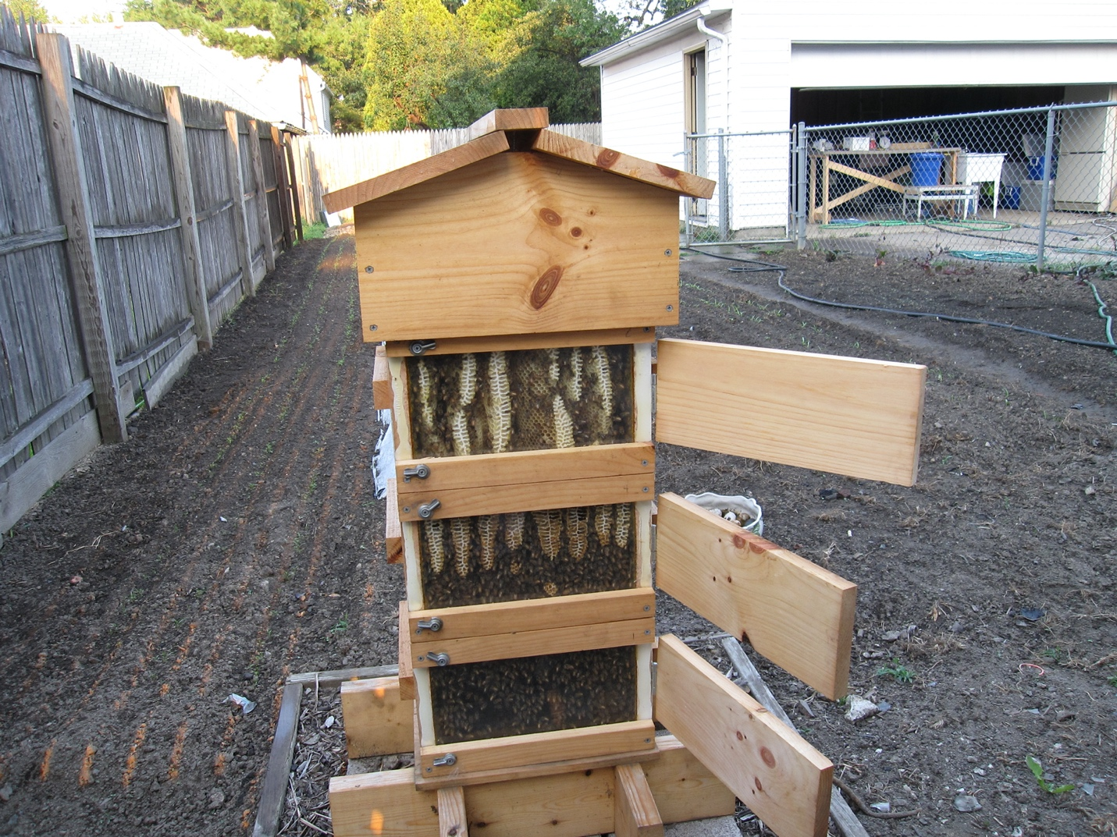

Protective Gear
Protective gear is an important piece of beekeeping because it allows us to be fully present with the bees while also being able to rely upon the gear to keep us safe. While many believe it is for the purpose of physical protection, it also serves to protect the mind from unwanted distractions

Bee Suits – Honeybee protection come in various suits that vary from region to region but typically, a three-layered ventilated bee suit is best in California for hobbyist beekeeping.

Gloves – Effective beekeeping gloves are typically made of goatskin or some kind of anima, skin. In recent days, beekeepers have begun utilizing heavy duty nitrile gloves that allow for more dexterity and sensitivity while in the have.

*Some beekeepers choose to bypass gloves as using their hands inside the beehives provides a more direct connection to the bees and requires them to move more slowly and fluidly through the hive inspection. *

Veil – A beekeeping veil covers the face of the beekeeper allowing for full visibility while remaining protected in the suit.

Boots – In Southern California, roughly 60-80% of feral honeybee colonies are Africanized demonstrating aggressive genetics. Therefore, in our region, boots should be worn at all times when keeping bees.

Session 3: About the colony
Topics:
- Types of bees
- Pheromones
- Division of labor
- Swarming

Types of Bees:

Apis:
The genus Apis—into which all honey bees fall—is a beautifully diverse bee species, with at least 44 known sub varieties. These are all united by traits of honey production, wax comb production, and living in a colony with a queen. They also demonstrate unique behaviors and characteristics that should be noted by keen beekeepers.

Apis mellifera—literally meaning honey-baring bee—is the most widely distributed and domesticated bee species in the world. Known for its striped yellow abdomen, large colony sizes, and propensity for enclosed communal hive-style living spaces (originally dead, hollowed trees) the European bee offers clear behavioral benefits to humans wanting to keep them. For the past 5,000 years, domestication has had a significantly impact on apis Mellifera’s genetics, selectively breeding out aggressive behaviors and prioritizing honey production and climate hardiness for their human utility. Due to these characteristics, our taste for honey, and our need for pollination services, apis Mellifera can now be found in many places it never previously existed, such as the USA, Australia, and South East Asia.

The Western honey bee, referred to scientifically as apis mellifera, plays a small but sweet role in the vast, global tapestry of bee species. There are over 20,000 known types of bee, spanning every continent bar Antarctica, and their ancestors have existed for over 80 million years. Bees are impressively pre-historic, global, and even after all this time, they’re still busy.
For most of history, geographic isolation—impassable areas such as high mountains, barren deserts, and expansive seas—created natural barriers to the spread of bee genetics. For apis Mellifera, the natural boundaries were the seas and oceans surrounding Western Europe (the Atlantic and Mediterranean), up to the Eastern Caucasian mountains and south as far as the Middle East.
Due to geographic pockets within Europe and selective breeding, apis Mellifera has developed a number of unique sub varieties on the continent and beyond. Below we will look at some of the popular sub varieties, though as you can see in the map legend above, there are many more to discover.

Key Honeybee Species:

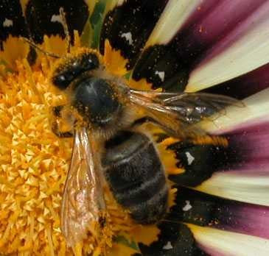
Apis Mellifera Mellifera
The Dark or German honey bee species.
The name is a bit of a mouthful, so let’s call them apis. M. Mellifera. These bees are a relative newcomer to Europe—if you consider the last Ice Age “relative”—which it is when we appreciate the vast history of bees. Apis m. Mellifera is smallish, stocky, and as the name suggests, ranges in color from jet black to dark brown. Natives to the UK, Scandinavia, and Germany, these bees are well adjusted to the cold and damp, and should show no hint of yellow coloring in their purest form. However, due to the proliferation of the Italian bee (more on them below) finding a pure variety of apis M. Mellifera is rare. This is a bummer, because when the German and Italian varieties breed, the resulting bees have been known to show significant aggression.

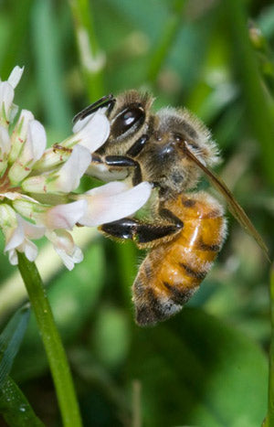
Apis Mellifera Liguistica
The Italian honey bee species.
Apis M. Liguistica is the most common sub-variety of apis Mellifera, making it buy and large the most popular variety of domesticated bee in the world. This variety seems to have successfully held out in Italy during the last ice age, and as a result is adapted to a warmer climate than its Northern cousins. Italian bees have been cross bred all over the world with other varieties due to their gentle temperament and industrious production of honey, brood (bee eggs) and wax. Some drawbacks to these guys are their habit of robbing their neighbors of honey, and hive drift, whereby they will, in a most disloyal fashion, join other colonies. Italian bees are also known to gorge on their own honey supplies if ample forage (pollinating plants) are not availabl

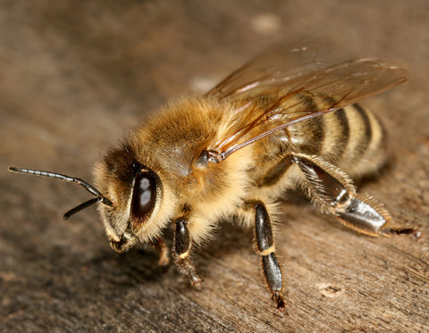
Apis Mellifera Carnica
The Carneolan or Grey honey bee species.
Apis M. Carnica originated in Eastern Europe, between Austria, Hungry, Bulgaria and Bosnia and Serbia. This variety is smaller than other European species, and appears grey due to the large amount of hairs on its body. These bees are especially known for being gentle and incredibly easy to work with, making them perfect for backyard beekeepers concerned with aggressive behavior. They are also known to over Winter with a greatly downsized population, so they do not require great stores of honey over Winter. However, as Spring takes place, apis M. carnica will jump rapidly to life, building up the size of the colony incredibly fast. This can be problematic, as it makes them prone to swarming—backyard beekeepers take note!

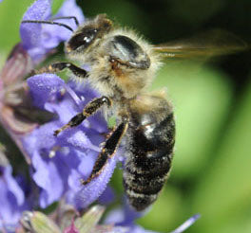
Apis Mellifera Caucasica
Caucasian honey bee species.
Native to the Caucasus region, whose mountain range divides South-Eastern Europe from Asia, the caucasian honey bee is a large variety. Like the carneolan, they are hairy and can appear grey, also sharing the mild temperament of the carneolan bee. However, they are known to be slow in building up their colony, and fair poorly in the cooler, damper climates of Northern Europe.

Apis Mellifera Iberiensis
The Iberian or Gibraltar honey bee species
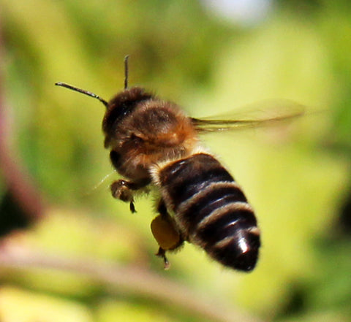
This is probably the most unusual variety of Western honey bee—and my personal favorite. These are a small black bee found mostly throughout the Iberian peninsula (Spain and Portugal) but despite sharing the area with the Italian bee, their genetics remain incredibly pure. This is because the drones (or male bees) of this variety are incredibly picky about which kinds of Queens they will mate with—namely only those sharing their own genetics! This makes them pure, but still genetically diverse within their own variety. Another interesting feature of apis M. Iberiensis is their stubborn defense technique. After being intruded upon, they are known to send a sentry group of bees to patrol the surrounding area up to 24hrs after the intruders have left, aggressively attacking anything in their path. Unfortunately, this has given them a bad reputation with local humans, who often destroy their colonies if found.

Apis Mellifera Scutellata
The Africanized honey bee species.
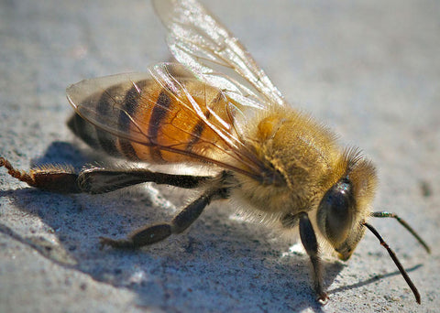
Although now synonymous with the “African killer bee” title, apis M. Scutellata is in fact not a great deal genetically different from its European cousins. Originating in Southern Africa, this variety rose to ill-fortuned fame when a group of Scientist in South Eastern Brazil allowed hybrid stock to escape. The scientists, who had been breeding apis M. Scutellata with other European varieties, bred an abnormally aggressive variety, exhibiting unusual behaviors such as an expanded 30 meter patrol radius surrounding their colony. This variety have expanded rapidly through the Americas due to other dominant tendencies, including forcibly taking over other colonies by executing and replacing their natural queen. Also of interest: apis M. Scutellata will send between 3 to 4 times the number of bees to defend against intruders as other varieties of honey bee … so please, wear a proper beekeeping suit

Other Honey Bee Species
Here we will briefly touch on some other notable varieties of apis, which are not as regularly kept by beekeepers, but are nonetheless fascinating to learn about.

Apis Cerana
Asiatic or Eastern or Himalayan honey bee.
Found in the vast range from Northern India, across South East Asia, Malaysia, Indonesia, the Pilippines and Japan is apis cerana. The smaller size, and less populous colonies of this variety mean they do not produce as much honey as their European counterparts. Because of this, a large number of apis Mellifera varieties have been imported by beekeepers in the region, which may have been good for the honey business, but perhaps not so good for bees. This is because many of the diseases previously isolated to this region, most notably varroa mites, have spread to apis Mellifera, and now becomes globally distributed issue for all apis varieties.
Due to the fact that apis cerana has coexisted with these diseases for several thousands of years, it has adapted better behaviors for dealing with them. An incredibly hygienic variety, it is an expert at clearing and renewing the wax of brood combs, protecting vulnerable bee larvae from pathogens such as varroa.
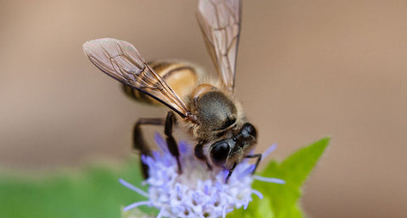
Other unique adaptations include a hardiness to temperature changes (they can reportedly survive freezing temperatures far better than European bees) and have also developed a means of defending against their particularly large predators such as the asian hornet. They do this by surrounding the large predator in a tight cluster, and vibrating their wing muscles so intensely that the heat generated will cook the covered hornet to death.

Apis Dorsata
Giant honey bee
As the name suggests, apis Dorsata, found in South and South East Asia, is considerably larger than most other honey bee varieties. Unlike apis Mellifera, their colonies do not nest in enclosed cavities, but under hanging trees and rocky cliffs, meaning they cannot be domesticated in hives, like other varieties. Instead, the honey of this group is harvested by climbing to the great heights where they build their colonies, and cutting off the combs directly. You may have seen amazing images of indigenous people harvesting honey and wax from apis dorsata wearing little or no protection--quite an amazing feat, considering how aggressively these giant bees will defend their honey!

Pheromones
What is a pheromone?
The pheromones of the honey bee are mixtures of chemical substances released by individual bees into the hive or environment that cause changes in the physiology and behavior of other bees.

Kinds of Pheromones:
In honey bees, as in other animals, there are two types of pheromones: primer pheromones and releaser pheromones. Primer pheromones act at a physiological level, triggering complex and long-term responses in the receiver and generating both developmental and behavioral changes. Releaser pheromones have a weaker effect, generating a simple and transitory response that influences the receiver only at the behavioral level.

Honeybee Pheromones:

Alarm Pheromone
Two main alarm pheromones have been identified in honeybee workers. One is released near the sting shaft and consists of more than 40 chemical compounds.
These chemical compounds have low molecular weights, are highly volatile, and appear to be the least specific of all pheromones. Alarm pheromones are released when a bee stings another animal, and attract other bees to the location and causes the other bees to behave defensively, i.e. sting or charge. The alarm pheromone emitted when a bee stings another animal smells like bananas oil. Smoke can mask the bees' alarm pheromone.
The other alarm pheromone is released by the mandibular glands. This compound has a repellent effect and it was proposed that it is used to deter potential enemies and robber bees. The amounts of 2-heptanone increase with the age of bees and becomes higher in the case of foragers. It was therefore suggested that 2-heptanone is used by foragers to scent-mark recently visited and depleted foraging locations, which indeed are avoided by foraging bees. However, this has recently been proven false. In a new discovery, it was determined that bees actually use 2-heptanone as an anesthetic and to paralyze intruders. After the intruders are paralyzed, the bees remove them from the hive.

Brood Recognition Pheromone
Another pheromone is responsible for preventing worker bees from bearing offspring in a colony that still has developing young. Both larvae and pupae emit a "brood recognition" pheromone. This inhibits ovarian development in worker bees and helps nurse bees distinguish worker larvae from drone larvae and pupae. This pheromone is a ten-component blend of fatty-acid esters, which also modulates adult caste ratios and foraging ontogeny dependent on its concentration. The components of brood pheromone have been shown to vary with the age of the developing bee. An artificial brood pheromone was invented by Yves Le Conte, Leam Sreng, Jérome Trouiller, and Serge Henri Poitou and patented in 1996.

Drone Pheromone
Drone Mandibular Pheromone attracts other flying drones to suitable sites for mating with virgin queens.

Dufour's Gland Pheromone
The Dafour’s Gland (named after the French naturalist Léon Jean Marie Dufour) opens into the dorsal vaginal wall. Dufour’s gland and its secretion have been somewhat of a mystery. The gland secretes its alkaline products into the vaginal cavity, and it has been assumed to be deposited on the eggs as they are laid. Indeed, Dufour’s secretions allow worker bees to distinguish between eggs laid by the queen, which are attractive, and those laid by workers. The complex of as many as 24 chemicals differs between workers in "queenright" colonies and workers of queenless colonies. In the latter, the workers’ Dufour secretions are similar to those of a healthy queen. The secretions of workers in queenright colonies are long-chain alkanes with odd numbers of carbon atoms, but those of egg-laying queens and egg-laying workers of queenless colonies also include long chain esters.

Egg marking Pheromone
This pheromone, similar to that described above, helps nurse bees distinguish between eggs laid by the queen bee and eggs laid by a laying worker.

Footprint Pheromone
This pheromone is left by bees when they walk and is useful in enhancing Nasonov pheromones in searching for nectar.
In the queen, it is an oily secretion of the queen's tarsal glands that is deposited on the comb as she walks across it. This inhibits queen cell construction (thereby inhibiting swarming), and its production diminishes as the queen ages.

Forager pheromone
Ethyl oleate is released by older forager bees to slow the maturing of nurse bees. This primer pheromone acts as a distributed regulator to keep the ratio of nurse bees to forager bees in the balance that is most beneficial to the hive.

Nasonov pheromone
Nasanov is emitted by the worker bees and used for orientation and recruitment. Nasonov pheromone includes a number of terpenoids including geraniol, nerolic acid, citral and geranic acid.

Other pheromones
Other pheromones produced by most honey bees include rectal gland pheromone, tarsal pheromone, wax gland and comb pheromone, and tergite gland pheromone.

Swarming

Honey bee swarming is a natural behavior of bee colonies. Spring with its warmer temperatures and blooming flowers. This is a time of growth and new beginnings for bees. As a bee colony grows in strength the interior of the hive becomes crowded. Soon a large part of the hive will leave to start a new colony.

Example of an irrigation box or bees in a confined space.

What is a Swarm?

Swarming is the honey bee’s method of colony reproduction. The old queen and about half of the worker bees leave their former nest and seek a new home, usually in the spring but sometimes at other times of the year when local conditions permit.
To start the process, certain worker bees, called “scouts,” begin to canvass the surrounding territory for a potential new nesting site even before the swarm leaves its original colony.
A departing swarm consists of a large number of bees flying in a cloud that seems to drift along through the air. People not familiar with honey bees are generally frightened by such a mass, which can contain 5,000 to 40,000 bees, but unless a bee becomes tangled in someone’s hair, it isn’t likely to sting. The queen is in the group, but not leading it. Usually within 100 to 200 yards of the original hive, the bees alight on an object and form a cluster, which looks like a seething, fuzzy glob of insects. Sometimes bees fly from the cluster to collect water and food, but most workers leaving the cluster are scouts that search out potential new home sites for the swarm. When they return from a good site, they dance on the cluster to communicate the location of their find.
A clustered swarm of many bees may appear frightening, but most spring swarm clusters of European honey bees—the common honey bees in central and Northern California—are extremely docile. It takes quite a bit of stimulation, such as being hit by sticks and stones or squirted with a hose, to induce defensive behavior. The same may not be true for Africanized honey bees or for any swarm of honey bees that has run out of food, as these aren’t nearly as predictable and can be very touchy, even as swarm clusters.
Honey bees will nest in cavities having a volume of at least 4 gallons but prefer cavities around 9 gallons. Honey bees also prefer dark cavities with an easily defended entrance that is at least 9 feet from the ground. Hollowed-out trees are ideal sites. However, honey bees may nest in all sorts of cavities such as inside walls of houses; in or around chimneys; in outbuildings, fences, shrubs, water meters, utility boxes, barbecue grills, and soffits; or under decks. Within a few hours to a few days, the swarm’s scouts usually reach a consensus about the best available site. Then the swarm takes to the air one last time to move to the new home.
Once in flight, the swarm is guided by scouts and arrives at the new site. It forms a cluster around the entrance with many bees fanning their wings and releasing a chemical signal to guide the others. Then the bees enter their new home, somewhat slowly. This is what most people notice when they see bees clustered on a section of a building. Inside, the low humming sound of the bees ventilating their nest often can be heard.
If the bees don’t find a new nesting location, they may begin producing beeswax and forming combs at the spot where the cluster formed, such as a tree limb, the overhang of a house, or another unusual place. These “exposed comb” colonies may exist until fall (or year-round in warm-winter areas), but robbing bees, hungry birds, and inclement weather usually put an end to these colonies and their combs.

