Thank you for contacting CALM house Niceville.

You will need to download and print the 4 items we have sent with this email or you can come by the CALM House
- Calm Application
- Calm House Rules
- Daily Schedule
- Phase Program

Please, read all items carefully.
We want you to fully understand how the phase program works. This program has been thoughtfully put together to help you be the best you can be.

You will need to fill out the application, sign and date it, and bring it with you to your interview appointment. Application can be brought by or send it in earlier if you can. The address to mail it is:
Calm House
Attention: Executive Board
201 Redwood Ave.
Niceville, FL 32578

You may scan and email it to Calmorganizationinc@gmail.com

We look forward to meeting you soon.

God bless,

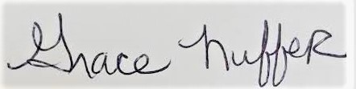

Grace Nuffer
President
CALM organization inc.
501c3
850-974-3780

