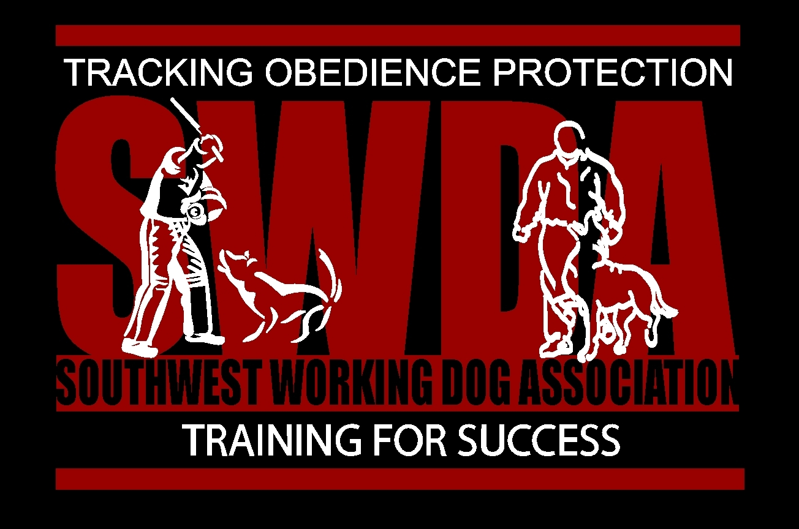
Southwest Working Dog Association
is announcing a

United Schutzhund Clubs of America

IGP Working Dog Trial
Saturday 11/21/2020

Judged by Craig Groh, USCA / SV

Contacts : Esther Hamil - 661.733.1648, ehamil@college.ucla.edu or Nathaniel Roque, 661.803.0728, workingdogs@sbcglobal.net
Location: SWDA Training Field, Acton, Ca. 93510
Titles Offered: BH, IGP 1-3, IGP V, GPR 1-3,
TR-OB 1-3 (tracking will be in Bakersfield about 1 hour 45 minutes away from club field and proposed meeting time in Bakersfield will be 0630. Tracking entries may be limited due to available fields).

Due to USCA and Local Covid – 19 guidelines spectators will be limited to only a maximum of 2 people with each entered competitor and club members and trial staff..
ANYONE NOT ON THE LIST OF 2 GUESTS WITH EACH COMPETITOR OR CLUB MEMBER WILL NOT BE ALLOWED ON THE PROPERTY. TEMPERTURES AND A MEDICAL QUESTIONER WILL BE REQUIRED OF EVERY GUEST APPROVED FOR ENTRY.
Proposed Schedule: (call for final trial schedule)
Sat. Tracking: 6:30 Dirt location TBD in Bakersfield. (Due to possible limited tracking fields entry may be limited)
Obedience and Protection will be at SWDA Training Field and will start approx. 11:00 am. Or on return from tracking. Schedule may change due to distance to tracking.
