A27 East of Lewes Scheme
Update - May 2022
Environment Special

We’ve been asked about how our scheme and the improvements that we’re making will impact the special local environment. We’d like to provide more information.

We have worked with Natural England, local councils and the South Downs National Park to design the best route for our new path. We carried out ecology surveys of the flora and fauna as part of the process. Protected by legislation, there are several European Protected Species locally. These include; bats, dormice and great crested newts and so we need licences from Natural England to carry out construction near them. The licences agree the mitigation measures needed for their protection.

Dormice

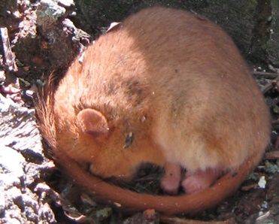
The life cycle of these creatures follows an annual pattern dictating that we plan activities to ensure that we match the pattern of the animals. Ecologists carries out desktop surveys to determine if there are any suitable habitats locally. Once this has been established, licensed ecologists carry out fingertip searches whenever work is taking place.

Great Crested Newts

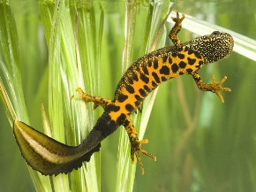
Working with Natural England and South Downs National Park (SDNP) we will replant and provide suitable habitat where it was removed. This includes the re-instatement of hedgerows. There are several areas such as Berwick where planting will provide broadleaved woodland. The scheme is also building and improving of several ponds to enhance habits for all protected species and other animals in the area.
Managing trees along the route

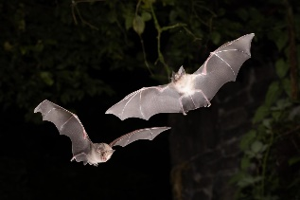
All trees along the route were surveyed in accordance with approved survey techniques by licensed ecologists. Trees that showed bat potential were individually investigated, climbed and inspected. If bats were found then a licence was applied for, if none, then we continued with vegetation clearance.

All nesting birds are protected and no works can be undertaken on trees where birds are shown to be building nests, have active nests or the feedings have not left. Our team waited several months for nesting rooks to move on near Polegate at the end of September last year.

Ash dieback
Photo shows the fungus
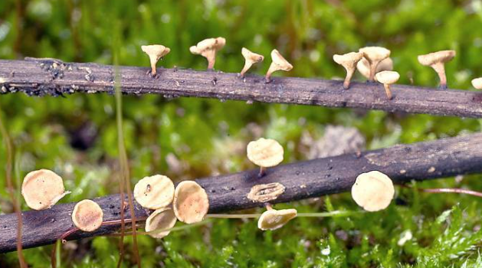
Ash dieback is fungal disease affecting the common ash tree. It is caused by a fungus native to eastern Asia. The disease was first identified in England in 2012, although it is likely to have been present since at least 2005.

Ash trees are common in woodland and non-woodland settings. They make up 12% of Great Britain’s broadleaved woodland,
and are often found in parks, gardens, hedgerows and roadside margins. Ash dieback is present in most parts of England, although the severity of the disease varies locally. Trees in woodlands with high proportions of ash are likely to decline more quickly.

The route of our new path runs next to the A27 from Firle to Polegate. We have worked with local landowners to try to minimise the impact on local trees and woodlands. In some places, we’ve had to remove some trees infected with ash die back to prevent the disease spreading even further. Two places where this is obvious are Firle and Folkington. We’ve also removed trees where there is a risk of them falling on to the path to keep everyone safe.

Regular updates
For more information about the scheme, please visit us at: A27 East of Lewes - Highways England (nationalhighways.co.uk)
If you would like to be added to our distribution list, please email a27eastoflewes@nationalhighways.co.uk requesting to be added. You can ask to be removed at any time.
We value your feedback

Visit our A27 East of Lewes interactive feed back tool to have your say. The tool includes an interactive map. You can click on a location to make a specific comment or give us your general feedback. This is a one-way feedback tool so if you would like a response to your feedback please email the project team at: A27EastofLewes@nationalhighways.co.uk

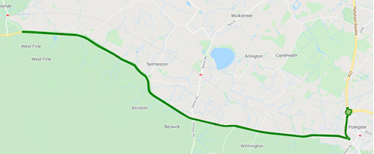
Click on the green line to leave feedback

