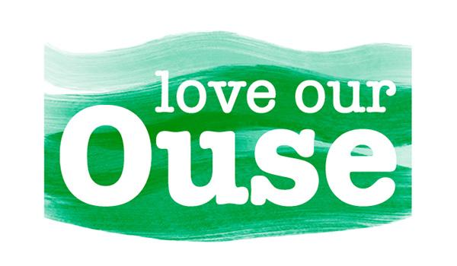
Glynde Reach - A Year in Observation

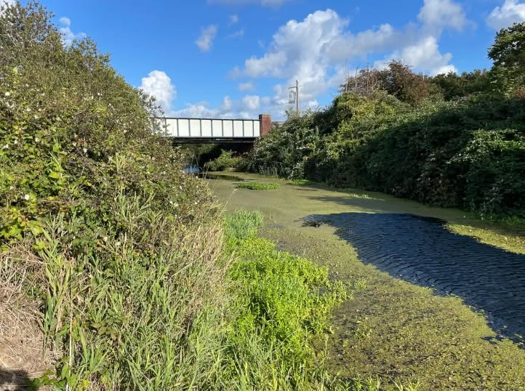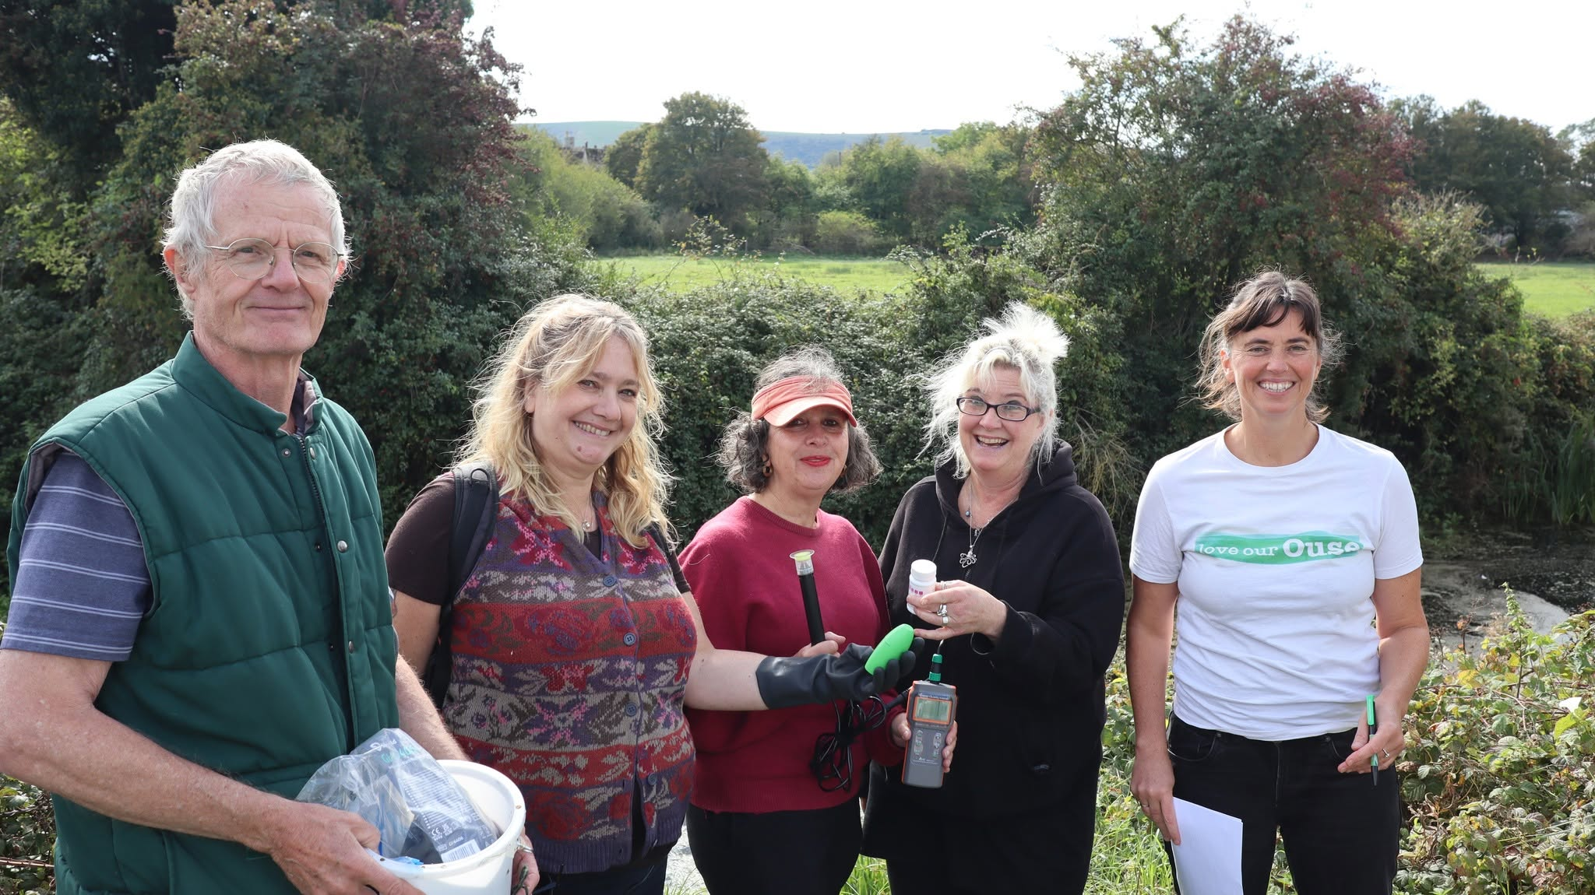

Dates, Times and Locations
10th September, 6 - 8.30pm in the Reading Room, Glynde, The Street, BN8 6TA
AND
20th September, 2 - 4pm at Gote Barn, Gote Lane, Ringmer, BN8 5HX

Join Love our Ouse and local community testers to learn about the citizen science programme they’ve been conducting across Glynde Reach; the worst rated waterbody in the River Ouse catchment. Learn about the challenges it faces, what that data tells us and how we can be part of a culture of care for our waterways to turn the tide on its health.

Across five sites between Ringmer and Beddingham we've been drilling down on the many issues this lower Ouse waterway faces through monthly water testing and regular observation streamside. Many people are concerned with the impacts on our precious rivers and hold valuable knowledge. We welcome people contributing their concerns, observations and hopes for Glynde Reach.

The Reading room event will be for local residents across Glynde, Beddingham and Firle to share and discuss together. The event in Ringmer will present the same insights plus be part of a weekend long community exhibition by The Collective with the theme ‘Conversations with Water’ as part of Artwave and Love our Ouse’s Riverlution: Thriving Ouse Festival.

Presentation and reports of the testing programme will be made publicly available to use as a local resource.

The events are free and everyone is welcome. Drinks and nibbles included. No need to book - just come along. We look forward to seeing you there.

This project has been funded with huge thanks to Ouse Valley Climate Action, The National Lottery Community Fund, Ringmer Parish Council, Glynde and Beddingham Parish Councils, fundraising by Ringmer Arts Collective and donations from the Ouse Angling Preservation Society with support from Environment Agency and Ouse and Adur Rivers Trust.

Love our Ouse is a community initiative to celebrate, learn and act for the River Ouse.
https://loveourouse.org

