Firle Playing Fields

Discussion of options to enhance the Playing Field area

June 2026

V1.1

Stakeholders
Firle community (FCA)
Village Hall & Playing Fields (VHPFC)
Firle Bonfire Society (FBS)
Firle Parish Council (FPC)
Firle Estate (FE)
Historical England
Background
The field area to the west of the cricket pitch has been in poor condition for a number of years. It is currently used annually for bonfire and the Village Fete, with occasional car parking for cricketers. The area becomes muddy in winter and rutted in summer, with poor access to the playground.
A community survey identified a need for improving the outdoor facilities in the village, and an adult exercise gym was a favoured option
The FCA agreed to research this further and draw up a costed proposal for stakeholders to include Village Hall & Playing Fields Committee, the Parish Council, and the Firle Estate.
Informal discussions with stakeholders and villagers revealed an appetite for other ideas and amenities to be included in the proposal, with various ideas floated.
The purpose of this document is to bring these ideas together and build a consensus on a proposal that can be developed into a funding proposal and a planning application.

Proposed enhancements:
- An Adult outdoor exercise area with 6 exercise machines
- A raised multipurpose Gazebo/stage (approx 6m x 4m – Oak framed, open sided)
- A hard-standing area (probably rubber mats with grass in-fill) and drainage
- A hardened bonfire site area (with possible other uses)
- A hardened track between the Village and the Park
- Replacement of steel gates with oak 5 bar gates
- Screening and hedging where appropriate
We need to strike the right balance between having a community space that offers appropriate facilities, and ‘urbanisation’ of the site.
A layout plan and further details are in the Appendices attached

Outline costs:
Adult Gym: £ 25,000 to £ 35,000 (detailed quotes)
Oak Gazebo: £ 10,000 to £ 15,000 (internet)
Hardstanding and track (150sqm): £ 10,000 to £ 15,000 (Internet)
Bonfire zone £ 2,000 to £ 3,000 (Internet)
3 x hardwood 5 bar gates £ 3,000 to £ 4,000 (Internet)
Screening and Hedging £ 1,000 to £ 2,000 (guess)
Total cost: £ 51,000 to £ 74,000 (ex VAT)
Likely costs may be reduced by the use of locals with appropriate skill-sets. A total cost estimate of £ 60,000 (inc VAT) is anticipated.

Funding Possibilities
There are a number of aspects to these enhancements that will be attractive to potential funding bodies:
- Health Benefits for an ageing village population
- Community benefits by creating an outdoor focal point
- Improved facilities for holding outdoor events
- Improved access by foot and pushchairs
- Business benefits from visitor usage
Veolia: Our proximity to Newhaven Incinerator allows access to Veolia grants
Sussex Partnership: TBC
Lottery Fund: TBC
Local Government: Lewes District Council, and Firle Parish Council
Local fundraising: Village Fete, Community fundraising events

Next Steps:
Feedback on these outline proposals from stakeholders: Mid-September ‘26
Full proposal for stakeholder approval: End-October ‘26
Planning application submission: December ‘26
Detailed costs: December ‘26
Grant application submissions: January ‘27

Attachments:
A: Site proposed layout
B: Samples of Gazebo options
C: Adult fitness equipment
D: Bonfire Zone

Appendix A: Playing fields proposed layout

Discussion ideas include:
- Grass matting (similar to the Charleston car park) would be used for hard standing and the access track between the park and the village
- The access track would be 2m wide and run alongside the cricket area
- Grass hardstanding area for event loading/unloading and cricket matches only
- A bonfire ‘pit’ with a hardstanding gritted area and non-flammable border.
- Possible additional use of the bonfire zone area for boules/pétanque
- Preventing vehicular access beyond the hardstanding area
- Picnic tables and screened bin
- Hedging to screen off exercise machines and field boundaries
- Using the car hardstanding area for an expansion village car park once the village car park has been more efficiently laid out
- Playground and exercise area moved to the School Field area (not costed or grantable)

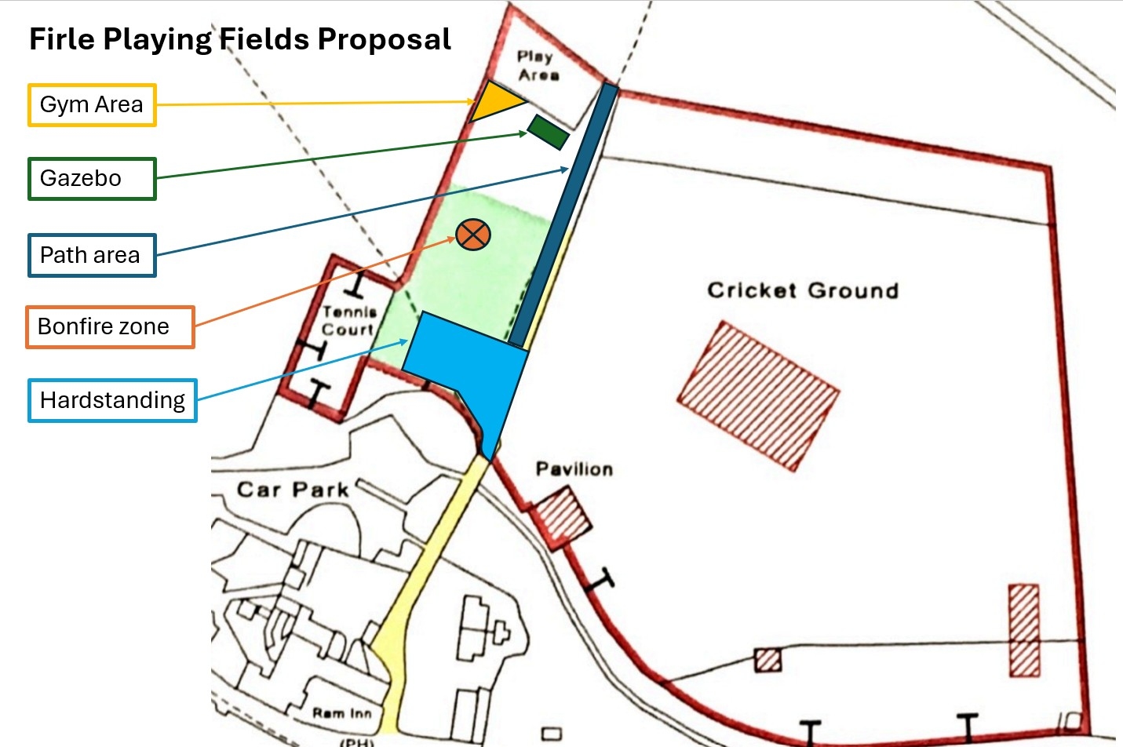

NB:
The light green zone is the designated area where car parking is allowed under the Firle Estate lease to the Parish Council and VHPFC
Appendix B: Gazebo Examples
An area of 20 - 25 sq m (eg 6m x 4m) with a raised floor of 0.5m would allow the Gazebo to work as a Meeting point, Weather shelter, Event Hub, and Outdoor Stage or classroom.
Electricity, a water fountain and a bike repair station have also been suggested.
NB:
- An oak rectangular shape would be most in keeping with the historic parkland context.
- The Gazebo height is likely to be no higher than the top of the zip-wire in the playground
- The examples below are ‘kits’ costing less than £10,000.
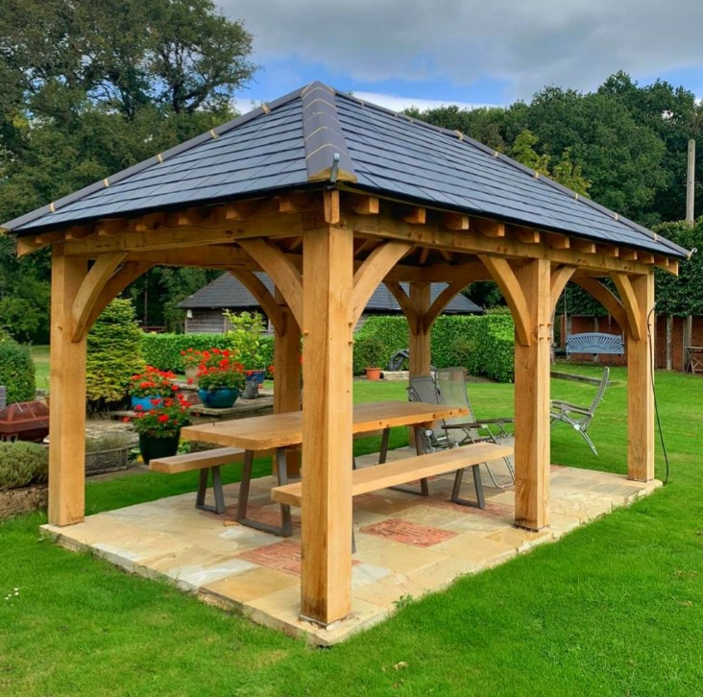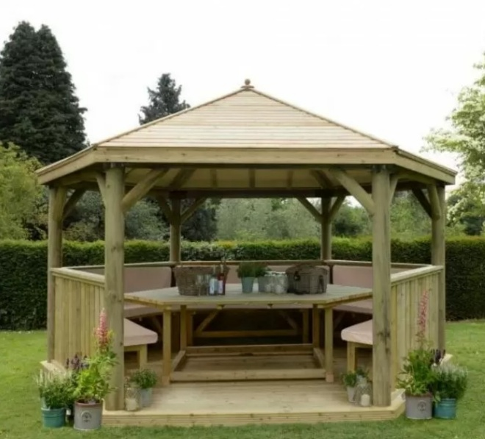
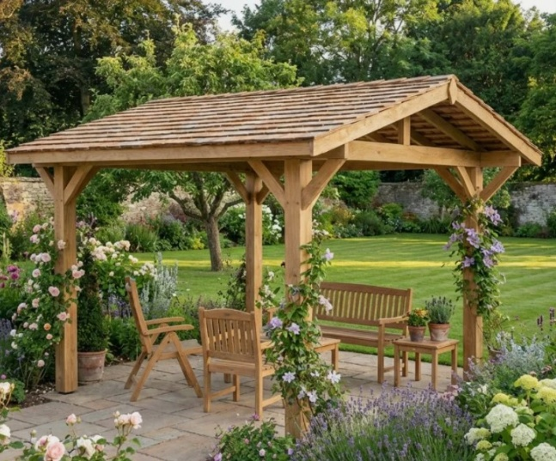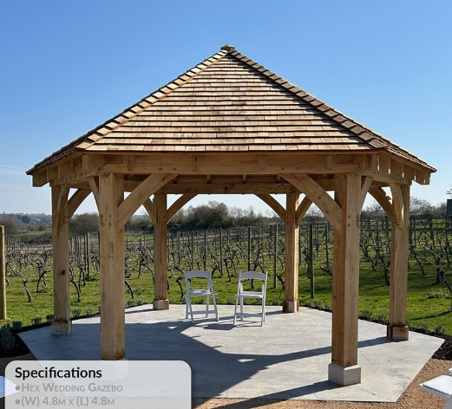

Appendix C: Recommended Exercise Machines
As discussed with Gemma and Sunshine Gym to cover all core body muscle groups. Other options will be researched prior to any funding application.

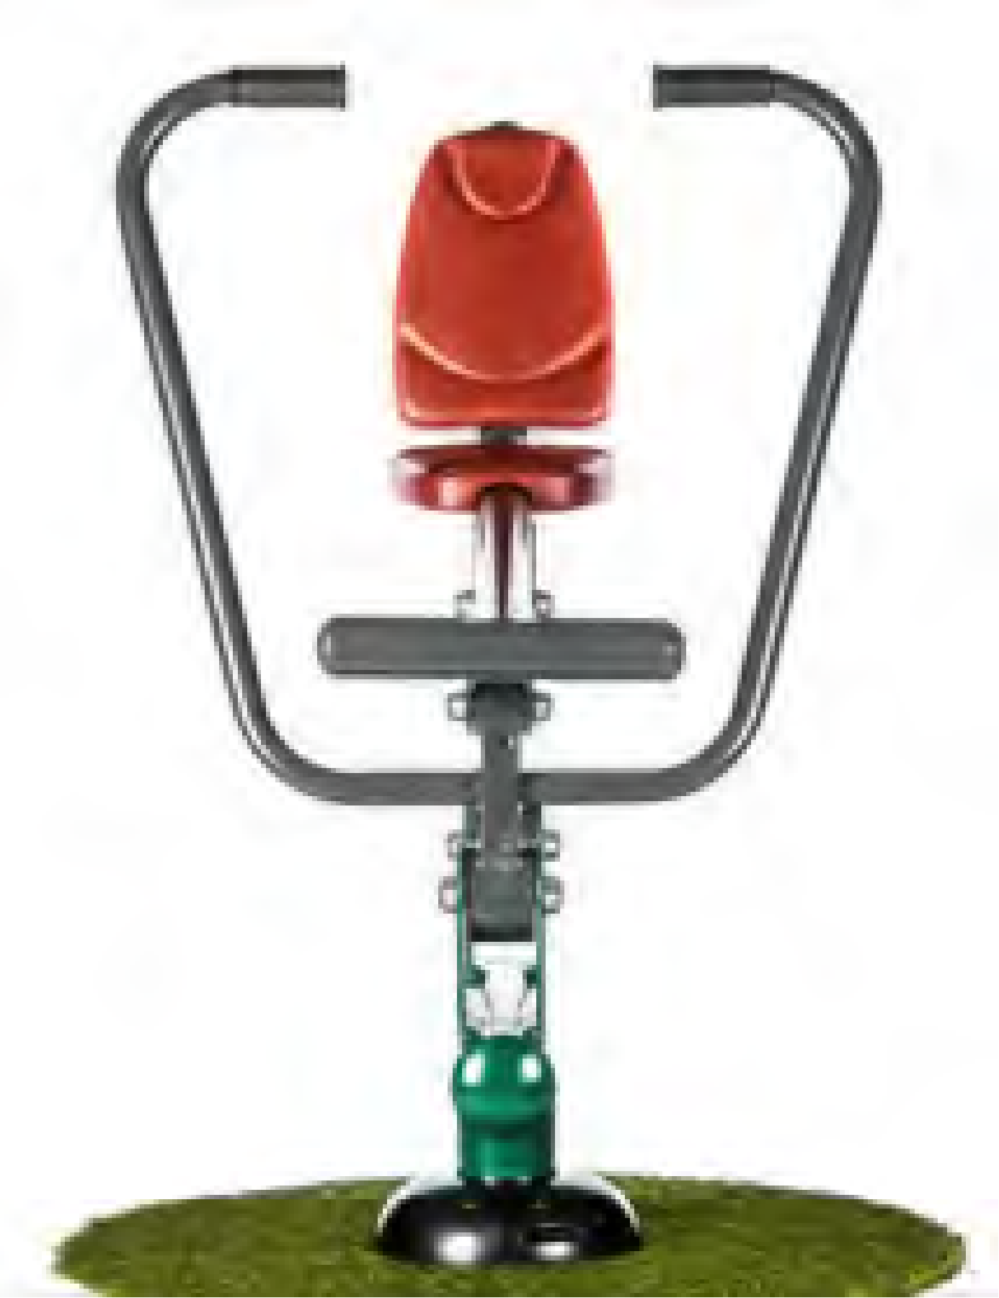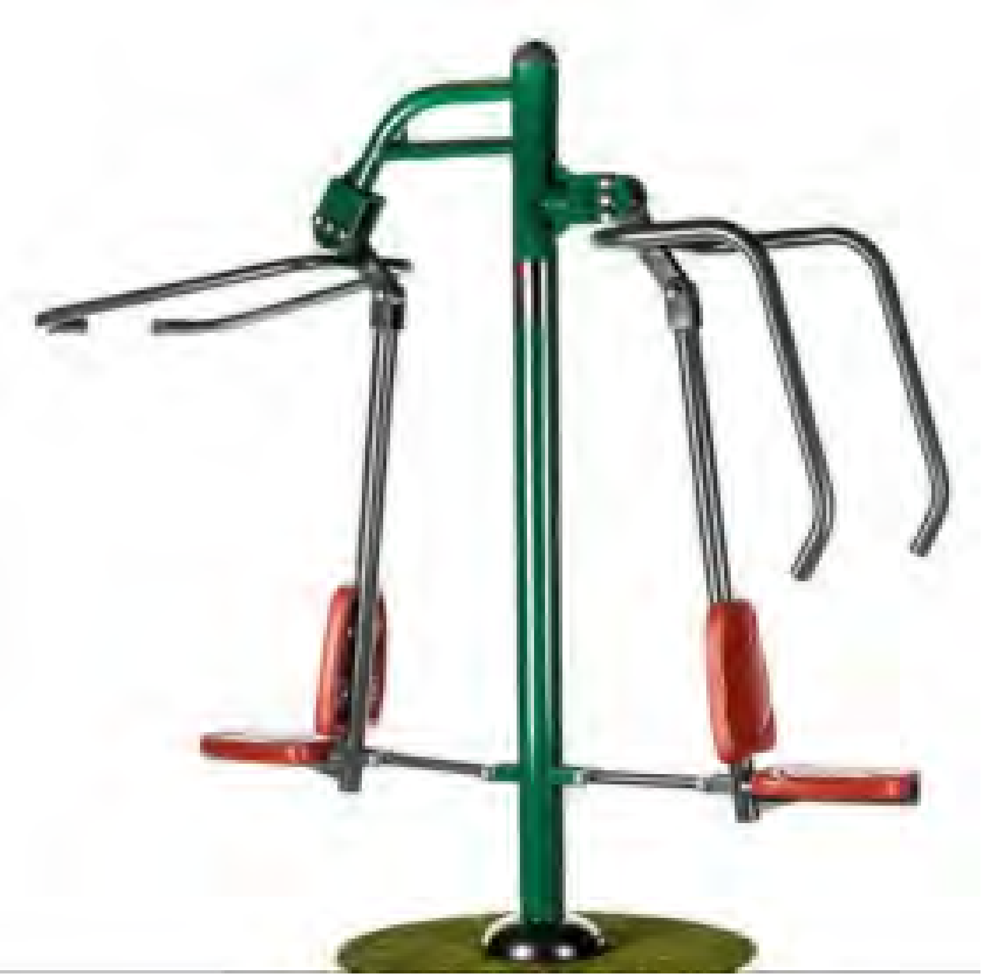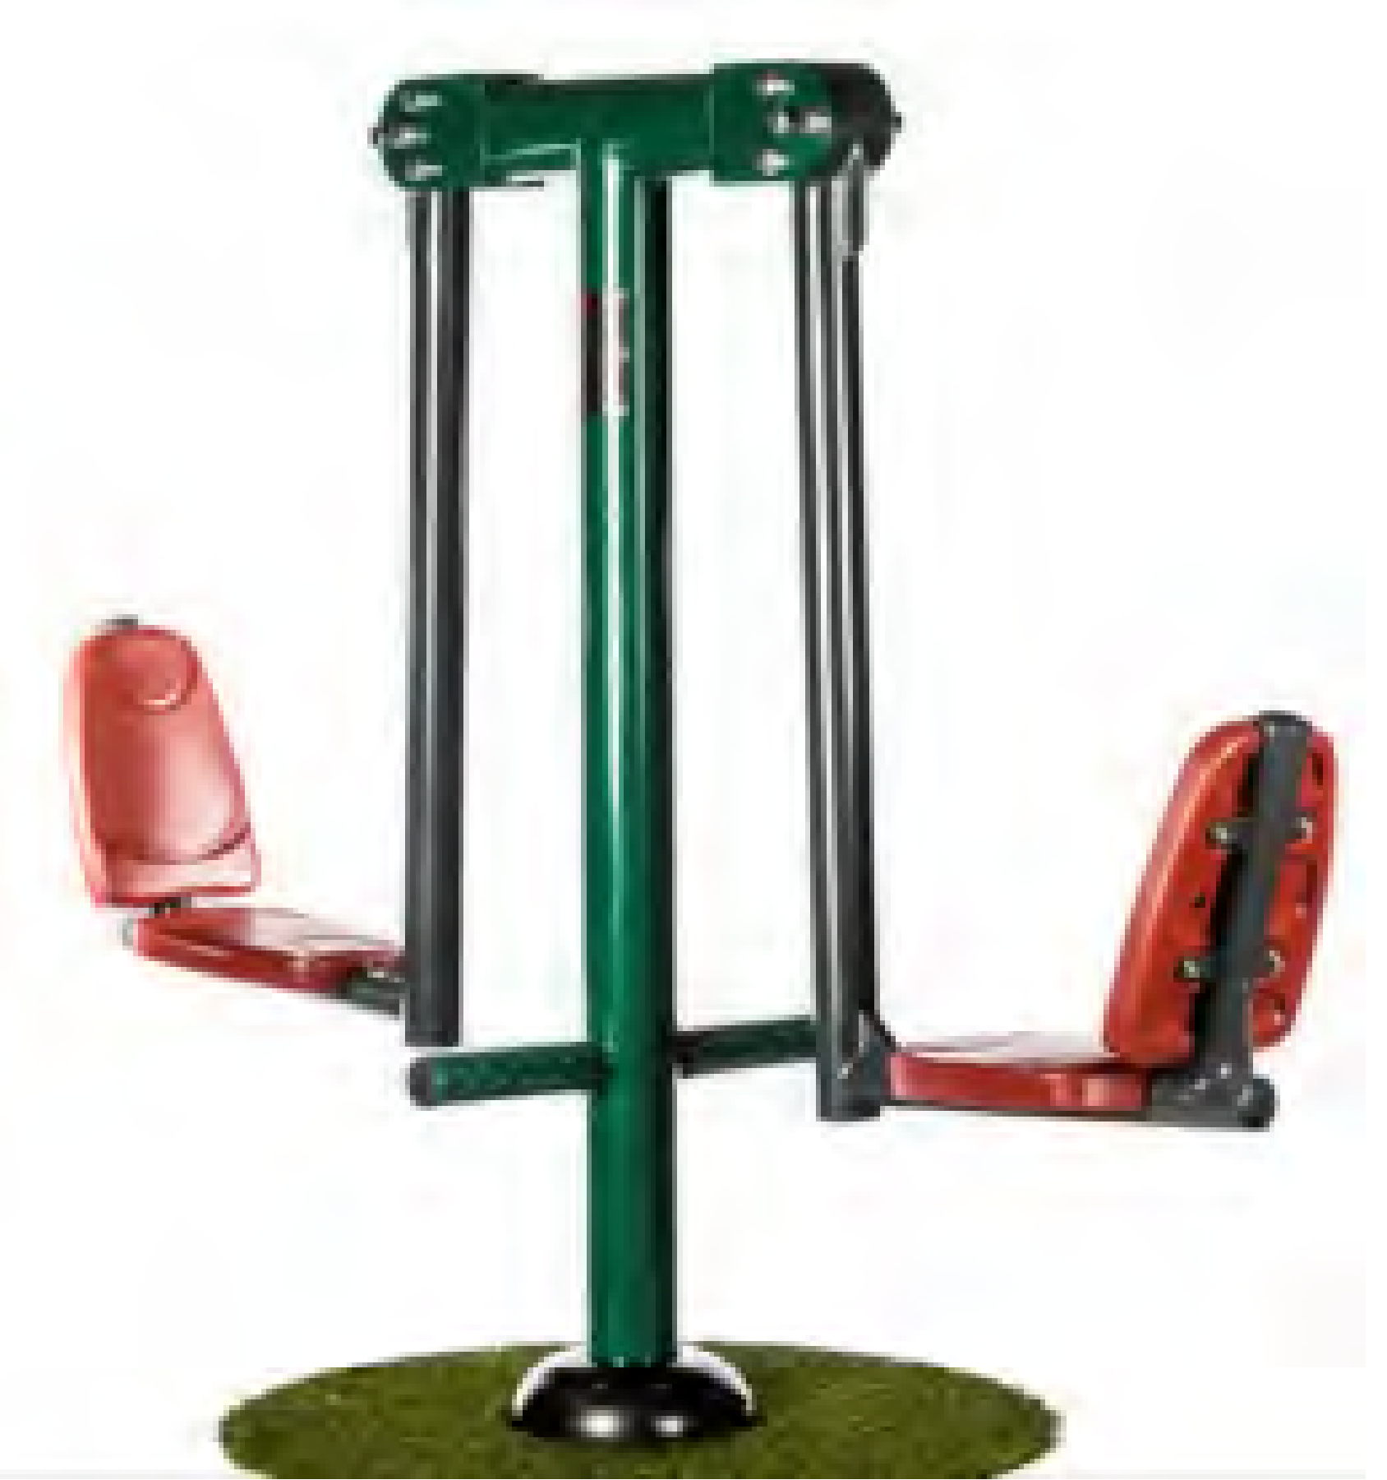
BX/SG 3014-GG
Rower - Green/Grey
Dimensions (mm) :1198(h) x 805(w) x 1296(l)
Weight = 40kg
1
£815.00
£815.00
BX/SG 3009-GG
Combi Pull Down Challenger & Power Push - Green/Grey
Dimensions (mm) :2088(h) x 840(w) x 2255(l)
Weight = 85kg
1
£1,337.00
£1,337.00
BX/SG 3010-GG
Double Squat Push - Green/Grey
Dimensions (mm) :1590(h) x 634(w) x 2268(l)
Weight = 60kg
1
£1,019.00
£1,019.00
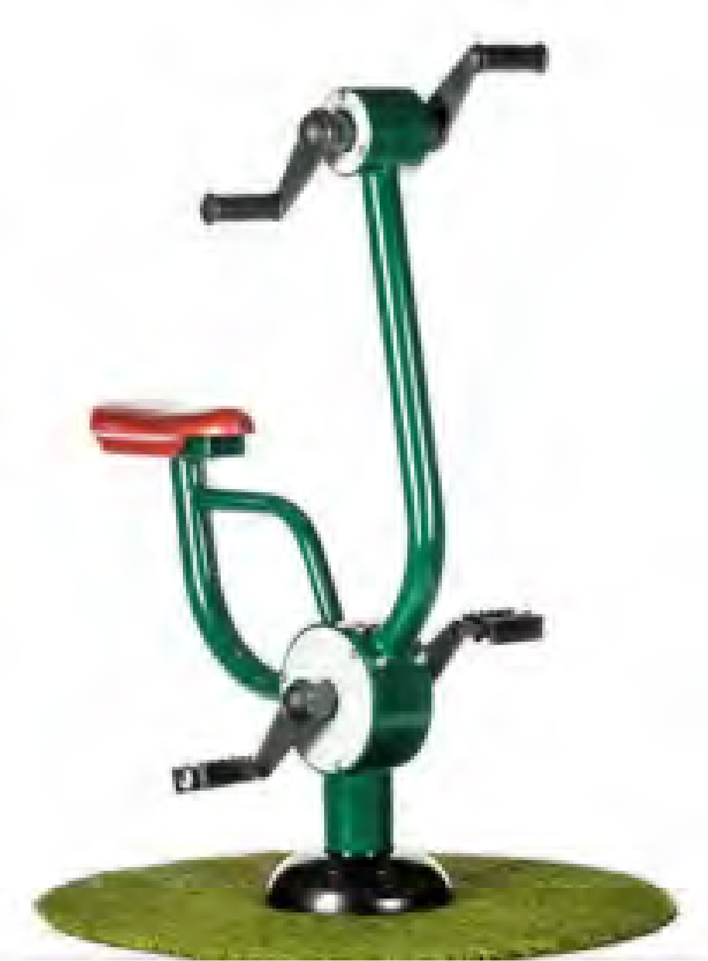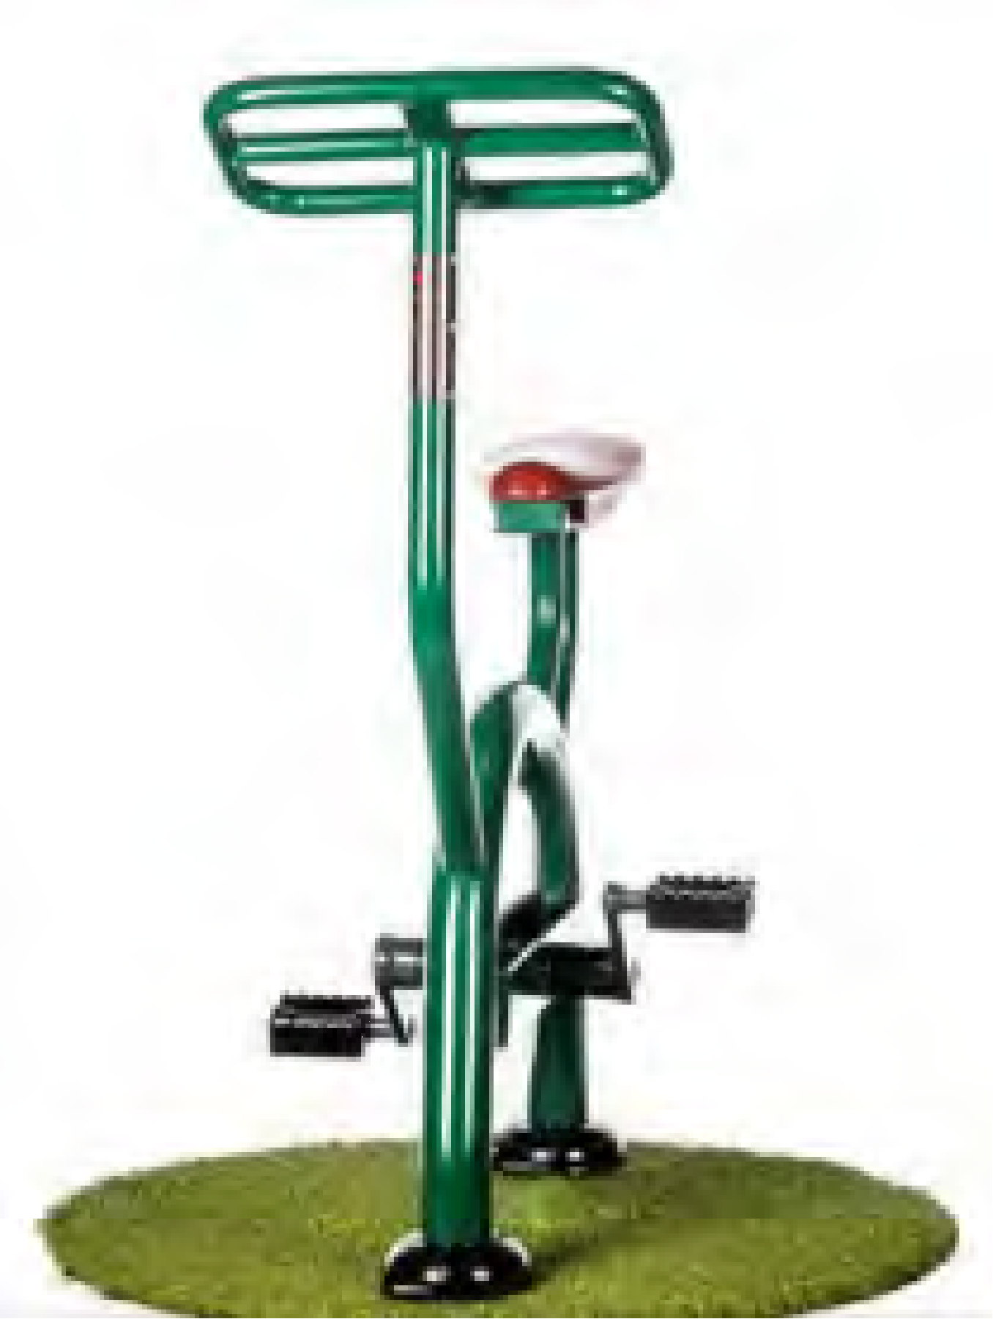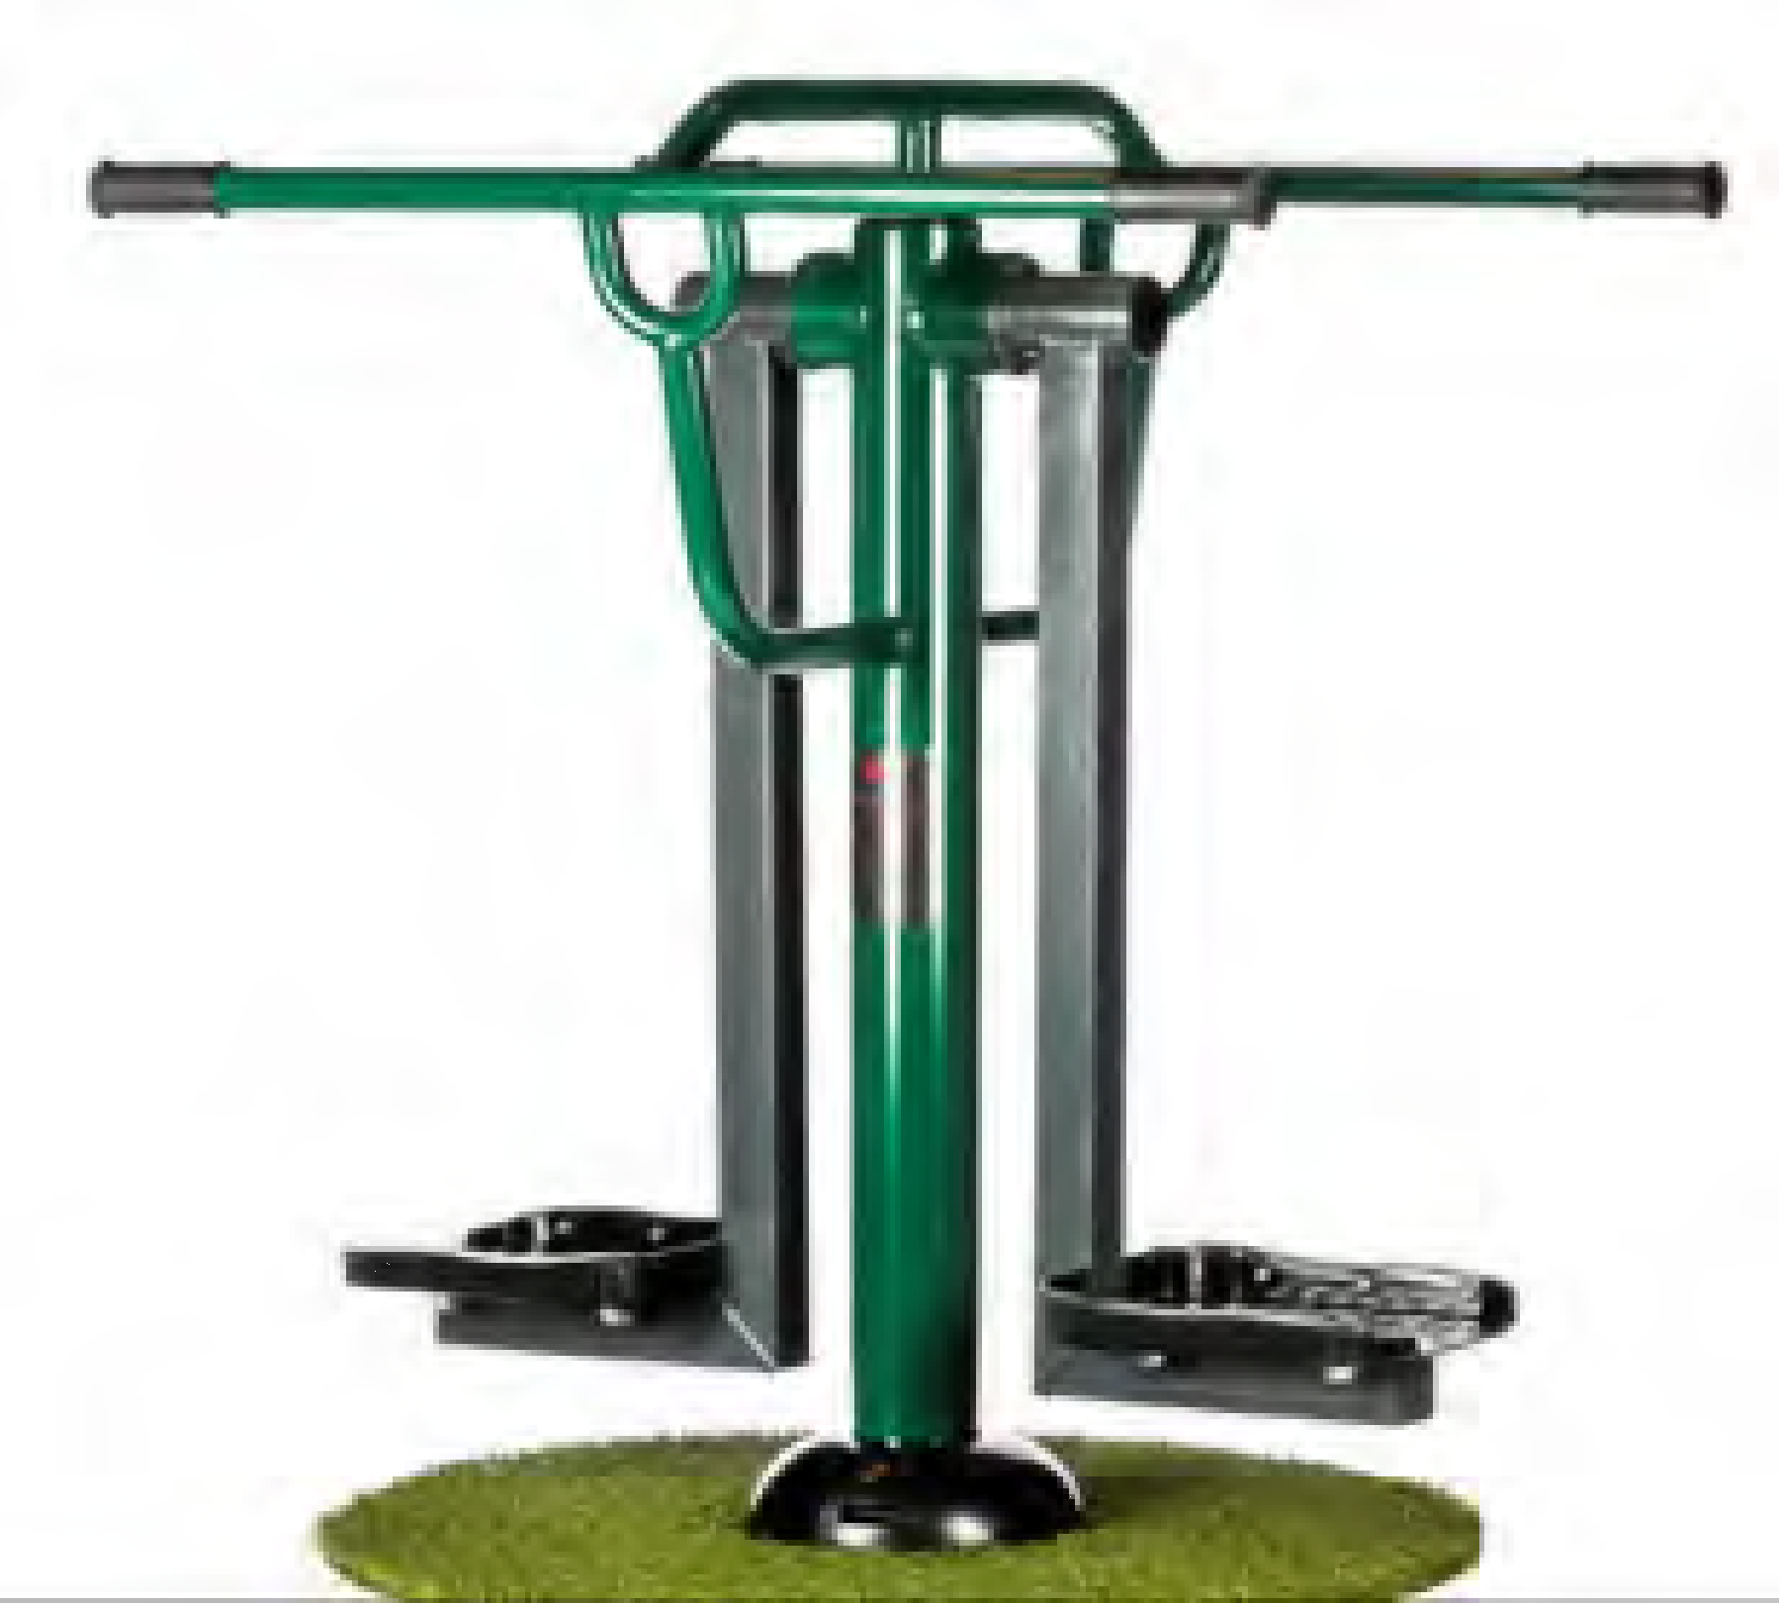
BX/SG 3017-GG
Arm & Pedal Bicycle - Green/Grey
Dimensions (mm) :1450(h) x 500(w) x 830(l)
Weight = 36kg
1
£880.00
£880.00
BX/SG 3019-GG
Bicycle - Green/Grey
Dimensions (mm) :1350(h) x 500(w) x 1000(l)
Weight = 44kg
1
£687.00
£687.00
BX/SG 3002-GG
Double Slalom Skier - Green/Grey
Dimensions (mm) :1234h) x 900(w) x 1150(l)
Weight = 53kg
1
£778.00
£778.00

Appendix D: Bonfire Zone
Firle Bonfire Night is a valued and cherished annual tradition in Firle. The radius of the ‘burnt’ area of the bonfire in 2025 was x m. It leaves a rutted and scorched area for most of the winter, and the grass partially returns in the summer. A JCB is currently used to assemble the bonfire, which can further damage the approached and cause rutting.
Options for the Bonfire zone include
- Leave as is
- Surface the fire area to limit damage and give the area an appeal beyond one night per year.
The lowest cost and most effective way of sealing the surface is to use granite grit (2mm to 6mm), approximately 50-75mm deep in the burn zone:
Granite grit will not explode when heated as there is no water trapped inside. The surface compresses to a firm layer which can be raked over after Bonfire to remove nails etc.
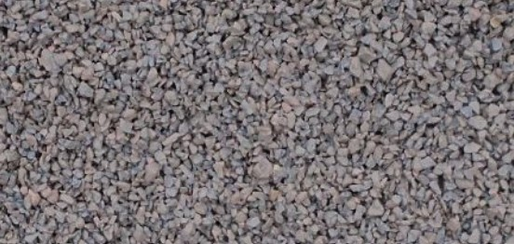
The border can be any shape round or square, with edging either with granite pavers or using Corten steel sunk into the ground. It would also be feasible to lower the surface by say 150mm to create a shallow fire-pit.
If sealed, the gritted area could be used with picnic tables, Boules (Petanque) or a smaller ‘campfire’ area (with suitable safety precautions)

