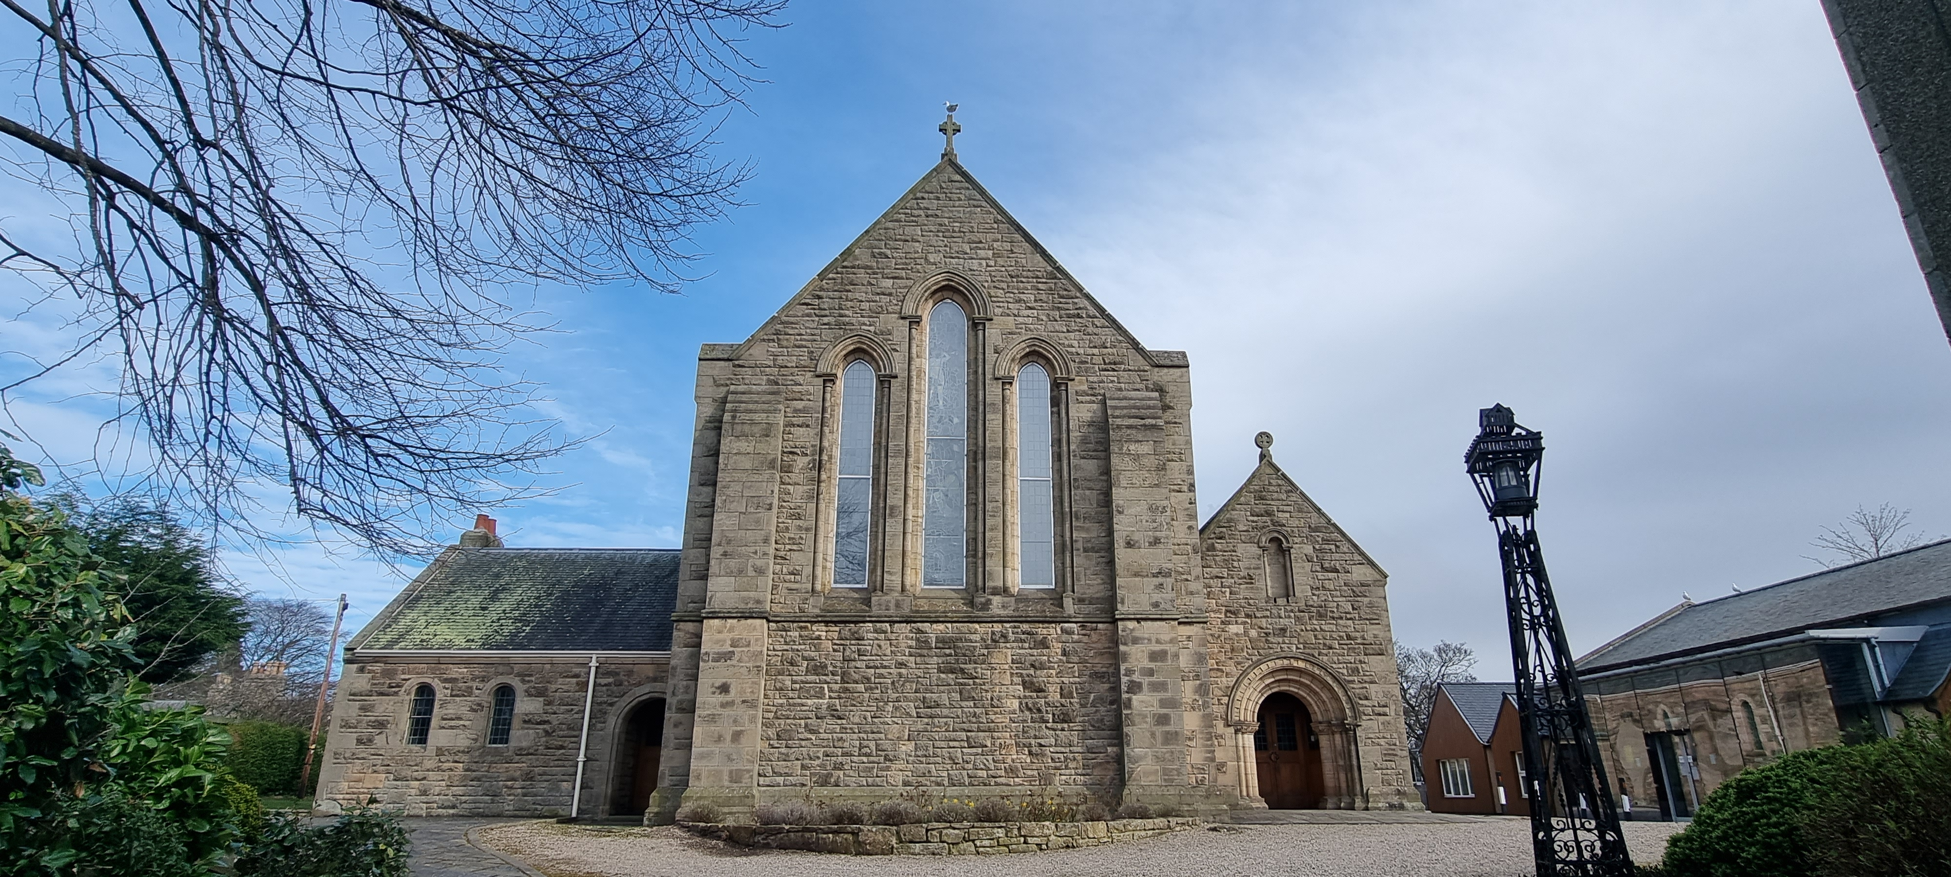
ELGIN PARISH CHURCH & WILLIAMSON HALL

CHURCH OFFICE: Williamson Hall, Duff Avenue, Elgin, IV30 1QS

OFFICE HOURS: Mon, Wed and Fri (0930 – 1230 hrs)

TEL NO: 01343 551501 E-MAIL: elginparishchurch@gmail.com

WEBSITE: www.elginparishchurch.co.uk
___________________________________________________________________ __
WILLIAMSON HALL BOOKING FORM

NAME OF ORGANISATION …………………………………………………………………………………………..……………..

Named Person making application ……………………………………………………………..………………………………..

Address ………………………………………………………………………………………..…………………….……………..……..

……………………………………………………………………………………………………POST CODE …………………………..

TEL NOS: (Landline) …………………………………………… (Mobile) ………………………………………………………..

E-MAIL ……………………………………………………………………………………………………………………………………….

AREAS FOR HIRE | CAPACITY  (seated) | COST | DATE/S | TIMES
Main Hall | 137 | £65  per session |  | 8:30 – 1pm  1pm – 5:30pm  5:30pm – 10pm
Main Hall + extension | 155 | £75  per session |  | 8:30 – 1pm  1pm – 5:30 pm  5:30pm – 10pm
West Meeting Room | 26 | £25  per session |  | 8 30 – 1pm  1pm – 5:30pm  5:30pm – 10pm
East Meeting Room | 33 | £25  per session |  | 8:30 – 1pm  1pm – 5:30 pm  5:30pm – 10pm
Kitchen | Nil | £30  per session |  | 8:30am – 1pm  1pm – 5:30pm  5:30pm – 10pm
Discounts – 6 bookings or more: 20% for charities; 10% for non-charitable groups
PLEASE NOTE: THE GENERAL INSTRUCTION BOOK FOR THE HALL IS LOCATED UNDER THE FIRE ALARM PANEL IN THE FOYER. IF YOU HAVE ANY QUERIES AND CANNOT FIND YOUR ANSWER IN THIS BOOK, PLEASE CALL THE NUMBER ON THE FIRE ALARM PANEL.
ADDITIONAL REQUESTS
Heating
Heating is normally provided as part of the hire (in very warm weather, it will not be switched on – if not required (NRQ) please indicate
Prior access to premises - do you wish to view the Williamson Hall before taking hire? If YES, please arrange with Church Office 01343 551501 for a date and time. A member of the Church community will meet you at the Hall. | YES/NO
GENERAL INFORMATION
Charges: When a hire extends into two or more consecutive sessions on a single day, then a discount of 20% will be applied to the charge for the second and subsequent session
Capacity – Capacity refers to numbers being seated – see Letting floor plan
Chairs – (Hall and store has 120 chairs)
Tables (Hall has 18 tables – 6 ft x 2.5 ft) and 3 tables (3 ft x 2.5 ft)
Tables and Chairs storage
Hirer’s responsibility to return rooms exactly as found
Projector Screen – An electric “drop down” screen is available in Main Hall  Sound System and whiteboard please indicate if required | Screen -----------  Sound System --  Whiteboard -----
Safety Announcement – a Safety Announcement script is available to hirers. Safety Announcement MUST be given at the start of any event held in the Hall. A fire alarm (an alternating klaxon sound) will activate or be activated | In docket left entrance to  Foyer beside Fire Alarm

- I agree to the terms and conditions of use, a copy of which I have agreed and kept.

- All users must have valid PUBLIC LIABILITY INSURANCE cover in force and evidence of this readily available as it may require to be inspected.

Name of Applicant (Please print)
Signature | Date

