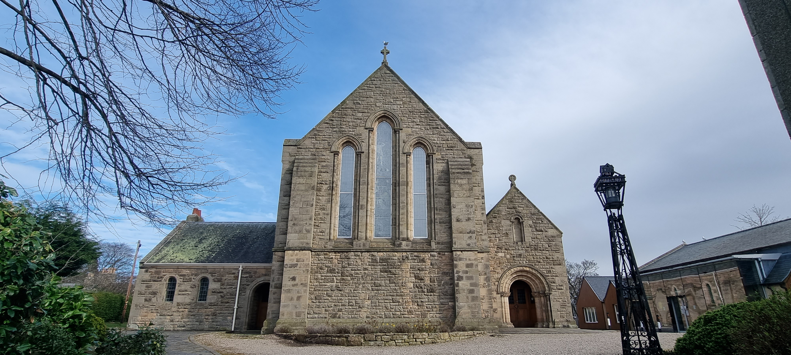
ELGIN PARISH CHURCH
(formerly St Columbas)

CHURCH OFFICE: Williamson Hall, Duff Avenue, Elgin, IV30 1QS

OFFICE HOURS: Mon, Wed and Fri (0930 – 1230 hrs)

TEL NO: 01343 551501 E-MAIL: elginparishchurch@gmail.com

WEBSITE: www.elginparishchurch.co.uk
____________________________________________________________________ _

Application for use of ELGIN PARISH CHURCH
(see separate booking form for weddings)

NAME OF ORGANISATION …………………………………………………………………………………………..……………..

Named Person making application ……………………………………………………………..………………………………..

Address ………………………………………………………………………………………..…………………….……………..……..

……………………………………………………………………………………………………POST CODE …………………………..

TEL NOS: (Landline) …………………………………………… (Mobile) ………………………………………………………..

E-MAIL ……………………………………………………………………………………………………………………………………….

AREAS FOR HIRE | CAPACITY  (seated) | COST | DATE/S | TIMES
Main Church Area | 500 | £65  per session |  | 8:30 – 1pm  1pm – 5:30pm  5:30pm – 10pm
Meeting area (south east in Main Church) | 25 (approx.) | By donation |  | 8:30 – 1pm  1pm – 5:30 pm  5:30pm – 10pm

Please complete info overleaf, sign form and return to Church Office
ADDITIONAL REQUESTS
Heating  Heating is normally provided as part of the hire (in very warm weather, it will not be switched on – if not required (NRQ) please indicate | NRQ
Prior access to premises - do you wish to view the Church before taking hire? If YES, please arrange with Church Office 01343 551501 for a date and time. A member of the Church community will meet you at the Church. | YES/NO
GENERAL INFORMATION
Capacity – Capacity refers to numbers being seated (see floor plan attached)
Pews – pews are in place – flexible seating for 25 only in “Meeting Area”
Safety Announcement – a Safety Announcement script is available to hirers. Safety Announcement MUST be given at the start of any hire event held in the Church. The script and an air horn will be located in the vestry and will be shown on viewing the Church before your event takes place.

- I agree to the terms and conditions of use, a copy of which I have agreed and kept.

- All users must have valid PUBLIC LIABILITY INSURANCE cover in force and evidence of this
readily available as it may require to be inspected.

Name of Applicant - please PRINT
Signature
Date

