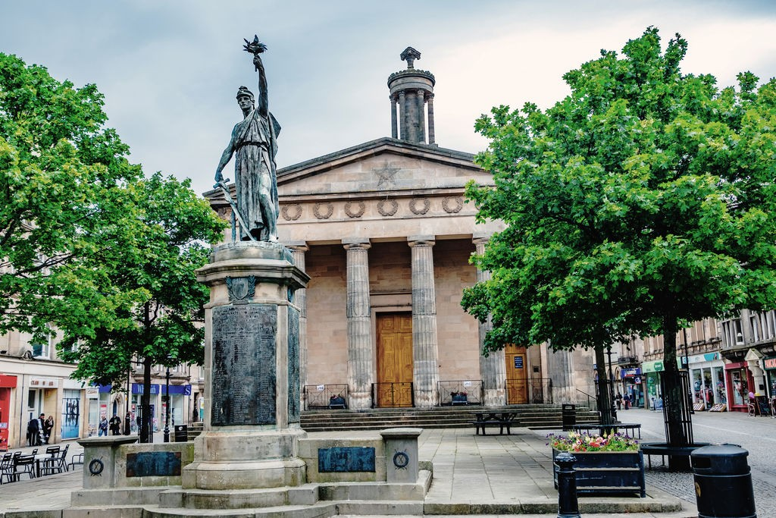

CHURCH OFFICE : Williamson Hall, Duff Avenue, Elgin, IV30 1QS

OFFICE HOURS: Mon, Wed, Fri (0930 – 1230 hrs)

TEL NO: 01343 551501 E-MAIL: elginparishchurch@gmail.com
WEBSITE: www.elginparishchurch.co.uk
_____________________________________________________________________
ST GILES CHURCH BOOKING FORM
(see separate booking form for weddings)

NAME OF ORGANISATION …………………………………………………………………………….

Named Person making application ………………………………………………………………….

Address ………………………………………………………………………………………..…………………….……………..……..

……………………………………………………………………………………………………POST CODE …………………………..

TEL NOS: (Landline) …………………………………………… (Mobile) ……………………………………….

E-MAIL ………………………………………………………………

AREAS FOR HIRE | CAPACITY | COST* | DATE/S | TIMES
Main Church area  (incl. New Room) | 275 + 50 | £125 per session |  | 8:30am – 1pm  1pm – 5:30pm  5:30pm – 10pm
New Room only | 50 | £65 per session |  | 8:30am – 1pm  1pm – 5:30pm  5:30pm – 10pm
Kitchen | N/A | No charge |  | 8:30am – 1pm  1pm – 5:30pm  5:30pm – 10pm
Front Portico | N/A | No charge |  | 8:30am – 1pm  1pm – 5:30pm  5:30pm – 10pm
Front Outside Precinct | N/A | No charge |  | 8:30am – 1pm  1pm – 5:30pm  5:30pm – 10pm
Back Outside Precinct | N/A | No charge |  | 8:30am – 1pm  1pm – 5:30pm  5:30pm – 10pm
Discounts – 6 bookings or more: 20% for charities; 10% for non-charitable groups
Please complete info below, sign form and return to Church Office

ADDITIONAL REQUESTS
Kitchen – if using the kitchen, please supply your own tea towels.
Heating
Heating is normally provided as part of the hire (in very warm weather, it will not be switched on – if not required (NRQ) please indicate
Prior access to premises - do you wish to view the Church before taking hire? If YES, please arrange with Church Office 01343 551501 for a date and time. A member of the Church community will meet you at St Giles’ Church | YES/NO
GENERAL INFORMATION
Charges: When a hire extends into two or more consecutive sessions on a single day, then a discount of 20% will be applied to the charge for the second and subsequent session.
Capacity – Capacity refers to numbers being seated – see Letting Floor Plan
Chairs– (New Room has available 80 stacking chairs, 12 non-stacking chairs)
Tables (New Room has available 8 tables (2 ft x 2 ft) and 4 tables (6ft x 2.5 ft)
Safety Announcement – a Safety Announcement script and an air horn is available to hirers. Safety Announcement MUST be given at the start of any event held in the Sanctuary | Script and air horn stored on Vestry windowsill
Main Church Area and New Room – furniture being moved out of position
Hirer’s responsibility to replace exactly as found
Main Church area – Gallery/Balcony (upstairs)  The first row ONLY provides provides a clear view of the dais below the pulpit. Fifty people can be accommodated | This area is only available by special request

- I agree to the terms and conditions of use, a copy of which I have agreed and kept.

- All users must have valid PUBLIC LIABILITY INSURANCE cover in force and evidence of this readily
available as it may require to be inspected.

Name of Applicant please PRINT
Signature
Date

