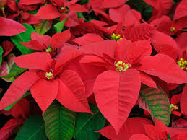

Cal Heights United Methodist Church
Poinsettia’s 2025

If you would like to dedicate a poinsettia in honor of or in memory of a loved one, please print the information below:

In Honor of:
or
In Memory of:

Poinsettias will beautify our sanctuary again thanks to your gift of $15.00.

Donor’s Name:
Phone:

The deadline to order is Wednesday, December 17, 2024!

