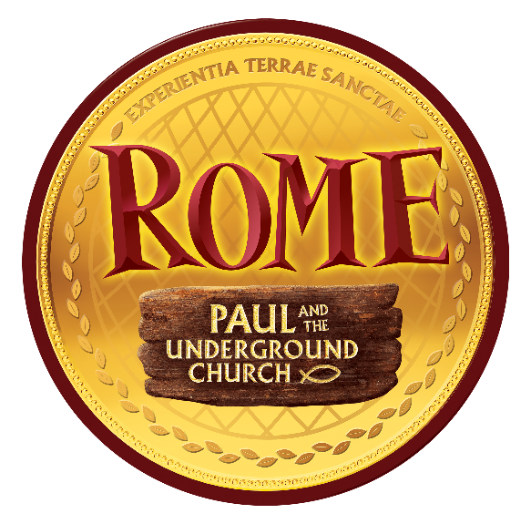

Dear Family,
At Rome: Paul and the Underground Church, your students can become part of history as they see, hear, touch, and even taste what it was like to live in Rome during Bible times!

They’ll explore authentic Marketplace shops, visit the Apostle Paul (who’s under house arrest), sneak to the cave where the Underground Church meets, take part in games, sing-along to lively Bible songs, and sample tasty tidbits as you discover more about the early church. These experiences make God’s Word come alive with new meaning for all who participate!

Also, we are going to participate in a special project. We are going to collect non-perishable food items for the Broken Loaf Food Pantry. The Broken Loaf is located at Lakewood United Methodist Church and provides food to families in the Lakewood and Long Beach communities. Bring items the week of VBS.

Join us as we travel back into Bible times - without setting foot outside our community.

The cost for this year's adventure is $20.00 per child or $40 for families with 3 or more children for the week!

Join us at | California Heights United Methodist Church

on | Monday, June 22, 2026 | through | Friday, June 26, 2026

from | 9:00 AM | to | 12:00 PM

To register or to find out more, call the church office at 562-595-1995. Or visit the church website at www.calheightsumc.org.

Sincerely,

Your Cal Heights UMC VBS Team

