So Little…So Much!
August 2nd, 2020

Chimes

Greeting
L: Call upon the Lord, and God will answer.
P: Show us your steadfast love, gracious God,
this day and always.

Prelude

Welcome & Sharing the Life of the Church
- Intro to Drive-Up Communion
- Tidy-Up
- Update on Facility Work
- Phone Tree
- Genesis Project
- God and the Pandemic

*Invitation to Worship
﻿L: God meets us in our greatest need;
P: God satisfies us with divine presence and provision.
L: In gratitude, let us worship the Lord our God.

*Opening Hymn You Satisfy the Hungry Heart UMH #629

*Opening Prayer (Unison)
O God, hear our cries: for those who hunger, and those who are full; for those who need you desperately, and those who feel no need for you; for those who wrestle with the impact of being your blessed children; for those who are unaware of your offered blessing; and for concerns that are too difficult to express. Hear our cries, O God of our salvation. In the name of your Son, Jesus the Christ, who fed the hungry and healed the wounded we pray. Amen.

Children’s Moments

Special Music

Scripture Matthew 14:13-21
¹³ Now when Jesus heard this, he withdrew from there in a boat to a deserted place by himself. But when the crowds heard it, they followed him on foot from the towns. ¹⁴ When he went ashore, he saw a great crowd; and he had compassion for them and cured their sick. ¹⁵ When it was evening, the disciples came to him and said, “This is a deserted place, and the hour is now late; send the crowds away so that they may go into the villages and buy food for themselves.” ¹⁶ Jesus said to them, “They need not go away; you give them something to eat.” ¹⁷ They replied, “We have nothing here but five loaves and two fish.” ¹⁸ And he said, “Bring them here to me.” ¹⁹ Then he ordered the crowds to sit down on the grass. Taking the five loaves and the two fish, he looked up to heaven, and blessed and broke the loaves, and gave them to the disciples, and the disciples gave them to the crowds. ²⁰ And all ate and were filled; and they took up what was left over of the broken pieces, twelve baskets full. ²¹ And those who ate were about five thousand men, besides women and children.

Message So Little…So Much!

*Response Hymn of Promise UMH #707

Holy Communion
- Introduction
- Prayer
- Receiving Bread and Cup
- Communion Hymn (Let Us Break Bread Together UMH #618 No Singing) If Jim has a version to play that would be wonderful!

Offering
- Offertory Sentence: ﻿In the faithful hands of Christ, our little is multiplied to feed many. Come now; let us offer our loaves and fishes to the All-sufficient One who said, “Bring them here to me.”
- Offering
- Offertory Prayer: Receive these gifts we offer, gracious God, and multiply them to meet the needs in your world.
Amen.

*Closing Hymn One Bread, One Body #UMH 620

*Benediction

Please Keep the Following in Your Prayers:
John & Sylvia Polinski, Marcia & Chris Dyer, Joan Wolfe,

Participating in Today’s Service & Communion:
Music Director Dr. Anna DeMichele
Organist Dr. James Petri
Soloist Owen Lovejoy
Guitarist Ashley Ventri
Liturgist
Video Operator Ron Koelling
Pastor Douglas Dickson

So Little…So Much!
August 2nd, 2020

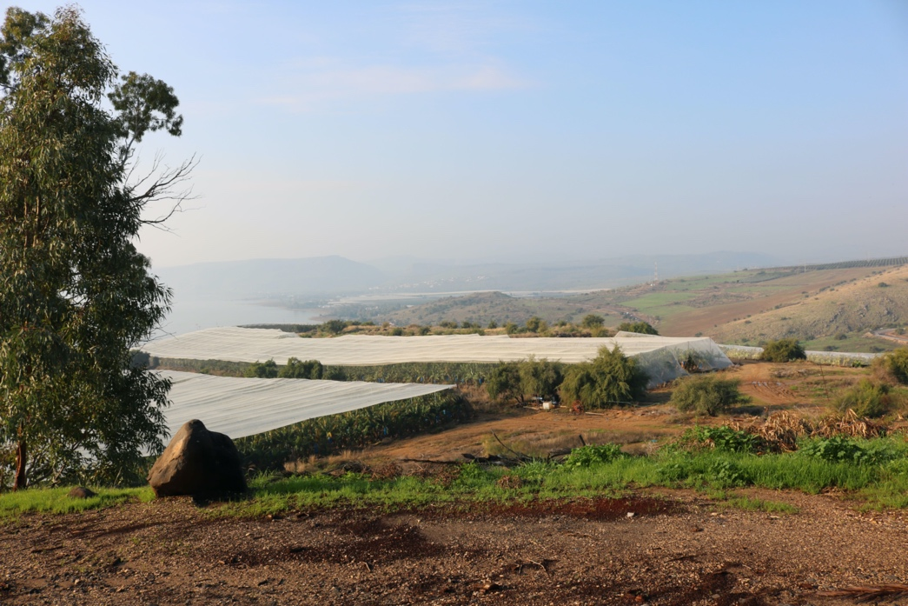

The Site of the Multiplication of Loaves and Fishes.

California Heights
United Methodist Church

CalHeightsUMC.org (562)595-1996

