Not a Chance Meeting…
August 9th, 2020

Chimes

Greeting
﻿L: God lifts us from death to life and preserves us for God’s purposes through the compassion of Jesus Christ our ﻿Lord and the guidance of the Holy Spirit.
P: With thanksgiving, we will praise the Lord!

Prelude

Welcome & Sharing the Life of the Church
- Announcements

*Invitation to Worship
L: Sunshine and celebration! Rain and remembrance! All are part of the richness of God’s mercy and love for us!
P: God has blessed us in so many ways!
L: Welcome this day to a celebration of these blessings!
P: Thank you. We are glad to be here!
L: Lord, open our hearts and spirits to your love
P: Bring us safely through the trials and tribulations of life, for we ask this in Jesus’ name. AMEN

*Opening Song What A Beautiful Name (Insert)

*Opening Prayer
﻿Son of God, you walk on the waters of turmoil to meet us in the midst of your purposed journey for our lives. Help us to recognize your presence, remember your promise, rely on your power, and receive your peace through every storm. Amen.

Children’s Moments

Special Music

Scripture Romans 10:5-17
⁵ Moses writes concerning the righteousness that comes from the law, that “the person who does these things will live by them.” ⁶ But the righteousness that comes from faith says, “Do not say in your heart, ‘Who will ascend into heaven?’ ” (that is, to bring Christ down) ⁷ “or ‘Who will descend into the abyss?’ ” (that is, to bring Christ up from the dead). ⁸ But what does it say?
“The word is near you,
on your lips and in your heart”
(that is, the word of faith that we proclaim); ⁹ because if you confess with your lips that Jesus is Lord and believe in your heart that God raised him from the dead, you will be saved. ¹⁰ For one believes with the heart and so is justified, and one confesses with the mouth and so is saved. ¹¹ The scripture says, “No one who believes in him will be put to shame.” ¹² For there is no distinction between Jew and Greek; the same Lord is Lord of all and is generous to all who call on him. ¹³ For, “Everyone who calls on the name of the Lord shall be saved.”
¹⁴ But how are they to call on one in whom they have not believed? And how are they to believe in one of whom they have never heard? And how are they to hear without someone to proclaim him? ¹⁵ And how are they to proclaim him unless they are sent? As it is written, “How beautiful are the feet of those who bring good news!” ¹⁶ But not all have obeyed the good news; for Isaiah says, “Lord, who has believed our message?” ¹⁷ So faith comes from what is heard, and what is heard comes through the word of Christ.
Response:
L: The word of God for the people of God.
P: Thanks be to God!
Message The Choice to Receive…

*Response In Christ Alone WS #3105

Prayer Time
- Sharing Joys and Concerns
- Prayer Chorus Holy Spirit, Truth Divine (Verse 1 2x)
- Pastoral Prayer
- Lord’s Prayer: Our Father, which art in heaven, hallowed be thy name. Thy kingdom com; thy will be done; on earth as it is in heaven. Give us this day our daily bread and forgive us our trespasses, as we forgive those who trespass against us. Lead us not into temptation but deliver us from evil. For thine is the kingdom, and the power, and the glory forever. Amen.

Offering
- Offertory Sentence: The richness of God’s mercy is poured over us every minute of our lives, even when we least expect it. We offer our gifts and tithes in gratitude for all that God does for and with us, that we might become better servants of the Gospel. AMEN.
- Offertory
- Doxology:
Praise God from whom all blessings flow;
Praise God, all creatures here below: Alleluia! Alleluia!
Praise, praise the source of all our gifts!
Praise Jesus Christ whose power uplifts!
Praise the Spirit, Holy Spirit, Alleluia! Alleluia! Alleluia!
- Offertory Prayer: Lord of sea and storm, of sunshine and meadow, we present these offerings as tokens of our lives in grateful praise for your love for us. Use these gifts for the ministries of hope and justice in this, your broken world. We ask this in Jesus’ name. AMEN.

*Closing Hymn Here I Am, Lord UMH #593

*Benediction

The Choice to Receive…

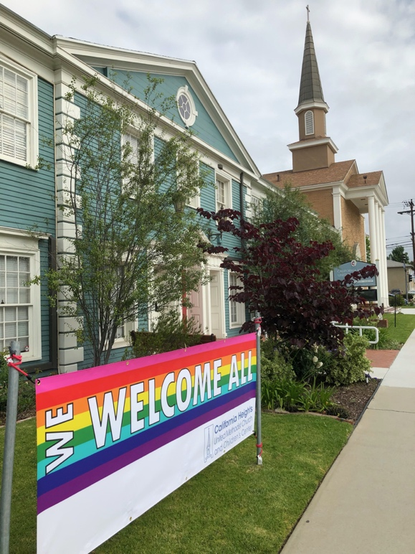

California Heights United Methodist Church

Calheightsumc.org (562)595-1996
3759 Orange Avenue

