Who Am I?
August 23rd, 2020

Chimes

Greeting
L: Jesus invites us to worship him today!
P: We worship Christ each day, every day with hearts of gladness!

Prelude

Welcome & Sharing the Life of the Church
- Artist’s Choice Tonight @ 6:00 pm
- Veteran’s Virtual 3-Mile Run November 1-15
- Drive-Thru Communion Sept 6th, 11:15-Noon

*Invitation to Worship
﻿L: Our help is in the name of the Lord, who made heaven and earth.
P: Confident in this ever-gracious, never-failing help, we come.
L: Let us come with hearts open and transparent
P: With our spirits humble and ready, we come.
L: Let us come seeking forgiveness, healing, wholeness;
P: We bow our hearts to receive God’s grace in Jesus Christ.

*Opening Hymn Christ for the World We Sing UMH #568

*Opening Prayer (Unison)
﻿God of revelation, mere flesh and blood cannot reveal divine truth; only your Spirit can give that gift. Be in my breath and voice, be in our ears and ﻿understanding, that through these words your word may be known and through our works your grace experienced. Amen.

Children’s Moments

Special Music Thy Word is a Lamp Unto My Feet
Michael Card sung by Karen Joy Smith

Scripture Matthew 16:13-20
¹³ Now when Jesus came into the district of Caesarea Philippi, he asked his disciples, “Who do people say that the Son of Man is?” ¹⁴ And they said, “Some say John the Baptist, but others Elijah, and still others Jeremiah or one of the prophets.” ¹⁵ He said to them, “But who do you say that I am?” ¹⁶ Simon Peter answered, “You are the Messiah, the Son of the living God.” ¹⁷ And Jesus answered him, “Blessed are you, Simon son of Jonah! For flesh and blood has not revealed this to you, but my Father in heaven. ¹⁸ And I tell you, you are Peter, and on this rock I will build my church, and the gates of Hades will not prevail against it. ¹⁹ I will give you the keys of the kingdom of heaven, and whatever you bind on earth will be bound in heaven, and whatever you loose on earth will be loosed in heaven.” ²⁰ Then he sternly ordered the disciples not to tell anyone that he was the Messiah.

Message Who Am I?

Special Music Who Am I?

*Response Jesus, Name Above all Names TFWS #2071

Prayer Time

Offering
Offertory Sentence: ﻿Brothers and sisters, present your bodies as a living sacrifice, holy and acceptable to God. As an act of worship, let us now return to God our offering.
Offertory:
Doxology:
Offertory Prayer: ﻿Almighty God, you took a baby from the Nile and used him to lead your people to the promised land. Take our offerings and use them for your people in this land and throughout your world. In Jesus’ name we pray. Amen.

*Closing Hymn Who You Say I Am (Insert)
Verse 1
Who am I that the highest King would welcome me
I was lost but He brought me in
Oh His love for me
Oh His love for me

Chorus 1
Who the Son sets free, oh is free indeed
I'm a child of God--yes I am

Verse 2
Free at last, He has ransomed me
His grace runs deep
While I was a slave to sin, Jesus died for me
Yes He died for me

Chorus 2
In my Father's house, there's a place for me
I'm a child of God, yes I am

Bridge
I am chosen not forsaken; I am who You say I am
You are for me not against me; I am who You say I am
CCLI Song # 7102401 Ben Fielding | Reuben Morgan

*Benediction

Postlude

Who Am I?
A Question for All…

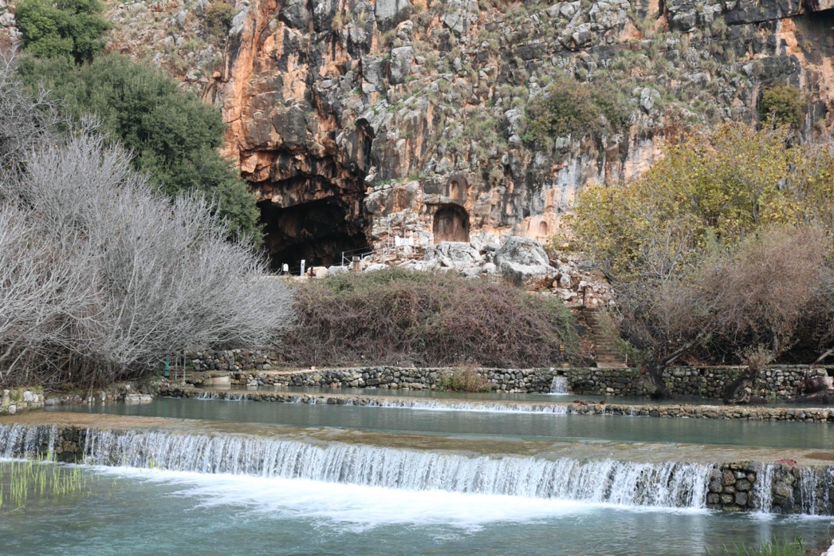

California Heights United Methodist Church

CalHeightsUMC.org (562)595-1996

