In the Beginning…
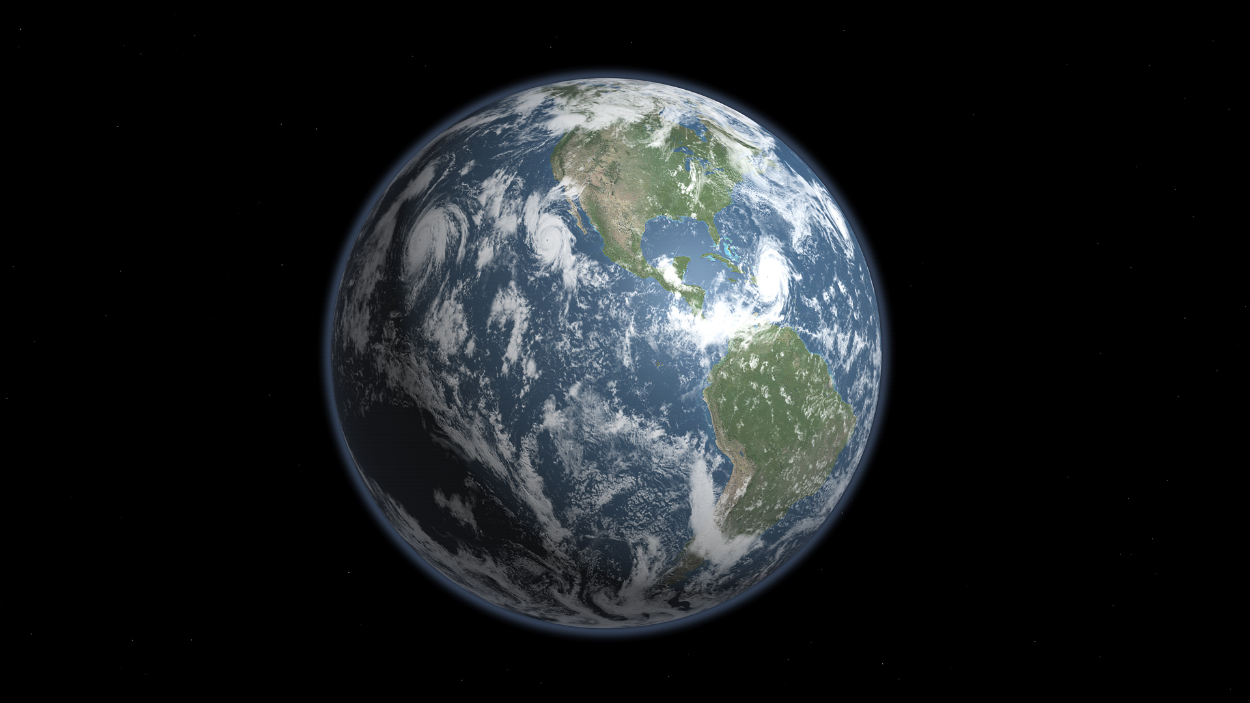
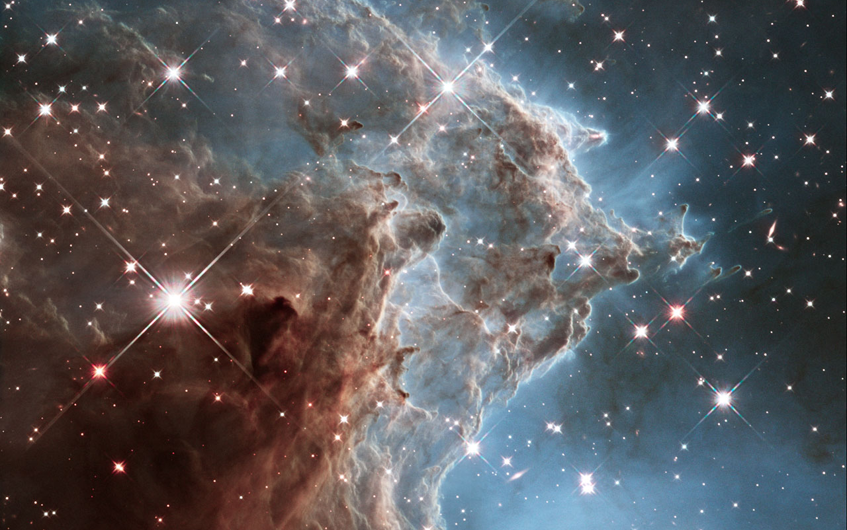
The book of Genesis begins with, well, the beginning (which is what it literally means). In an extraordinary turn of events, the description contained in its first chapter, the seven days of Creation, mirrors the scientific account from cosmology, biology, and even evolutionary theory! Not bad for a document that was written to boast of God’s power over Creation as well as other deities that was written around 2,500 years ago!

In the Beginning…

Genesis Forms the basis for our history, theology, and Answers our questions.

How did it all begin?

Creation and Humanity beginnings

What about language and culture?

Nomads, Farmers, and Israel.

How did we come to Mount Zion?

Israel’s Origin Story and Manifest Destiny stories.
Did you know?
The creator of the “Big Bang Theory” was a Catholic Cardinal

The Genesis Project

Context is everything!!
One of the most important things to remember when reading Genesis is that this work is a religious and spiritual document that never intended to speak to scientific realities. The fact that much of the first chapter aligns with scientific theory doesn’t make it the scientific authority it never intended to be. Even given the advanced science found in the eras before Christ’s birth in Mali, Africa, and the wisdom of the Celtics, the religious leaders that wrote the accounts of Creation sought more to explain the omnipotence and orderly character of their God, the God of Israel, and eventually Christians and Muslims alike.

“The fact that much of the first chapter aligns with scientific theory doesn’t make it the scientific authority it never intended to be.”
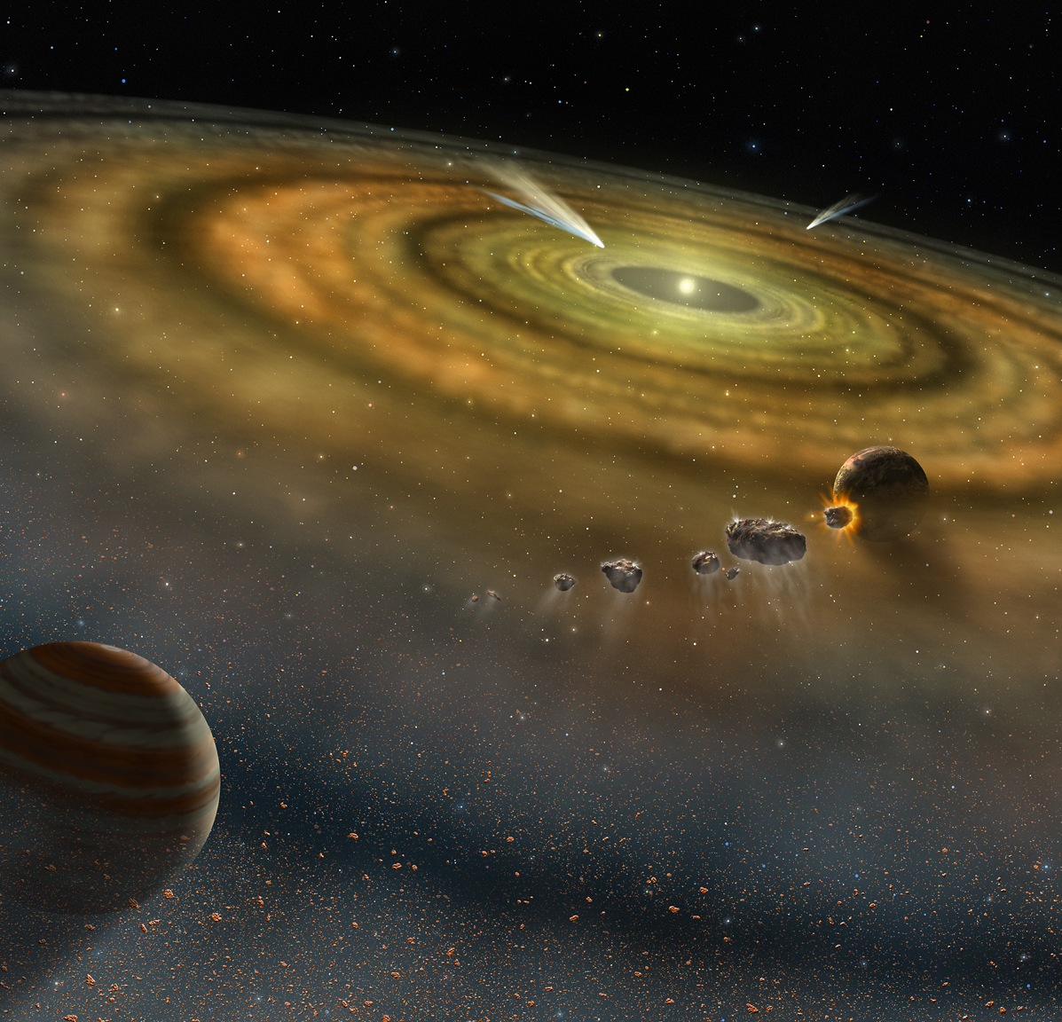
So let’s take a look at this wonderfully mysterious first Chapter and praise God for the incredible truths that we find within it! Let’s start at the very beginning…it’s a very good place to start!

First Aspects of Creation Story in Pictures…
The first part of Creation is the creation of Creation! God takes the formless and void clay and molds it into a setting for life to flourish.

The Prelude to Creation
Read Genesis 1:1-2
1 In the beginning when God created the heavens and the earth, ² the earth was a formless void and darkness covered the face of the deep, while a wind from God swept over the face of the waters.
The Holy Bible: New Revised Standard Version. (1989). (Ge 1:1–2). Nashville: Thomas Nelson Publishers.
What does the Hebrew say? The “Bible” used by most Jews today is the Tanakh, a text interpreted by Hebrew scholars of Jewish, not Christian, faith. The importance here is simple: The Jewish Hebrew scholar is not impacted as heavily by previous interpretations of Scripture such as the Vulgate, King James, and other famous interpretations of old as are Christian scholars. This is most obvious in the first statement of Genesis—“in the beginning.” The Tanakh interprets the Hebrew in the way the Hebrew verb seems to intend, “When God began to create…”

This change in the English translation brings a greatly different understanding of the beginning of time, eternity, and Creation itself. It makes sense of the next phrase of the passage and implies that the “true” beginning was when God began to act, not when matter began to exist. Traditional Christian thought, based on a different interpretation of the Hebrew assumes that nothing exists prior to God’s act of Creation. We call this, “Creation ex nihilo”, or, “Creation from nothing.” The Jewish interpretation of the Hebrew allows for an earth that is formless and devoid of living matter. God’s hand, or voice, beginning the act of creating marks the beginning regardless of the existence of matter or not. So let’s take a deeper look into the opening line:
“Tehom” is the Hebrew word translated as, “deep” and likely refers to the Babylonian Goddess, “Tiamat” See below for some history of her story.
“Ruach” is the Hebrew word for Spirit, wind, and, breath. The Greek word, “Pneumos” translates in similar fashion. Read the passage using the alternative translation for the word, “wind”.
“Heavens and the earth,” should more likely be translated, “sky and land” as it refers more to the physical properties of what we see above and below us rather than heaven and the Earth.

“In the beginning, when God began to create the land and skies,
the earth was formless and void.”

God’s act of creating is the beginning point in the narrative for the people of God! There is no concern for trying to describe the cosmology through scientific understanding. God’s act and God’s act alone are the basis of the Genesis story. Before God’s act of creating the Creation was formless and devoid of life. God brings life to the universe through his actions. How does God act in Genesis? How is God’s power made manifest? Through speaking, God’s word moves throughout all of Creation bringing forth life and order.

The story of Genesis is in direct contrast to some of the known creation stories of its day. One of the Babylonian creation stories features their goddess of the ocean, Tiamat. Read the story below:
Tiamat is the Babylonian goddess of salt waters, the ocean. Here is a sample of the mythology and an explanation of the creation story involving her.

“And the lord stood upon Tiamat's hinder parts,
And with his merciless club he smashed her skull.
He cut through the channels of her blood,
And he made the North wind bear it away into secret places.”

Slicing Tiamat in half, he made from her ribs the vault of heaven and earth. Her weeping eyes became the sources of the Tigris and the Euphrates, her tail became the Milky Way. With the approval of the elder deities, he took from Kingu the Tablet of Destinies, installing himself as the head of the Babylonian pantheon. Kingu was captured and later was slain: his red blood mixed with the red clay of the Earth would make the body of humankind, created to act as the servant of the younger Igigi deities.
It seems that the Israelites were very interested in promoting the power not only to create with a stolen word, but, in the very first sentence of Scripture, to hover over the symbolic goddess of the Babylonian creation story. The God of Israel is dominant over all other gods. Furthermore, God takes chaos and creates order through God’s power and speech. We are reminded of a number of Scripture passages, including Isaiah 55:11, which says:

“So shall my word be that goes out from my mouth;
it shall not return to me empty,
but it shall accomplish that which I purpose,
and succeed in the thing for which I sent it.”

The Holy Bible: New Revised Standard Version. (1989). (Is 55:11). Nashville: Thomas Nelson Publishers.

or,

“Ever since the creation of the world his eternal power
and divine nature, invisible though they are,
have been understood and seen
through the things he has made.”

The Holy Bible: New Revised Standard Version. (1989). (Ro 1:20). Nashville: Thomas Nelson Publishers.

Our God, the God of Israel, the Creator and Father of our Lord, Jesus Christ, speaks with purpose (to create order), with authority (in subjugation to none), and goodness (to bring life). This is the nature of God according to the opening passage of Genesis as well as the whole of Scripture which is an account of God’s shaping of Creation and Humanity into what we historically call, “The Kingdom of God.”

The Genesis Project:
Over the next 8 weeks, we will be jogging through the first section of the book of Genesis—from Creation to the flood. We will do our best to look openly and honestly at the text, the context, the history and how this ancient text shapes our understanding of our Christian faith, personal philosophy, and daily praxis (living out our faith/philosophy). We will look closely at the people of the stories, the actions they take, and the work of God in their midst. We will challenge our notions of how God acts and works as well as motivations for God’s continuing actions in Creation. Here’s an overview:

Week 1: The Beginning of the Beginning—How the first paragraph of Genesis shapes our understanding of the people of Israel and our belief in the character and powers of God.

Week 2: The Creation of All Things—A look at the sequence and organization of God’s creating acts of Genesis, chapter one, and how it interacts with modern scientific theories. How does it affirm or conflict with historical theology and science?

Week 3: We Come to the Garden— The story of Adam and Eve, the fallacies and truths we learned in Sunday school. What does the story tell us about ourselves and the understanding of humanity that the people of Israel held?

Week 4: We Run From the Garden— Once the fruit is eaten, God banishes Adam and Eve from Eden. We’ll look into the ramifications of their actions and how we can even find mercy in the judgement God hands to the wayward couple.

Week 5: The Beginning of Conflict— Cain kills Abel. What is behind the murderous conflict of the primary siblings of Scripture? What can we learn from the tragedy and the resulting consequences?

Week 6: Secrets of the Boring Parts— What good are genealogies? Why are they here and what do they mean? We’ll take a deeper look at the back-story of the rest of the story—the parts most people glance over.

Week 7: God’s Grief and One Righteous Man— Noah. When God’s “experiment” with humanity goes sideways, God begins again. We’ll look at God, Noah, and the Flood.

Week 8: Beginning Again—When the waters recede and the story of humanity begins to take center stage, it seems we can’t always start over. This story of redemption and falling over..and over is a turning point in God’s activity in the world around us. We’ll look back at the what we’ve covered, and ahead to what’s next—just like the story itself.

