More Than You Know...
Sunday, July 25, 2021

Chimes

Greeting
L: God lavishes upon all God’s grace and mercy!
P: Shower down your mercy, O God! Shower down your grace!

Prelude Holy God We Praise Thy Name Grosser Gott

Welcome & Announcements

*Invitation to Worship
L: Fools say in their hearts, “There is no God.”
P: Too often we have been fools in word or deed.
L: Still, the Lord looks from heaven for those who seek God.
P: May we be found among the company of the righteous!
L: Deliver us from evil, O God. Restore your people’s fortunes.
P: Lord, only in you can we find refuge. Amen.

*Opening Music Here I Am To Worship W&S #3177

*Opening Prayer (Unison)
Holy One, we bow our hearts before you this day. Strengthen us in our innermost being and dwell in our hearts through faith. May we be rooted and grounded in Christ, whose love is beyond all knowledge. Help us comprehend even the smallest part of the beautiful mystery of your grace. Grant that we may experience the fullness of your presence with us. Amen.

Children’s Message

Special Music Beautiful Savior Darwin Wolford
arr. Amber Schumann
Robyn Frey-Monell, Soprano and Owen Lovejoy, Tenor

Scripture John 6:1-21
6 After this Jesus went to the other side of the Sea of Galilee, also called the Sea of Tiberias. ² A large crowd kept following him, because they saw the signs that he was doing for the sick. ³ Jesus went up the mountain and sat down there with his disciples. ⁴ Now the Passover, the festival of the Jews, was near. ⁵ When he looked up and saw a large crowd coming toward him, Jesus said to Philip, “Where are we to buy bread for these people to eat?” ⁶ He said this to test him, for he himself knew what he was going to do. ⁷ Philip answered him, “Six months’ wages would not buy enough bread for each of them to get a little.” ⁸ One of his disciples, Andrew, Simon Peter’s brother, said to him, ⁹ “There is a boy here who has five barley loaves and two fish. But what are they among so many people?” ¹⁰ Jesus said, “Make the people sit down.” Now there was a great deal of grass in the place; so they sat down, about five thousand in all. ¹¹ Then Jesus took the loaves, and when he had given thanks, he distributed them to those who were seated; so also the fish, as much as they wanted. ¹² When they were satisfied, he told his disciples, “Gather up the fragments left over, so that nothing may be lost.” ¹³ So they gathered them up, and from the fragments of the five barley loaves, left by those who had eaten, they filled twelve baskets. ¹⁴ When the people saw the sign that he had done, they began to say, “This is indeed the prophet who is to come into the world.”
¹⁵ When Jesus realized that they were about to come and take him by force to make him king, he withdrew again to the mountain by himself.
¹⁶ When evening came, his disciples went down to the sea, ¹⁷ got into a boat, and started across the sea to Capernaum. It was now dark, and Jesus had not yet come to them. ¹⁸ The sea became rough because a strong wind was blowing. ¹⁹ When they had rowed about three or four miles, they saw Jesus walking on the sea and coming near the boat, and they were terrified. ²⁰ But he said to them, “It is I; do not be afraid.” ²¹ Then they wanted to take him into the boat, and immediately the boat reached the land toward which they were going.

Message More Than You Know...

*Hymn Response You Satisfy the Hungry Heart UMH #629
Vs 1,2,5
Sharing the Life of of the Church
- Joys and Concerns
- Centering Prayer El Shaddai UMH #123
- 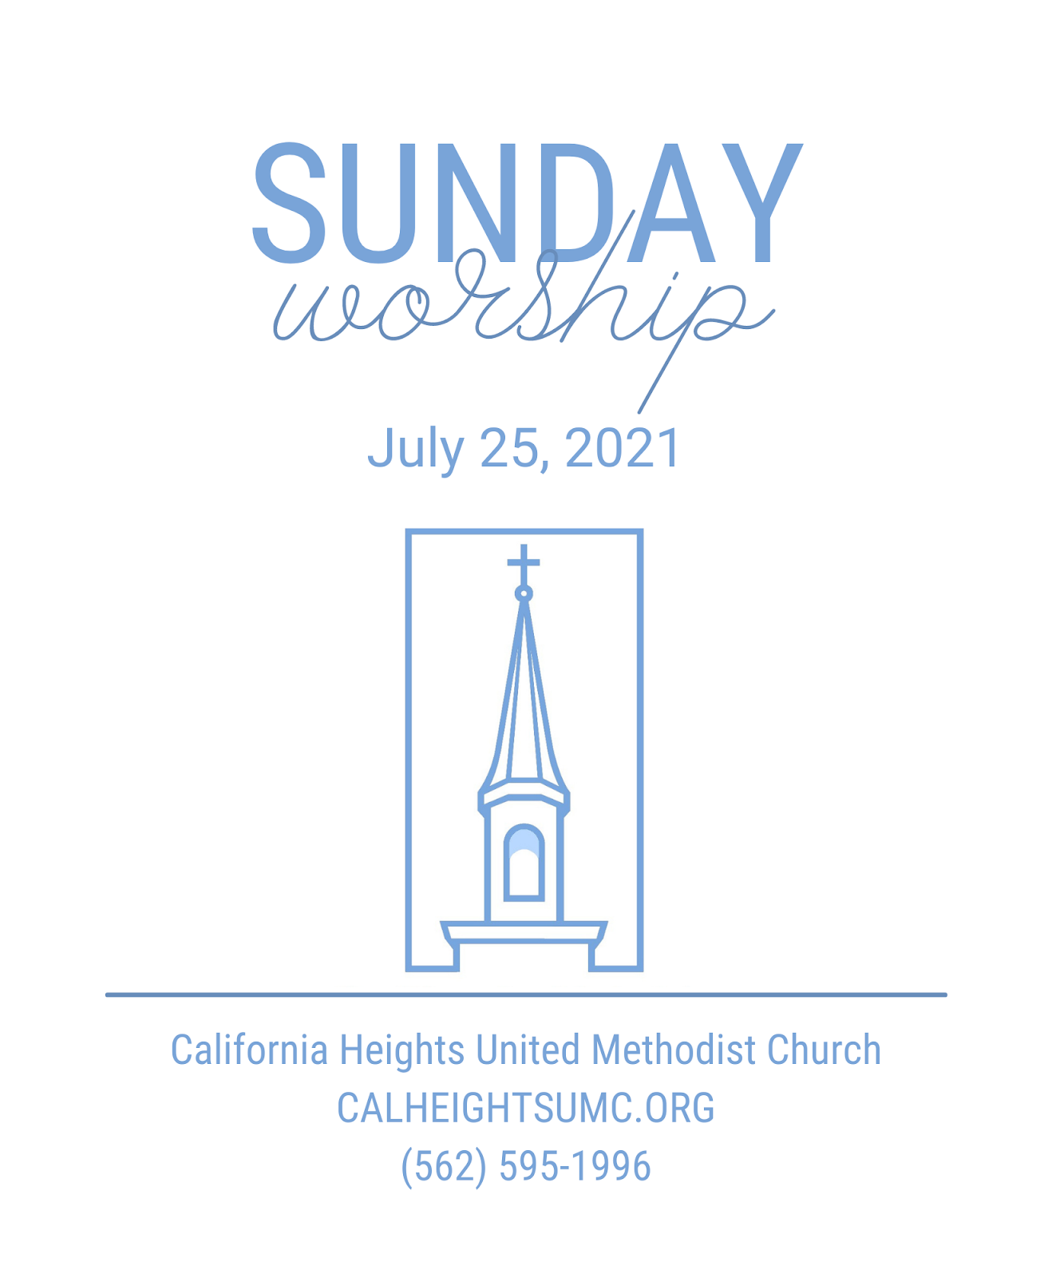Pastoral Prayer
- The Lord’s Prayer

Offering
- Offertory Sentence: The God who comes to us calls us to reach out with the same loving and gracious arms of welcome and embrace to the world around us. Let us give so that the world may know God’s love, God’s grace, God’s forgiveness.
- Offertory Ask Me Now Thelonious Monk
- *Doxology: Praise God from whom all blessings flow;
Praise God all creatures here below; Alleluia! Alleluia!
Praise God the source of all our gifts!
Praise Jesus Christ whose power up-lifts!
Praise the Spirit, Holy Spirit! Alleluia! Alleluia!
- Offertory Prayer: Gracious God, it would be pure hubris for us to think that the world needs our message. It does not. The world needs your message of grace and unconditional love. Bless these gifts that we give that they may be a source of grace and comfort for your glory. Amen.

*Closing Hymn Blessed Be Your Name W&S 3002

*Benediction

Postlude Go Tell It On The Mountain Spiritual

