The Difficult Choice
September 20,2020

Chimes

Greeting
L: The Peace of Christ be with us as we worship.
P: The grace of Christ go with us as we live.

Prelude

Welcome & Sharing the Life of the Church
- Announcements

*Invitation to Worship (Psalm 105)

L: Call on the name of God and give thanks.
P: Make known God's deeds among the people.
L: Sing and tell of God's wonderful works.
P: Let those who seek God rejoice in their hearts.
L: Let us worship God.

*Opening Hymn Lift Every Voice and Sing UMH #519

*Opening Prayer
God of fruitful labor, work sometimes brings out the worst in us. At home, at school, in the workplace, even in our relationship with you,
we too easily question what others do and get, instead of taking care of our own business. Take away our bitterness. Teach us the art of the careful complaint. Give us grateful hearts, we pray. Amen.

Children’s Moments

Special Music

Scripture Philippians 1:18b-30
Yes, and I will continue to rejoice, ¹⁹ for I know that through your prayers and the help of the Spirit of Jesus Christ this will turn out for my deliverance. ²⁰ It is my eager expectation and hope that I will not be put to shame in any way, but that by my speaking with all boldness, Christ will be exalted now as always in my body, whether by life or by death. ²¹ For to me, living is Christ and dying is gain. ²² If I am to live in the flesh, that means fruitful labor for me; and I do not know which I prefer. ²³ I am hard pressed between the two: my desire is to depart and be with Christ, for that is far better; ²⁴ but to remain in the flesh is more necessary for you. ²⁵ Since I am convinced of this, I know that I will remain and continue with all of you for your progress and joy in faith, ²⁶ so that I may share abundantly in your boasting in Christ Jesus when I come to you again.
²⁷ Only, live your life in a manner worthy of the gospel of Christ, so that, whether I come and see you or am absent and hear about you, I will know that you are standing firm in one spirit, striving side by side with one mind for the faith of the gospel, ²⁸ and are in no way intimidated by your opponents. For them this is evidence of their destruction, but of your salvation. And this is God’s doing. ²⁹ For he has graciously granted you the privilege not only of believing in Christ, but of suffering for him as well— ³⁰ since you are having the same struggle that you saw I had and now hear that I still have.

Response:
L: The word of God for the people of God.
P: Thanks be to God!

Message

*Response Immortal Invisible God Only Wise UMH #103

Prayer Time
- Sharing Joys and Concerns
- Prayer Song Jesus, Name above all names
- Pastoral Prayer
- Lord’s Prayer: Our Father, which art in heaven, hallowed be thy name. Thy kingdom come, thy will be done; on earth as it is in heaven. Give us this day our daily bread and forgive us our trespasses, as we forgive those who trespass against us. Lead us not into temptation, but deliver us from evil. For thine is the kingdom, and the power, and the glory forever. Amen.

Offering
- Offertory Sentence: Whatever our struggles, whatever our miracles, whatever our burdens, whatever our fruitful labor, we are thankful for the blessings from God and from God's good creation. As signs of that gratitude, let us offer now our tithes and gifts.
- Offertory
- Doxology
- Offertory Prayer: God of abundance, receive these gifts
with thanks from your people, we pray. May they and we
help your love and grace flow like rivers in deserts of need. Amen.

*Closing Hymn. Lord, Dismiss us With Thy Blessing UMH #671

*Benediction

California Heights
United Methodist Church
September 20th, 2020

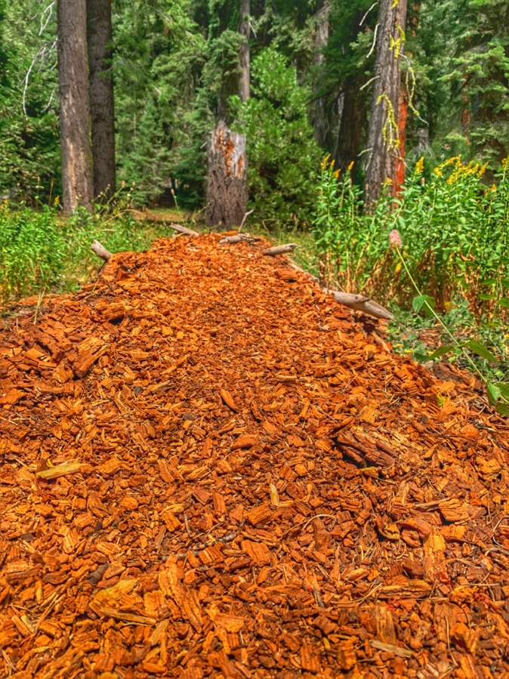

The Holy Bible: New Revised Standard Version. (1989). (Php 1:18–30). Nashville: Thomas Nelson Publishers.

