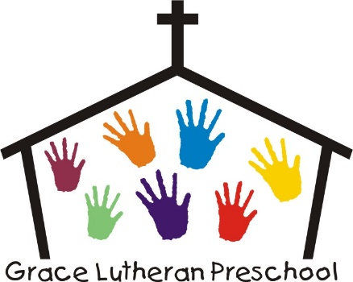

Class Registration Form

**Preschool 3s**  (Must be 3 on or before Sept. 15, 2022) $35 Registration Fee is due at time of enrollment and is non-refundable.

____ M & W AM 8:30 – 11:00 $110/month (Class limited to 8 students.)

____T & Th AM 8:30 – 11:00 $110/month (Class limited to 8 students.)

**Preschool 4s**  (Must be 4 on or before Sept. 15, 2022 to qualify to SVPP grant.)

____ M – F AM 8:15 – 11:15 Class limited to 8 students.

____M – F PM (4s and 5s) 12:00 – 3:00 Class limited to 16 students.

* You will also need to complete the Student Application ( Central DeWitt Community School District), in addition to this form, and return the district form to the superintendent’s office to be enrolled in the grant program. **This form is to be returned to the preschool**.

Child’s Name ______________________________ Birthdate:_________________

Name of Parents ____________________________________________

Mailing Address**____________________________________________**

**________________________________________________**

**Email Address: ____________________________________________**