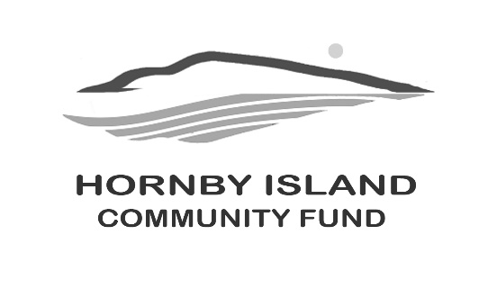
First Edition
Feb 2026
Report from the Community Fund

Big Thinking on a Small Island: How the Community Fund Is Building Hornby’s Future
On an island where volunteer effort sustains almost everything, the Hornby Island Community Fund is quietly doing something bold: transforming everyday generosity into a lasting community legacy.
As 2026 begins, the Fund is entering an important new chapter. For the first time, donations to the Hornby Community Fund are being accepted through the Vancouver Foundation, as part of a pilot project designed to access higher investment yields and strengthen long-term granting power. It’s a strategic step that reflects a growing confidence in what Hornby Island can achieve when local generosity is paired with smart stewardship.
By directing donations through the Vancouver Foundation, the Community Fund can grow its capital more effectively, allowing today’s gifts to support island organizations not just this year, but for generations to come. Donations to the Hornby Community Fund can now be made at
give.vancouverfoundation.ca/s/hornby-community-fund.
This forward-looking move builds on more than two decades of local impact. Since 2002, the Hornby Island Community Fund has distributed over $300,000 in grants to local non-profit organizations, supporting arts and culture, health and wellbeing, environmental stewardship, and social and economic resilience. With a fully volunteer Board of seven directors, the Fund has supported more than 30 non-profits on the island, with nearly every dollar raised going directly back into the community.

Looking Back to 2025
The Comox Valley Community Foundation has already notified organizations receiving 2025 funding. The Hornby Island Community Fund is now awaiting final authorization to publicly release its own grant decisions. Once approved, those details will be shared with the community in an upcoming report.
Momentum carried strongly through 2025, when the Fund’s Matching Funds Campaign exceeded expectations. Thanks to four Lead Donors who each contributed $5,000, the campaign surpassed its $40,000 goal. These funds, plus the $25,000 net proceeds of the 2025 Celebration of Summer, were added to the Capital Investment Fund, where annual interest supports ongoing community grants. As a thank-you, donors who contributed more than $400 will receive a freshly baked pie — a simple, heartfelt symbol of collective generosity.

Who Loves Books?
The Annual Book Sale, traditionally held in early July, is hoped to return this year, though its future depends on new volunteers stepping forward. After many years of dedicated service, the long-standing Book Sale team is ready to pass the torch. This much-loved sale has quietly generated critical funding over the years, particularly for community groups that are not eligible for official charitable status. Anticipating a new Book Sale team, we have booked the Hall for June 30th-July 2nd for the event.
Anyone who loves books, community, or both — and wants to help keep this tradition alive — is encouraged to contact: Lindsay Allen, Alison Stevenson, or Margot Bushnell.

Who Loves a Celebration?
Another highlight of the summer calendar is the Celebration of Summer — an evening that has become synonymous with good food, warm light, and shared purpose. Hosted in 2025 in the apple orchard at the iconic Cardboard House property, the gala features gourmet dining, fairy lights, live music, and a signature silent auction. Planning is underway, and the July date and details will be announced soon.
As preparations begin, the Community Fund is inviting sint auction donations from local businesses and supporters. Weekend getaways, dining experiences, artwork, professional services, and unique experiences are always popular, offering strong visibility to a generous and community-minded audience. We would be honoured to have your donation, please get in touch with Vicky or Karen, or other Board members, to talk!
With strong roots, smart partnerships, and a clear eye on the future, the Hornby Island Community Fund is proving that even a small island can think — and give — for the long term.
Community Fund Board Members:
Angie Read, Anne Carney, April Lewis, Brenda Cha, Byron Corner, Doug Bouey, Karen Ross, and Vicky Peterson.

