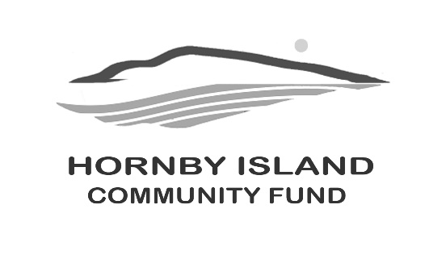
First Edition
March 2026
Growing Community, Growing Capacity:
A Spring Update from the Hornby Island Community Fund
Spring on Hornby Island brings fresh energy, and the Hornby Island Community Fund is feeling that momentum through generosity, new leadership, and renewed calls for community involvement.
This winter, the Community Fund’s Matching Funds Campaign raised more than $44,000 in support of local charities and community initiatives. Contributions of every size played a vital role in reaching this total, reinforcing a simple truth on Hornby Island: every dollar counts. The campaign was anchored by four Lead Donors whose early commitments helped inspire island-wide participation.
As a thank-you, donors who contributed $400 or more will receive a special gift — a home-made lemon meringue pie from Honey Bee, one of Hornby’s much-loved local bakers. Over two dozen pies will be baked and delivered as a warm expression of appreciation, while recognizing that the campaign’s success was built on generosity at every level.
Another important milestone this year is the successful launch of a new higher-yield investment fund through the Vancouver Foundation. This partnership allows the Hornby Island Community Fund to grow its capital more effectively, strengthening long-term granting capacity and ensuring that donations made today can support island organizations well into the future.
The Community Fund is also pleased to welcome Shawn Pedersen as its newest Board member. Shawn has had a connection to Hornby Island since 1972, when his family first built a summer home here. In 2016, he and his wife built their own home on Anderson Drive, now their full-time residence.
Professionally, Shawn has spent much of his career as an entrepreneur, including owning a Ford dealership in Squamish and co-founding Echoflex Solutions Inc., a technology company he helped grow over 17 years before its sale in 2021. He currently serves as CEO of UK-based software firm Mobiusflow and brings a long history of community involvement and fundraising to his work with the Hornby Community Fund.
The Fund is also putting out an early and enthusiastic call for volunteers to help revive the much-loved Annual Book Sale. Normal advertising and book collections begin early in the spring, and the Community Hall has been tentatively booked for the July long weekend. What’s missing now is a small team of willing hands and shared enthusiasm to “get ’er done.” This fundraiser has quietly generated important support over the years, particularly for community groups that do not have charitable status. If you love books, community, or organizing something that truly matters, now is the time to step forward.
Looking ahead to summer, planning is also underway for one of Hornby’s most anticipated events. Save the date: Sunday, July 26th, when the annual Celebration of Summer returns to the iconic Cardboard House apple orchard. Details will unfold throughout the spring.
The Community Fund warmly thanks past silent auction donors and would be honoured to continue those relationships. New donors are equally welcome. If you’d like to contribute, please contact Karen, Vicky, or any Board member.
With strong community support, new financial tools, and people willing to pull together, the Hornby Island Community Fund continues to turn local generosity into lasting impact.
Hornby Island Community Fund Board:
Angie Read, Anne Carney, April Lewis, Brenda Cha, Byron Corner, Doug Bouey, Karen Ross, Shawn Pedersen, and Vicky Peterson.

