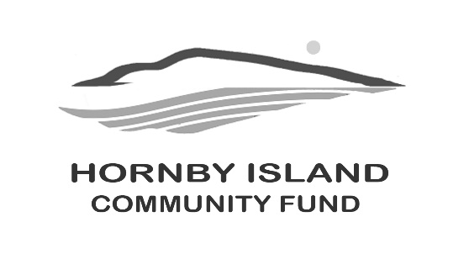
First Edition
Dec. 2025
Report from the Community Fund


Matching Funds
Our Matching Funds program is entering its fourth year and gaining momentum!

We’re excited to set our target at $40,000. With generous Lead Donors, putting up the seed money for the campaign. For every donation made to the Fund, our generous patrons will match it dollar for dollar, up to that $20,000. limit. For example, if you donate $500, that means an additional $500 will be added, resulting in a total of $1,000 for the capital fund. It’s a great way to double your impact while also receiving a tax receipt for your charitable donation—especially timely with the end of the tax year approaching!

And there’s more! Donors who contribute over $400 will receive a delicious homemade pie. A big thank you to Sheila McDonnell and Eli Trimble for their amazing pies in the past campaigns! Our goal is to raise $40,000 for the Hornby Community Fund, and with your support, you’ll not only make a difference but could also enjoy a tasty reward!

Take the challenge, become a “Double Down Donor”
by Dec.31/25:
Donate what you can. Many hands make light work………….
the more people who come forward, the more likely it is we’ll “match” the initial funds.
Information on how to make your donation is at: https://hornbycommunityfund.org/donations

A Rewarding Time of Year
This is a crucial time for our community as grant applications are being reviewed by the Community Fund Board of Directors. Some applications will receive funding from the Hornby Fund’s interest, while others may qualify for funds from other sources. The eligibility for funding depends on the intended use of the money. We do not grant for operating funds, only capital project. Through our fund, local capital project funding are evaluated locally.
As we go to print, the grants are still pending evaluation, so stay tuned for our report next month for updates. This year we have committed $23,800 in grants from local funds, T.B.A. in January/26. In addition to this:

Additional HICF 2025 Grant Funding
- The Arne Olsen Fund, established for the benefit of the Hornby Festival, paid out $2800. this year.
- The Bruce Fairbairn Fund for furthering education for a Hornby resident (with the priority being in the field of music and the Arts) granted $1000.
- The Book Sale monies are paid out annually, and do not form part of the capital fund. $6000. is being dispersed for 2025. Many thanks to the folks who organize the sale, and all the patrons.

As in previous cycles, the Directors of the Hornby Fund are proud to honor our promise to donors: your contributions will make a lasting impact in our community. Thank you for trusting us with your philanthropic support!

When you donate to the Hornby Community Fund, the funds benefit Island recipients directly. Our organization ensures that you won’t have to weed out where the real needs are; we do that on your behalf. Together we are making a difference.

Patrons & Friends, your support and contributions are a community blessing. Our Board wish you all a joyful Holiday Season and a healthy and happy New Year.

With thanks from the Community Fund Board: Angela Read, Angeleah Hoeppner, April Lewis, Brenda Cha, Byron Corner, Doug Bouey, and Karen Ross
www.hornbycommunityfund.org

