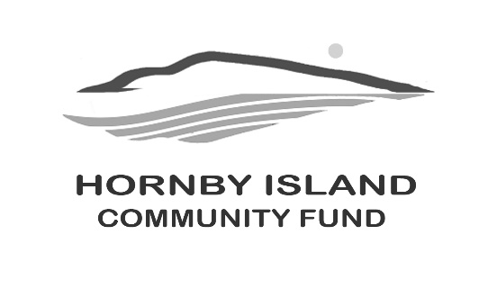

First Edition Report from the Hornby Community Fund
April 2026

Supporting Community Projects on Hornby Island
We are pleased to announce the recipients of the 2025 Hornby Community Fund granting cycle, with $33,000 distributed to local projects that strengthen our island community.
Hornby Island 2025 Grants
- Community Hall – Green Roof Project: $18,000
- Hornby Island Daycare Society – Technology Upgrades: $3,000
- Hornby Island Farmland Trust – “The Shed” Root Cellar Access: $1,000
- Hornby Island Athletic Association / Food Bank – Storage Sea-Can: $9,000
- Bruce Fairbairn Bursary: $2,000
These grants are made possible through the generosity of donors and the dedication of volunteers who sustain the many organizations that contribute to life on Hornby Island.

Summer Events – Save the Dates
Two beloved community traditions are just around the corner.

Annual Book Sale — July 1 & 2
Community Hall
Start your summer reading at the Island’s much-anticipated Book Sale, where tables are stacked with books for every age and interest. Every purchase helps support grants to local non-profit organizations. Donating books drop-offs start March 16th, 5100 Central Road.
This event is only possible thanks to the incredible Book Sale volunteer team, past and present, whose work collecting, sorting, and organizing thousands of books keeps this Island tradition thriving.
Celebration of Summer — July 26
Cardboard House Orchard
Join friends and neighbours for an unforgettable evening at the Celebration of Summer Dinner, Entertainment, and Silent Auction.
Originally known as the Golf & BBQ, this gathering has been a cherished part of Hornby summers for nearly 30 years. The event began as a small community fundraiser hosted by Brenda and Peter Wardle-Cha at Little Tribune Bay, and has grown into one of the Island’s favourite social evenings.
This year’s celebration will be held at the Cardboard House, featuring a West Coast inspired dinner, live music in the orchard with Ted Tanner, and a lively silent auction.
If you would like to donate an item or experience for the auction, we would love to hear from you.

Matching Funds Campaign
The final results of the 2025 Matching Funds Campaign are in: $44,400 was raised for the Hornby Community Fund. The campaign began with the generosity of four leadership donors, whose combined $20,000 in leadership gifts set the campaign in motion by creating the matching pool. Their early commitment helped inspire many others across the community to participate, with individual contributions matched through the program—significantly increasing the impact of every gift. The result is a growing fund that continues to support projects and organizations that strengthen life on Hornby Island.
As the Community Fund grows, so too does the value of grants returned each year to Hornby organizations.
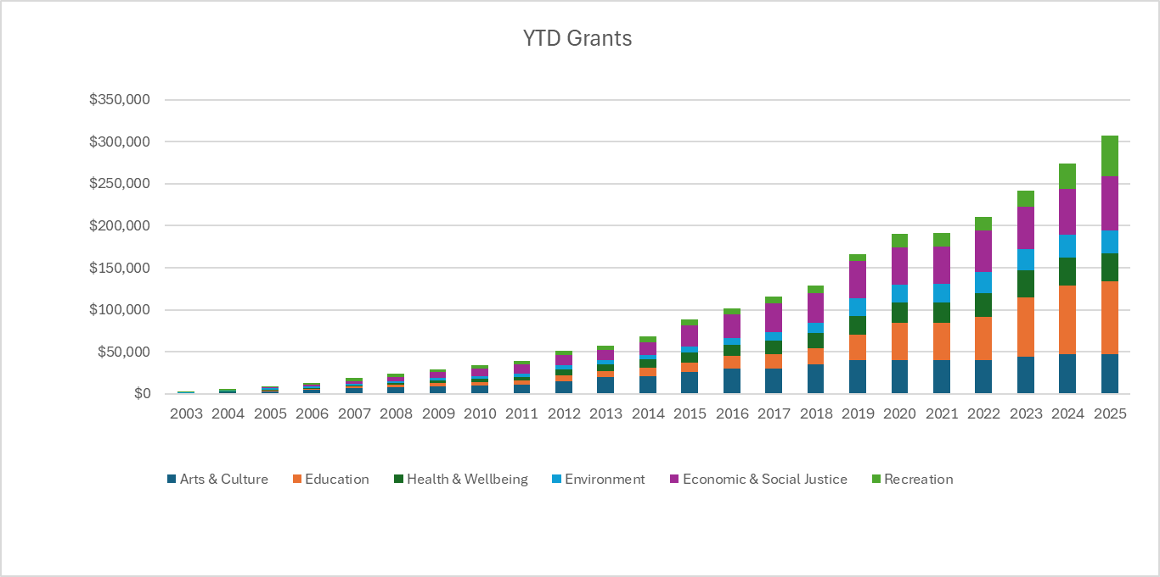 2003 to 2025: growth of the annual grants
As a special thank-you, all donors contributing $400 or more are invited to reserve one of our “made with love” thank-you pies—this year featuring Honey Bee’s lemon meringue.
It is through this spirit of generosity that the Fund continues to grow and give back to the Hornby community year after year.

Legacy Giving
Legacy gifts help ensure that future generations of Islanders continue to benefit from a strong and resilient community. We thank those community members who have included the Hornby Community Fund in their wills. With new donations to the Hornby Fund now directed through the Hornby Community Fund held at Vancouver Foundation, we have prepared a simple guidance document outlining how to include the Fund in estate plans.
Learn more:
www.hornbycommunityfund.org/donations

With Gratitude
We extend sincere thanks to our Advisory Board members:
Angie Read, April Lewis, Brenda Cha, Byron Corner, Doug Bouey, Karen Ross, Shawn Pedersen, and Vicky Peterson.
Their time, experience, and commitment help guide the work of the Fund.
Together, we are strengthening our community—one project, one event, and one donation at a time.
For more information or to donate:
www.hornbycommunityfund.org

