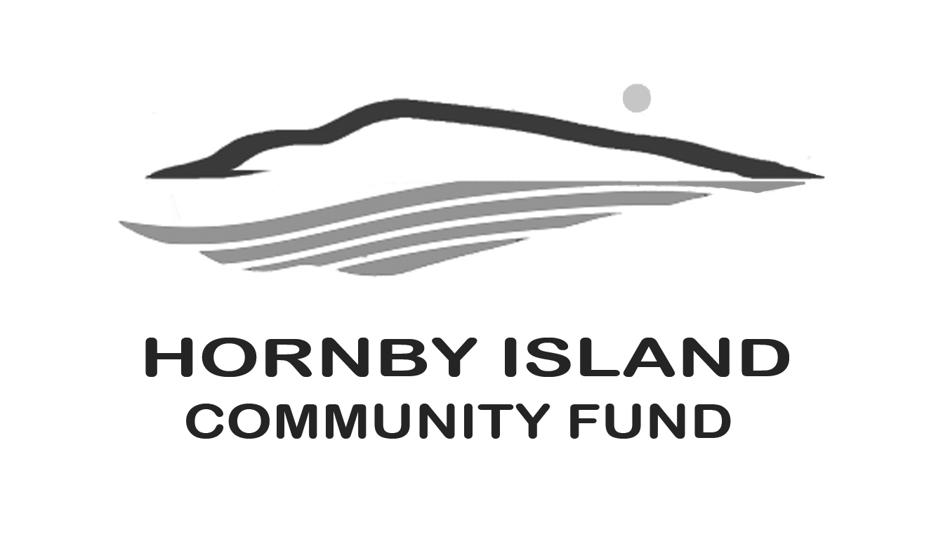

**First Edition**

**April, 2020**

**Report from the Community Fund**

**Where did the money go?**

Between 2002 and 2019, $158,115. has been granted from General Funds.

(an additional $6300 for the Bruce Fairbairn Fund).

Grants are tracked based on sectors, and the specific recipient organizations.

Here is the record of grants awarded between 2002 and 2019:

**Arts & Culture, $39,840.:**

* Hornby Island Festival, $12,390.
* Hornby Island Arts Council, $14,300.
* Hornby Island Quilters, $1,000.
* Hornby Island Radio Society, $6,850.
* Hornby Island Blues Society, $3,650.
* No Horses Music Society, $1.300.
* Wild Indigo Theater, $350.

**Education, $22,220.:**

* Hornby Daycare Society, $6,250.
* Natural History, $9,600.
* Hornby Island Education Society, $6,370.

**Health & Well Being, $21,630.:**

* Hornby Isl. Fire Rescue, $1400.
* Hornby Island (formerly Elder) Housing Society, $13,630.
* Hornby Island Clinic, $2,000.
* Hornby Island Cats Society, $650.
* Hornby Denman Health Care Society, $350.
* Hornby Island Emergency Preparedness Environment, $3,600.

**Environment, $21,350.:**

* Heron Rocks Friendship Centre, $3,800.
* Groundwater Institute, $500.
* Conservancy Hornby Island, $14,050.
* Hornby Island Recycling Committee, $2,250.
* HIRRA Broom Eradication Project, $750.

**Economic & Social Justice, $44,672.:**

* Tribune Bay Outdoor Education Centre/Bus, $4000.
* The Spark, $5,000.
* HICEEC, $500.
* First Edition, $500.
* Island Growers, $800.
* Farris Farmland Trust, $8,500.
* Islanders Secured Lands Association, $24,372.
* New Horizons, $1,000.

**Recreation, $8,403.:**

* Hornby Island Recreation, $250.
* Hornby Island Hall Committee, $500.
* Hornby Island Athletic Association, $5,350.
* Hornby Island Tennis Association, $2,303.

**Thank you to all the Friends of the Fund.**

The civic minded donors, cadre of volunteers who help with events and fundraising, and to our host organization – the Comox Valley Community Foundation.

Together we are making a difference in our community.

Submitted by: Community Fund Advisory Board: **Anne Carney, Brenda Cha, Gary Duke, JoAnn Harrison, April Lewis, Angie Read, Karen Ross and Eva Wetzel**