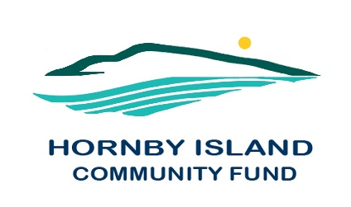

**First Edition**

**April 2021**

**Report from the Community Fund**

The impetus to establish the Hornby Fund came from a large community meeting (approx. 45 community members were in attendance, with a wide representation from the island non-profit groups that were in existence at that time) held in the year 2000. There was unanimous support from all in attendance to create our own community fund to help address financial needs for various community groups and projects; to decrease the reliance on government funding; to increase our local autonomy; and to support long term sustainability for capital projects of local groups.

A local Community Advisory Board of respected and dedicated volunteers became responsible for determining policy and direction, educating the community about the fund, soliciting donations, and developing and maintaining criteria for disbursement of the grants. These advisors additionally charged with providing information on funding sources and fundraising techniques to support the fundraising efforts of community groups. In 2019, the Advisory Board elected to form a non-profit society.

As an independent charitable organization, we are only limited by the will and imagination of our donors, and the groups and people we support in the community. A gift of any size does and will continue to make a difference. To date, **$181,481. has been granted** from General Funds’ investment returns (and an additional $6300 for the Bruce Fairbairn Fund bursaries).

And this will keep growing!  
  
We take a broad view of what a community is and what it needs to thrive.  Therefore, grants have gone to the Festival Society, Arts Council, Quilters, Radio Society, Blues Society, No Horses Music Festival, Wild Indigo Theatre, Daycare, Natural History, HIES, Fire Rescue, Housing Society, Clinic, Cats Society, Hornby Denman Health Care, Emergency Preparedness, Heron Rocks Friendship Centre, Groundwater Institute, Conservancy, Recycling, Invasive Plant Removal, Tribune Bay Outdoor Ed., The Spark, HICEEC, First Edition, Island Growers, Farris Farmland Trust, ISLA, New Horizons, Hornby Rec, Community Hall, Joe King, and the Tennis Assoc.

Our granting and community engagement help make our community more caring and compassionate, resilient and better positioned for an improving future for all who live here.

**On behalf of the Hornby Fund, we are very grateful, to our local donors and supporters, and to the Comox Valley Community Foundation for their generosity and for hosting our local Fund.**

Hornby Community Fund Board: **Anne Carney, Brenda Cha, JoAnn Harrison, April Lewis, Angie Read, Karen Ross and Eva Wetzel**

[www.hornbycommunityfund.org](http://www.hornbycommunityfund.org)