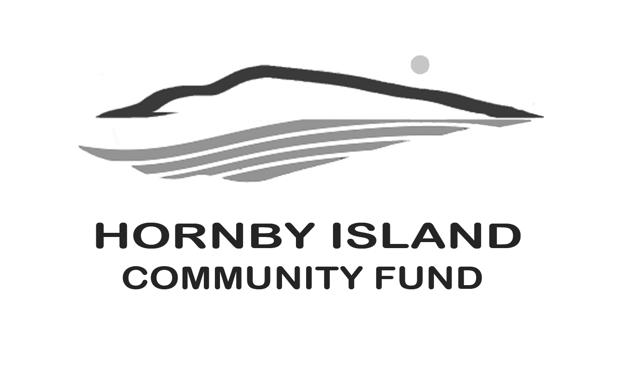
First Edition
April 22
Report from the Community Fund

In last month’s article we mentioned the Comox Valley Community Foundation “neighbourhood small grants”. In 2021, the Foundation funded 36 projects, with $245-$600. provided/project. Projects ranged from block parties to gardening stimulators to environmental projects.
Neighbourhood Small Grants are small-scale, community-based grants designed to kickstart our community’s imagination and create connection within neighborhoods. Neighbourhood Small Grants projects must be free, accessible, and welcoming for all. Non-profits and businesses are NOT eligible for these grants. These grants are grass roots, neighbourhood driven:
Applications for the 2022 Neighbourhood Small Grants program will be accepted beginning March 15 through April 21, 2022.
If you have an idea for elevating the sense of connectedness in your neighbourhood, you may be able to get some funding for a project or event through this program. F.M.I.: https://cvcfoundation.org/grant-seekers/neighbourhood-small-grants/
This year the Hornby Community Fund is reaching outside our borders, to the many Friends of Hornby that come to visit, with an ad in the Visitor Guide:
How do those who LOVE HORNBY show they care?
The gift that keeps on giving: www.HornbyIslandCommunityFund.org
So, if you are in the position to do so, please be encouraging, donations of all sizes are welcomed.
It is with sadness that we are saying good-bye to Judy Saks and Suzanne Duke.
Judy, and her family, are long time community members with a deep love for Hornby. Their generosity and support of community organizations and activities is well known and valued. Judy’s warm personality, wit and wisdom will be sorely missed.
Suzanne was a long-time Community Fund supporter, wife of retired Board member Gary Duke, and all round wonderful human being. A gathering in Suzanne’s memory is being held on April 8th in West Vancouver.
Our condolences to Judy and Suzanne’s many friends and family.
To all of our “Friends of the Fund”, we look forward to seeing you in 2022. Together we are making a difference in our community.
Please visit our website for more information: www.hornbycommunityfund.org
Submitted by: Community Fund Board: Doug Bouey, Brenda Cha, April Lewis, Angie Read, and Karen Ross

