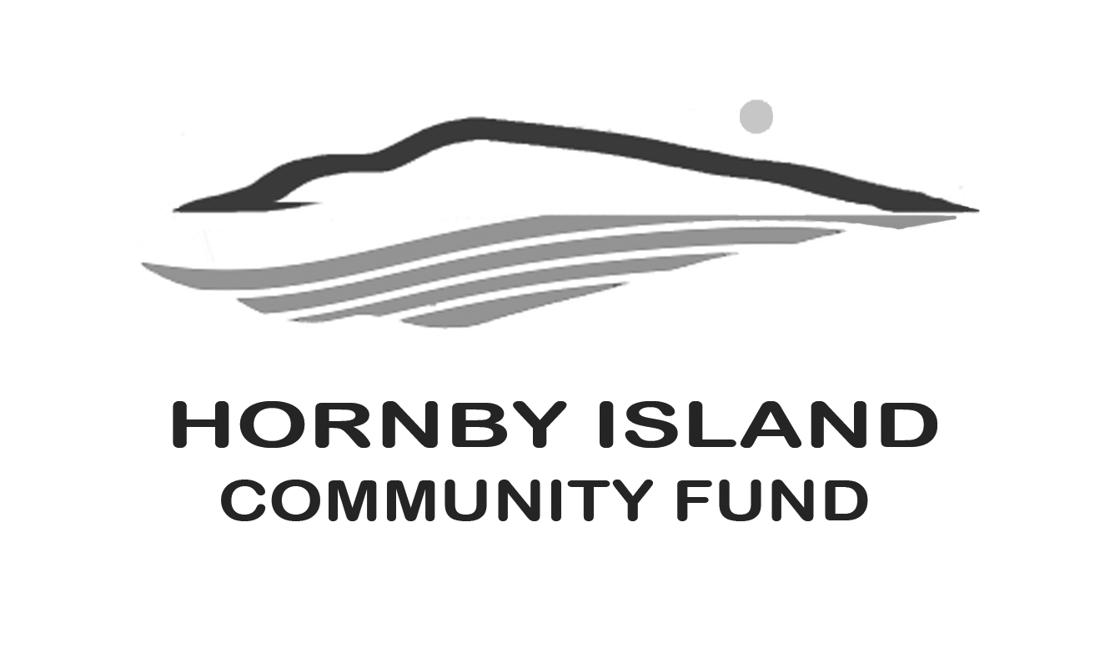

**First Edition**

**December, 2020**

**Report from the Community Fund**

**The granting process in a pandemic year**

With the Book Sale being a casualty of COVID, the Hornby earnings available for this year’s grants was $12,066. With an “ask” of $74,715., the need to grow our capital fund becomes glaring. We simply need to be earning more interest in order to meet our community’s needs. We ask that you consider making a donation, in your own name or as a Seasonal Gift in someone else’s name.

There are a multitude of ways to donate, all of them easy: <https://cvcfoundation.org/giving/make-a-donation/>

Please just be sure to earmark your donation for the “Hornby Island Community Fund”.

Having said that, we were delighted when the Comox Valley Foundation used some of their money towards the Hornby applications this year. We very much appreciate their care and commitment to the whole region.

So, without further adieu, the Hornby organizations that are the successful recipients of this year’s grants:

HIES for upgrades to Room to Grow

HI Athletic Association for the laundromat/shower Wash House upgrade

HI Housing Society for a kitchen upgrade

HI Natural History Centre for strategic planning

HI Daycare Society for a portable U.V. air purifier

**For a total distribution of $23,366.**

It is with sadness that we could not meet all the needs, and know that the organizations that did not receive the funding they had identified as needed in their applications, will be disappointed. As we work together to increase the size of the Fund, there will be more money for supporting these organizations in the future.

**Online auction**

There is a saying, “want something done, ask a busy person”. Well, that doesn’t always work! Sometimes we simply need to say…....HELP! Are there community members who have expertise in e-commerce, online auctions, art auctions, photography, graphic design, social media promotions, target marketing, etc. that could offer some assistance with the Community Fund Online Auction? Donations have been coming in, for both art and collectibles, so the supply side of the auction is building. (Yes, of course we are still accepting donations.)

Where we could use some assistance is in moving it through to the next stage, which is setting up and conducting the auction. We anticipate that the auction will take place next Spring. If you would like to help make this happen, please contact Brenda Cha, 250-335-1116 or one of our other Board members.

**Interested in Gifting?**

For those considering making a charitable gift, it’s useful to know that the ways to donate are virtually limitless. The following are the most common types of gifts:

* **Cash** can include cheques, money orders, and online credit card payments, one-time or pre-authorized repeat contributions. These gifts qualify for maximum charitable benefit under federal law.
* **Publicly Traded Securities -** Donating appreciated securities to the Fund allows you to eliminate capital gains tax and receive an immediate tax receipt for the market value of the securities.
* **A Gift in Your Will,** a.k.a. a charitable bequest, may specify a certain sum of money, a particular asset, or a portion of an estate. Donors of bequests can receive a substantial reduction in federal gift and estate taxes.
* **RRSP / RRIF,** all or a portion, during your lifetime with no tax consequences, or the Fund may also be made a beneficiary upon an individual’s death

**Thinking of You**

We have missed visiting with many of our generous contributors this year, and look forward to seeing you all in 2021. Our sincere thanks to those that have reached, across the miles, and made a donation to the Fund, to support their “heart home”.

Wishing you all a wonderful **holiday season** and a New Year of peace and happiness.

Community Fund Board: **Anne Carney, Brenda Cha, JoAnn Harrison, April Lewis, Angie Read, Karen Ross and Eva Wetzel**

[www.hornbycommunityfund.org](http://www.hornbycommunityfund.org)