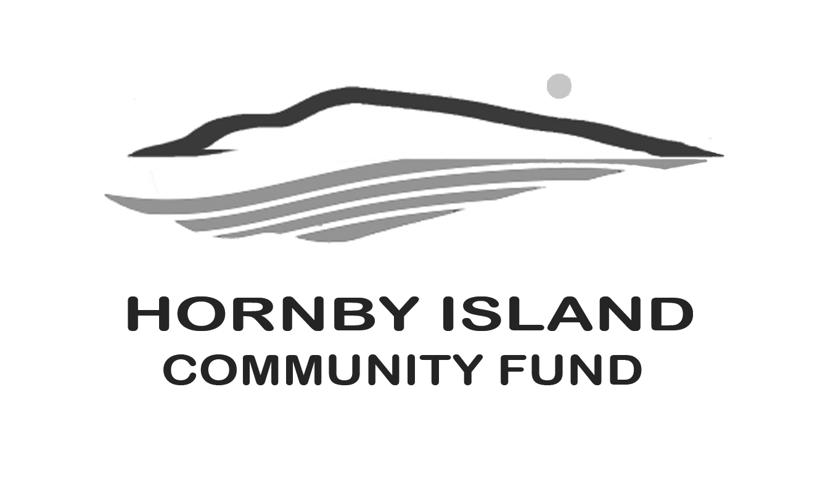

**First Edition**

**February, 2020**

**Report from the Community Fund**

**Celebrating with our Community**

New ground has been broken in the Community Fund granting. The local fund has aligned more closely with our host foundation, both for online applications and notifications. This allows a more streamlined process, but also access to the larger funds controlled by the Comox Valley Community Foundation. The CVCF added $14,270. to the amount that Hornby had available (from interest and proceeds from the annual Book Sale), for a grand total of $37,920 in funds distributed for 2019!

**2019 Grants were awarded to:**

Hornby Island Quilters, storage area, $1000.

HIES, Room To Grow improvements, $6370.

HIAC, Arts Centre prep., $1500.

CHI, Beulah Creek restoration, $9000.

Emergency Preparedness, radios and supplies, $2900.

Tribune Bay Outdoor Education Society, septic wetland restoration, $1000.

H.I. Housing Society, dehumidifiers, $1000.

Festival Society, $2800. (from the Arne Olsen Fund)

Spark, bathroom renovations, $3000.

Natural History, cabinets, $1350.

Hornby Island Daycare Society, playground upgrades, $3000.

Farris Farmland Trust, driveway and well, $5000.

The annual money distributed has been steadily increasing from $1500. in the Fund’s inception year, 2002. The total of grants, 2002 through to 2019, is $158,115. An itemized $ breakdown of which groups have successfully applied for grants is on our website: <https://hornbycommunityfund.org/recipients>

**Thank you to our donors**

This year has been one of transition. As we embrace all the benefits of liaising more closely with the Comox Valley Community Foundation, there have been a few glitches in acknowledging our donors. If you have not received your tax receipt, please contact April Lewis, our most capable Treasurer, and she will help track the receipt down. Also, from now on, we ask that all donations are made to the CVCF, with instructions to direct the money into the Hornby Island Community Fund. Many blessings!

Many of our donors want anonymity, never the less, we thank you from the bottoms of our collective community hearts!

We would note that Jim Bulmer and Dr. Barbara have again donated $1000. from the Token Project that they spearhead. Thank you to them, and to those people who support this work.

**Tax deductible transfer of securities**

For those wanting to make a provision to make a charitable donation, by transferring stocks or securitiesto the Community Fund, there is information on our website on how to do this: <https://hornbycommunityfund.org/donations>

**Thinking of getting married? Or planning a celebration?**

Now is the time to book your party rentals!

We also count on a cadre of volunteers to help with this service, so if you have some good time, please contact us!

More information is on our website: https://hornbycommunityfund.org/party-rentals

**Thank you to all the Friends of the Fund.** Together we are making a difference in our community.

**Blessings for your Spirit of Giving, and may 2020 be a year full of JOY!**

Submitted by: Community Fund Advisory Board: **Anne Carney, Brenda Cha, Gary Duke, JoAnn Harrison, April Lewis, Angie Read, Karen Ross and Eva Wetzel**